451/1
COMPUTER
PAPER 1
OCT/NOVEMBER 2014

KCSE ONLINE

MARKING SCHEME

COMPUTER
Paper 1
OCT/NOVEMBER 2014

- In each of the following situations state the most appropriate data processing mode. (2 marks)
a). Hotel reservations
- online data processing
b). Pay roll preparations
- batch data processing .
- a) Explain two uses of an uninterruptible power supply unit. (2marks)

- Regulate the flow of power
- Store power shortly after power failure
b) Explain the meaning of BACKUP. (1marks)
- This is storage of a copy of program or data in another place to be used if the original is lost or damaged.

- State two consequences of a poorly implemented system change over strategy (2 marks)
- failure to obtain anticipated benefits
- un expected time slippage
- cost overruns that vastly exceed budgets
- technical shortfalls resulting in performance that is significantly below the estimated level
- a). What is a section break as used in word processing? (2 marks)
- a section break marks the end and beginning of a section in a document
b). State two section breaks that can be used in a word processor (2 marks)
- Odd
- Even
- Continuous
- Next
5. a) Portability refers to whether a program can be copied or installed in more than one computer
b) – in-house developed programs
- venue at the-shelf software purchase through a vendor
- open source
i). Language syntax (1 mark)
- The grammatical rules that govern the way in which words, symbols, expressions and statements may be formed and combined.
ii). Semantic
- These are rules that govern the meaning of the statements, symbols — what happens when the program is executed.
- Distinguish between Job scheduling and job sequencing (2 marks)
- Job scheduling — can only handle one task at a time therefore, the operating system has to determine which
task will be processed first and makes sure that the one that is currently being processed is closely monitored to
avoid wasting time in the processor.
- Job sequencing — the operating system keeps a list ofjobs or tasks currently being run and clocks them in and
out of the processor.
- a) Subtract 110₂ from 11010₂ (1mk)
b). State what the following key combination will do when pressed in
Microsoft word 2003
i). Ctrl + END (1 mark)
- moves the cursor from the current position in the document to the end
ii). Ctrl + DEL (1 mark)

8. Explain the difference between central processing unit (CPU) and microprocessor (2 marks)

A CPU carries out all the arithmetic and computing functions of a computer, while a microprocessor houses the CPU, BIOS and memory access circuits.

- Suppose that i and j are integer type variables that have been assigned the values of 3 and -5 respectively. What
is the value of the following Boolean expressions? (2 marks)
a). (iDIV2)>=(j+6)
- false
b). i - 3=j+5
-true
- a). State two characteristics of Rom (2 marks)
- can only be read but can not write on it
- it is non volatile
- stores permanent instructions from manufacturer
b). Name two devices other than the typical computer where ROM may be used (2 marks)
- microwaves
- cell phones
- videos
- Explain two uses of DVDs. (3mks)
–entertainment – e.g. music, movie
- distribution of software
- archival storage

12. a). Dot matrix (2 marks)
is a type of computer printing which uses a print head that runs back and forth, or in an up and down motion, on the page and prints by impact, striking an ink-soaked cloth ribbon against the paper, much like the print mechanism on a typewriter.
- Draft, which is of relatively poor appearance
- Near letter quality (NLQ)
- Super letter quality (SLQ) which is nearly as good as the letters produced on a typewriter or a full character
printer.
b). Inkjet printer (2 marks)
Inkjet printing is a type of computer printing that creates a digital image by propelling droplets of ink onto paper, plastic, or other substrates.
- Draft quality
- Standard quality
- High quality
13 a). what is meant by disk defragmentation? (1 mark)
- refers to arranging of scattered folders and files on a storage media for access of files and folders
b). State the purpose of disk defragmentation (2 marks)
- put the files back together so that they are contiguous
- consolidate the free space together after all of the files
14. - one -to -one

-one – to – many
-many – to – many

15. a) Define the following web related terms:
i) Web browser (1 mark)
A browser is an application program that provides a way to look at and interact with all the information on the World Wide Web.
ii) Hyperlink (1 mark)
This is the clickable link in text or graphics on a Web page that takes you to another place on the same page, another page, or whole other site.
iii) Hypertext document (1 mark)
A document usually web document (file) where the user interacts with the whole document using hyperlinks

SECTION B (60 MARKS)

16. Study the flowchart below and answer the questions that follow

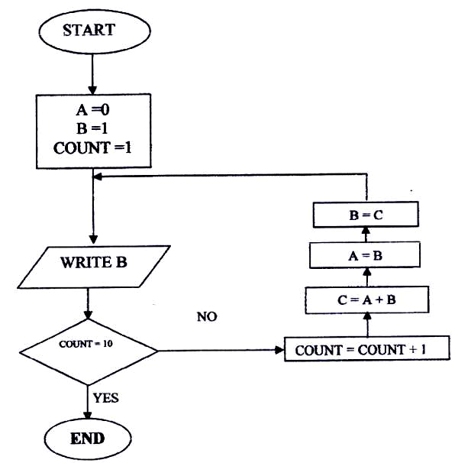

(a) Write a high level language program for the above flowchart (7mks)

Program Displays (input, Output);  Var  A,B,C count: Integer;  Begin  A:=0;  B:=1  Count =1  While Count <10 do  Begin  Count:= Count + 1;  C: = A + B;  B:=C;  Writeln (B);  End; | or | Program displays (input, Output);  Var  A,B,C, count: Integer;  Begin  A: = 0  B:-1  Count: 1  For count: =1 to 10 -1 do  Begin  C: A + B;  A: =B;  B:=C;  Writeln (B);  End;  End.

(b) List the outputs of the flowchart above
1,2,3,5,8,13,21,34,55

(c) Modify the flowchart so that it adds up all its outputs and displays the sum obtained (3mks)
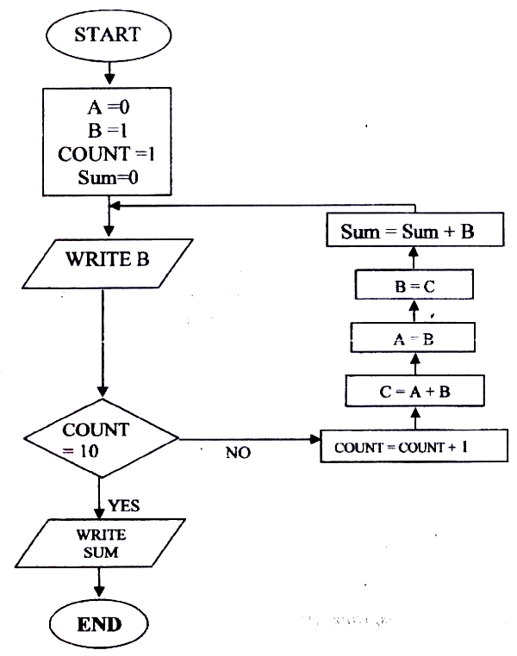

17. i ( a) What is the hexadecimal equivalent of 767₈
Step1 convert 767₈ to decimal
7x 8² + 6x8¹ +7x8⁰
448+48+7=503₁₀
Step2
Convert 503₁₀ to hexadecimal
16 | 503 | Rem
16 | 31 | 7
16 | 1 | 15
 | 1 | 1
767₈=IF 7₁₆
Correct method/ step and answer give a mark

b) Use one’s compliment to solve the following sum:-5₁₀ (2mks)
2 | 5 | Rem
2 | 2 | 1
2 | 1 | 0
 | 1 | 1
-5₁₀ = 101₂
ii (a) 24.35₁₀ = X₂
24₁₀ + 0.35₁₀
24 -:- 2 = 12RO
12 -:- 2 = 6RO
6 -:- 2 = 31RO
3 -:- 2 = 1R1 Read up
1 -:- 2 = OR1 •
11000₂• 0101100₂

0.35
x 2
0.70
x 2
1.4
x 2
0.8
Read down x 2
1.6
x 2
1.2
x 2
0.4
x 2
0.8 (1mk)

(ii) 6A13_{H} = X₁₀
1
2
6, (10), 1, 3₁₆ = X₁₀

6 10 1 3
16³ 16² 16¹ 16⁰

(6 x 16³) + (10 x 16²) + (1 x 16¹) + (3 x 16⁰)
A
B 24576 + 2560 + 16 + 3
C
D = 27155₁₀
E
F

(b) 36₁₀ – 25₁₀
36 -:- 2 = 18RO
18 -:- 2 = 9 RO
9 -:- 2 = 4 R1
4 -:- 2 = 2 RO
2 -:- 2 = 1RO
1 -:- 2 = OR1 100100₂

25 -:- 2 = 12R1
12 -:- 2 = 6RO
6 -:- 2 = 3 RO
3 -:- 2 = 1R1
1 -:- 2 = OR1 11001

100100₂ – 11001₂

Make the bits equal
100100₂ – 110010₂
(3mks)

Gets one’s complement of negative number
i.e.
110010
001101₂
Add a 1, to the 1st complement
001101
+ 1
001110

Add the two numbers
100100
+ 001110
110010₂ answer

(c) 11101.11 + 111.011
11101 . 110
+ 111. 011
(1) 00101.001
overflow + 1
00110.001₂
(4)
00110.001₂ – X₁₀

0 0 1 1 0 . 0 0 1
2⁴ 2³ 2² 2¹ 2⁰⁻¹2 -²2 ⁻³2

(1 x 2²) + (1 x 2¹) + 0 . (2⁻³ x 1)
4 + 2 .¹/₈
6.125₁₀

18. A student at Kula Mawe High school was asked to name four computer consumables. The student responded by naming the following; Toner, ink cartridge, plotter pen, ink ribbon.
a). Which of the items mentioned is likely not to be actively used in a school situation (1 mark)
- Plotter pen
b). Explain to the rest of the students what is meant by:
i). Toner cartridge (2 marks)
- is a fine powder of carbon that is used by photocopying and laser printers to produce printed text and images on paper. The powder is usually carried inside a cartridge, which also contains a photosensitive drum onto which the image to be printed is first reflected.
ii). Ink cartridge (2 marks)
- These are small containers of solid that is heated to boiling point when in use; the ink is then forced into very thin jets of a print head and sprayed onto paper
iii). Ink ribbon (2 marks) It is a narrow but long piece of fine cloth, which is soaked in ink and its ends fixed onto two spools inside a sealed ribbon cartridge.
c). Output devices are classified as either hard copy or softcopy devices.
i). Name two hard copy output device that can be used in a busy architectural firm (2 marks)
- Plotter
- Printers
- Computer Output on Microform (COMs)
ii). State two reasons why the user may prefer softcopy to hard copy output device (2 marks)
- to save on space and stationery
- the display of output is almost instantaneous
- some of the output, reading is not necessary
d). Use the two’s binary compliment method of subtraction to work out the following (4 marks)
4561.558— 10011111.0012

19. a). Explain the meaning of the following field properties;
i). Validation rule (1 mark)
- It is a logical expression that relates values to be entered in a field.
ii). Validation text
- This is the message that appears once the validation rule is violated
b). Below are two table structures of files in a database
TableA Table B
Field Data type Field Data type
Employee name text Employee no Number
Employee number Auto number Data employed Data/time
DOB Date/ Time Department Text
Address Text Salary Currency
i). Which of the two tables is likely to be the parent table (1 mark)
- Table A because it has employee information
ii). It is advisable to ‘enforce referential integrity’ when creating a relationships. What do you
understanding by the term referential integrity?. (2 marks)
- To ensure all records entered in the related table exists in the primary table.
iii). The field ‘employee no’ in table B likely to be the foreign key. What is a foreign Key? (2 marks)
- Is a unique field that identifies each record in the secondary table in a relationship.
iv). Which fields in both tables is most appropriate for creating a relationship? (I mark)
- Employee number
v). What would make the relationship between the table fail to work? (2 marks)
- The data type is not similar
c) i). In databases the field properties specify finer details related to the fields and the table entries
expected. State THREE field properties. (3 marks)
- input mark
- Validation Rule
- Required
- Indexed
ii). State THREE functions of a database (3 marks)
- To enhance security of data
- To share file between departments
- To reduce redundancy
- To enable updating and deleting of data
- In faster searching of data

- a). I). Explain three communication services offered through internet (3 marks)
- Chatting
- E-mails
- Video conferencing
ii). Describe the following internet terms (2marks)
Sign Up
Download
b). The following is a spreadsheet relating to a farmer.
i). a function 1F(B2<200 “Not Viable”), IF(B2>300,” Moderate”), IF (B2>1000, “Viable”))). Give the appropriate result returned in cells C2, C3, C4 and C5 (2 marks)
ii). Text can easily be selected using a mouse in word processing. How do you select
a). Multiple paragraph
- Triple click (2marks)
b). Vertical block of test
- Hold down Ctrl as you drag the mouse pointer
c). Distinguish between (2marks)
i). A window and an orphan in word processing

 | A | B | C
1 | Crop | Amount | Remark
2 | Maize | 150 | Not viable
3 | Bean | 300 | Not viable
4 | Cashew nuts | 850 | Moderate
5 | Cabbages | 1036 | viable
- A window is a heading without the appropriate body part while an orphan is the body without the heading.
ii). Computer Crime and Computer abuse
d) i). Give one purpose of drop caps on a text paragraph (mk)
- To emphasize the beginning of a paragraph
ii). What is meant by desktop publishing? (1 mark)
Process of producing publications like cards, newspapers etc by designing their text and graphic layout and inserting, editing, formatting and printing of text and graphical objects using a special desktop publishing software
- This is the ability of computers to think and reason like human beings
ii). Cards, certificate, newspapers, magazines, pamphlets, newsletters, books, calendars

