HOME SCIENCE

PAPER ONE
*NRBS*
1. Explain the role of sweat glands in the soiling of the body (2mks)
2. Identify any four main causes of accidents in the house (2mks)
3. State any two characteristics of clothes made of fabric that develop static electricity (2mks)
4. Explain how living a relatively sedentary lifestyle can lead to obesity (1mk)
5. State two qualities that make the run and fell (machine fell) seam suitable for making night dress
6. Explain two precautionary measures to be taken when cleaning a painted wall
7. Give two reasons why low heeled shoes are recommended for a pregnant woman (2mks)
8. Give four uses of fat in flour mixture (2mks)
9. State the two main roles of garnishing in food presentation (2mks)
10. Identify linen using burning test (3mks)
11. Give reasons for using the following processes during garment construction (2mks)
(a) Basting
(b) Trimming
12. Identify any six factors that may affect normal foetal development (3mks)
13. Define the term food fortification (1mk)
14. State any two dangers of misusing drugs (1mk)
15. State any two factors that affect the efficiency of a detergent (2mks)
16. Define the term ‘hue’ as used in colour (1mk)
17. State any function of riboflavin (2mks)
18. What are two disadvantages of credit buying (2mks)
19. Mention any two preparations to be made before carrying out a family wash (1mk)
20. Suggest two reasons for using smoking in garment construction (2mks)
21. Give two reasons for having a plan for spending the money available to a family (2mks)
22. What are the two forms of “malnutrition” (1mk)
23. You have visited your aunt who is sick
(a) Wash and treat her loose coloured cotton bed sheets (10mks)
(b) Clean a pair of stainless steel cutlery she will use (5mks)
(c) Clean her tooth brush (5mks)
24. (a) State five factors that affect individual nutrient requirement (5mks)
(b) State five factors to consider when packing meals (5mks)
(c) State six ways of ensuring that a sleeve is well set (6mks)
(d) Suggest for advantage of blending wool with nylon (4mks)
25. (a) Giving four examples explain why some nutritional disorders are referred to as
lifestyle related (4mks)
(b) Discuss five precautionary measures to take when using frying as a method of cooking (5mks)
(c) Explain five ways in which consume can protect herself from being exploited (5mks)
(d) With the aid of diagram explain the procedure of working out wide tucks (5mks)
26. (a) State five factors to consider when choosing fastenings (5mks)
(b) State five precautions to take when using kerosene as a fuel (5mks)
(c) Discuss five points to consider when selecting lighting fixtures (5mks)
(d) State five qualities of a well constructed piece of furniture (5mks)

*SBC*
1. Explain why dump dusting is better than dry dusting in a sick room
2. Mention any two results of lack of vitamin C in the diet
3. Give any two factors to consider when making a choice of accessories for an evening
Part
4. State two disadvantages of concealed drainage system
5. Mention two uses of (dhania) coriander leaves in cookery
6. What is the reason for giving a teething baby a hard object to bite on
7. State two qualities of a good soup
8. Give two areas in a garment where top stitching is done
9. Mention one way in which each of the following articles is given special treatment
(i) Tray cloth
(ii) Baby Napkin
10. Mention two advantages of blending cotton and nylon fibres
11. Give two methods of credit buying
12. Outline three points to consider when choosing a work surface in the kitchen
13. Give one reason for kneading yeast dough
14. Write down any two reasons why it’s important to eat raw carrots
15. State three qualities to look for in a pair of cutting out scissors
16. Give two ways in which a mother can infect her new born baby with HIV/AIDS virus
17. Outline two reasons for snipping curved seams
18. Name three types of immunization given to children before their first birthday
19. Give two reasons for disposing of waste properly
20. (a) Explain the procedure of sweeping a cemented floor
(b) Give the procedure of cleaning an enamel plate
21. (a) Describe any three types of meal service
(b) Supporting your answer with four reasons, give a most suitable fabric for an institutions
bed linen
(c) Give four ways in which scarcity of time would affect a consumer
(d) With two specific examples, give three uses of permanent stitches
22. (a) Give the systematic order of placing bedding items when preparing a baby’s cot
(b) Explain three desirable qualities of ironing board
(c) Give three characteristics of a well- made dart
(d) Your house is experiencing frequent black outs. Explain how you would clean a hurricane
lamp in readiness
23. (a) Breast milk is the best option for any new baby. In which ways would a lactating mother
improve supply of breast milk to her baby? (Give five points)
(b) State five points to consider when giving general care to all the clothes
(c) Explain five rules to observe when fixing fastenings
(d) Discuss five factors that influence consumer buying

*MHS*
1. Outline three forms of food service (3 marks)
2. State three reasons for interfacing collars (3 marks)
3. State two properties which make asbestos suitable for theatre curtains and protective clothing
4. State two factors that influence choice of a method of controlling fullness (2 marks)
5. State three characteristics of a good French seam (3 marks)
6. List down four methods of neatening an open seam (2 marks)
7. Mention three positive effects of advertisements to a consumer (3 marks)
8. State two important rules to observe when darning (2 marks)
9. Give three factors determining the choice of color in a sitting room (3 marks)
10. Explain three rules to observe during stain removal (3 marks)
11. Mention four points to observe when packing meals (4 marks)
12. State three principles of wise buying (3 marks)
13. Identify three dangers of weaning the baby when it is too late (3 marks)
14. Give two reasons why common salt is iodized (3 marks)
15. State four disadvantages of using charcoal when cooking (2 marks)
16. a) Launder cotton blood stained sheet (7 marks)
b) Describe how to occasionally clean a gas lamp (4 marks)
c) Give the procedure for cleaning two Aluminium cups (5 marks)
d) Explain briefly how you can carry out spotting on a woolen skirt (4 marks)

17. a) Describe how run and fell seam is made on the side of a cotton skirt (8 marks)
b) State four functions of tucks in garment construction (4 marks)
c) With the aid of a diagram, describe the making of gathers before attaching to the waist band

18. a) Explain points to consider when choosing flowers for flower arrangement (5 marks)
b) Describe the procedure of cleaning a wooden polished table surface (7 marks)
c) List four ways of enhancing personal appearance (4 marks)
d) Explain four ways of encouraging a child to play (4 marks)

19. a) State six points to consider when choosing and preparing weaning foods (6 marks)
b) Give three desired qualities of a deep frying pan (3 marks)
c) State five reasons for preserving foods (5 marks)
d) Explain six dietary needs of an elderly person (6 marks)

*AGHS*
1. List four fat soluble vitamins
2. State two possible causes of anaemia
3. Give two points to look for when buying spinach
4. State two effects of strong heat on proteins
5. State two disadvantages of suing left over foods
6. State two forms in which laundry soap is found in the market
7. Give the steps of removing chewing gum stain from a garment
8. Mention the three areas (centres of work that make up the work triangle in a kitchen
9. Suggest two measures to take immediately nose bleeding occurs
10. List two improvised abrasives in the home
11. Identify three tacks that are carried out only during special cleaning of a bedroom
12. Mention two dangers of heavy smoking during pregnancy
13. Give four methods of advertising
14. State two reasons why cotton fabrics are popular for the table linen
15. Give two reasons why silk is expensive
16. State three qualities of a good tape measure
17. Give three reasons for a needle freaking during machining
18. Give two reasons why press studs are not suitable for use in children’s garments

19. (a) You are arranging dinner for your two friends, describe how to carryout the listed chores.
(i) Thoroughly clean a stained melamine cup you will use
(ii) Starch a previously laundered cotton tray cloth using boiling water starch
(iii) Thorough cleaning the terrazzo kitchen floor
20. (a) Mention four ways of improving maize meal porridge
(b) Explain three precautions to take when using an oven to bake cakes
(c) Explain six factors to look for when selecting a frying pan
(d) Explain four uses of carrot in cookery
21. (a) Identify two fibers in each case wet the properties listed below;
(i) Stronger when wet
(ii) weaker when wet
(iii) elastic
(iv) luctious
(iv) Flakes with a yellow flame
(b) Describe the procedure of taking the following body measurements
(i) hips
(ii) Inside arm length
(iii) Couch
(c) Using diagram, describe the procedure of preparing a straight collar without interfacing
ready for attachment
22. (a) Discuss four desirable qualities of a good clothes line
(b) Explain five ways of disposing of refuse in the home
(c) Explain five factors to consider when selecting an electric coon
(d) Giving a reason in each case, state three factors to consider when wearing a baby
23. (a) Explain three preparations to make on a sewing machine in readiness to stitching
(b) Describe the procedure of making a single pointed dart
(c) Explain four points to consider when selecting clothes for a short plump figure

*MUM*
1. Mention any three classes of stain removers used in laundry work
2. State two uses of facings in garment construction
3. State three uses of eggs in flour mixtures
4. Give any two precautions measures to take when using dry cleaning fluid
5. What is the cause of swelling of body tissues that is symptomatic of kwashiorkor
6. Name any four common groups of people that are usually affected by anaemia
7. List three functions of water in the bodies of human beings
8. Define the term essential Amino acids correctly
9. Why are there more than usual numbers of Tuberculosis victims in today’s
societies than in the past (i.e. after the 80’s than before)
10. What is the work of a thermostat in an electric iron box
11. What are the following parts of an enclosed drainage system ?
a) Water closet:
b) Man hole
c) Septic tanks
12. State three general causes of poor sanitation
13. Give two advantages of frying as a method of cooking
14. State any two common problems that may afflict a pregnancy before its full term
15. Give two reasons why the double stitched seam is commonly used on children’s
garments
16. Explain two methods or ways in which the body can gain immunity to help resist
disease attacks
17. Give two advantages of using carpets in the home
18. State two reasons why wooden surfaces in the home need finishing
19. List four points to look for when buying cabbages
20. State two measures to take in order to control the incidence of bed sores in bed
ridden invalids
21. Your friend is celebrating her seventeenth birthday and you are to help in the preparations.
Describe how you would:
a) Launder her loose coloured cotton dress that she is going to wear that afternoon
b) Explain how you will thoroughly clean the cemented floor in the living room to be used
22. a) A doctor diagnosed pellagra in a foreign student. Briefly describe two symptoms he might
have noticed that were affecting his patient
b) Explain any two common faults often encountered in the making of yeast based mixture
products
c) Explain one disadvantage of advertising
d) With aid of a labeled illustration describe how to make an overlaid seam
23. a) Explain three causes of dental caries
b) Explain one main difference between inter facing and interlining
c) With the aid of clearly labeled diagrams describe how to work and make a box pleat
d) Explain four factors to consider before choosing a method for mending a tear in the
fabric of an item to be laundered
24. a) Explain four points to consider when weaning a baby
b) Explain two types of play to which growing children are normally exposed AND
mention one benefit and one demerit in each case
c) State four reasons or ways in which a consumer needs protection from negative market
effects
d) Draw a simple illustration and state the main function of each of the following
tacking stitches
i) Tailors tacking:
ii) Fishbone tacking:
iii) Basting:
*MHS*
1. Outline three forms of food service (3 marks)
2. State three reasons for interfacing collars (3 marks)
3. State two properties which make asbestos suitable for theatre curtains and protective clothing
4. State two factors that influence choice of a method of controlling fullness (2 marks)
5. State three characteristics of a good French seam (3 marks)
6. List down four methods of neatening an open seam (2 marks)
7. Mention three positive effects of advertisements to a consumer (3 marks)
8. State two important rules to observe when darning (2 marks)
9. Give three factors determining the choice of color in a sitting room (3 marks)
10. Explain three rules to observe during stain removal (3 marks)
11. Mention four points to observe when packing meals (4 marks)
12. State three principles of wise buying (3 marks)
13. Identify three dangers of weaning the baby when it is too late (3 marks)
14. Give two reasons why common salt is iodized (3 marks)
15. State four disadvantages of using charcoal when cooking (2 marks)
16. a) Launder cotton blood stained sheet (7 marks)
b) Describe how to occasionally clean a gas lamp (4 marks)
c) Give the procedure for cleaning two Aluminium cups (5 marks)
d) Explain briefly how you can carry out spotting on a woolen skirt (4 marks)
17. a) Describe how run and fell seam is made on the side of a cotton skirt (8 marks)
b) State four functions of tucks in garment construction (4 marks)
c) With the aid of a diagram, describe the making of gathers before attaching to the waist band
18. a) Explain points to consider when choosing flowers for flower arrangement (5 marks)
b) Describe the procedure of cleaning a wooden polished table surface (7 marks)
c) List four ways of enhancing personal appearance (4 marks)
d) Explain four ways of encouraging a child to play (4 marks)
19. a) State six points to consider when choosing and preparing weaning foods (6 marks)
b) Give three desired qualities of a deep frying pan (3 marks)
c) State five reasons for preserving foods (5 marks)
d) Explain six dietary needs of an elderly person (6 marks)

*TNW*
1. Why is figure type an important factor to consider in choice of your clothes? (2mks)
2. What is the importance of learning first aid? (2mks)
3. Which laundry processes are carried out before washing a fast- coloured cotton shirt? (2mks)
4. Differentiate between tear and wear (2mks)
5. Give two reasons as to why steel wool is not suitable for cleaning plastics (2mks)
6. Name two main methods of purchasing goods and services in Kenya (2mks)
7. What are the advantages of dry cleaning? (2mks)
8. State two ways of minimizing wastage of detergents when washing (2mks)
9. Give any two uses of running stitches (2mks)
10. How can one identify the warp thread in the absence of the selvedge? (2mks)
11. Which factors make meat dry and tough after roasting (2mks)
12. State three points to bear in mind when making seams on under wears (3mks)
13. Define the following terms as applied to meal??????
14. Give one flavouring that is suitable for salads (1mk)
15. State two points to consider when selecting the baby’s layette (2mks)
16. Differentiate between complementary and supplementary feeding (2mks)
17. Why is management of fullness important (3mks)
18. Give two uses of vinegar in cooking (1mk)
19. Your father is to facilitate a very important seminar. Explain how to:
a) Dry clean his tie (5mks)
b) Finish his cotton shirt (5mks)
c) Clean the leather bag be will use (5mks)
d) Clean a pair of shipper he will use (5mks)
20. a) Giving examples in e ach case explain three changes that take place in a dough
during the frying of mandazi (6mks)
b) Give four faults that could occur in cooking of mandazi (4mks)
c) Explain four nutritional needs of an adolescent (8mks)
d) Explain four qualities of a well made vegetable salad (2mks)
21. a) Explain three points to consider when using a sewing machine (6mks)
b) Mention six stitches used during the blouse/shirt construction from cutting to readiness (3mks)
c) Explain the procedure followed in preparation of around patch pocket ready for attaching (6mks)

22. a) Explain two positive and two negative effects of advertisements on the consumer (4mks)
b) What precautions would one take when using kerosene (4mks)
c) Explain five advantages of breast feeding (5mks)
d) What five problems could result to a baby during weaning (5mks)
e) Give two reasons for labelling products (2mks)

*NDW*
1. State the importance of sebaceous glands in relation to a healthy skin (1mk)
2. State two qualities that make aluminium popular for household utensils (2mks)
3. Give a reason why nylon is unsuitable for sports wears (1mk)
4. Mention two uses of dhania (coriander) leaves in cookery (2mks)
5. Mention two advantages of blending cotton and nylon fibers (2mks)
6. State any two reasons why a child’s growth monitoring is important (2mks)
7. List four laundry processes that are harmful to woolen fibres and in each case state the
harm caused
8. State three ways of providing variety in meal planning and management (3mks)
9. State two factors to consider when choosing where to buy vegetables (2mks)
10. Give two qualities of a good advertisement (2mks)
11. Explain three ways of economizing fuel when using electricity for cooking (3mks)
12. Explain two reasons for using interfacing during garment construction (2mks)
13. Identify three methods of finishing the edges of sleeves other than using a cuff (3mks)
14. State three reasons for labeling products in a factory (3mks)
15. State two precautions to be taken to prevent bed sores when taking care of the sick persons
at home
16. List two uses of lamp shades (2mks)
17. State two factors to consider when planning lighting for various rooms in the home (2mks)
18. Differentiate between advancing and receeding colours (2mks)
19. Give two reasons why most women in the rural areas are less groomed (2mks)

20 a) Describe the correct procedure of laundering nylon dress (8mks)
b) Describe the correct procedure of cleaning white canvas shoes without shoe laces (7mks)
c) Give the correct procedure of cleaning two aluminium cups (5mks)
21 a) Mention two uses of butter in the home (2mks)
b) Identify four major nutrients found in butter (4mks)
c)i)Describe four changes that takes place when heating butter (4mks)
ii) Name four main groups of fats giving an example for each (4mks)
d) Explain three considerations to make when selecting a storage facility for butter (6mks)
22. a)Outline four tests undertaken at the clinic to an expectant mother in the first month of
pregnancy (4mks)
b) Describe two supplementary foods for a baby (2mks)
c) Explain two benefits of supplementary food (4mks)
d)i)Explain four reasons why a mother may be unable to breast feed
ii) Explain four points on care of play items (2mks)
23. a) Explain four properties of viscose rayon which are undesirable (8mks)
b) Suggest four features that can be used to finish a nigh dress decoratively (4mks)
c) Give three reasons for ironing a night dress during construction (3mks)
d) Explain five desirable qualities of an iron box (5mks)

*RCH*
1. State the importance of sebaceous glands in relation to a healthy skin (1mk)
2. State two qualities that make aluminium popular for household utensils (2mks)
3. Give a reason why nylon is unsuitable for sports wears (1mk)
4. Mention two uses of dhania (coriander) leaves in cookery (2mks)
5. Mention two advantages of blending cotton and nylon fibers (2mks)
6. State any two reasons why a child’s growth monitoring is important (2mks)
7. List four laundry processes that are harmful to woolen fibres and in each case state
the harm caused (2mks)
8. State three ways of providing variety in meal planning and management (3mks)
9. State two factors to consider when choosing where to buy vegetables (2mks)
10. Give two qualities of a good advertisement (2mks)
11. Explain three ways of economizing fuel when using electricity for cooking (3mks)
12. Explain two reasons for using interfacing during garment construction (2mks)
13. Identify three methods of finishing the edges of sleeves other than using a cuff (3mks)
14. State three reasons for labeling products in a factory (3mks)

15. State two precautions to be taken to prevent bed sores when taking care of the sick persons
at home (2mks)
16. List two uses of lamp shades (2mks)
17. State two factors to consider when planning lighting for various rooms in the home (2mks)
18. Differentiate between advancing and receeding colours (2mks)
19. Give two reasons why most women in the rural areas are less groomed (2mks)
20. a) Describe the correct procedure of laundering nylon dress (8mks)
b) Describe the correct procedure of cleaning white canvas shoes without shoe laces (7mks)
c) Give the correct procedure of cleaning two aluminium cups (5mks)
21. a) Mention two uses of butter in the home (2mks)
b) Identify four major nutrients found in butter (4mks)
c)i)Describe four changes that takes place when heating butter (4mks)
ii) Name four main groups of fats giving an example for each (4mks)
d) Explain three considerations to make when selecting a storage facility for butter (6mks)
22. a)Outline four tests undertaken at the clinic to an expectant mother in the first month
of pregnancy (4mks)
b) Describe two supplementary foods for a baby (2mks)
c) Explain two benefits of supplementary food (4mks)
d)i)Explain four reasons why a mother may be unable to breast feed
ii) Explain four points on care of play items (2mks)
23 . a) Explain four properties of viscose rayon which are undesirable (8mks)
b) Suggest four features that can be used to finish a nigh dress decoratively (4mks)
c) Give three reasons for ironing a night dress during construction (3mks)
d) Explain five desirable qualities of an iron box (5mks)

*KKE*
1. Why is comfort an important factor to consider during the choice of cosmetics (2mks)
2. What observation should you make when cleaning a house? (2mks)
3. What is the difference between drainage and refuse disposal (2mks)
4. Green vegetables should be blanched before freezing. Give three reasons why (3mks)
5. State any two vaccines that every child should receive (2mks)
6. State ways of preventing insect bites and stings in an environment (2mks)
7. Give three uses of facing in garment construction (3mks)
8. Which factors influence the rise of prices of commodities in the market? (2mks)
9. Which precautionary measures should one take to prevent food spoilage during storage? (2mks)
10. Identify two kitchen equipment that occupy small space and are easy to store (2mks)
11. Explain two functions of water in the body (2mks)
12. Suggest two points to ob serve when cooking beef (2mks)
13. State two nutritional needs of adolescents (2mks)
14. State two reasons why bicarbonate of soda is not popular used in flour mixtures (2mks)
15. Explain how food can be preserved at home without refrigerator (2mks)
16. List three classes of convenience foods (2mks)
17. State the effects of insufficient/light pressure exerted by the pressure foot during stitching (2mks)
18. Give properties that make linen suitable for making kitchen clothes
19. State two qualities of a well made patch pocket (2mks)
20. In the space provided, sketch two pattern marking that will assist in laying of pattern (2mks)
21. You are taking care of an aunt who is recovering from n infection disease:
a) Explain how you could launder a white cotton bed sheet (14 mks)
b) Describe how you would clean a plastic basin she has used in the room (6mks)
22. a)Mention three methods used to coat before frying(3mks)
b) State 4 ways of improving appetite when presenting food at the table (4mks)
c) Discuss general points to observe when drying meat (3mks)
d) Discuss five important points to observe when planning meals for the elderly (10mks)
23. a)State three ways of transferring pattern markings(5mks)
b) State five advantages of home based care of the sick (5mks)
c) Giving reasons, explain 5 rules to observe when removing stains (10mks)
24. a) explain three roles of play in child development (3mks)
b) Give five qualities of a well made cuff (5mks)
c) With the aid of a well labeled diagram, describe how to make machine fell seam (7mks)
d) Describe how you would clean your wooden locker (5mks)

*STK*
1 Define the term hue as used in home science (1mk)
2. Give two Ways in which the studying of home science benefits an individual (2mks)
3. Give two functions of a colander as kitchen equipment
4. Sate four basic instructions on the use of medicine (2mks)
5. Name two types of accidents that can cause fractures (2mks)
6. State two points to consider when choosing a toilet brush. (2mks)
7. Why are clothes dampened before ironing? (1mk)
8. Give three precautions to take when cleaning wooden surfaces (3mks)
9. State three qualities to look for when buying a sauce pan (3mks)
10. Give three uses of eggs in flour mixtures (3mks)
11. Give two different methods of identifying linen as a textile fibre (2mks)
12. List four decorative methods of disposing off fullness in a toddlers dress (2mks)
13. Give two causes of needle breaking when machine stitching (2mks)
14. Suggest two reasons why a French seam is suitable for fraying fabrics (2mks)
15. Give two points on the importance of consumer education to a consumer . (2mks)
16. State three factors that will affect the efficiency of a laundry soap (3mks)
17. (a) State two reasons for using tucks on children’s clothing (2mks)
(b) Identify any four factors that may affect normal foetal development (2mks)
18. Explain two advantages of home-based care of the sick. (2mks)
19. You are taking care of your sister who is recovering from an infectious skin disease
(a) Giving reasons in each case, explain the procedural steps you would take to launder her
woolen shawl (10mks)
(b) Thoroughly clean her white canvas shoes with laces (6mks)
(c) Explain the steps you would take in cleaning her stained melamine cup (4mks)
20. (a) Discuss five danger signs of pregnancy 10mks)
(b) Explain four points to consider when buying hand sewing needles (4mks)
(c) Give two common faults and their causes in each of the following flour mixtures.
(i) A coarse open texture in rubbed –in cakes (2mks)
(ii) Heavy and close texture in creamed cakes (2mks)
(iii) Hard and tough pastry (2mks)
21. (a) With the aid of three clearly labeled diagrams, explain the working of a lapped seam (8mks)
(b) Explain the functions of each of the following:-
(i) Balance wheel (1mk)
(ii) Bobbin case (1mk)
(iii) Pressure foot lifter (1mk)
(c) Explain four qualities of a good cutting out shears (4mks)
(d) (i) Explain three points of importance of care labels (3mks)
(ii) Give two undesirable properties of nylon (2mks)
21. (a) Explain five changes that occur when cooking ugali using maize flour (10mks)
(b) Define the following terms as used in home science. Give an example in each case:-
(i) Food fortification (2mks)
(ii) Food vehicle (2mks)
(iii) Food supplements (2mks)
(c) Explain four factors that influence consumer buying (4mks)
© SIJE- 2010 Form 4 Home science 441/1 End
4

*STK²*
1. Give two economical ways of disposing refuse. (2mks)
2. Define the term descaling as used in home science (1mk)
3. Using an example in each case list three types of drainage (7mks)
4. Give two use of a mangle (2mks)
5. Name the three categories under which clothes should be sorted out in laundry work (3mks)
6. Name two inexpensive sponging solutions (2mks)
7. Define the term natural immunization (2mks)
8. Give two major functions of vitamin K (phylloquinone) (2mks)
9. Explain two effects of cooking on vitamin C (ascorbic acid) (2mks)
10. Give two differences between weaning and supplementary feeding (2mks)
11. Define the term medicine as used in home science (2mks)
12. State two precautions to take when using grease solvents (2mks)
13. (a) What is valeting in home science?
(b) Explain it’s importance (1mk)
14. List three processes through which sodium s lost in the body (3mks)
15. List three methods of neatening an overlaid seam (3mks)
16. Give two reasons why consumer education is caught in schools (2mks)
17. (i) Which is the most important meal for the day? (1mk)
(ii) Give a reason for your answer (1mk)
18. You’re preparing to entertain visitors in our birthday party.
(a) Sponge your aunties woolen coat to be worn on the day (10mks)
(b) Launder your white cotton blouse with chewing gum stain (6mks)
19. (a) Explain four principles of conserving nutrients while preparing vegetables (8mks)
(b) Explain five major functions of advertisements (5mks)
(c) Explain five factors to consider when renting a family house (5mks)
(d) Give two uses of salt in the house (2mks)
20. (a) Describe how to make a machine fell seam at the shoulders of a blouse (8mks)
(b) Mention four ways of watering an open seam (2mks)
(c) Mention three types of beriberi. Give three differences between any two types you’ve
listed above (6mks)
21. (a) Explain five social needs of an expectant mother (10mks)
(b) Explain five points to consider when choosing personal clothes (10mks)

PAPER TWO
*NYR*
1. A pattern of a child’s dress is provided. You are advised to study the sketch and the layout before you begin the test.
MATERIALS PROVIDED
- PATTERN PIECES:-
A Dress Front
B Dress Back
C Sleeve
D Sleeve binding and ties
E Sleeve opening facing
F Front neck facing
G Back neck facing
- Plain light weight fabric 60cm long by 91cm wide.
- Sewing thread to match the fabric colour
- One large envelope

THE TEST
Using the materials provided, cut out and make the LEFT HALF of the child’s dress to show the following:-
- The joining of the front to back bodice at the shoulder line using a neatened open seam.
- Making a French seam at the sides of the front and the back
- Joining the front and back neck facing with a neatened open seam
- Neatening the outer edge of the joined neck-facing
- Using the prepared facing to neaten the neck-line of the dress bodice
- Preparation of the sleeve opening facing
- preparation of the faced slit opening on the sleeve
- Attachment of the binding sleeve ties onto the sleeve
- Making of the French seam on the sleeve
- Attaching the sleeve on the bodice. DO NOT NEATEN THE SEAM.
At the end of the examination, firmly sew onto your work, on a single fabric, a label bearing your name and the index number. Remove the needle and pins from your work. Then fold and place it
in the envelope provided. Do not put scraps of material in the envelope.
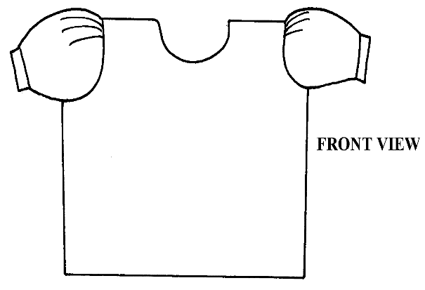
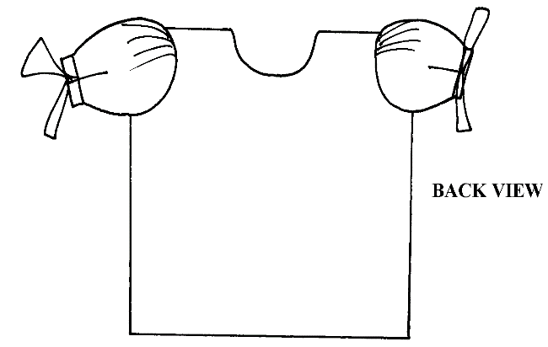
VIEWS

*SBC*
A pattern of a girl’s blouse is provided. You are advised to study the sketches, instructions and layout carefully before you begin the test. *SBC*
MATERIALS PROVIDED
1. Pattern pieces for the blouse *SBC*
- - BODICE FRONT
- - BODICE BACK
- - BACK NECK FACING
- - ARM HOLE BINDING STRIP
2. Light weight plain cotton fabric 45cm long by 90cm wide.
3. Sewing thread to match the fabric
4. One large envelope

THE TEST
Using the materials provided, cut out and make the LEFT HALF of the blouse to show the following processes;
- Working of the front bodice double dart
- Making a French seam at the shoulder
- Making a neated open seam on the side of the blouse
- Joining the back neck facing to the front facing and neatening the free edge
- Attachment of the facing to the neckline and under stitch
- Neatening the armhole using a binding strip
- Cutting the marked tear on the back bodice and repairing it with hand darning

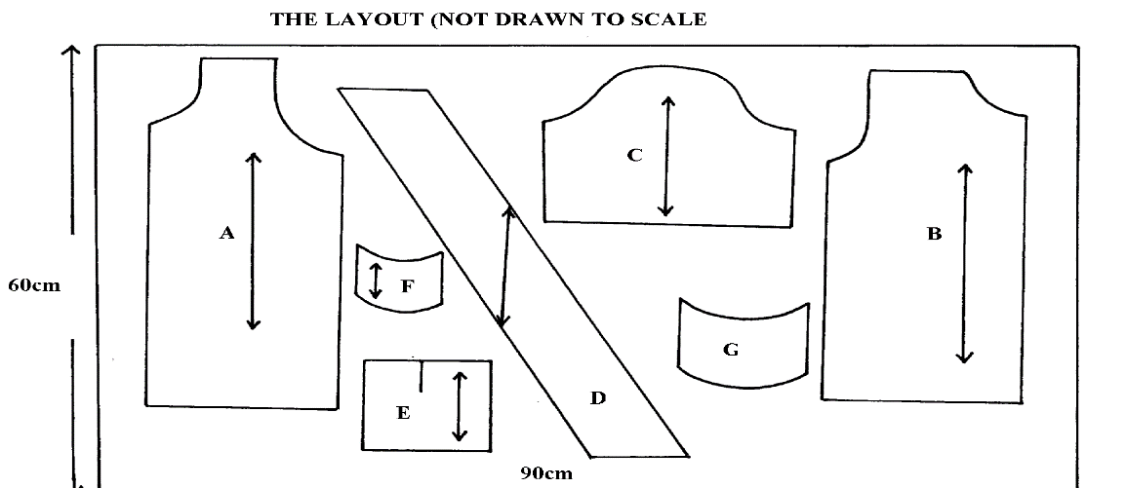

SELVEDGE

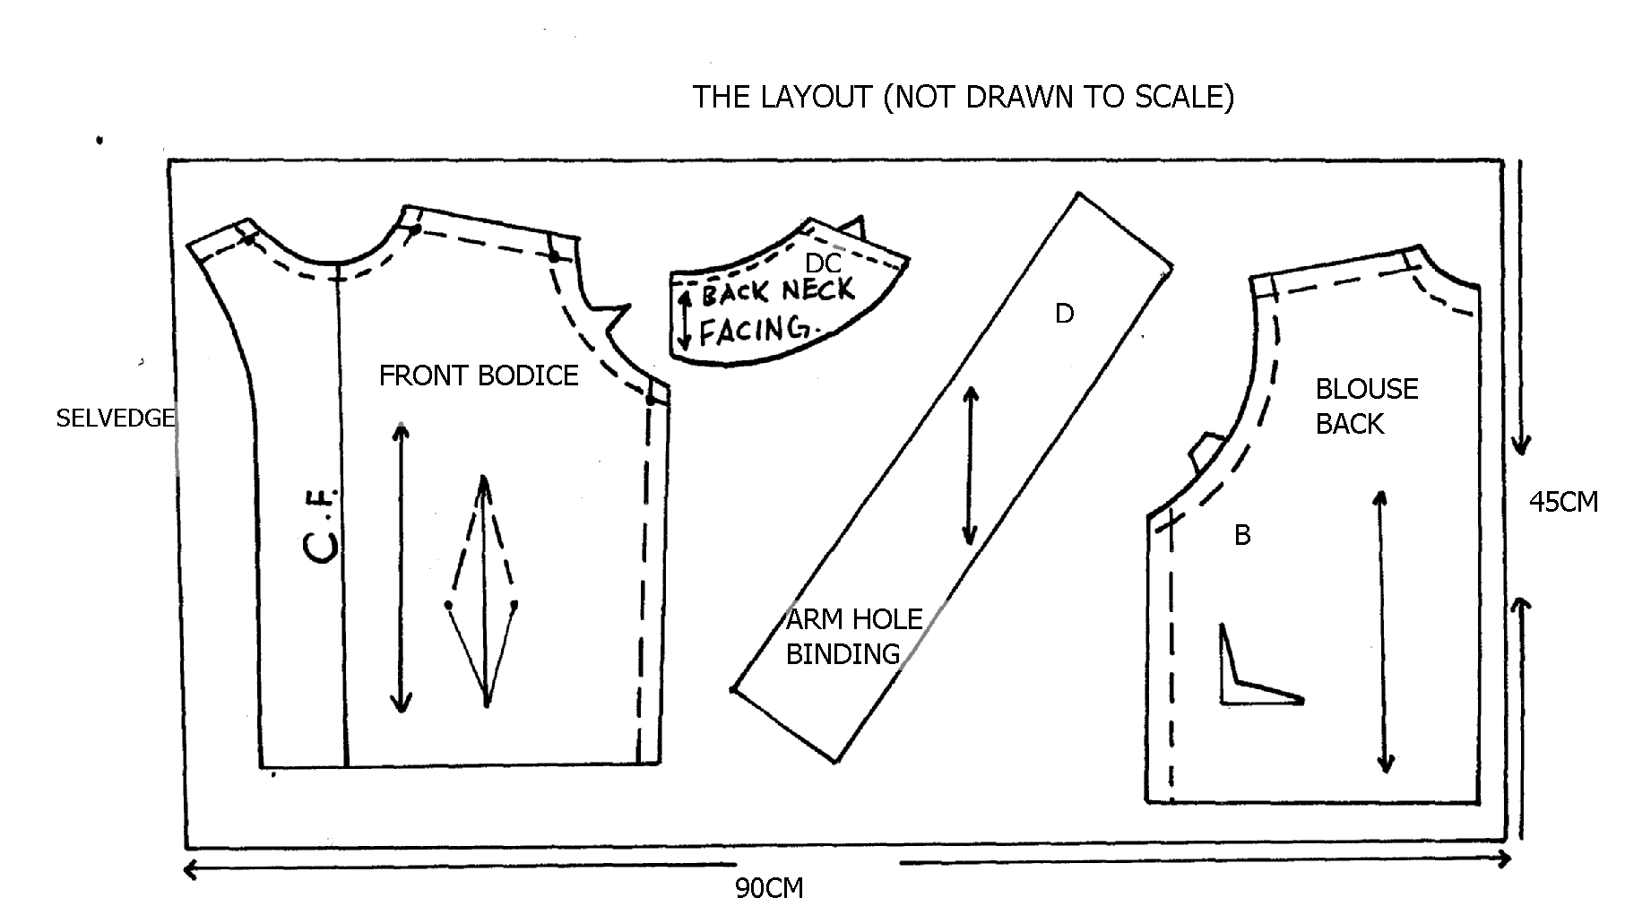
A
C

*NRBS*
A pattern of a child’s blouse is provided. You are advised to study the sketches instructions and the layout carefully before you begin the test.
Materials provided:-
1 pattern pieces
A. - bodice front
B. - bodice back
C. - sleeve
D. - cuff
E. - front facing
F. - back facing
G. - patch
H. - straight strip
2. Plain lightweight cotton fabric 45cm long by 90cm wide.
3. Cotton sewing thread to match the fabric.
4. One button (shirt) with to holes
5. One envelope.

THE TEST
Using the material provided cut out and make the left half of the blouse to show the following processes:
(a) Making of the waist dart
(b) Working of the calico patch
(c) Working of the shoulder seam to make French seam
(d) Making the side seam using an open seam.
(e) Working of continuous wrap opening
(f) Preparing an attaching the cuff on sleeves
(g) Preparing and fixing the neckline facing
(h) Attaching the sleeves on to bodice
(i) Slip hemming the back bodice lower hem
(j) Working of buttonhole and attaching of the shirt button.
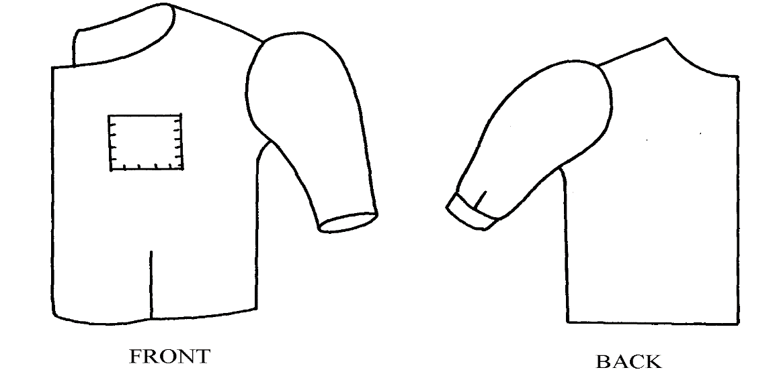

LAYOUT NOT DRAWN TO SCALE

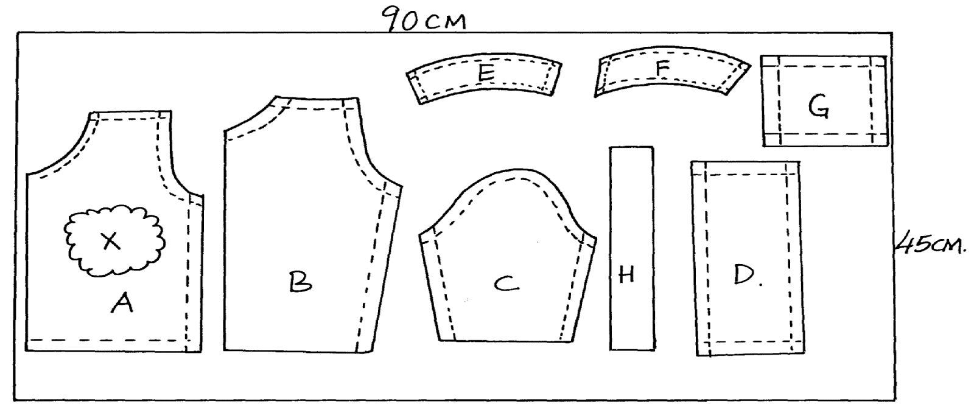

N/B: X represents the hole to be patched.

*MHS*
1. A pattern of a child’s dress is provided. You are advised to study the sketches, instructions and the layout carefully before you begin the test.
MATERIALS PROVIDED
1. Pattern pieces for the dress
A - Dress front
B - Dress back
C - Pocket
D - Front facing
E - Back facing
2. Plain light weight cotton fabric 55cm long by 90cm wide
3. Sewing thread to match the fabric
4. One large envelope

THE TEST
Using material provided, cut out and make the LEFT HALF of a child’s dress to show the following
- Working of a shoulder dart
- The joining of the shoulder seam using a French seam
- The joining of the side seam using a plain seam
- The preparation of the patch pocket
- Fixing of the patch pocket on to the garment
- The joining of the front and the back facings at the shoulder. Neatening the outer edge of the facing
- Attaching of the facing at the neckline of the dress. Understitching the seams
- Hem the lower Bodice using slip hemming stitches
At the end of the examination, firmly sew onto your work, on a single fabric a label bearing your name and index number. Remove the needle and pins from your work, then fold your work neatly and place it in the envelope provided. Do not put scraps of fabric in the envelope.

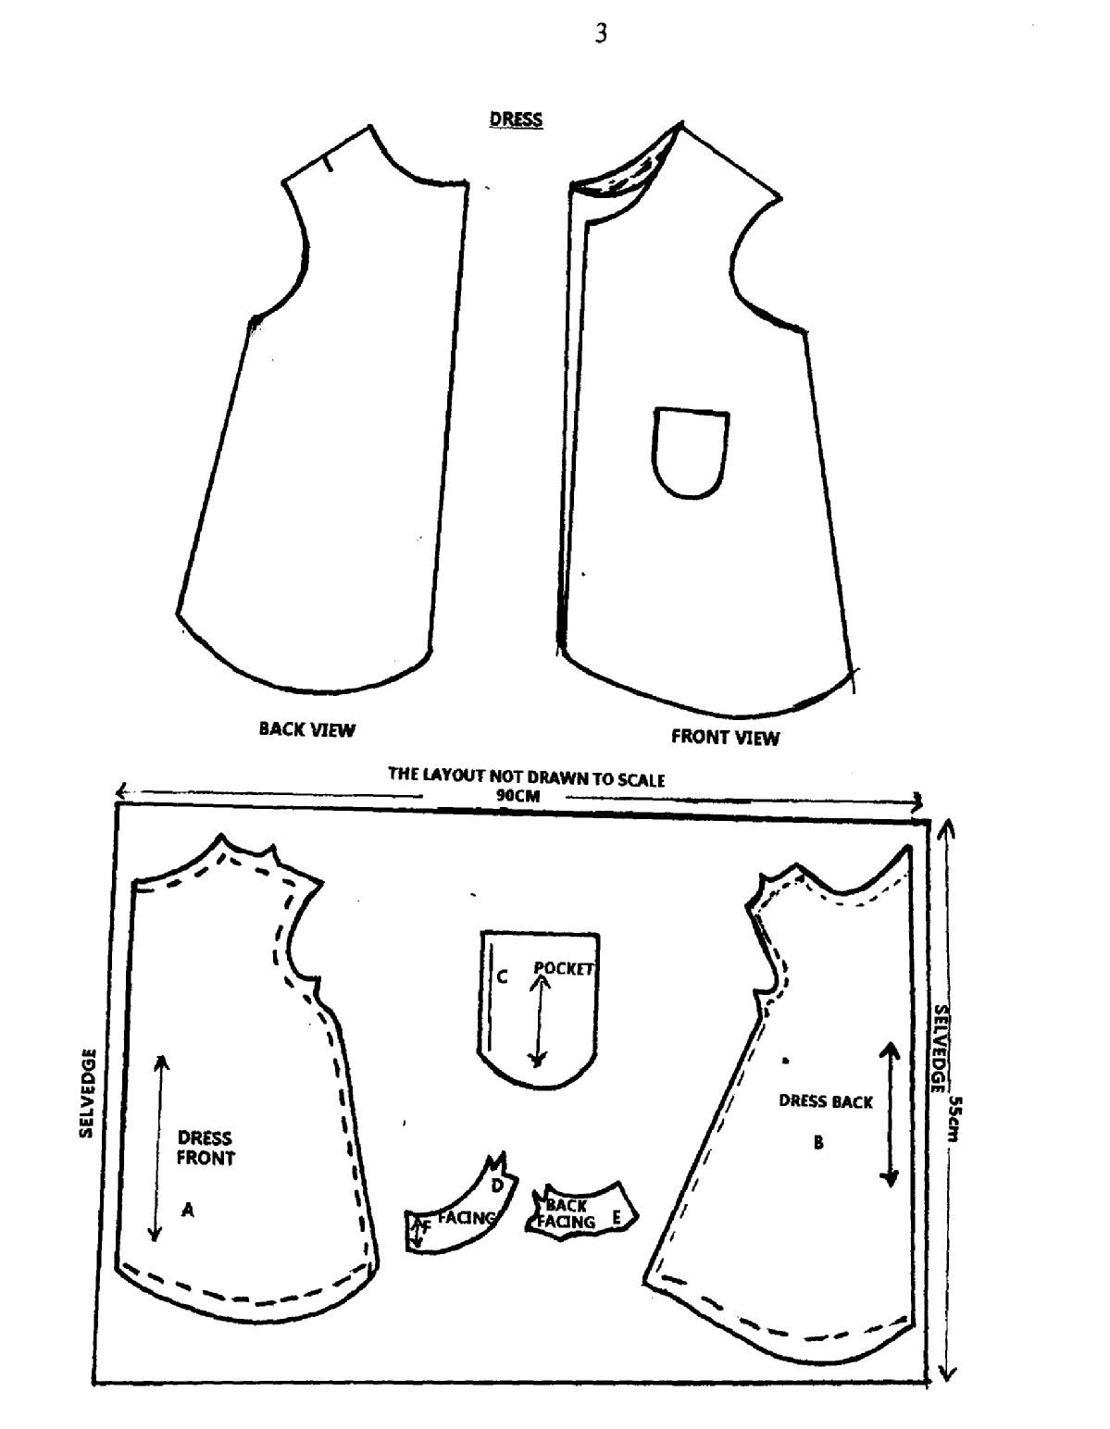

*RCH*
1. MATERIALS PROVIDED
- – Skirt front
- – Skirt back
- - Front yoke
- – Back yoke
- – Collar
- – Front neck facing
- – Back neck facing
- – Frill
N.B Interfacing for collar is cut with pieces from the same fabric

2. Light weight cotton fabric 70cm by 91 cm wide
3. Sewing cotton thread to match the fabric
4. An envelope

THE TEST
Using the materials provided, cut out and make the left half of a child’s dress as shown in the sketch below to give the following;
- The attachment of the back yoke to the back skirt using an overlaid/ seam
- The attachment of front yoke to front skirt using an overlaid seam
- The working of a open seam at the shoulder
- The preparation of an interfaced collar
- The neatening of the free edge of the facings
- The attaching of the collar using the facings
- The making of a French seam at the side of the dress
- The preparation of the frill. Use inverted pleats
- The attaching of the frill to the skirt front only using neatened open seam ( use loop stitches)
At the end of the test, remove all the pins, loose hanging threads and attach your name, index number on a single layer of fabric. Fold your work neatly with the label on the top most and put them inside the envelope provided.
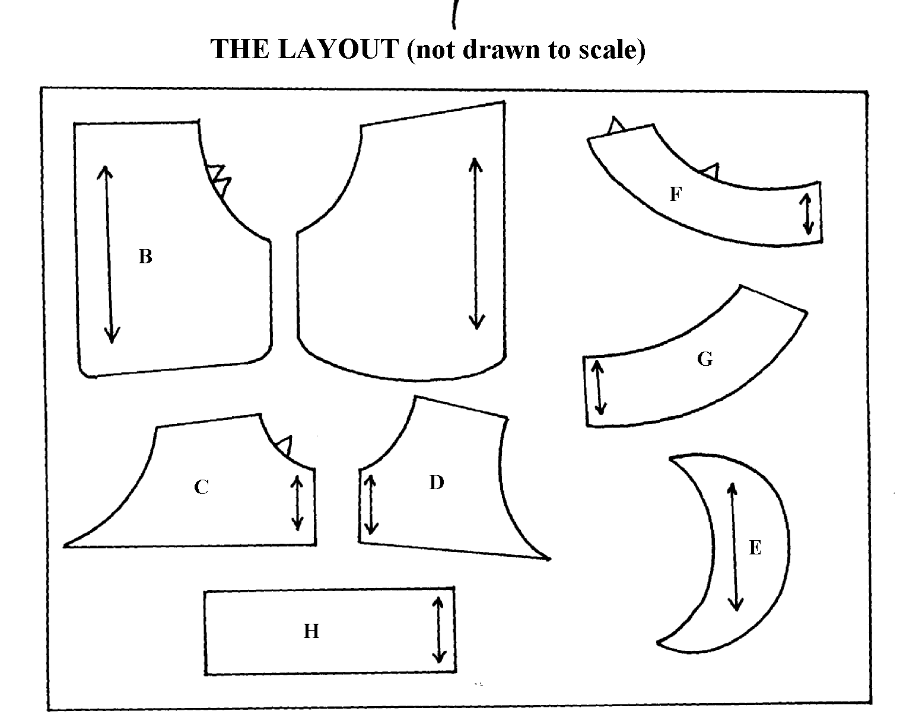
O
A

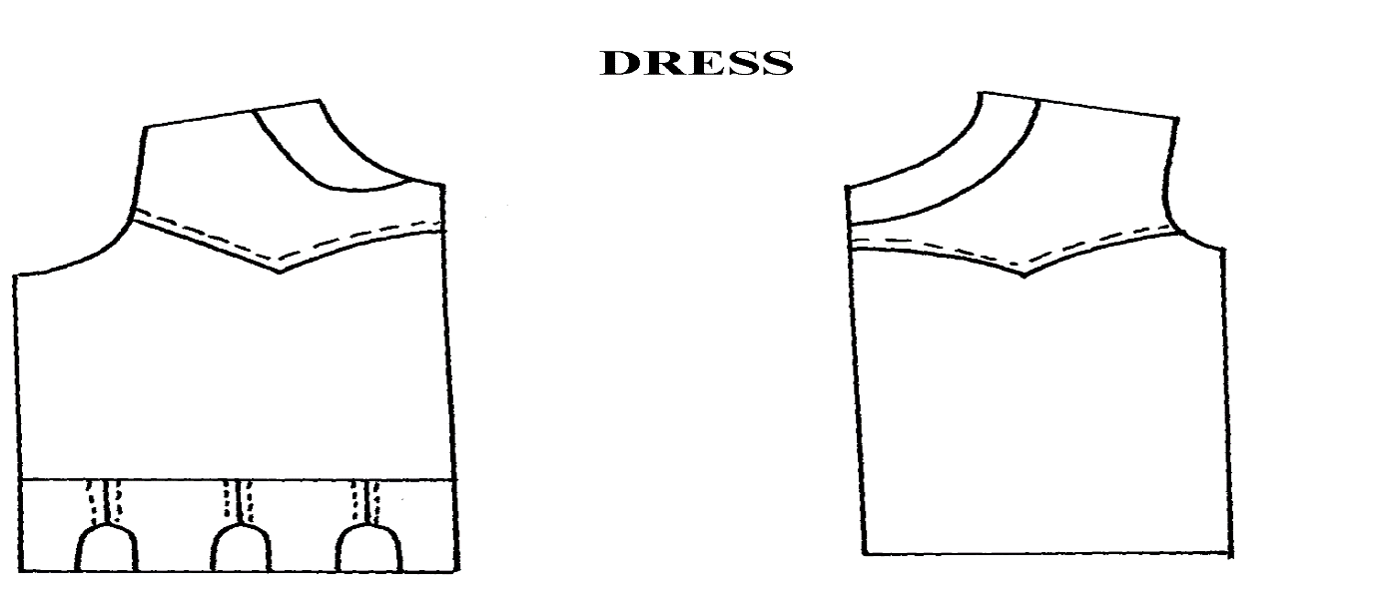

*MUM*
1. A pattern of girls skirt is provided. You are advised to study the sketches the question paper and the layout carefully before you begin the test
MATERIALS PROVIDED
1. Pattern pieces:-
- Skirt front
- Skirt back
- Pocket
- Pocket facing
- Front waist band
- Back waist band
2. Light weight plain cotton fabric 60cm long by 90cm wide
3. Zip (13 cm long)
4. Sewing threads match the fabric
5. One large envelope
THE TEST*MUM*
Using the materials provided cut out and make the RIGHT HALF of the skirt below to show
the following processes:
- Making the back dart
- Facing of the pocket mouth
- Preparation and attachment of the pocket
- The preparation of the gathers on the skirt front piece
- The making of a neatened open seam at the side – below the opening
- The attachment of the zip using concealed method
- The preparation of un-interfaced waist bands
- The attachment of the waist band to the skirt pieces and preparation of the tie ends
- Edge stitching the hem and holding down using running stitches (do not hem)
At the end of the examination firmly sew onto your work, on a single fabric, a label bearing your name and index number. Remove the needle and pins from your work, then fold your work carefully and place it in the envelope provided. Do not put scraps of fabric in the envelope.
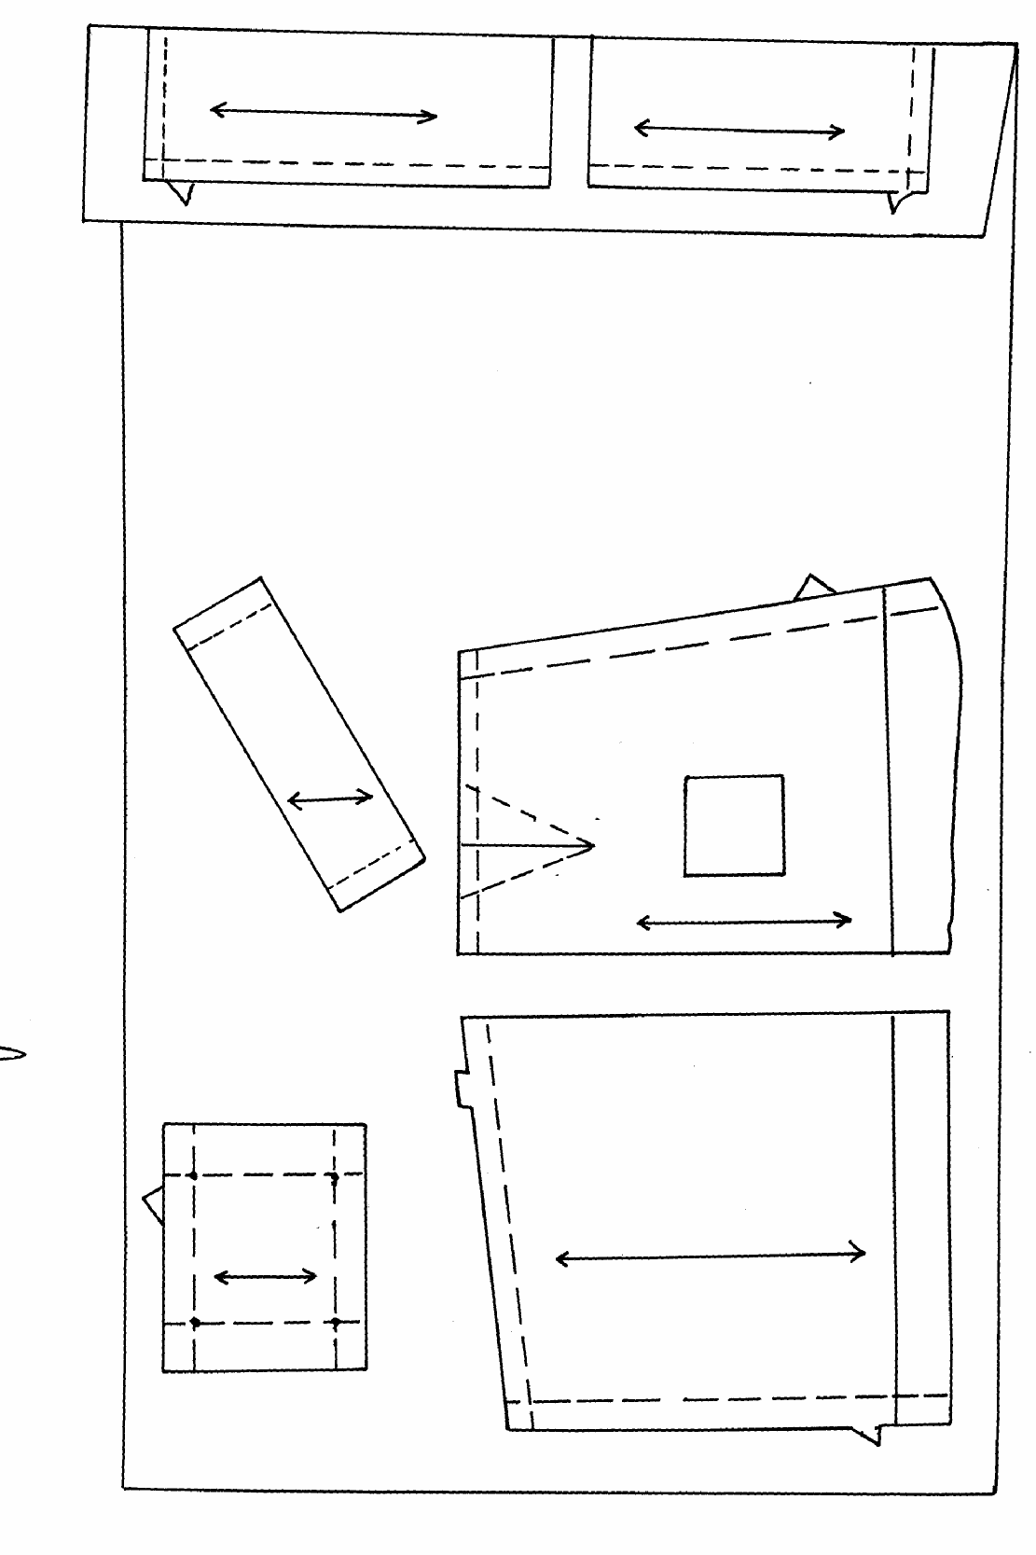
THE LAYOUT (not drawn to scale)
FOLD
E
F
SELVEDGE
D
B
A
C
SELVEDGE A
50cm

BACK VIEW
FRONT VIEW
Zip

*KKE*
A pattern of a girls dress is provided. You are advised to study the question paper, sketches, instructions and layout carefully before you begin the test.

MATERIALS PROVIDED
1. Pattern pieces for the dress:
A -Dress front
B -Dress back
C -Sleeve
D -Sleeve binding and ties
E -Sleeve opening
F -Front neck facing
G -Back neck facing
H -The collar
2. Plain light weight cotton fabric 80cm long by 90cm wide
3. Sewing thread to match
4. One large envelope

THE TEST
Using the materials provided, cut out and make up the right half of a child’s dress to show the following
a) The making of a French seam at the shoulder
b) The making of a neatened open seam at side
c) The preparation of the sleeve opening
d) The joining of the underarm seam using a neatened open seam
e) The preparation of the interfaced collar
f) The preparation of the front and back facing.
g) The joining of the collar to the neckline using the facings.
h) The binding of the lower edge of the sleeve and preparation of the tie ends
i) The preparation and attachment of the sleeve.

N/B Do not trim or neatened the armhole seam allowance.

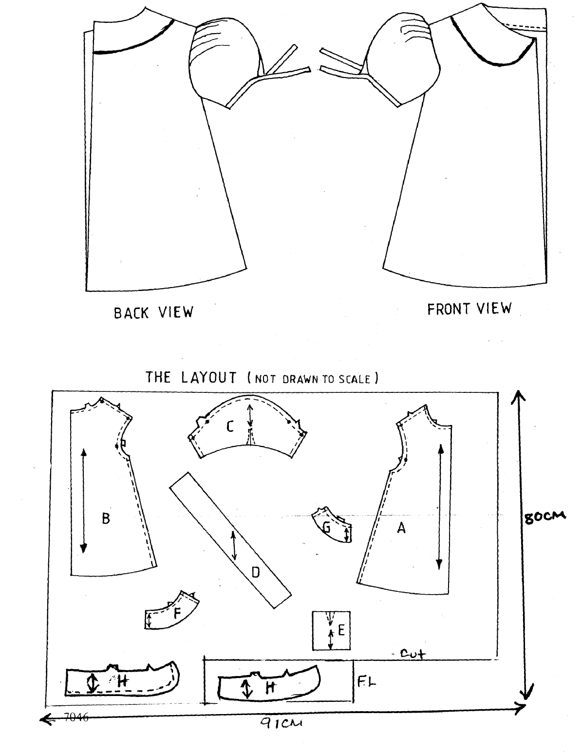

*NDW*
A pattern of a boy’s pair of shorts is provided. You are advised to study the sketches, the question paper and the layout before you begin the test.

1. MATERIALS PROVIDED
A. Shorts front
B. Shorts back
C. Waist band
D. Fly and opening facing
E. Fly binding.

2. Light weight cotton fabric of 70cm long by 90cm wide
3. Cotton sewing thread to match the fabric
4. One large envelope

THE TEST

Using the provided materials cut out and make up the LEFT LEG of the shorts to show the following:

1. The making of the back dart
2. The facing of the short
3. The preparation of the fly
4. The lining of the prepared fly with the attached facing
5. The neatening of the raw edges if the fly together with the facing using the bias binding
6. The fixing of the fly in position by top stitching.
7. The joining of the side seam using a plain seam (not open) and neatening half of it
8. The joining of the inner-leg seam using a neatened open seam.
9. The preparation and attachment of an interfaced waist band
10. The preparation and slip-hemming of half of the hem (i.e. from side seam to inner leg only)

At the end of the examination, firm sew on to your work, on single fabric a label bearing your name and index number. Remove the needle and pins from your work. Then fold your work carefully and place it in the envelope provided. Do not put scraps of materials in the envelope.

BOY’ S SHORT
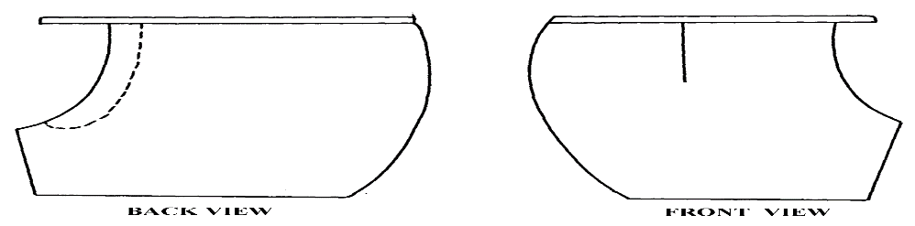

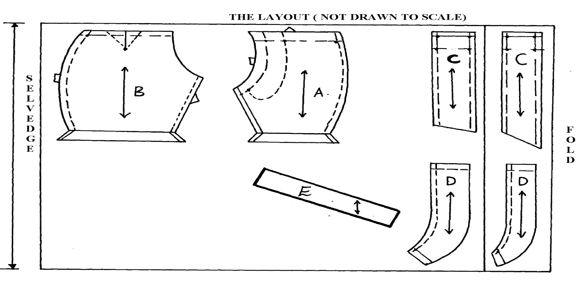

*STK*
A pattern of a girl’s blouse is provided. You are advised to study the sketches, instructions and layout carefully before you begin the test.

MATERIALS PROVIDED
1. Pattern pieces for the blouse
- BODICE FRONT
- BODICE BACK
- BACK NECK FACING
- ARM HOLE BINDING STRIP
2. Light weight plain cotton fabric 45cm long by 90cm wide.
3. Sewing thread to match the fabric
4. One large envelope

THE TEST
Using the materials provided, cut out and make the LEFT HALF of the blouse to show the following processes;
- Working of the front bodice double dart
- Making a French seam at the shoulder
- Making a neated open seam on the side of the blouse
- Joining the back neck facing to the front facing and neatening the free edge
- Attachment of the facing to the neckline and under stitch
- Neatening the armhole using a binding strip
- Cutting the marked tear on the back bodice and repairing it with hand darning
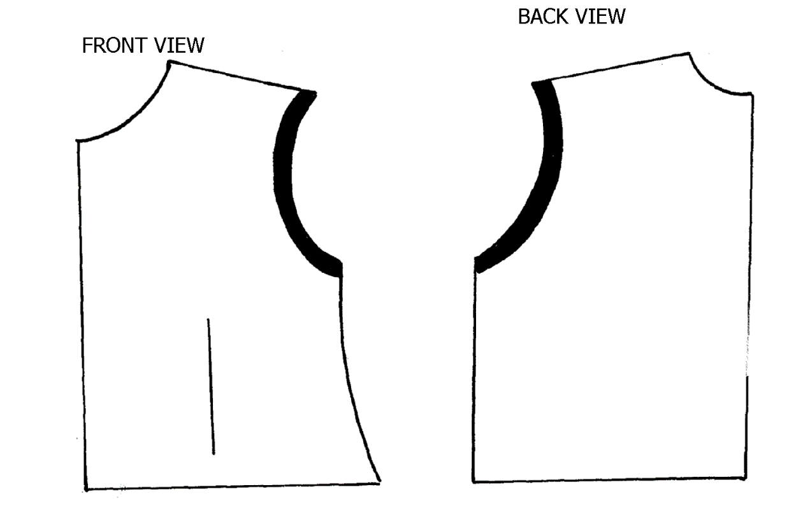

C
A

PAPER THREE

*MHS*
1. THE TEST *MHS*
Your parents are away on a journey and you are expected to make breakfast for yourself and two visitors who have just arrived in the wee hours of the morning
Use the foods given below to come up with a balanced breakfast
INGREDIENTS
- Wheat flour
- Eggs
- Baking powder
- Sugar
- Milk
- Maize flour/ millet flour
- Oranges
- Salt
- Fat

*NYR*
INSTRUCTIONS TO CANDIDATES
- Read the test carefully
- You are advised to spend not more than thirty minutes for planning
- Recipe books may be used for planning
THE TEST
You are getting ready to go back to school after the December, holidays. Using the ingredients provided prepare cook and serve:
- A one-course lunch for you and a friend
- A baked tea item to carry to school
PLANNING SESSION
Make a rough order of work to include:
- List of dishes
- List of food stuff and equipment you would require
- Order to work
LIST OF INGREDIENTS
- Meat/chicken/peas
- Rice
- Cabbage/sukuma wiki
- Tomatoes
- Onions
- Sugar
- Salt
- Self rising flour/flour + Raising Agent
- Carrots
- Cooking oil/fat

*NRBS*
Your younger sister is celebrating her 10th birthday and your mother has asked you to help her in some preparation for the party. using the ingredient listed below, prepare and serve one sweet and one savoury item suitable for passing round in addition include a suitable beverage
- Eggs
- Fruits in season
- Sugar
- Sausages
- Self raising flour
- Margarine
- Fat/oil
- Milk
- Salt
- Sultanas/mixed peel/grated rind of lemon

PLANNING SESSION (30MINUTES)
PRACTICALS 1 ¼ HOURS)
Read the test carefully and proceed as follows:-
- Write the ingredient and recipes your shopping list, your list of requirements on separate sheet of paper using carbon paper to form duplicate copies.
2. Write a time plan to guide your work in duplicate copies.
3. Text books and recipes may be used but constant reference to them during practical and planning
session should be avoided
4. Write your name and index number on your plan and your entire list. After planning assemble your
duplicates and originals separately remove shopping list from duplicate to be used to purchase your
requirement.
At the end of the examination hand in both your question paper. Original and duplicate time plans with separate shopping list to the examiner

*SBC*
THE TEST
You are left with our brother at home. Using the ingredients listed below, cook and present a two course breakfast for the two of you
Ingredients
- Fruit in season
- Margarine
- Tea leaves
- Bread
- Eggs
- Sugar
- Tomatoes
- Milk
- Fat
- Seasoning
PLANNING SESSION: 30 MINUTES
Use separate sheets of paper for each task listed below and use carbon paper to make duplicate copies then proceed as follows:-
Identify the dishes, then write down their recipes
Write down you order of work
Make a list of the food stuffs and equipment you will require

*NDW*
TEST
Your cousin is visiting you over the weekend for an overnight stay. Using the ingredients listed below prepare, cook and server a complete breakfast for the two of you.

Ingredients
- Margarine
- Tomatoes
- Eggs
- Fruits in season
- Finger millet/sorghum flour
- Fat/oil
- Salt
- Tea leaves
- Milk
- Bread

PLANNING SESSION (30MINUTES)
Use separate sheets of paper for each task listed below and use carbon paper to make duplicate copies then proceed as follows:

1. Identify the breakfast then write the recipes
2. Write down your order of work
3. Make a list of the food stuff and equipments you will require.

*AGHS*
THE TEST
Your parents are coming for lunch, using the ingredients listed below, prepare cook and present a two course meal for two.
- Rice (spaghetti/ macaroni/ wheat flour/potatoes
- Fat/oil
- Salt
- Tomatoes
- Vegetables
- Fruits
PLANNING SESSION
Use separate sheets of paper for each task listed below:
Make duplicate copies then proceeds as follows;
- Identify the dishes (write down their recipes)
- Write down your order of work
- Make a list of the foodstuffs and equipment you will require.

*RCH*
THE TEST
Your elder brother has just recovered from severe malaria attack. Your mother has asked you look after him while she is away.
Using the ingredients listed below, prepare, cook and serve a two course lunch for both of you. Include a nutritious drink

INGREDIENTS
Beef/ Eggs
Onions
Tomatoes
Cooking fat/ oil
Sugar
Fruit in season
Salt
Rice/ Wheat flour/ maize flour
Milk
Green leafy vegetables
PLANNING SESSION
Use a separate sheet of paper for each task listed below and use carbon paper to make duplicate copies then proceed as follows;
- Identify the dishes and write down their recipes
- Write down your plan/ order of work
- Write a shopping list of the food stuff that you will require and a list of equipment

*KKE*

THE TEST

You are a day scholar who stays with your grandmother and you carry packed lunches to school. Using the ingredients provided, prepare, cook and serve.

i) One course supper for both of you.
ii) Include a nutritious drink.

- Liver/beef/green grams
- Green bananas/rice
- Green leafy vegetables
- Tomatoes
- Onions
- Cooking fat/oil
- Salt
- Garlic
- Sweet pepper
- Corrianda
- Spices
- Oranges
- Pineapples
- Mangoes

PLANNING SESSION 30 MINUTES
Use separate sheets of paper for each task listed below and a carbon paper to make duplicate copier.

Then proceed as follows:
1) Identify the dishes and write down their recipes.
2) Write down your order of work.
3) Make a list of the food stuffs and equipment you will require.

*MUM*

THE TEST
You are traveling to a neighbouring province to visit your friend during the holidays. Using the ingredients listed below, prepare, cook and pack a suitable snack for two to be eaten on the journey. Omit baking method

- Ground nuts/eggs
- Fruits in session
- Baking powder
- Wheat flour
- Milk/water
- Eggs
- Sugar
- Salt
- Margarine
- Oil/fat
- Carrots

Planning session – 30minutes
Use separate sheets of paper for each task listed below and a carbon paper to make duplicate copies.
Then proceed as follows:
- Identify the food items used and write down their recipes.
- Write down your order of work.
- Make a list of the food stuffs, material and equipment you will require.

*STK*
You are expecting your friend for lunch. Using the ingredients listed below, prepare cook and present a one course lunch and a nutritious drink for the two of you.

Ingredients
Plain wheat flour
Beef
Green leafy vegetables
Fruit in season
Salt
Cooking fat
Tomatoes
Onions
Capsicum
Sugar
Rice/macaroni/spaghetti

PLANING SESSION (30 MINUTES)
Use separate sheets of paper for each task listed below and use a carbon paper to
make duplicate copies then proceed as follows:-

- Identify the dishes then write down their recipes
- write down your order of work
- make a list of foodstuff, equipment and materials that you will require

*TNW*
THE TEST
You are expecting your friend for lunch. Using the ingredients listed below, prepare, cook and present a one lunch and a nutritious drink for the two of you.
Ingredients
- Plain wheat flour/rice
- Beef
- Green leafy vegetables
- Fruit in season
- Salt
- Cooking fat
- Tomatoes
- Onions
- Capsicum
- Sugar
- Milk

PLANNING SESSION (30 MINUTES)
Use separate sheets of paper for each task listed below and use a carbon paper to make duplicate copies then proceed as follows:-

- Identify the dishes then write down their recipes
- Write down your order of work
- Make a list of food stuff, equipment and materials that you will require.

*STK2*
THE TEST
You are hosting your two friends who came on an overnight stay in your home. Using the ingredients listed below, prepare, cook and present a well balanced full breakfast for the three of you.

Ingredients:-
- Baking flour
- Baking powder
- Eggs/liver/kidney
- Cooking fat/oil /margarine
- Bread/sweet potatoes/arrow roots
- Lettuce/cucumber/tomatoes/onions
- Drinking chocolates/tea/coca
- Sugar
- Milk
- Salt

PLANNING SESSION- 30MINUTES
Use a separate sheet of paper for each task listed below. Use carbon paper to make duplicate copies.
- Identify the dishes and write down their recipes
- Write down your order of work
- Make a list of foodstuff and equipment you will require

*STK 3*
PLANNING SESSION – (30 MINS)
You are taking care of your 10yr old nephew who is recovering from malaria. Using the ingredients listed below, prepare, cook and present;
- A one course lunch for both of you.
- Include of refreshing drink.
Ingredients
  - Meat/eggs
  - Rice/spaghetti/macaroni
  - Cabbage/kales/spinach
  - Passion/orange/pineapple fruit
  - Sugar
  - Salt
  - Cooking fat/oil
  - Tomatoes
  - Potatoes
  - Onions
  - Capsicum
  - Carrots
  - Dhania
  - Royco

Planning session (30mins)
Use separate sheets of paper for each task listed below and use carbon paper to make duplicate copies then proceed as follows;
- Identify the menu, then write down the recipes.
- Write down the order of work.
Make a list of the equipment and foodstuff you will require to carry out the practical

ANSWERS
PAPER ONE
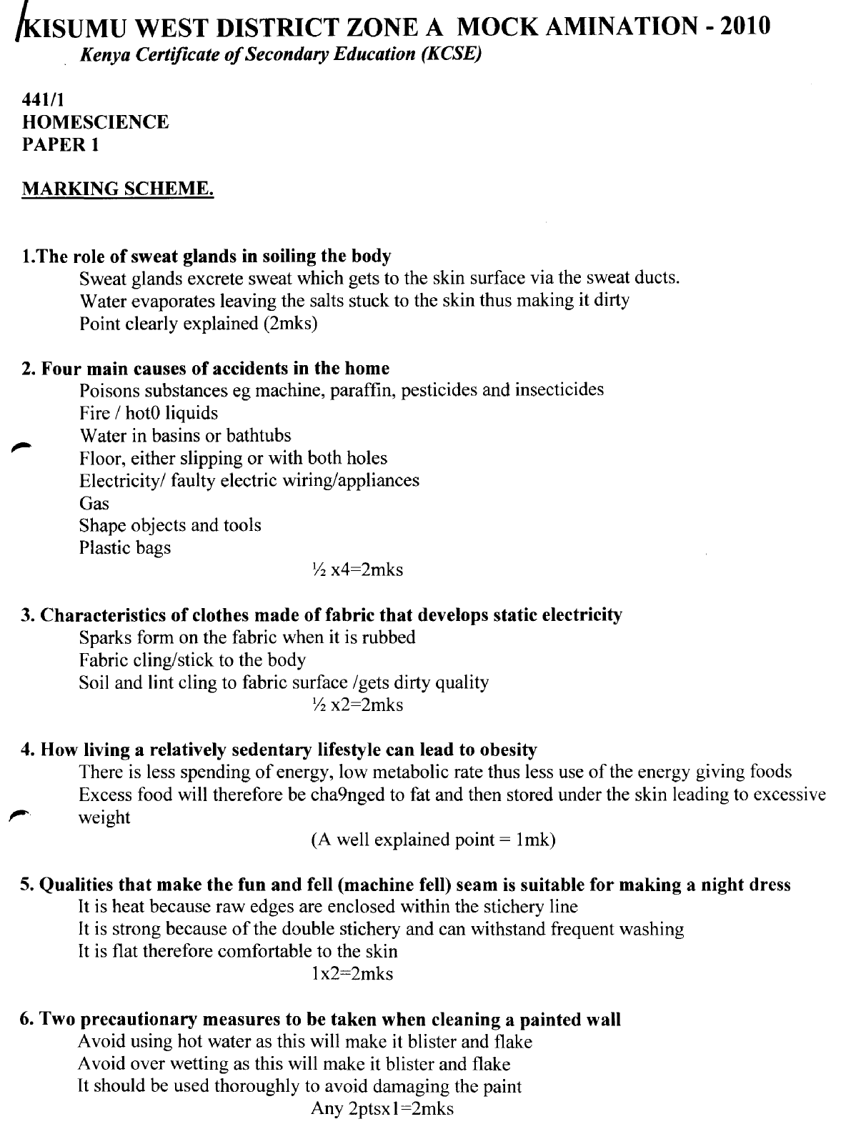
*NRBS*

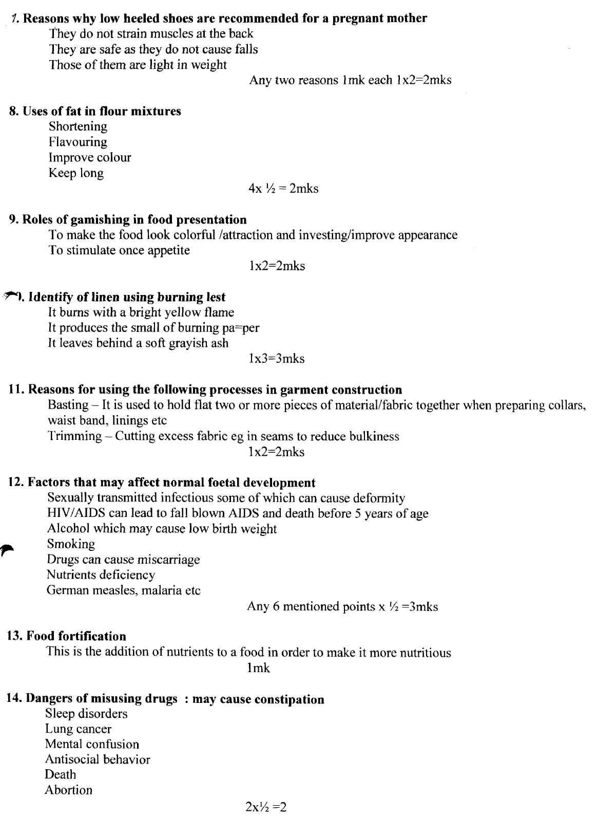

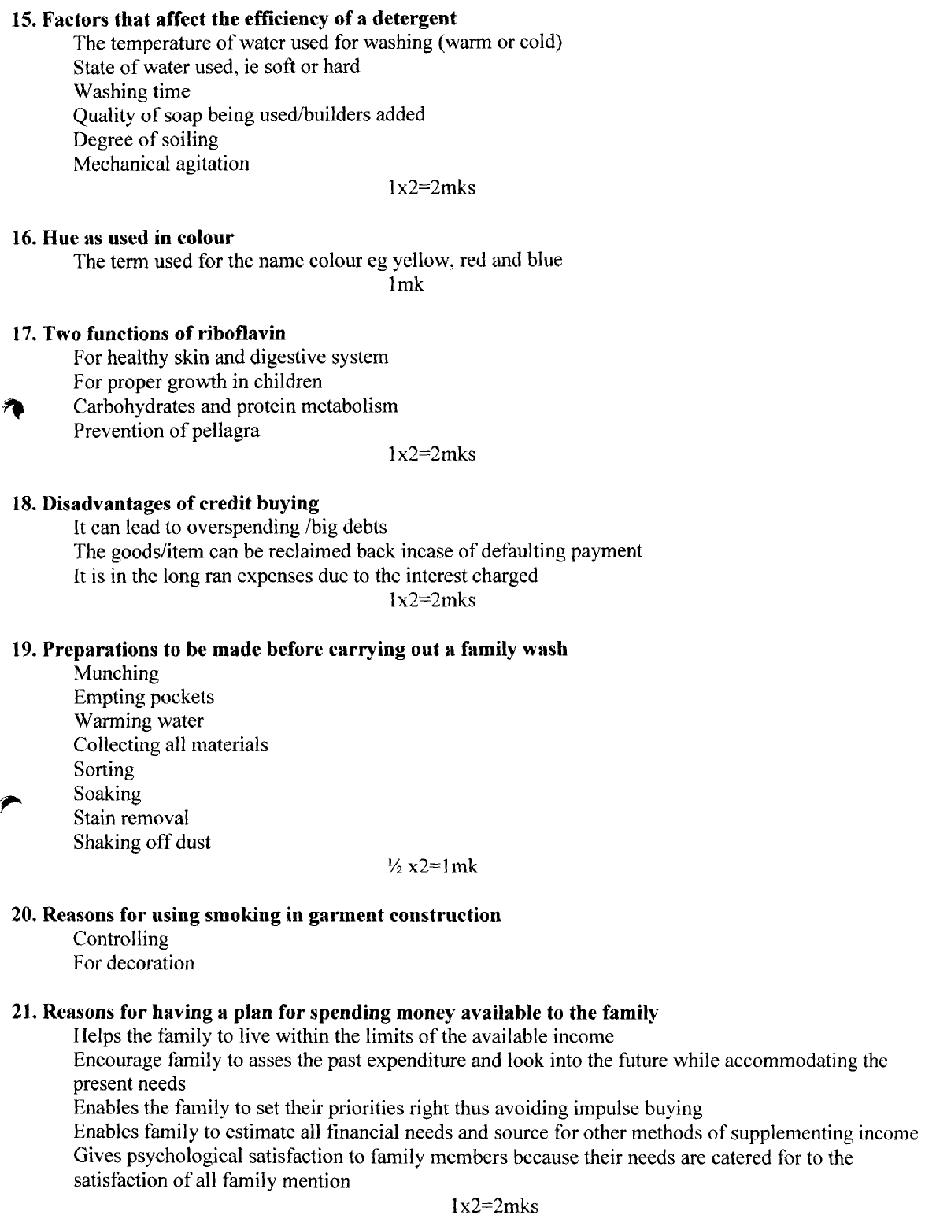
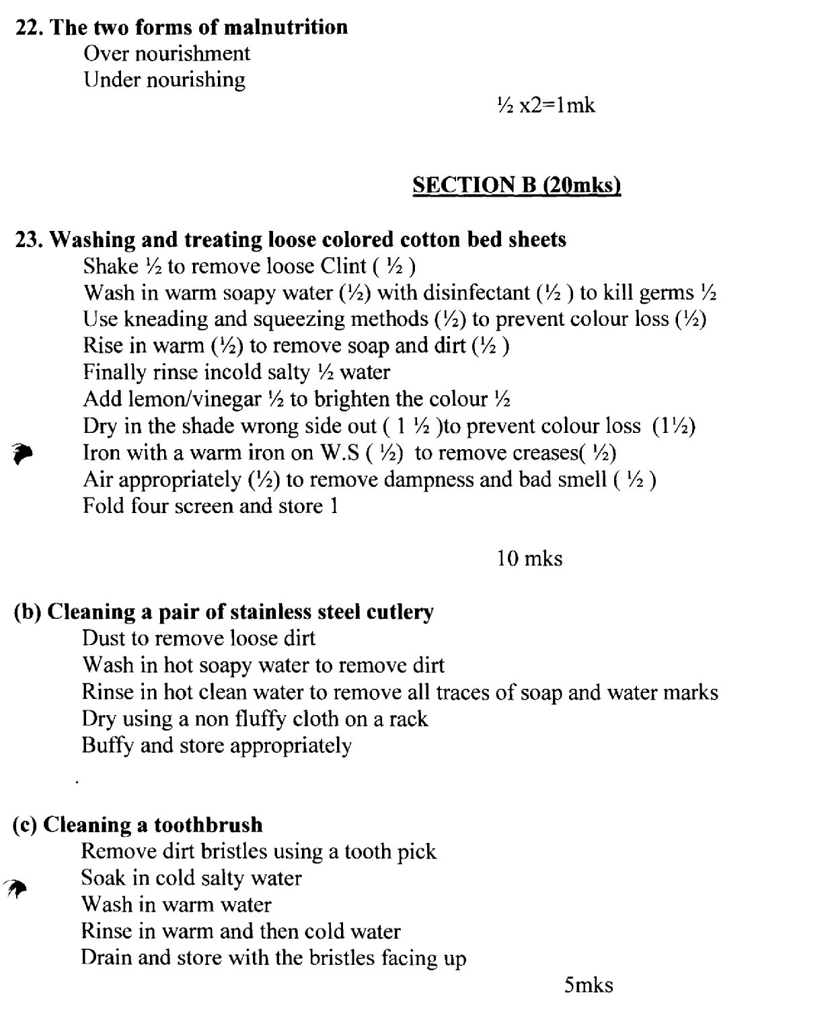

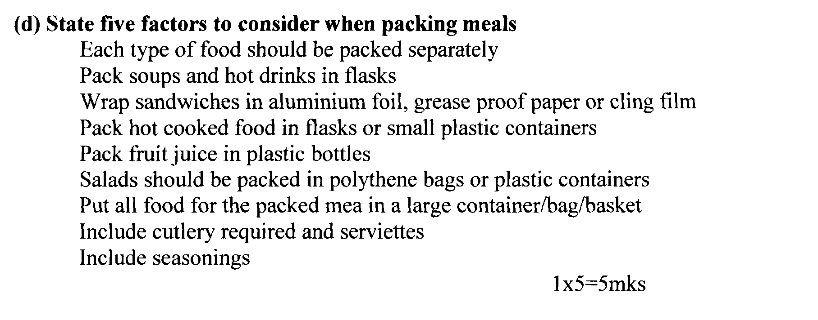

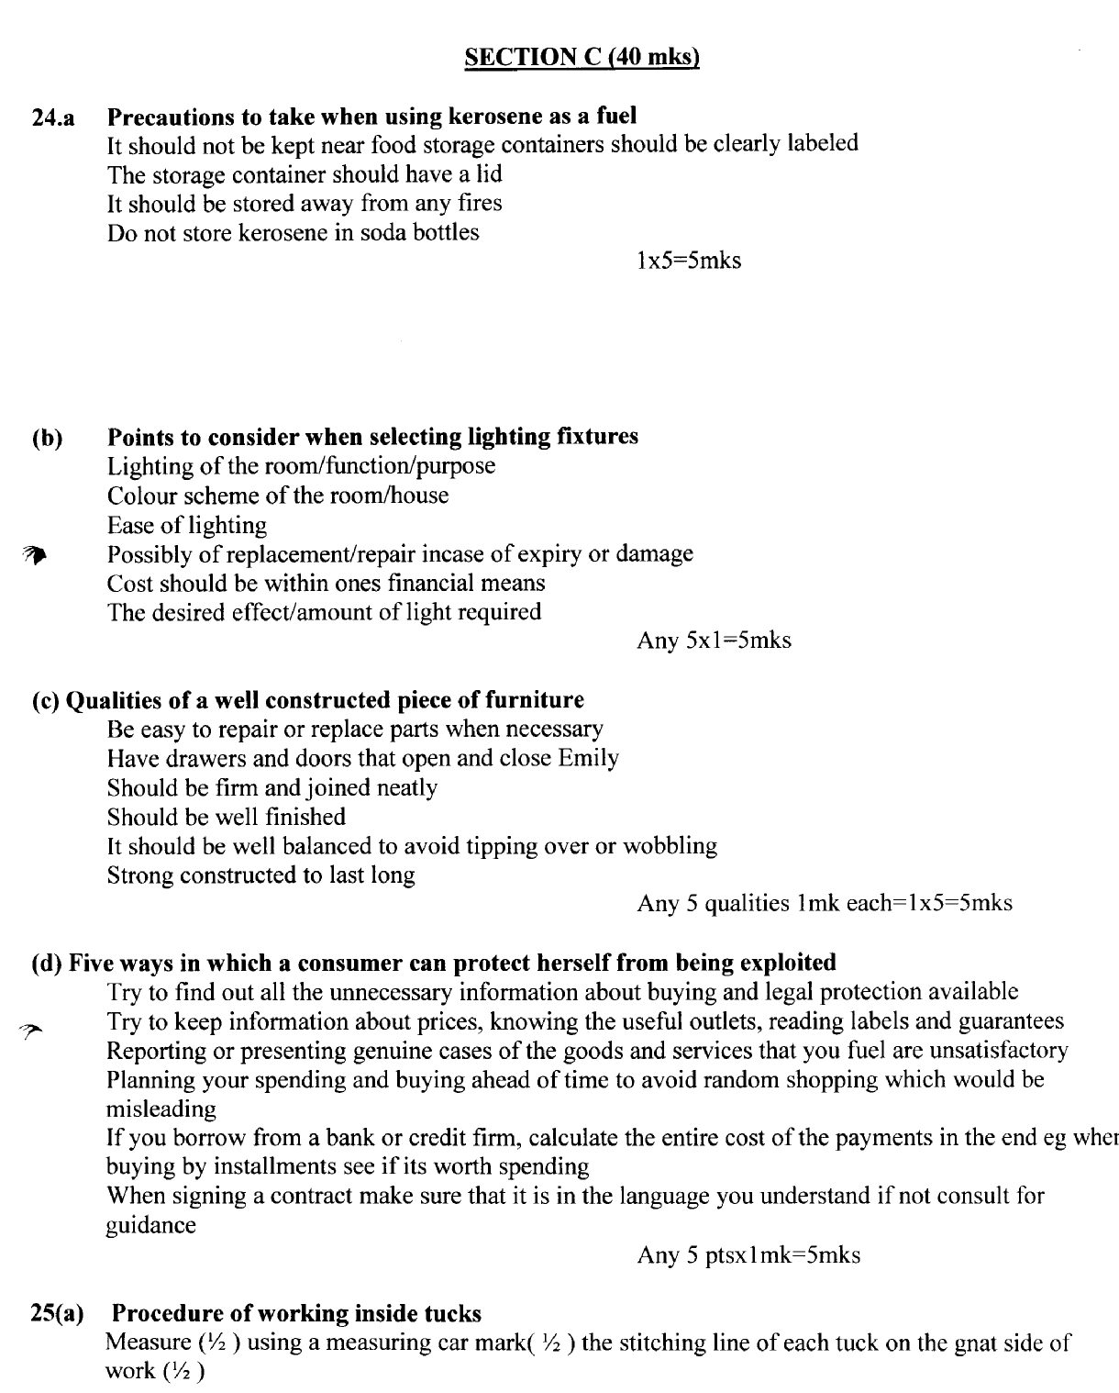

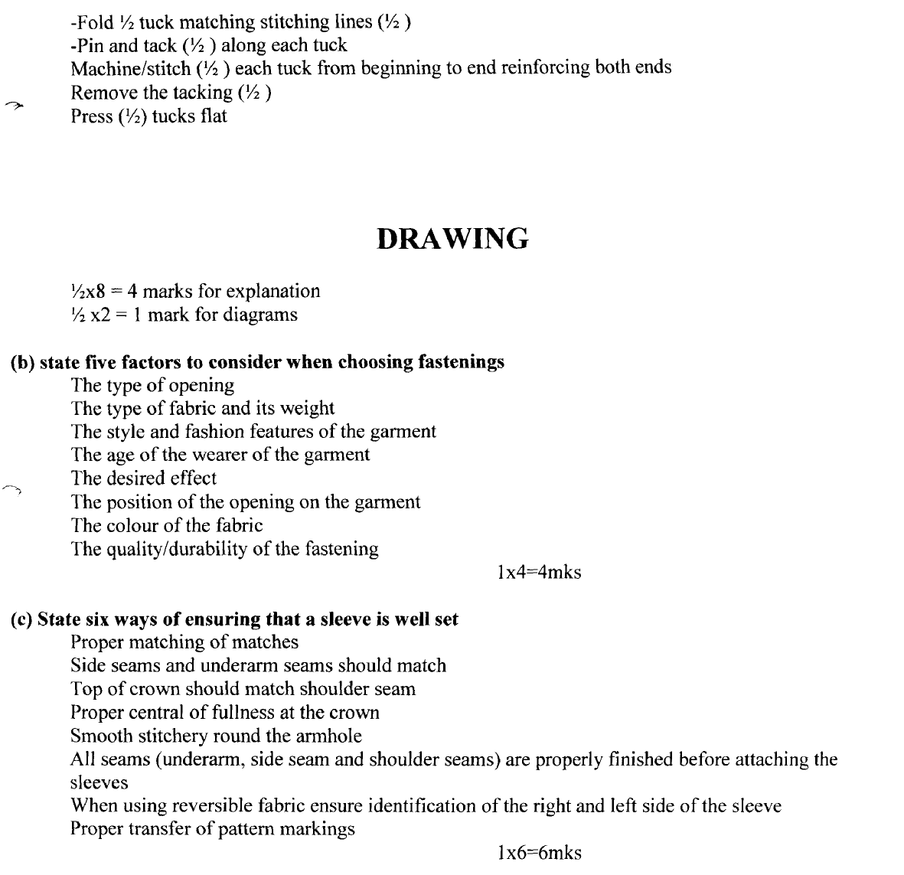

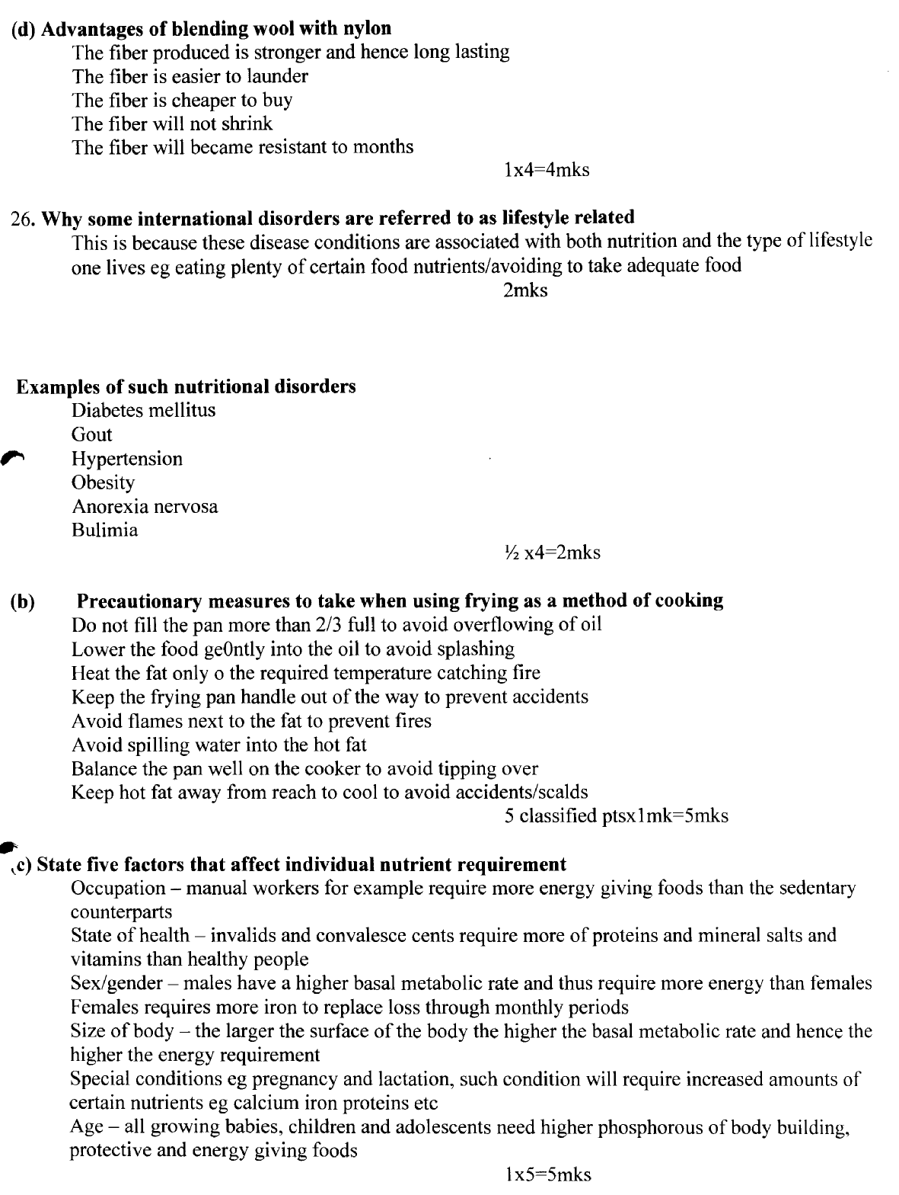

*SBC*
1. -To avoid blowing dust into the air.
- To prevent cross infection.
- So that dust particles in the air cannot spread germs.
2. - Swollen gums with weak capillaries that bleed easily.
- Blood in he stool and urine due to ruptured capillaries.
- Unhealthy skin.
- Slow healing of wounds.
- General weakness of the body.
3. -The style.
- The colour.
- - Material i.e. metal, shiny etc.
4. -Can only be used where there is supply of piped water.
- Are expensive to install.
- Maintenance may be expensive if carelessly used especially when plumbers have to be
engaged in unblocking sinks and drains or replacing broken fitting.
5. -Decorative purposes.
- Adding flavour.
6. - Strengthen the teeth as they come out.
- Exercise the jaws.
- To ease discomfort.
7. -Should have skin on the surface.
- Right in consistency.
- Well flavoured.
- Not oily on the surface.
8. -Waist band.
- Cuffs.
- Neck.
- Collar.
- Hem
9. i) Tray cloth
- By starching.
(ii) Baby Napkin
- By boiling or disinfecting. (2 x 1 = 2 mks)
10. Mention two advantages of blending cotton and nylon fibres. *SBC*
Fabric made is:-
- Light in weight.
- Crease resistant.
- Becomes absorbent.
- Not attacked by moth.
- Does not attract static electricity. (2 x 1 = 2mks)
11. Give two methods of credit buying. *SBC*
- Hire-purchase.
- Use of credit cards.
- - Simple non-installment credit. (2 x 1 = 2mks)
12. - Height
- Smoothness
- Source of light
13. -Kneading divided\s the gluten strands and spreads them evenly through the mixture, holding carbon dioxide produced during the fermentation process.
14. --Exercise the teeth.
- Get all the nutrients it contains because cooking destroys some. (2 x 1 = 2mks)
15. -Should be made of stainless steel / Rustless.
- Should be sharp.
- Firmly fixed or hinged.
- One blade should be pointed.
- One end should be curved.
- Comfortable handles with one hole large enough for two or more fingers. (2 x 1= 2mks)
16. -Through breast feeding.
- When giving birth.
17. -To smoothen the edge.
- For shaping the curve.
18. -BCG. – Given at birth.
DPT – Given at 6, 10 14 weeks respectively.
Yellow Fever and Measles – Given at 9 months .
Vitamin A capsule – Given from age 6 – 9 months.
19. Give two reasons for disposing of waste properly. *SBC*
- To prevent thee environment degradation.
- To prevent breeding of disease causing organisms.
- To prevent the spread of communicable diseases.
- To prevent environmental pollution.
(c) State the method of dry cleaning a polyester tie *SBC*
20. (a)-Collect necessary equipment and material. (1)
- Move all the moveable furniture to one side. (1)
- Close all the windows and doors (1)
- Sweep from the furthest and to the door. (1)
- Keep head of broom down and stand behind the broom. (1)
- Sweep methodically. (½)
- Gather all the dust together and collect and dispose. (1)
- Rearrange the furniture and open the window and door. (½ )
- Dust all the surfaces. (½ )
- Clean used equipment (½ )
(b)Procedure of cleaning an enamel plate.
- Use warm soapy water. (1)
- Clean using sponge or soft cloth/ sisal fibre. (1)
- Rinse thoroughly (½) in warm water (½ )
- To remove dirt and soap traces. (1)
- Dry completely (½ ) before storage to avoid rusting. (½ ) (5 mks)
(c)Methods of dry cleaning a polyester tie.
- Work in a well ventilated place away from flames. (1)
- Shake the article to be dry cleaned. Thoroughly to remove loose dirt. (1)
- Pour an adequate amount of dry – cleaning liquid in a small basin. (1)
- Immerse the tie, knead and squeeze until clean. (1)
- Squeeze out as much of the liquid as possible. (1)
- Hang the tie to dry in an airy place. (1)
- When the sediments have settled out the bottom of the basin holding the sediment, pour back in the storage can. (½ )
- Press the tie. (½ )
21. (a)Describing any three types of meal service. *SBC*
Blue plate service.
- Food served on an individual plate and the family member can eat anywhere.
Self Service
- Different dishes are cooked and placed on the table and the diners serves themselves and eat while either seated at the table or standing.
Family Service
- Cooked dishes placed on the table and people serve themselves what they want to eat while seated.
Buffet Service
- Food served on a large table and plates and cutlery are neatly arranged at one end.
(b)Supporting your answer with your reasons, give a most suitable fabric for an institutions bed
linen.
COTTON FABRIC
- Its absorbent, cool and comfortable, light and durable.
- Withstands high temperatures, cheap, attractive. (2 x 2 = 4 mks)
(c)Give your ways in which scarcity of time would affect a consumer.
- Deprives consumer from comparative shopping.
- Prevent consumer from setting the right goals or commodity.
- -
- Prevents the consumer from purchasing items. (4 mks)
(d)With two specific examples give three uses of permanent stitches.
-To join two or more pieces of fabric together e.g. Running stitches Back stitches, oversewing and others.
- To neaten raw edges to prevent them from fraying and make edges look smart e.g. items, over casting, loop stitches.
- Decorative stitches meant to add beauty to design e.g loop stitch, chain stitch etc.
22. (a) Give the systematic order of placing bedding items when preparing a baby’s cot. *SBC*
- Place the under blanket R.S. up & wide hem towards head side.
- Place markin tosh in the middle.
- Place under bed sheet R.S up to cover markin tosh & tuck.
- Place top blanket R.S down.
- Place down the sheet over the blanket & tuck both sides.
- Put the bed spread (bed cover).
(b)Five desirable qualities of ironing board.
- Height can be adjusted.
- Board is padded, making ironing easy and comfortable.
- Ironing board has a heat proof mat attached for placing iron.
- Most of them are sold with sleeve board for ironing sleeves and children’s garment.
- Stand steadily on their own.
- Can be folded easening storage.
(c)Five characteristics of a well made dart.
- Should taper gradually to a point.
- Should be of correct length and width.
- The stitching line should be straight.
- Should be firmly secured at the point.
- - Should be pressed towards the right direction. (5 mks)
(d)Cleaning a hurricane lamp.
- Protect the working surface.
- Remove glass and wipe gently with a soft cloth/ tissue.
- Weep the inside of the metal chimney to remove soot.
- Trim the wick if necessary.
- Wipe the burner and other metal parts.
- Refill the reservoir with enough oil.
- Wipe off any split paraffin.
- Replace the glass and keep the lamp ready for use.
23. (a)Ways in which a lactating mother would improve supply of breast milk to her baby. *SBC*
- Mother taking in nutritious and adequate fluids for milk production.
- Eating a well balanced diet but rich in calcium, energy and protein.
- Adopt a positive attitude towards breast feeding the baby in a relaxed and free atmosphere.
- Massage and clean breasts with warm water to stimulate milk production.
- - Avoid stress and stressful situations when feeding the baby. (5 mks)
(b)Five points to consider when giving general care to all the clothes.
- Make fastening secure before they become loose.
- Strengthen openings at the base so that they do not tear readily.
- Neaten raw edges if a seam is likely to fray.
- Sew hanging loops onto jackets, coats and skirts.
- Keep clothing clean and free from dust e.g. regular washing and dusting.
- Brush outer garments before putting them away and mend if necessary.
- Press clothes regularly.
- Use hangers whenever possible.
- Remove brooches and other ornaments before putting away clothes.
- Do not allow perfumes and deodorants harmful to clothes to come into conduct. (5 mks)
(c)Five rules to observe when fixing fastenings.
- Must be sewn on double fabric for support and strength.
- They must be sufficiently distributed.
- Should be evenly spaced to avoid gaping.
- Many are sewn on after the opening has been made and pressed.
- Must be well aligned so that the opening can lie flat when closed.
- Buttons should not protrude beyond edge of the opening.

(d)Five factors that influence consumer buying.
Income limitation
- If income is low, it is a serious struggle to meet basic necessities without proper planning.
Prices
- When prices change, the various allocations in a budget are affected.
Substitute goods
- e.g. use of butter and margarine interchangeably in order to cut down on cost.
Complementary products.
- Where one needs to be used with another e.g. a shoe polish and shoe, sugar and bread etc.
- Limitation of time and energy.
- Availability of a product within a given time.
- Availability of product with urban and rural and vice versa.
- Age of the family.
- Change in customs and traditions.
- Social status.
- Advertisement.

*MHS*

1. Food service. (3 mks)
- Plate
- Buffet
- Family table service.
- Tray / trolley service.
2. Interfacing collars. (3 mks)
- Stiffen.
- Prevent stretching or sagging.
- Give body or shape,
- Increase crease resistance.
- Obtain a good knife – edge.
3. Asbestos suitable. (2 mks)
- Non- inflammable
- Resistant to chemicals, insects and microbes.

4. Choice of controlling fullness.
- Effect desired.
- Type of fabric.
- Body figure – figure type of person.
5. Characteristics of a good French Seam. (3 mks)
- All raw edges closed.
- Straight stitches.
- Seam allowance width uniform.
6. Neatening an open seam. (4 x ½ = 2 mks)
- Overcastting stitches.
- Using over lock.
- Using pinking hears zig zag cuts.
- Using loop stitches.
7. Effects of Advertising to a customer. (3 mks)
- Entertaining
- Creates employment of advertising .
- Creates competition among producers.
- Information – creates awareness of goods and services to customers.
8. Darning (2 mks)
-Use darning needle for the fabric being darned.
- Darn on the wrong side.
- Avoid stretching or pulling fabric while working.
- Loops of threads should be left.
9. Choice of colour in a sitting room.
- Size of room.
- Effect desired.
- Personal taste.
- Orientation of the room.
10. Rules to observe during stain removal.
- Removed when still fresh.
- Identify the kind of stain and type of fabric to get suitable stain remover.
- For unknown stain start with milder stain removals.
- Rinse the article well to remove traces of reagent.
- Work outside towards inside – prevent spreading

11. Packing meals.
- Each type of food packed separately.
- Each soups and hot drinks in flasks.
- Pack fruit juices in plastic bottles.
- Salads be packed in polythene bags and plastic containers.
- Put all foods for the packed meals in a large container such as a bag or plastic basket.
12. Principles of wise buying.
- Set goals and priorities.
- Prepare budget.
- Suitability of item.
- Durability of item.
- Versability of item
- Attractive in colour and design.
- Shopping list preparation.
- Shopping list preparation.
- Interpret advertisement.
13. Dangers of late weaning.
- Child becomes malnourished.
- Child refuse to accept new foods.
- Deficiencies due to lack of extra nutrients.
- Baby growth slow and development.
14. Salt iodized.
- Avoid deficiencies
- Supply iodine not food in other foods.
15. Disadvantages of using charcoal.
- Dirty
- Not properly burned produce smoke.
- Not readily available in some areas.
16. (a) Cotton blood stained sheet.
- Soak the sheet in cold water (1) to remove the blood stain.
- Wash it thoroughly using friction method in cold water. (1)
Procedure for washing
- Soak in cold water (½) for less than 12 hours.
- Wash in hot water. (½)
Using friction method. (½)
- Rinse in hot water. (½)
- Final rinse in cold water. (½)
- Add jik to the final rinse or laundry blue to brighten the garment or boil it. (1)
- Iron while still damp with a hot iron.
- Air (½)
- Fold and store. (½) (8 mks)
- Use of curtains.
- To filter light. 1mk for each
- For privacy
- Decorative purposes.
- For comfort
- For screening widows at night or during the day.
(c) Give the correct procedure – Aluminium.
- Soak in jik to remove stains. (1 mk)
- Wash them using a scoring pad in warm water. (½)
- Rinse in warm (½)water one at a time (½)
- Final rinse in cold water. (1)
- Drip them. (1).
- Dry with a piece of clothe. (1).
- Store it well (½) (5 mks) (d) SPOTTING - WO
- Use warm water. (1)
- Use a piece of cloth as pad. (1)
- Dip in clean soapy water and rub on the stained are hem to remove dirt and other
areas. (1)
- Work on all areas with stain (1)
- Air (4 mks)
17. (a) Run and fell seam
- Place the fabric together wrong sides facing and fitting matching. Pin and tack along
fitting line. (1 mk)
- Remove pins and machine along the fitting line. (½)
- Remove tacking and press. (½)
- Trim back turning to 6 mm and front to 12mm. (½)
- Fold over the front over to the back to form the fell. (1).
- Press the fall to lie on the back of the garment. (½)
- Tack and machine close to the fold through the three layers. (1)
- Remove tacking and press the completed seam. (½)

(b) Functions of tucks.
- Decorative.
- Serve as styles feature.
- Used on blouses, night dresses and mothers wear.
- Children’s garment to give room and take extra lengths on children garment.
- Reduce fullness. (4 mks)
(c) Making of Gathers
- Working by Hand Running stitches. (1)
- Begin with Hand knot to secure the thread then work first row running stitches. (1)
- Work second row running stitches, 6 mm from the fitting line. 1 mk
- Leave the thread hangings at the end of the row of running stitches. (1)
- Work second row of running stitches and leave the thread hangings at the end. 1mk.
- Pull both the thread ends together to draw up the fabric until the required size is achieved. 1 mk.
- Wind the Hanging threads round a pin, forming a figure 8 and secure the gathers. 1
18. a)Choosing flowers.
Choose fresh flowers. (1)
Make sure the foliage is clean. (1)
Avoid choosing flowers in bloom. (1)
Avoid choosing scented plants (1) because people may be allergic (1).
Choose a mixture of feat and pointed. (1) (5 mks)
b)
Wooden polished table surface. (7 mks)
Dust surface table thoroughly.
Clean with cloth wrung out (1) warm soapy water with cloth wrung out of clean water. (1)
Apply polish sparingly on the surface and old piece of cloth. (½)
Rub in circular movement that overlap. (1). Ensure that it is evenly distributed on the
surface and no polish is fed into open cracks. (1 mk)
Shake the spray polish container hold it 6 inches away from the surface and spray sparingly. Leave it for ten minutes to enable the polish to set for easy shining buying immediately.
Use soft pad to buff in a circular motion. (4 mks)
(c)Personal appearance (4 mks)
Care of body.
Wearing clean and appropriate clothes.
Keep the hair neat and well groomed.
Use cosmetics, body creams and deodorants properly.
Use jewelry and accessories properly.
(d)Child play. (4 mks)
Provide plenty of room.
Allow for independence by encouraging a child to do things.
Encourages responsibility it is good for every child to have possessions.
Provide child with play things or tags.
Parents and older children take some time and play with small children.
Child should be dressed in clothing which does not restrict playing.
19. (a) Six points to consider when choosing and preparing weaning foods;-
- Balanced with first class protein, milk being the main food.
- Food should be easy to chew and digest i.e soft food.
- Foods should not be strongly seasoned hence avoid spices in foods.
- Fats and oils should be used minimally in their foods.
- Scare foods in small quantities.
- Foods should be cooked and served in a hygienic (clean) environment.
- Milk should be an important part of the diet.
(b) Three desirable qualities of deep frying fat.
- Should have a pleasant flavor.
- Should have a high smoking point.
- Should not solidify on cooling.
(c) Preserving food:
- Stop multiplication of micro-organisms which produce toxins harmful to human
health.
- Neutralize the action of enzymes which can cause food deterioration.
- Make food available for use when out of season.
- Stop wastage in bumper harvest when the yields are more than can be consumed.
- Maintain freshness and retain nutrients.
- Protect it from contamination by bacteria and other disease causing micro-organism.
- Retain as many qualities of fresh food as possible e.g. flavour, colour, texture and
nutritional value.
(d) Dietary needs of an elderly person.
- Balanced diet with normal amounts.
- Rich in body building foods like vitamins to boost the generating immunity as changes.
- Less energy giving foods.
- Non-fatty and non-greasy foods as they have weak digestive systems when may not be
able to digest fatty foods.
- The food should be soft, palatable and easy to chew.
- Provide foods rich in mineral salts like calcium, phosphorus, iron, iodine and vitamins A, B, C and D to strengthen their softening bones.
- Serve in small amounts and at regular intervals.

*AGHS*
1. List four fat soluble vitamins *AGHS*
- Fat soluble vitamins
2. State two possible causes of anaemia *AGHS*
- Loss of blood (extreme)
- Chronic malaria
- Hook worm infestation
- Lack of iron
3. Give two points to look for when buying spinach *AGHS*
- should be form a reputable grocer
- should be leafy
4. State two effects of strong heat on proteins *AGHS*
- Denatures then
- Hardness them making them indigestible
6. State two forms in which laundry soap is found in the market *AGHS*
- If food stored can cause food poisoning when contaminated
- Flavour altered so needs strong flavouring
- That can be a health hazard
- Some foods becomes indigestible e.g protein
- Colour may be lost ways of improving colour must be used.
7. Give the steps of removing chewing gum stain from a garment *AGHS*
- Use ice cubes / put in freezing coupantment
- Scraple off the gum
- Rib bitten/land
- Use carbon tetrachloride/other grease solvents
- Wash normally
8. Mention the three areas (centres of work that make up the work triangle in a kitchen
- Cooking area
- Storage area
- Washing area
9. Suggest two measures to take immediately nose bleeding occurs
- Melting person sit down – head slightly raised to prevent blood from flowing down throat.
- Cooling person with cold wet towel
10. List two improvised abrasives in the home
- Sieved sand
- Ash
- Crushed egg shells
- Couched charcoal
- Sisal fiber
11. Identify three tacks that are carried out only during special cleaning of a bedroom
- Dinign bedding
- Cleaning the bed; wardrobes chest of drawers and cupboards
- Changing pillow and sheets
12. Mention two dangers of heavy smoking during pregnancy
- Causes underweight babies
- Causes long disease to mother
13. Give four methods of advertising
- Brochures
- Pamphlets
- Decoration by promoters
- Bill boards
- Mass media
- Through radio, t.v, newspapers, magazines, journals and books
- Dealers /agents through displaying products and personnel available to explain to consumers about goods
- Other consumers and consumer organizations ; one consumer to another/ two consumer organizations that each people on matters concerning goods and services.
- K.B.S and government department – can be from different departments that deal some goods.
14. State two reasons why cotton fabrics are popular for the table linen
- Its strong and stronger when wet
- Its water proof
- Can be mixed with other fibers to lower cost
- Stands high temperature can be boiled of white to whiter
15. Give two reasons why silk is expensive
- Its soft and draper well
- It has lovely sheen and pleasant be handle
- Its warm coz it’s a good inoculation in winter and cool in summer.
- Its elastic so wears well
- Shreds creates easily so good for travel
16. State three qualities of a good tape measure
- Should be plastic coated to avoid fraying and stretch and firmly woven.
- Should have metal ends to keep flat when measuring and prevent fraying.
- Should clearly marked on both sides of 150cm.
17. Give three reasons for a needle freaking during machining
- Beat needle
- Machining close to zip teeth
- Needle too fine for work
- Press foot loose and needle hits its straight stitch foot is used for zigzag
- Needle not firmly fixed in place
- Fabric too thick for needle
18. Give two reasons why press studs are not suitable for use in children’s garments
- are dangerous children may pluck off loose and swallow them
- are difficult to fasten
19. (a) Ways of improving maize meal porridge
  - enriching with milk
  - sweetening with sugar
  - adding a lemon
  - adding an egg
(b) . Precautions to take when using an oven to bake
- The oven must be preheated before putting in food to bake.
- Oven and be cleaned and shelves arranged.
- Over door should not be opened once it makes hot aim to escape and oven all take long to retreat
- Temp should be lowered when the oven turns slightly brown to enable inside to cook
- Baking time should be noted to avoid over baking/ under baking.
(c) Factors to look for when selecting a frying pan
- Should balance well on the cooker and be thick for even distribution of heat
- Should have a fitting lid
- Should have a smooth finish
d) To be well moulded and no cracks
- Uses of carrot in cookery
- For garnishing
- For flavouring
- Enlarge foods e.g when added in meat
- To improve flavour
20. (a) Mention four ways of improving maize meal porridge
  - enriching with milk
  - sweetening with sugar
  - adding a lemon
  - adding an egg
(b) . Explain three Precautions to take when using an oven to bake
- The oven must be preheated before putting in food to bake.
- Oven and be cleaned and shelves arranged.
- Over door should not be opened once it makes hot aim to escape and oven all take long to retreat
- Temp should be lowered when the oven turns slightly brown to enable inside to cook
- Baking time should be noted to avoid over baking/ under baking.
(c) Explain six Factors to look for when selecting a frying pan
- Should balance well on the cooker and be thick for even distribution of heat
- Should have a fitting lid
- Should have a smooth finish
(d) Explain four To be well moulded and no cracks
- Uses of carrot in cookery
- For garnishing
- For flavouring
- Enlarge foods e.g when added in meat
- To improve flavour
21. (b) procedure of taking the following measurements
(i) Hips – Tape is place around fullest part between 18cm and 23cm waistline depending on
height of one.
(ii) Inside warm length
- From armhole under arm to waist with arm outstretched at an angle of 45o
(iii)couch
(c)Using diagram to explain preparation of the collar without interfacing
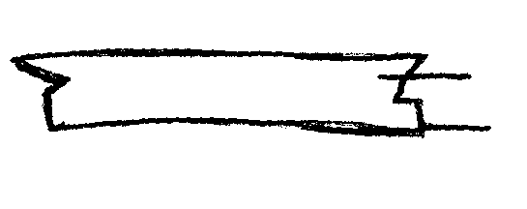
- Cut colour and under collar depending on pattern may be with stand or without
collar
stand

Transfer pattern markings
- Place collar on under collar 2.s facing hatch raw edges, fl and notches
- Pin tuck along fl leaving lower edge where its attached to neckline
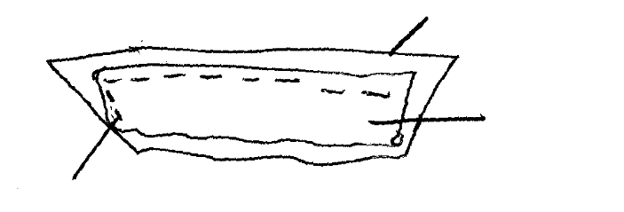
- Remove this machine sides and to edge leaving lower edge unsitched
Under collar
Collar w.s
Collar machined on the sides upper part from w.s

- Trim and layer seam allowance
- Lay covered sections of collar and clip pointed edges
- Neck collar
- Top stitch round edge for a neat finish and flatness

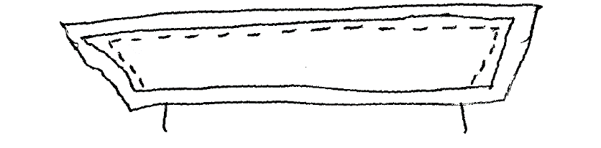
R.s

W.s
Lower edge left free

22. (a) Discuss four Desirable qualities of a good clothes line:
- Should be firmly held/strong
- Should not be of a material that stretches
- Should be strong not ward
- Smooth not to damage clothes
- Easy to excel clean and moist all weather conditions
(b) Explain five ways of disposing refuse in the home
- Use of dust bins
- Use of local authority
- Compost pits
- Feeding to animals (organic)
- Using for mulching e.g. organic
- Burying
- Burning
(c) Explain five Factors to consider when selecting an electric iron
- Should have a thermostat for controlling temperature
- Should have a insulated long enough flex
- Should have a plot indicator that shows when current temperature is riched
- Parts must be firmly fixed with temperature control labeled according to fabric
(d) Giving a reason in each case, state three factors to consider when wearing a baby
- Nutritive value of cereals
- Carbohydrates in endosperm
- Protein in germ bean and endosperm
- Fat
- Mineral salts calcium iron and phosphorous
- Vitamins
23. (a) Explain three preparations to make on a sewing machine in readiness to stitching *AGHS*
- Threading correctly
- Oiling he machine
- Putting it at correct tension
- Regulating the stitch correctly

*MUM*
1. Mention any three classes of stain removers used in laundry work
- Bleaches
- Grease solvements
- Absorbents.
2. State two uses of facings in garment construction
- Decorating of edges of garments fabric sections.
- Strengthening of portions of fabric enabling fiture of fastening e.t.c
- Neatening raw edges of fabric.
3. State three uses of eggs in flour mixtures
- Aeration: Expand with mixture on heating.
- Liquidisation; Are partially liquid and add this to the mixtures
- Improve the nutrive value of mixture as are of high biological value.
- Imbue own unique inherent flavor to mixtures.
4. Give any two precautions measures to take when using dry cleaning fluid
- Work in well ventilated rooms to avoid suffocation or poisoning.
- Keep away from naked flames because it is usually inflammable.
- Air all dry cleaned articles well to remove traces of fluid and or fumes.
- Keep away from children as is hazardous in the most.
5. What is the cause of swelling of body tissues that is symptomatic of kwashiorkor*MUM*
- The Accumulation of interstitial fluid due to poor cellular metabolism and the lack of protein content.
6. Name any four common groups of people that are usually affected by anaemia *MUM*
- Pregnant mothers
- Women and girls who experience heavy menstrual flows.
- Poorly nourished children or individuals who don’t get enough supplies of iron their diets.
- People suffering from hookworm whipworm and other similar parasitic infection
7. List three functions of water in the bodies of human beings
- forms the matrix in which almost all metabolic reactions take place.
- Water is required for all bodily fluids e.g digestive juice, blood,lymph, sweat and urine.
- Keeps the linings of all mucous membranes necessary for absorption and exchanges of elements moist
- Dissolves nutrients and thus carries and transports them.
8. Define the term essential Amino acids correctly
- Amino acids that cannot that be manufactured in the body from its pool of nutrient elements and must be obtained through consumption in food.
9. Why are there more than usual numbers of Tuberculosis victims in today’s
societies than in the past (i.e. after the 80’s than before)
- the incidence and prevalence of the HIV/AIDS pandemic in the contemporary diaspora and its singular effect of destroying or degrading the human immune system has rendered many a victim highly susceptible to infection and disease opportunistically, hence the aggravated onslaught of many of the said infections like Malaria, cancers and thus notably this particular one.
10. What is the work of a thermostat in an electric iron box
- It is a bimetallic strip made up of two metals or conductive materials with different rates of expansively, such that when the strip is subjected to an increase in temperature, it bends due to the differential expansion of the parts fused together
11. What are the following parts of an enclosed drainage system ?
(a) WATER CLOSET: A toilet or ablution system that consists of manually automated flushing
process with water kept in a reservoir that employs potential energy to efficiently and effectively disposes sewage from the toilet pan or bowl below.
(b)MANHOLE: An externally placed lidded pit – junction between two or more drains or sewers that doubles up as an emergency access point through which examination, repair and regulation of the working of the enclosed drainage system is possible.
(c) SEPTIC TANKS: 1. A sewage disposal system usually made up two tanks; of which
2. The first is the Receptacle of all the wastes from the household, and in which it
3. separates out into the sludge; that sinks to its bottom compacting there and
4. the effluent; the liquid part that over flows into the second and is
5. Either passed off into the surrounding soils ( for soak-pits) or pumped out and
carried away for further disposal by tankers to the sewage works.
12. State three general causes of poor sanitation *MUM*
- Carelessness and the lack of objective endevour in environmental hygiene and related practices in the wider community.
- Poor planning of human settlements and other housing infrastructures in communities.
- Overpopulation, overcrowding, poverty and general inefficacy and inebriation of personal, social, communal and other entities that exist in this scenario.
13. Give two advantages of frying as a method of cooking *MUM*
- Produces usually very tasty food and foodstuffs.
- Is usually quick and there saves time in execution.
- Is consequentially cost effective on fuel.
- Is relatively simple to execute in comparison with other methods of cooking e.g baking.
14. State any two common problems that may afflict a pregnancy before its full term *MUM*
- Malnutrition and lack pf proper food for the pregnant mother due to unfavourable circumstances that may be prevalent as is.
- Illness or disease that may be opportunistic, infective or even hereditary.
- Psychological or emotional inebriation.
- Physiological indisposition e.g in the case of underage pregnancies and underdeveloped bodily structures.
- Trauma from environmental, climatic or sociological disasters.
15.
- It is decorative and attractive
- It is strong
16.
- Breast feeding
- Immunization at hospital
17. Give two advantages of using carpets in the home *MUM*
- Decorative interiors
- Protecting floors from damage
- Keeping rooms cool
- Keeping rooms clean
18. State two reasons why wooden surfaces in the home need finishing *MUM*
- For decoration and enhancement of appearance
- For protective covering from adverse effects of the weather
19. List four points to look for when buying cabbages *MUM*
- Buy from a reliable seller
- Buy in season
- Avoid shriveled wrinkled ones
- Prefer heavier samples
- Avoid those whose leaves are faded
20. State two measures to take in order to control the incidence of bed sores in bed
ridden invalids *MUM*
- Turn the patient over regularly in the bed
- Turn over the mattress once in a while
- Provide cushions and rests

*TNW*
1. Why figure type is an important factor in choice of clothes
- So as to choose clothes that can enhance your personal appearance
2. Need to learn first aid
- To save life
- To prevent injury from becoming worse
- To promote recovery
- To present the injured to a medical practitioner 2x1 = 2 mks
3. Laundry processes carried out before washing a fast – colored cotton shirt
- Mending
- Removal of stains
- Soaking/ steeping
- Empting the pockets 2x1 = 2 marks
4. Difference between tear and wear
- Wear- thinning or weakening of a section of a garment
- Tear- A hole found on any part of a garment Each 1 mark = total 2 marks
5. Reasons why steel wool is not suitable for cleaning plastics
- It removes color of the outside
- It is difficult to rinse out steel wool particles
- Steel wool will scratch and roughen the surface
6. Two main methods of purchasing goods and services in Kenya
- Cash buying
- Credit buying 1x2 = 2 marks
7. Advantages of dry cleaning
- The solvent used are volatile, they therefore do not wet the garment and make it heavy as water does
- It is a fast method of cleaning clothes, the solvents evaporate very fast leaving the garment dry
- The method maintains the shape, size, color and luster of the garment and the fibres in it
- The method does not demand a lot of energy since is little mechanical rubbing
8. Ways of minimizing wastage of detergents when washing
- Using just enough
- Avoid leaving bar soap in water
- Do not use too much water
- Wash many articles using the same water starting with less dirty ones
- Use of soft water
- Use of warm water 2x1= 2 marks
9. Uses of running stitches
- It is used as a decorative stitch when a contrasting color is used
- It is a joining stitch 1x2= 2 marks
10. How to identify warp threads in the absence of the selvedge
- It is a thicker thread
- Will not stretch when pulled
- When the fabric is tagged or jerked, the warp threads produce sharper sound, higher pitch than the weft threads
- It is a stronger thread 1x2= 2 marks
11. Factors that make dry meat dry and tough after roasting
- Meat cut too thin for roasting
- Heat too fierce or too hot
- Meat exposed to heat for too long or too low heat
- Wrong cut of meat used for roasting (tough cuts)
- Meat not basted or turned during roasting 1x2 = 2 marks

12. Points to bear in mind when making seams on underwear
- The seam should be flat and comfortable
- Should be firmly stitched therefore durable
- Seams should match where they cross
- Have ever width
- Accurately made, observing seam allowance and fitting line so that the drape and shape of the garment is maintained 1x3= 3 marks
13. Definition of the following terms
i) A course: Is a dish/ dishes eaten as part of a meal
ii) A dessert: A third course in a three course meal 2 marks
iii) A cover: A table mat with food items served for one person 2 marks

14. A flavoring that is suitable for salads
- Garlic
- Onions
- Parsley
- Lemon 1x1 = 1 mark
15. Two points to consider when selecting the baby’s layette
- They should be loose and full so that the baby can be move its arms and legs freely
- Of soft, light weight material that is easy to wash
- Cool and warm to wear as needed
- Easy to put on small babies e.g. skirts and gowns with openings 1x2 = 2 marks
16. Difference between complementary and supplementary feeding
17. Why management of fullness is important
- It gives a good fit
- It shapes the garment
- It provides fashion features 1x3 = 3 marks
18. Uses of vinegar in cookery
- As a preservation
- As a flavoring ½ x2 = 1 mk
19. a) Dry cleaning a tie
- Work in a well ventilated room away from the fire ( ½ )
- Put sufficient dry cleaning solvent in a bowl ( ½ ) shake the tie to remove dust ( ½ )
- Immerse ( ½ ) in the solvent and clean by kneading and squeezing ( ½) quickly to save the solvent from loss through evaporation ( ½ )
- Squeeze out as much as possible ( ½ )
- Hang out to dry in an open place ( ½ )
- Leave the solvent in a covered bowl for dirt to settle then decant into a bottle for other use. Discard the dirt ( ½ )
- Press ( ½ ) with a warm iron ( ½ ) 5 marks
b) Finish a cotton shirt
- Sprinkle water and roll
- Iron while damp
- Iron double parts first on the w.s
- Turn to the R.S and iron the skirt away from the worker
- Air
- Fold and store 5 marks
c) CLEAN THE LEATHER BAG
- Cover the working surface
- Dry dust to remove loose dirt
- Clean using warm soapy water and a piece of cloth both inside and outside
- Wipe with a damp cloth wrung out of clean water
- Dry with a dry cloth both inside and outside
- Air it under the shade 1x5= 5 marks
d) CLEAN A PAIR OF SLIPPERS
- Remove any loose dirt
- Use warm soapy water with a disinfectant
- Scrub to remove fixed dirt using a soft brush
- Rinse in warm water
- Wipe dry using a clean cloth and put away
- Clear up 1x5 = 5 marks

20. a) Changes that take place in a dough during frying mandazi
- Color changes from original color to brown when exposed to hot oil
- The mixture becomes porous due to expansion of air
- The outside becomes porous due to expansion of air
- The outside becomes crisp because of lack of starch granules (dextrin)
- The size/ volume increases due to expansion of air
- The mandazi becomes easily digestible because the starch granules are cooked 1x6 = 6 marks

b) Four faults in cooking of mandazi
- Burning on the outside before the inside
- Excessive hollowness
- Heavy texture due to lack of enough raising agent
- Sogginess due to low temperatures 1x4= 4 marks
c) Four nutritional needs of an adolescent
- They need a balanced diet with plenty of proteins, minerals e.g. iron, calcium, phosphorous and vitamin C
- Girls require additional supply of iron to compensate for the amount lost during menstruation
- Include fatty foods to reduce the bulk of the food consumed e.g. bread and butter
- Give adequate amount of food as teenagers have healthy appetite
- Meals should be regular and be served attractively
- Provide plenty of fresh vegetables and fresh fruits for roughage
- Fluids should be included for compensation lost water during activities
- Energy giving foods should be included because they are very active ½ x4 = 8 marks
d) Four qualities of a well made vegetable salad
- The vegetables should be fresh
- They should be attractive
- They should have different nutrients
- They should be greased to stop oxidation
- It should be made of different types f vegetables
- Vary in texture ½ x4 = 2 marks

21. a) Three points to consider when using a sewing machine
- Ensure that there is good light to avoid straining the eyes and ensure adequate visibility
- Ensure that machine is correctly threaded for efficiency in stitch formation’
- Use appropriate needle for the fabric, the needle should be sharp to achieve good stitchery
- Ensure that the correct stitches are set for the right stitch length and tension to work out good stitches
- Test the machine before actual stitching to avoid handling the work
- Ensure the work is guided through machine 1x6 = 6 marks

b) Six stitches used during the blouse/ skirt construction
- Tailors tacking/ thread marking
- Even tacking/ long tacking
- Machine stitches
- Hemming stitches
- Running stitches
- Basting stitches ½ x 6 = 3 marks
c) Five points to observe when laying pattern pieces onto the fabric and cutting out
- Ensure the pattern pieces are smooth and flat for accuracy
- Ensure all the pattern pieces required for the garment are available
- Plan a rough layout using the provided layout for the width at the fabric before pinning to ensure that the fabric is enough
- Pins should not be sticking out to avoid damaging the scissors
- The fabric should be grained for straight edges 1x5= 5 marks

d) The procedure in preparation of around patch pocket ready for attaching
- Neaten the top edge ( ½ ) of the pocket fold the hem ( ½ ) along the hemline ( ½ ) to the R.S ( ½ ) of the pocket
- Stitch ( ½ ) the pocket along the stitching line ( ½ ) to fix hem in position
- Trim the corners ( ½ ) of the hem to reduce bulkiness ( ½ )
- Turn the hem to W.S ( ½ ) along stitching line
- Snip/ notch ( ½ ) the turnings of the curves ( ½ )
- Fold the edges ( ½ ) of the pocket along the stitching line

22. a) Two positive and two negative effects of advertisements
i) Positive effects
- Makes consumers aware of goods and services, which improve or add to their life style
by providing greater efficiency or pleasure
- Consumers are able to choose what they want 2 marks

ii) Negative effects
- Consumers may be misled to prefer a product of low quality to one of high quality which is advertised less
- Consumers bear the cost of advertising because the final price of the commodity is increased to cover the cost
- Adverts sometimes appeals to the emotions and thus influences consumer psychologically

b) Precautions one would take when using kerosene
- Reservoir should never be empty to prevent rusting
- Do not overfill to avoid spills
- Ensure lamps are replaced on flat and stable surfaces during use and storage to prevent spills
- Do not light them near flammable substances e.g. textile materials, flammable liquids
- Keep them out of reach of children to avoid accidents
- Ensure flame is not too high to prevent production of smoke and soot
- Handle them carefully to prevent falls- glass might break 1x4= 4 marks

c) Five advantages of breast feeding
- Breast milk is at the right temperature
- It contains all the nutrients needed in the right proportion
- It is clean and free from contaminator
- It does not need any preparation
- It is available all the time
- Improves the bond between mother and child
- Assists the mothers uterus to turn to normal size and position 1x5 = 5 marks

d) Five problems related to weaning
- The baby’s digestive system is not able to process the new foods leading to stomach upsets
- Late weaning may lead to malnutrition due to shortages of nutrients with age
- The weaning diet adopted may have too much fat and carbohydrate leading to obesity
- Unhygienic handling of food and feeding equipment may lead to diseases such as diarrhea and cholera
- The weaned baby is exposed to allergies from different foods 1x5=5 marks

e) Reasons for labeling products
- Provide a products name
- Provides the name of the manufacture
- Gives information on the product e.g. ingredients, instructions for use, manufacturing and expiry dates
- Enables the consumers to recognize the product 1x2=2 marks

*NDW*
1. State the importance of sebaceous glands in relation to a healthy skin (1mk)
- Secrete an oily substance called sebum that keeps the skin oily preventing it from becoming dry,
Scaly and from cracking
- Sebum makes the skin water proof and destroys micro-organism
2. State two qualities that make aluminium popular for household utensils (2mks)
- Shinning in appearance
- Light in weight
- Does not rust
- Good conductor of heat
- Cheap
- Does not react with food to form poisonous substances
- Easy to clean
- Easy to care for
3. Give a reason why nylon is unsuitable for sports wears (1mk)
- Non-absorbent
- Produce static electricity therefore it clings to the body
- Does not conduct heat therefore it is not warm
- Damaged by heat therefore cannot be foiled to remove stains and brighten colour
4. Mention two uses of dhania (coriander) leaves in cookery (2mks)
- To improve flavour
- As a garnish
5. Mention two advantages of blending cotton and nylon fibers (2mks)
- When cotton is blended with nylon fibers it be comes more crease resistant
- When nylon is blended with cotton fibers it increase resistance to abrasion
6. State any two reasons why a child’s growth monitoring is important (2mks)
- Monitoring a child’s growth by weight for age is an immediate indicator of normal or abnormal growth
- Monitoring a child’s growth by means of height for age helps to determine if the child is standard or is getting too tall
- If the growth is too fast or too slow for the age the health clinic officers should suggest measures to correct it to avoid an obese or underdeveloped child

7. Four laundry processes that are harmful to woolen fibres and the harms they cause are; (2mks)
- Soaking-causes wool to shrink and weaken
- Rubbing/fiction washing stretching of wool
- Starching-causes hardening and breaking of wool fibres
- Ironing-causes stretching and produces shinning patches on the garment
- Airing by hanging causes
- Drying wool in the sun-causes hardening and breaking of wool
- Washing in hot water-causes wool to shrink harden, and crease
- Rinsing in cold water-causes wool to felt and matt

8. three ways of providing variety in meal planning and management (3mks)
- Variety in colour-choose interesting colour combination
- Texture-variety in texture e.g. crispy, crunching and tender
- Flavours-variety of flavours e.g. salty, sweet, plain flat aromatic
9. two factors to consider when choosing where to buy vegetables (2mks)
- Availability of vegetables
- Variety of vegetables required
- Availability of transport
- Money available
- Hygienic conditions of the place
- Fresh vegetable
- The price of vegetable should be affordable
10. Give two qualities of a good advertisement (2mks)
- Message should be clear
- It should attract consumers
- It should be brief
11. three ways of economizing fuel when using electricity for cooking (3mks)
- Soaking food that takes long to cook
- Use energy devices e.g. pressure cooker
- Use of energy only when required i.e. Electric power should be switched off when not in use
- Use utensils that fit the entire cooking unit for electricity etc
- Plan your activities such as cooking and ironing in such a way that conservation of energy is maximized
- Covering cooking pots with well fitting lids
- Electrical appliances should be well taken care of so that they work efficiently

12. two reasons for using interfacing during garment construction (2mks)
- Give body or shape to the garment
- Stiffening to add firmness
- Prevent stretching or sagging
- Obtain a good knife edge
- Give a crisp tailored look to the area applied
- Increase crease resistance
13 three methods of finishing the edges of sleeves other than using a cuff (3mks)
- Facing
- Binding
- Lace
- Frills
- Piping
- Hemming/shell hemming
14. State three reasons for labeling products in a factory (3mks)
- Provide a product name
- Provide the name of the manufacturer and contact
- Provide information on the products; its ingredients, quality, instructions for use, manufacturing and expiry date.
- For recognition by consumer.

15. Two precautions to be taken to prevent bed sores when taking care of a sick persons at home
-Turn the patient more often to change positions
- Massage hip and back muscles
- Ensure beddings are dry all the time
- Check them for bed sores often
16. List two uses of lamp shades (2mks)
- Add to interior decoration
- Helps to avoid glare
17. State two factors to consider when planning lighting for various rooms in the home (2mks)
- Purpose of the room
- Size of the room
- Existing colour scheme

18. Differentiate between advancing and receeding colours (2mks)
- Advancing colours-colours that make a room or a figure appear larger
- Receeding-colours that make a room or a figure appear smaller
19. Give two reasons why most women in the rural areas are less groomed (2mks)
- They lack exposure
- Environment in which they live in may not promote the art of good grooming
- They have low income and lack of proper education to utilize the little resources they have
- The kind of jobs they are involved in may not permit the exact art of grooming
- Lack of clean water and cleaning materials
20 a) Describe the correct procedure of laundering a nylon dress (8mks)
- Soak( ½ )in cold water( ½ )for a short time
- Wash in warm soapy water( ½ )using kneading and squeezing methods(1mk)
- Rinse severally in warm water( ½ )
- Rinse in cold water( ½ )
- Add fabric conditioner in the final cold rinse( ½ )
- Drip dry( ½ )in the shade( ½ )
- Iron( ½ )using warm iron( ½ )
- Air to dry completely( ½ )
- Fold( ½ )and store in a clean dry place( ½ )
b) Describe the correct procedure of cleaning white canvas shoes without shoe laces (7mks)
- Dust them to remove loose dirt or remove mud if any(1mk)
- Dash in warm soapy water( ½ )and scrub with a scrubbing brush( ½ )clean the inside( ½ )as well as the outside( ½ )
- Rinse in warm water( ½ )
- Final rinse in cold water( ½ )
- Shake to remove excess water( ½ )
- Dry( ½ ) by tilting them against the wall/ stone under the sun( ½ )
- Apply white polish ( ½ ) while still damp ( ½ ) and leave to dry. use a clean dry duster to remove/wipe off excess polish( ½ )
- Store in a cool dry place( ½ )
c) Give the correct procedure of cleaning two aluminium cups (5mks)
- Rinse in clean water
- Wash one at a time in warm soapy water using a mild abrasive
- Rinse in warm water
- Rinse in cold water
- Wipe to dry or drip on a rack then dry later
21 a) Mention two uses of butter in the home (2mks)
- Gives a delicious flavour in cakes and sauces
- Soften cakes and baked items
- Enriches food e.g. babies food
- Greasing baking vessels
b) Identify four major nutrients found in butter
- Energy
- Vitamin A
- Vitamin D
- Fats
c) i)Describe four changes that take place when heating butter
- Melts
- Changes from solid to liquid
- Burns and produces smoke
- Turns brown
- Finally turns black
ii) Name four main groups of fats giving an example for each
- Animal fats e.g. cow fats, butter
- Vegetable fats e.g. salad oil, margarine, palm
- Solid fats-solid room temperature e.g. margarine
- Oils liquid at room temperature e.g. Elianto
d) Explain three considerations to make when selecting a storage facility for butter (6mks)

22. a) Four tests undertaken at the clinic to an expectant mother in the first month of pregnancy Establish blood group
- Weight
- Pregnancy test
- Establish level of iron in blood to determine whether there is need to administer pills or not.
- Checking sugar and proteins in urine to ensure the uterus gets the normal flow of blood. b) Describe two supplementary foods for a baby (2mks)
- Those which provide vitamin C e.g. Orange juice
- Those which provide vitamin D e.g. Cod liver oil

c) Explain two benefits of supplementary food (4mks)
- It helps meet the nutritional needs of the growing baby, because their nutritional requirement has increased
- To substitute breast milk which may not meet all the nutritional needs of the baby.
d) i)Explain four reasons why a mother may be unable to breast feed
- Being away from the baby because of work. This reduces feeding time.
- Sickness, where the mother is too weak to breastfeed or is admitted to hospital or is taking medicine that can harm the baby.
- Multiple births; a mother who gives birth to twins or triplets may not be able to adequately breastfeed all the babies
- Successive births-A baby born before the older one has finished breastfeeding may cause the mother to stop breast feeding the older one in order to carter for the younger one.
ii) Explain four points on care of play items (2mks)
- Keep clean according to type.
- Store in clean places after play.
- Wash the washable ones to ensure that the baby handles them when clean.
- Assemble the dismantled ones and repair the broken ones in time.

23 a) Explain four properties of viscose rayon which are undesirable (8mks)
- Creases badly, so needs a lot of ironing.
- Flammable and can get burnt easily.
- Develops mildew when left wet.
- Yellows and rots when exposed to sunlight for long periods.
- Its weaker when wet than dry so can get torn easily.
b) Suggest four features that can be used to finish a nigh dress decoratively (4mks)
- Use of lace
- Bias binding
- Embroidery stitches
- Frill
c) Give three reasons for ironing a night dress during construction (3mks)
- Ensure seams are flat on attaching
- Ensure parts are attached flat
- Produce a neat article.

d) Explain five desirable qualities of an iron box (5mks)
- Made of non rusting material
- Medium weight.
- Smooth soul.
- Pointed toe to reach fullness.
- If electric, should be thermostatic i.e. control heat automatically.

*RCH*
1. A,D,E and K (any 4x ½ =2mks)
2. List four causes of anaemia
- Iron deficiency
- Worm infestation
- Chronic malaria
- Excessive bleeding due to accidents etc
- Hookworm infestation (any 4x ½ =2mks)
3. State two points to look for when buying spinach
- Should be fresh
- Examine well for grubs and insects (any 2x1=2mks)
4. Give two forms in which laundry soap is available in the market
- Bar soap/had soap
- Soap flakes
- Soap power
- Disinfectant or antiseptic soap
- Liquid soap
- Toilet soap
- Toilet soap (any 2x1=2mks)
5. State two advantages of using firewood as a fuel for cooking
- It is cheap
- It is locally available
- Can be used both for cooking, warming and lighting especially camp fires (any 2x1=2mks)
6. Identify two ways of storing dressmakers pins
- Using a in cushion
- Using a metal plastic set
- Using pin wheel (any 2x1=2mks)

7. Give four special points to note when washing babies clothes
- Use mild detergent
- Use fabric conditioner in final rinsing water to soften garment
- Rinse severally to ensure complete removal of detergents and laundry agents which may cause harm to the baby’s delicate skin
- Disinfectant occasionally to kill germs
- Dry whites in direct sunlight for further whitening (any 4x1=4mks)

8. State two measures taken immediately nose bleeding occurs
- Let the persons sit down with he slightly raised to prevent the blood from floming down the throat
- Plug nostril for about 15seconds,making the person to breath through the mouth
- Cool the face with a cold wet towel
- Repeat the treatment for another 15minutes if bleeching does not stop
- Encourage the person to spit out any blood that flows into the month
- If bleeding persist seek mechanical assistant (any2x1=2mks)

9. Name two improvised abrasives in the home
- Charcoal
- Ash
- Sand
- Rough leaves
- Sisal
- Egg shells
- Maize cobs (2x1=2mks)

10. State two points to consider when choosing a refrigerator
- Needs of the family
- Ease of use
- Type of fuel
- Size
- Cost or affordability
- Efficiency
- Space available for storage (any 2x1=2mks)
11. Name four methods of advertising
- Mass media
- Pamphlets/brochures/magazines/newspapers/promotions/sales
- Packing
- Posters
- Billboards(any 4x ½ =2mks)
12. Give two reasons why cotton is popular for table linens
- They are easy to launder
- Are strong
- Can withstand extremes of temperatures/can be boiled
- Can withstand frequent washing (any 2x1=2mks)
13. Give two ways by which HIV/AIDS is transmitted
- Through transfusion with HIV infected blood
- Co-genital infection by an infected mother
- Use of unsterilized infected equipment
- Having intercourse with an infected person (any 2x1=2mks)
14. Mention four conditions necessary for growth of micro organism
- Warmth
- Moisture
- Darkness
- Dirt (any 4x ½ =2mks)
15. Give four factors to consider when renting a house
- The family income
- Size of the family
- Composition of the family
- Place of work and school
- Social amenities (any 4x ½ =2mks)
16. Give four examples of air pollutants
- Smoke from any burning
- Dust blown by the wind
- Bacteria released in to the air by infected people
- Exhaust fumes from vehicles and aircrafts which produces CO₄
- Cleansing agents
- Natural pollutants such as pollen from flowering plants
- Insecticides and pesticides used to control insects and pests
- Hair and body sprays (any 4x ½ =2mks)
17. State two symptoms of food poisoning
- Vomiting
- Severe stomachache
- Burning sensation in the stomach
- Dizziness
- Diarrhea
- Fever
- General body weakness (any 2x1=2mks)
18. Give two ways to ensure variety in meal presentation
- Colour variation
- Texture variation
- Flavour variation (any 2x1=2mks)
19. Give two ways of avoiding impulse buying
- Budgeting
- Having a shopping list any time you go shopping and ensuring you stick to it
- Carry just enough money to shop-avoid having a lot of extra-money (any 2x1=2mks)
20. Suggest two important ways of using mineral fibres in clothing
- Used as overalls by fire fighters
- For theatre curtains (any 2x1=2mks)
21.your mother is sick and has asked you to assist her with house work
a) Suggest how you would launder her loose coloured Khangal leso (10mks)
- do not soak ½
- wash very fast ½ in warm ½ soapy water ½ . wash using kneading ½ and squeezing method
- do not ring ½
- rinse in clean warm water ½
- final rinse in cold ½ water to which salt (1)has been added to fix colour and some vinegar (1)to brighten
- flat dry under the shade ½
- iron while still slightly damp using a warm iron ½
- air to remove excess moisture ½
- store appropriately ½
b) Suggest how you would clean an aluminium sufuria used to prepare her breakfast
- wash in hot ½ soapy ½ water
- rub any strains with nylon scouring pad or steel wool ½
- work thoroughly in clean hot water to remove all soap and dirt ½
- dry well ½
- store appropriately ½ (3x1=3mks)
c) Say how you would clean a cemented kitchen floor
- remove light furniture ½
- sweep floor and dispose of the dirt .dust the skirting board ½
- use warm soapy water a hard scrubbing brush to scrub the floor starting from the furthest end in small sections including the skirting board. Ensure you are circular motions ½
- wipe with a clean cloth or a mop wrung out of warm water ½
- repeat until the room is complete ½
- dry thoroughly with a floor cloth or a dry mop
- rearrange furniture
- clean equipment used and store appropriately ½ (7mks)
22.a)outline the points to consider when planning meals for a vegetarian
- Should be balanced
- Use vegetable fats and oil in the preparation
- Vary foods cooked to avoid monotony
- Season meats well to make it tasty
- Include a good amount of vegetables to provide the would be omitted nutrients
- Egg dishes milk and cheese in addition to pulses should be provided(for lacto- vegetarian) (any5x1=5mks)
b) Rough puff pastry has a well defined layers divided by air space ad should be very light. State
the four factors that its success depends on
- sift flour and salt together
- rub in fat very lightly into the flour and salt mixture
- keep it as cool as possible during preparation so that on cooking, gases expand as much as possible giving light results
- use a mixture of land and margarine for better results
- roll lightly in a highly floured surface with light short and forward strokes
- bake in a fairly hot over (any 4x1=4mks)
c) Outline the qualities of a good cloth storage facility
- should be lockable
- should have adequate deep drawers which should shide with ease
- rod for hangers in the wardrobe should be strong enough be bear the weight of clothes
- should be clean and dry and have smooth surface which are easy to clean
- should be strong and durable with enough storage space
- hangers should be smooth and durable (any 6x1=6mks)

d) Explain how kitchen waste contributes to environmental pollution (5mks)
- bad smell
- garbage especially is carelessly damped
- can be health hazard if carelessly damped into water bodies

23.a)Explain five points to consider when weaning a baby (10mks)
- Introduce new foods gradually .one food at a time to give the baby time to be come familiar with the food before giving another
- Start by giving small portions and increase as you absence the baby’s reaction
- Don’t force the baby’s to eat food they are not interested in stop and try again later.
- Feed from a cup using a spoon
- Sterilize all feeding equipment by boiling
- First food should be very soft and become a less soft as the baby grows
- Once the baby accepts a new food, give it fairly frequently so that it be comes familiar then gradually increase amount offered
- Give food after breastfeeding
- Ensure that milk continue to be a major part of the diet
- Prepare foods hygienically
- Allow the child to handle food and feeding equipment (any 5x1=5mks)

b) List five points to look for when choosing a toy for a child
- should be attractive
- must be durable to last long
- must be appropriate for age and sex
- shouldn’t be easy to dismantle because the child could put it in the mount
- safe to use i.e. doesn’t contain poisonous substance
- should be big enough so the child cannot swallow
- shouldn’t be sharp which can injure the child
- should be easy to clean (any 5x1=5mks)

c) Discuss five problems related to weaning a baby (5mks)
- too early weaning
- too late weaning
- the diet may be too fatty and rich in carbohydrates leading to obesity poor muscle development and low resistance to infections
- unhygienic handling of feeding equipment leads too disease e.g. diarrhea
- bonding between mother and baby is interfered with since a baby who is weaned can be fed by any other person
- the baby is expected to allergies from different foods
- learning to use the feeding equipment may cause distress to the baby.
24.a)State two main nutrients found in each of the following foods
i) Beans-carbohydrates and protein
ii) Kales-minerals salt and vitamins
iii)Wheat-carbohydrate and proteins

b) Discuss the importance of repairing garments
- to retain smartness/enhancing good grooming
- to prevent further tear especially during laundry
- in order not to expose the parts of the body they cover
- to make clothes last long (any 5x1=5mks)

c) With the aid at east one well labelled diagram explain how to work a single pointed dart (6mks)
- fold the dart along the fold line so that the fitting lines are matching
- pin and tack from the wider and tapering to the point to hold the two layers of fabric firmly
- remove pins and machines along the tacking line from the wider end to the tapering end at a point
- secure stitching at the point by
-stitching backwards-0.5cm
-threading both stitching thread in a needle and concealing them in the fold or wearing
a few stitches
- Press waist and shoulder darts to either (CF) or (CB) and underarm darts downwards.

d) State three importance of meal planning (3mks)
- it ensures that meals are
i)adequate for the family members and meet their individual preferences
ii)balanced to meet dietary requirements of all the family members such as children,
the elders, adolescents and the sick
- presented and served attractively to stimulate appetite and enjoyment (any 3x1=3mks)

*KKE*
1.
- It will prevent an individual from getting irritation and damage of the skin
- To prevent an artificial look
2
- To ensure good health by keeping away harmful; micro- organisms
- To ensure original appearance of surface is retained/ surface free from stains remain attractive and in good condition
- To ensure maintenance cost is retained
3. Drainage – System of getting id of waste water, run off and sewage from house or building
Refuse disposal – It is getting rid of rubbish or waste matter from a house
Give 1 mk for each well defined

4.
- To help retain colour
- Reduce bulk
- Retain nutrients
- Retain flavour
5.
6.
- Maintain high standards of cleanliness to contain infection by insects and other pests
- Ensure the house is well lit
- Beddings should be changed regularly and be properly aired
- Use of insecticides
- Sleeping under nets
- Draining stagnant water
- Clear the bushes around the home
7.
- To neaten raw edges
- To decorate the garment
- To shape and give body where applied
- To provide enough thickness for attaching fasteners
- To give strength to withstand strain
8.
- Drought
- Scarcity
- Transportation cost
- Tastes/ fashion
- A lot of money in circulation
9.
- Store in cool dry conditions
- Away from chemicals
- Cover it properly during storage
- Store in clean conditions
10.
- Knife
- Potatoe peelers
- Spalular
- Forks
- Spoons
- Graters 1x2=2mks
11.
- Excretion of wastes materials from the kidney and in sweat
- Maintaining body temperature by perspiration
- Aiding the digestion and absorption of food
- The formation of all body fluids
12.
- Use the correct method of cooking as per cut of beef to preserve nutrients
- Take correct precautions to ensure food hygiene
- Use correct temperature during its cooking to prevent denaturing of proteins and loss of other nutrients
- Use correct time for cooking as required for the method chosen
13.
- Balanced food provided plenty of proteins, minerals, salts such as iron, calcium, phosphorous and vitamin C
- Include plenty of energy rich foods to reduce the bulk of food consumed e.g. bread with butter, rice starch and vegetables
- Serve adequate amount of food as teenagers have healthy appetite
- Serve regularly and attractively
14.
- The strong flavour is disguising
- Its yellowing effect is undesirable
15.
- Making into jam
- Canning/ bottling
- Store in a cool and well ventilated area
- Drying
- Salting/ sugar
- Smoking
16.
- Ready to serve e.g. bread, cakes, ice cream
- Partially prepared – require minimal preparation and coking e.g. dehydrated soups
- Foods that are prepared and ready to cook e.g. cake mix
17.
- Skipping stitches
- Uneven stitch length
- No movement of fabric
18.
- It can withstand high temperatures
- Can be boiled to disinfect and remove stain
- It is absorbent and less fluffy thus suitable for drying glass utensils
- It is strong thus withstands frequent washing
19.
- Should have mitred corners
- Have mouth reinforced
- Fix hem using appropriate stitches
20.
21.
- Soak ( ½ ) in cold ( ½ ) water for at least 30 mins
- Wring out of soaking (1) water
- Wash in hot (1) soapy water ( ½ ) using friction method (v)
- Rinse in warm water ( ½ )
- Final rinse in cold ( ½ ) water in which a disinfectant(1) is added
- Drip dry (1) in the sun ( ½ ) secure with pegs
FINISHING
- Dampen ( ½ ) by sprinkling warm water (1) roll ( ½ ) and leave for a while
- Iron ( ½ ) double part ( ½ ) on WS ( ½ )
- The whole surface ( ½ ) on the WS away from the worker (1)
- Air ( ½ ) and fold
- Clear up
b)
- Clean in warm (1) soapy (1) water (1) with sisal fibre/ sponge/ clothe(1)
- Disinfect with a suitable disinfectant e.g. vim (1)
- Rinse (1) severally in cold ( ½ ) clean water
- Dry ( ½ ) thoroughly using a dry cloth
22. Some foods are cooked with seasoned flour or milk, eggs, wheat flour
Bread crumbs and eggs or melted margarine, butter
b)
- Garnishing/ decorating food property
- Serving food on clean plates/ bowls
- Use various/ varied cooking bowls
- Use clean or well ironed table linen
- Good flower arrangement/ centerpiece
- Use of menu cards
c)
- Cut into thin strips
- Dry on a tray covered with a thin cloth netting nustiline/ wire mesh
- Place it away from reach of animals and children
- Can be dried in a cage

d)
- Provide a well balanced diet with normal amount of Vitamin and mineral to improve the immune system
- Provide food rich in calcium, phosphorous, iron, iodine and vitamin A, B, C and D, protein for repair of body tissues and less carbohydrates and fats because they are not very active
- Avoid fatty and greasy foods for easy digestion
- Ensure the foods are soft and easy to chew
- Consider likes and dislikes to ensure they eat what is presented to them’
- Ensure good seasoning and attractive serving to attract and stimulate appetite
23.
- Tailors tucks
- Use of tracing wheel and carbon paper
- Use of tailors chalk
- Long and short tacking
- Thread marking
b)
- Caters for those who lack funds for hospitalization
- Elderly people prefer to be nursed at home in a familiar environment not surrounded by strangers
- It is cheap especially for illness that is not life threatening like minor wounds/ terminal cases
- It is suitable for lactating mothers so as not to expose their babies to a hospital environment
- Patients receive emotional support from family members
c)
- Stain should be removed when they are still fresh
- Reason: They get fixed when old and become difficult and expensive to remove
- Identify the kind of stain and type of fabric affect: in order to use a suitable stain remover
- If the composition of the stain is unknown start with a milder removal method followed by mildies reagents to avoid damaging the fabric
- After stain is removed rinse the article well Reason: To remove traces of reagents
- Work from outside towards when removing stain Reason: To avoid spreading the stain
24. a) Physical development – A child’s muscles develop through running
b) social development – A child learns to co-operate with play mates and observe the rules of
the game and make friends
c) Mental development- A child learns how to put similar things together, model colour or
paint and construct patterns
b)
- Both cuff and under cuff should be of the same size
- The width should be even on both the cuff and the under cuff
- The cuff should be flat
- The cuff should be of right proportion to the rest of the garment
- The cuff should fit the weave well
c)
- Place raw edges together ( ½ ) wrong sides facing
- Pin tack and machine ½ stitch 1.5cm from edge or along the fitting line ( ½ )
- Trim ( ½ ) both seam allowance to allow 1.2cm( ½ )from front 6mm ( ½ ) on the back
- Fold ( ½ ) front turning over back turning from a fell
- Press/ crease the turning in position ( ½ )
- Pin/ tack and machine stitch ( ½ ) close to the fold ( ½ )
- Remove tackings and press (½ )
d)
- Dust (½ ) with a dry duster ( ½ ) to remove loose dirt
- Clean (½ ) using warm soapy water ( ½ ) and scrubbing brush ( ½ )
- Scrub in direction of the grain ( ½ ) ensure overlapping ( ½ ) the surface previously cleaned
- Wipe ( ½ ) with a duster wrung out of soapy water ( ½ )
- Clean ( ½ ) under pants ( ½ ) and legs ( ½ )
- Rinse ( ½ 0 with a cloth wrung out of clean water
- Dry ( ½ ) with a cloth well rinsed and wrung out

*STK*
1. The term hue refers to name of colour e.g. red, blue, yellow e.t.c. (1mk)
2. Benefits of studying home science to an individual are:-
- Equips an individual with knowledge, skills and attitudes one requires for quality life
- Helps an individual to adopt to the changing living conditions in the home, community and nation
- Prepares an individual to take care of their personal hygiene, feeding, clothing, resources and health
- Lays foundation for career development in industries such as catering, accommodation, hotel management and interior decorations e.t.c. (Any pts 2mks)
3. Two uses of a collander are:-
(i) Used as a separating tool-for separating liquids from other foodstuffs – e.g. for cleaning rice over
a tap of running water
(ii) Used for steaming foods (2mks)
4. Basic instructions on the use of medicine
(i) Dosage
- Instruction
- Frequency
- Storage
- Caution
- Duration (1ny 4pts – ½mk each Total (2mks)
5. Accidents that may cause fractures
  - Road accidents
  - Heavy blow
  - Falls caused by slippery floor, pot holes and cracks on the floor, split water or fruit peelings, loose tiles, littered clothes e.t.c. (any 2pts – 2mks)
6. Points to consider when choosing a toilet brush are:-
- The bristles should be firmly fixed
- The handle should be smooth
- The handle should be of reasonable length (Any 2pts – 2mks)
7. Reasons for dampening clothes before ironing are;- (1mk)
- For easy removal of creases
- Smoothening of fibres (Any 1pt 1mk)
8. Precautions to take while cleaning wooden surfaces
- Scrub along the grains to avoid damaging the grains
- Avoid rough abrasives as they roughen the surface
- Avoid use of hot water – it discolours the wood
- Do not expose to direct sunlight as it will warp
- Avoid sharp objects as it scratches the wood hence making it rough (Any 3pts 3mks)
9. Points to look for when buying a saucepan are:-
- The base should be flat to help the pan balance and for even distribution of heat
- The lid should be well fitting
- Fairly thick- walled for even thermal distribution and for durability purposes
- The handle should be strong and firmly fixed to support the weight of the pan
- The handle should be heat resisting
- It should be smooth and well rounded for easy cleaning (Any 3pts 3mks)
10. Uses of eggs in flour mixtures are:-
- For aeration – e.g. in cake mixtures
- For enriching the mixtures
- To improve on colour of mixtures – e.g. cakes (Any 3pts 3mks)
11. Linen fibres are identified as follows:-
- Burns rapidly in and out of flame
- Smells like burning papers when burnt
- Resembles glass rod when viewed under the microscope (Any 2 different pts (2mks)
12. Decorative methods of disposing off fullness are:-
- Use of pleats
- Use of wills
- Use of smoking
- Shirring (Any 4pts – 4mks)
13. Causes of needle breaking when machine stitching are:-
- Machining over pins/zip teeth
- Pulling the fabric from the front when machining or while removing it from the machine
- Needle crossly fixed
- Bent needle (Any 2pts- 2mks)
14. Suitability of French seams on fraying fabrics are:-
- It’s exceptionally strong
- It’s self-neatening
15. Importance of consumer education
- Helps people to understand their roles as consumers and their importance to manufacturers and service providers
- Informs people on their rights as consumers so as not to be exploited
- Enables one to interpret and use advertisements wisely and to their own advantage
- Informs one on the importance of family finance and the need to budget and spend family resources wisely and economically (2mks)
16. Factors that will affect the efficiency of a laundry soap are;-
- Temperature of water used – whether warm or cold
- State of water – whether hard or soft
- Degree of soiling
- Washing time
- Mechanical agitation applied
- Quality of soap being used (Any 3pts – 3mks)
17. (a) Reasons for using tucks on children’s clothing are:-
- For decoration
- For letting out-to increase size
- For management of fullness
- To provide fashion features (Any 2pts – 2mks)
17. (b) Factors that may affect normal foetal development are:-
- Nutrients
- Drugs
- Sexually transmitted infections
- HIV/AIDS
- Alcohol
- Smoking
- German measles, malaria, e.t.c. (Any 4pts – 2mks)
18. Advantages of home-based care of the sick are:-
- Caters for those who lack funds for hospitalization
- Elderly people prefer to be nursed at home in a familiar environment not surrounded by strangers
- Its cheap especially for illness that are not life threatening e.g. minor wounds, colds and flu, e.t.c
- Its suitable for nursing/lactating mothers so as not to expose their babies to a hospital environment
- Patients receive emotional care from relatives and friends (Any 2pts 2mks)
19. (a) Steps in laundering wool
- Take measurements and record to later confirm whether there was any change in size
- Prepare warm water –wool is laundered in warm water throughout
- Immerse a basin of heavily built warm soapy water and wash under water by kneading and squeezing keeping under water throughout the washing time
- Warm water since wool shrinks when cold water is used
- Water heavily built to ensure article is well immersed in water/soapy solution
- Kneeling and squeezing used since wool felts and stretches if exposed to friction method of washing
- Wash quickly and do not soak – soaking leads to shrinkage
- Rinse severally in warm water
- Final rinse in warm water to which a disinfectant has been added, Wool should never come in contact with cold water, Disinfect to kill germs
- Dry under shade on well protected ground/surface wool is affected by sunlight – it makes the fibres harsh and felt protected surface because wool is eaten by moths
- Take measurements and compare with previous to confirm whether there was any change in size –incase of any pat and pull gently where applicable.
- Finish with a cool iron whilest damp – high temperature affects wool/wool air stretches and felts if ironed
- Air and store appropriately (well explained pts (10mks)

19. (b) Steps in cleaning white canvas shoes with laces
- Protect the work surface
- Remove shoe laces
- Dust or remove mud as is appropriate
- Clean in warm soapy water with a laundry brush’ – scrub to remove all dirt
- Rinse severally in warm water
- Final rinse in cold water to freshen
- Flick to remove excess water
- Apply white polish sparingly using an old piece of cloth or polish brush
- Dry in the hot sun tilted on it’s heels
- Remove when dry and rub with a dry cloth to remove excess polish. Clean shoe laces appropriately
- Dry n the sun
- Lace up the shoes and leave ready for use (Well explained points 6mks)
19. (c) A stained cup is cleaned by the following process:-
- Soak in a hot solution of household bleach. Pour the solution when cold
- Clean in warm soapy water and sponge
- Rinse in warm water severally
- Drip dry or dry with a soft cloth
- Store appropriately (4mks)
20. (a) Danger signs of pregnancy are;-
- Vaginal bleeding – may lead to miscarriage
- Oedema – signs of poor blood circulating or poisoning the foetus
- Varicose veins – swollen and twisted painful veins on the legs may burst and cause anaemia
- Excessive vomiting – prevents proper nourishment to both mother and foetus
- Dizziness-may be caused by inadequate iron in the blood (Toxaemia)
- Haemorrhoids/piles – varicose veins in the anus. These are painful and may encourage constipation and loss of blood
- Severe abdominal pain/backache signs of threatened miscarriage (Any5pts well explained 10mks
20. (b) Factors to consider when buying hand sewing needles are;-
- Weight and thickness of fabric – the needles should be fine for the fabric
- Eye should be big enough to take in thread
- Rust proof for easy slipping
- Farm,, straight and sharp- i.e. should not be deformed
- Buy a variety of needles to carter for the sewing needs (5pts stated & explained 5mks)

20. (c) Causes of each of the following common faults.
(i) A course texture in rubbed in cakes
- Too high temperature
- Too much raising agent
- Insufficient mixing (Any 2pts – 2mks)
(ii) Heavy and close texture in creamed cakes:-
- Too slow an oven
- Too much liquid
- Insufficient creaming
- Inadequate raising agent
- Insufficient cooking
- Too hot an oven, resulting in mixture forming in hard crust before air expands (Any2pt–2mks)
21. (a) Three labelled diagrams to explain the working of a lapped seam
- Fold the overlay along the seam or fitting line to the W.s and press. The under lay remains unfolded
- Place the overlay on the R.S of the underlay, matching the F.L pin and tack
- Working on the R.S machine stitch close to the fold through all the three layers of fabric
- Remove tackings and press
- On the W.S trim the raw edges to about 1cm
- Neaten the two raw edges together by overcastting, or machine zigzag
- Press the seam on the R.S and W.S
Overlay folded to the W.S and pressed
F.L Underlay remains unfolded
R.S Overlay
Machine
stitches
R.S underlay
W.S Overlay
Raw edges being neatened
W.S underlay
R.S overlay
R.S underlay

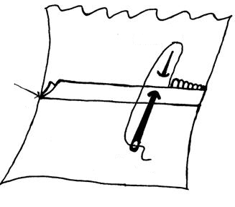

21. (b) Functions of the following machine parts
(i) Balance wheel
- Controls the movement of the machine/needle-it’s used for starting and stopping stitching
(ii) Bobbin case – Secures the bobbin in place and for effective stitching (1mk)
(iii) Pressure foot lifter – Holds the fabric in place onto the feed dog during sewing (1mk)
21. (c) Qualities of a good cutting out shears
- Must be rustproof
- Sharp and firmly hinged
- Long blades of at least 15cm for effective cutting
- One blade should be narrower to slip under the fabric and another heavier to weigh down the fabric
- Handles should have a smaller round hole for the thump and a larger heavy hole for the first three fingers
21. (d)(i) Importance of care labels
- Gives the correct laundry treatment so that the article is not damaged
- Assist in the selection of the garment so that one does not buy a garment which he/she is unable to care for appropriately
- Assists professional dry cleaners to know which dry cleaning solvents to use for a particular garment
21. (d) (ii) Undesirable properties of nylon are;-
- Its absorbent
- Generates static electricity
- Destroyed by long exposure to sunlight
- Poor conductor of heat
- Forms piles
- Yellows with age
- Slippery and frays easily (Any 2pts – 2mks)
22. (a) Changes that occur when cooking ugali are;-
- Boiling water softens the starch in the maize
- Starch grains swell and burst releasing starch granules. This is termed as gelatinization
- Stirring vigorously causes even distribution of water and starch granules and prevents formation of lumps
- Further heating causes water that’s not combined with starch grains to evaporate thus setting the ugali
- Continuous stirring of the ugali as it sets ensures even distribution of heat for thorough cooking
- Covering the heat for a while ensures thorough cooking (Any 5pts well explained – 10mks)
22. (b) (i) Food fortification refers to the addition of a food nutrient into a given food e.g.
addition of vitamins ABDE into blue band, iodine in salt, e.t.c
(ii) Food vehicle- Food to which fortification is carried out –e.g. when iodine is added to salt, salt becomes the food vehicle
(iii) Food supplements – These refer to alternative sources of food nutrients. Usually in form of
pills, tablets or capsules. They are taken in addition to the normal meals. E.g. iron
tablets, vitamin A or C tablets e.t.c
22. (c) Factors influencing consumer buying are;-
- Price fluctuation
- Complementary products
- Substitute products
- Income available
- Time and energy
- Family set-up
- Inflation
- Customs and traditions
- Need to keep a certain self image/class
- Rural/urban set-up (Any 4pts well explained 4mks)

*STK²*
1. Economical ways of disposing refuse
- Recycling
- Making a compost pit
- Mulching
- Feeding animals Any 2 pts = 2 mks
2. To descale/ defur
Means removing deposits caused by hard water on the walls of bodies 1 mk
3. Types of drainage
- Free drainage – This is where waste water is poured anywhere around the house. Mainly common in the rural 2 mks
- Open drainage system – This consists of open drains which directs waste water away from the house and compound 2 mks
- Conceded drainage system – In this drainage system waste water from the kitchen bathrooms and water closet is directed away from the house through waste pipes which lead it to the sewage works
4. Uses of mangles
- It rinses out water from wet clothes
- It presses flat articles
5. Categories under which clothes are sorted out
- Amount of dirt
- Use of the garment
- Fibre content
- Colour
- Nature of garment/ article i.e. whether loose or fast coloured 3 mks
6. Two common sponging solution
- Warm water
- Warm water and soap
7. Natural immunizations def:
This refers to the immunization a child receives from the mother while in the womb and while
breast feeding
8. Functions of Vitamin K
- Essential for blood clotting
- Necessary for normal functioning of the liver 2 mks
9. Effects of heat on Vitamin C
- Vitamin C is water soluble and is destroyed (lost) during preparation and cooking
- Foods rich in vitamin C should be cooked quickly and served immediately to avoid reheating
- The vitamin is also readily oxidized hence vegetables should be cooked with the lid on to minimize oxidation
- Vegetables and fruits should be preferably served raw 2 mks
10. Differences between weaning and supplementary feeding
- A baby is introduced to supplementary feeds at early stages in life – e.g. may begin at one month – weaning is introduced at 3 months and above- though there is no specified set age
- In weaning, the child us introduced to solid foods, supplementary feeds are mainly in liquid form
- Supplementary feeding comes before weaning – it is the introduction to weaning
- Supplementary feeds are given in very small quantities – in weaning the proportion are larger
11 Medicine are chemical preparation that are used to prevent/ cure various diseases as prescribed
by a qualified medical personnel 2 mks
12. Precaution to take when using grease solvents
- Work in an open airy place as they are highly toxic
- Work away from flame as they are highly inflammable
- Wash hand thoroughly immediately after use as they are poisonous
13. What is valeting in home science? Explain its importance
Valeting involves simple tasks that are carried out to clothes and accessories to maintain or
enhance their appearance
14. Major processes through which sodium is lost in the body
- Perspiration
- Urination
- Tears
15. Methods of neatening an overlaid seam
- Loop stitching
- Blanket stitch
- Machine zigzag
- Overcastting
- Bin ding 3 mks
16. Give two reasons why consumer education is taught in schools
- Makes people to plan for the family resources and budget so as to spend family resources wisely
- Informs people about their rights to avoid being exploited by manufacturers and sellers
- Helps to interpret and use advertisements wisely
- Helps people understand their role as consumers and their importance to manufactures and service providers 3 mks
17. The most important meal for the day is - Breakfast
Why
- Because it is taken after most of the food eaten the previous day have been absorbed leaving
the stomach empty
- It is the meal that starts the day 1 mk
18. a) Methods of sponging woolen coat
- Shake and brush the garment thoroughly to remove surface dirt
- Spread the garment on clean surface
- Remove any stains using appropriate stain removers
- Prepare two basins of warm water, add detergent to one and the other free of detergent
- Dip a folded cloth in the warm soapy water and squeeze out excess solution
- Sponge a small section at a time, overlapping parts
- Rinse in clean warm water using a clean folded cloth
- Final rinse in warm clean water
- Clean systematically, starting from the W.S and move inwardly to the R.S. pay attention to double parts on W.S
- Rinse each portion appropriately
- Dry in an airy place
- Press with a warm iron
- Air fold and store appropriately 10 mks
b) Laundering a white cotton blouse with chewing gum stain
- Remove the stain appropriately by pouring very cold water or rub an ice cube over the stain. This hardens the chewing gum and then you can scrap it off using a blunt object e.g. knife
- Treat the stained area with a solvent e.g. benzene or petrol then wash normally
- Wash in hot soapy water using friction method
- Rinse severally in hot water and finally in cold water to freshen
- You can boil to further bleach or use laundry blue
- Rinse in cold water
- Dry on the clothes line in the hot sun
- Iron with a hot iron
- Air fold and store appropriately 6 mks
c) Points to consider when buying a washing machine
- Consider the price and cost of maintenance should be reasonable
- Select a well designed machine that is pleasant to work with
- Bug from a reliable dealer who can service and repair when need arises
- Check to ensure that all electrical are in good working order are of appropriate length and that the plug is of the proper cottage
- Buy a machine made from rust proof material
- The size and cleansing action must be suitable for the work it is expected to perform
- Consider the control of the machine
- It should be supplied with an instruction manual and a guarantee it is sighed and date
- Consider the amount of space available. There should be adequate space for storage and operation of the machine 4 mks

19. a) Principles of nutrient conservation in preparing vegetables
- Foods e.g. legumes and pulses should be cleaned before soaking
- Foods should be thinly placed before couching. Using a sharp knife. Cutting and exposing them for long periods causes oxidation of vitamin such as A, C and E leading to their wastage
- Wash vegetables and fruits before cutting them. Washing after cutting dissolves away vitamins and minerals that are lost since the washing water disorded
- Clean vegetables and fruits using cold water. Hot water destroys heat sensitive vitamins e.g. vitamin C and B
- Do not soak vegetables in the washing water because this dissolves vitamins nd minerals
b) Functions of advertisements
- Informs the consumer on the availability of certain goods or services and goods to access them
- It is a quick and effective way of passing information about a new product
- Advertising gives information on the varieties available of a specific product
- Good advertising gives additional information about the product e.g. the nutritive value of foods or characteristics of textile fibre
- Advertisements also entertain 5 mks
c) Explain five factors to consider when renting a family house
- Family size
- Location
- Tenancy conditions
- Transport
- Security
- Amount of rent
- Location 5 mks
d) Uses of salt in the house
- For flavouring foods
- For removal of blood stains
- To fix colour in loose coloured garments and articles
- For dissolving mucus in handkerchiefs 2 mks

20. a) Procedure of working machine fell seam, at shoulder
- Place two pieces of fabric together W.S facing – working on the right side
- Pin tack and machine stitch along the tacked line
- Remove tackings and press the seam flat
- Trim the back turning to within 3-4 mm. (The front turning remains uncut)
- Fold the front turning over the cut back turning
- Pin and tack close to the fold. (The seam should be flat)
- Machine stitch close to the fold
- Remove tackings and press the seam flat

b) Ways of neatening an open seam
- Loop stitching
- Over casting
- Binding
- Machine zigzag
- Edge stitching
- Pinking
c) Types of beriberi
- Wet beriberi
- Dry
- Infertile beriberi
- Infertile beriberi

Wet beriberi | Dry beriberi
- Fluids are retained in the body  - Pronounced and rapid heart beat  - Chest pains  - Reduction in the amount of urine passed due to water retention in the body | Fluids not retained  Numbness and feeling of pin pricks  Weakness and wasting of muscles  Difficulty in walking or rising from a squarting position

d) Points to consider when packing foods
- Pack hot foods and drinks in flasks to be served hot
- Pack each type of food separately
- Remember to pack seasonings
- Consider the number of people – pack adequate food according to number of people
- Include cutlery in the packing
- The meal should be easy to pack and eat
- Include a refreshing drink 4 mks

21. a) Five social needs of an expectant mother
- Friends and family members should be considerate and to ensure that they do not sideline her in their activities and decisions
- It is important that the expected mother is assured that while she will be away someone will take care of her children while away
- She should not be exposed to pressure or frustration both at home and at place of work
- Nasty remarks about the pregnant mother should be avoided
- Young children in the family should be informed about the coming baby and encouraged to welcome and accept the situation 10 mks
b) Points to consider when choosing personal clothes
- Weather
- Occasion
- Fashion
- Personal tastes and preferences
- Figure type
- Colour 10 mks

PAPER TWO
Answers 441/2
*NYR*
 | PRESENTATION
1. | PRESENTATION  - Label on single fabric  - Well pressed work  - neat and no pins  - Firm attachment of the label  - Left half of the dress
2 | CUTTING OUT  - Smooth cutting  - Dress front  - Dress back  - Sleeve  -Cutting on straight grain for the  1. Front  2. Back  3. Sleeve  4. Back neck facing  5. Front neck facing  Cutting diagonally for the sleeve binding and tiles
3. | OPEN SEAM  - At the shoulder line award zero if or open seam used  - Straight stitchery line  - Well neatened seam allowance  - Even width of the neatened seam allowance  - Seam pressed to lie flat  - Matching well with the seam of the facings
4 | FACINGS  - Joining of the front and back neck facings  - With an open seam  - well neatened and neat work  - Straight stitchery
5 | FRENCH SEAM  - Worked at the sides  - Award zero if not French seam  - Worked from R.s to W.s  - Finishing on the W.s  - Straight stitchery  - Good tension of stitches  - Knife edging  - Neat  - Within 0.4-0.8 final full  - Fell facing the back
6 | SLEEVE  FACED SLIT OPENING  - Preparation of the facing  - Attaching on the R.S  - Slashing the opening  - Turning to the wrong side evenly  - Pressed to lie flat  - Finishing on the W.s
7 | UNDERARM SEAM  - French seam  - Fell 0.4-0.8mm  - From R.S – W.s  - Even in width
8 | THE BINDIGNS  - Attached onto the sleeve  - Neat stitchery  - Evenness of the binding
9 | ATTACHMENT OF SLEEVE  - Straight stitchery along the armhole  - Good hang of sleeve  - Gathers at the crown  - Well distributed gathers  - Armhole not neatened  - Notches matching i.e. single to single and double to double  - Underarm seam matching the side seam

*SBC*

 | PRESENTATION *SBC*
1. | PRESENTATION  - Work well pressed ( ½ ) and folded( ½ )  - Label firmly (1) fixed on a single (1) layer of fabric.  - Pins and unnecessary tackings removed. (1)  - Made up LEFT HALF (1)
2 | CUTTING OUT *SBC*  - CB/CF smoothly cut. (1)  - Fabric cut on straight grain. (2)  - BF (½) BB ((½)) Bindering (½) Facing (½)  - Lower edge of blouse well cut. (1)
3 | WORKING ON DOUBLE POINTED DART *SBC*  - Correctly positioned dart (1)  - Straight stitching (1)  - Tapering to nothing on both ends (1)  - Correct length of dart ( ½ ) (with 2 mm)  - Firmly secured points ( ½ )  - Darts pressed towards C.F. (1)  - Middle of double dart snipped (1) to lie flat on both sides. (1)
4 | SHOULDER SEAM (FRENCH SEAM)  (AWARD ZERO IF NOT FRENCH SEAM) *SBC*  - Good straight stitching. (1)  - Correct width of seam (1) (0.5 – 06 cm)  - Evenness in width (1)  - Self neatened raw edges all enclosed.. (1)  - Good knife edge produced.. (1)  - Seam pressed flat. (1)
5 | SIDE SEAM (NEATENED OPEN SEAM) *SBC*  (AWARD ZERO IF OT OPEN SEAM)  - Good straight stitchery.(1)  - Evenness of both sides. (1)  - Flatness at the armhole joint. (1)  - Correct size of seam (1) (0.8 – 1.2 cm each side) correctly neatened with edge stitching. (1)  - Presses open. (1)
6 | NECKLINE FACING *SBC*  - Facing correctly joined (1) to back facing using plain seam. (1)  - Free edge of facing correctly. (1)  - And neatly neatened (1)
ATTACHMENT TO FACING
(Front Facing and Back Facing) *SBC*
- Correct (½) placing of facing to neckline.
- Good stitchery (1) (Back Front flatness of facing. (½)
- Smoothness of neckline. (½)
- Facing firmly fixed. (1)
- Facing under stitched (½) from Top of neckline correctly produced.
7 | CUTTING AND REPAIR OF HEDGE TEAR USING DARNING *SBC*  - Correctly (1) cut triangular hedge tear repair using hand darning. (½)  - Marked the vent of the tear. (½)  - Used fish boned (1)  - stitches to bring edges together.  - Darn extending beyond vent. (½)  - Threads firmly secured. (½)  - Raw edges completely enclosed. (1)
8 | BINDING ARMHOLE  - Joining the binding piece. (1)  - Correctly joined to armhole. (1)  - Evenness of binding on both sides.(1)  - Correct final stitching. (1)

*NRBS*
 | Maximum  score | Actual  score | remarks
1 PRESENTATION  -clean  -Well pressed  -Neatly pressed  -Tacks and pins removed  -Label firmly fixed and on singles fabric | ½  ½  ½  1  1
 | 3 ½
2.CUTTING OUT  -Straight grain to within 2mm  -C.F straight to within 2mm  -C.B straight to within 2mm | ½  ½  ½
 | 1 ½
PREPARATION
A)WAIST DART  -correct length  -straight width  -straight stitchery  -dart tapering to nothing  -dart fastened on and off  -pressed flat  -dart facing C.F | ½  ½  ½  ½  ½  ½  ½
 | 3 ½
B)CALICO PATCH  -patch correctly aligned  -straight grain running continuously  -good stitchery  -straight stitchery  -stitching close to fold  -regular shape of patch  -regular shape of patch  -pressed flat | ½  ½  ½  ½  ½  ½  ½  1/2
 | 4
C)FRENCH SEAM  -Straight stitchery  -Good knife edging  -Raw edges enclosed  -Seam allowance trimmed  -Seam ¼ wide  -pressed | ½  1  ½  ½  1  ½
 | 4
D)OPEN SEAM  -straight stitching  -open seam 1 wide when finished  -pressed open  -neatened by edge stitching | ½  ½  ½  ½
E) CONTINUOUS WRAP OPENING  -Straight stitchery  -Raw edges enclosed  -seam allowance trimmed ½ wide  -turning hemmed on W.S  -turning even throughout | ½  1  ½  1  1
 | 6
F) CUFF PREPARATION AND ATTACHMENT  -Straight stitchery  -Raw edges trimmed  -Good knife edging  -Cuff interfaced  -Under cuff interfaced  -Correct alignment of cuff on sleeve  -Straight stitchery | ½  ½  ½  ½  ½  ½  ½
 | 3 ½
g)-seam allowance trimmed pressed  -cuff hemmed down to position  -cuff even | ½  1  1/2
 | 2
H)PREPARATION AND FIXING OF NECKLINE FACING  -front and back facing joined  -pressed  -edge stitching on free edge of facing  -correct alignment at neckline  -under stitching done  -seam allowance trimmed  -facing pressed and catch Stitched in position | ½  ½  ½  1  1  ½  1
 | 5
I) ATTACHING OF SLEEVE  -Sleeve correctly aligned  -Smoothly attached  -Gathers evenly distributed at crown  -Good hang  -Good stitchery  -Armhole seam neatened with loop stitches  -Armhole seam and side seam crossing  to within 2mm | ½  ½  ½  ½  ½  ½  1
 | 4
J)SLIP HEMMING BACK BODICE LOWER HEM  -correct section hemmed  -hem edge stitched  -slip hemmed  -hem even  pressed flat | ½  ½  ½  ½  ½
 | 2 ½
K)WORKING OF BUTTONHOLE AND  ATTACHING SHIRT BUTTON  -Button hole cut along the thread  -Correct Button hole stitch used  -Button hole stitch even  -Round end over sewn  -Bar end with a bar of stitches  -button correctly positioned  -Shank created  -Button hole stitch worked to fasten WS  -Button firmly fixed | ½  ½  ½  ½  ½  ½  ½  ½  ½
 | 4 ½
total | 45

*MHS*
 | AREAS MARKED | MAXIMUM  SCORE | ACTUAL  SCORE | REMARKS
1. | PRESENTATION  - Pins and threads removed.  - Work well pressed.  - Work well folded.  - Labeled.  - Label firmly fixed.  - Label fixed on single layer of fabric. | ½  ½  ½  ½  ½  ½
 |  | 3 ½
2. | CUTTING OUT  - Pieces cut out on straight grain of fabric as shown in the pattern pieces.  - C.F. and C.B. well cut on grain line. | 5  2
 |  | 07
3. | DART  - Straight stitchery.  - Tapering to the point.  - Thread well fastened at the point.  - Flatness of the dart on W.S. and R.S.  - Pressed to C.B.  - Correct length of dart.  - Correct width. | 1  1  1  1  1  1  1
 |  | 07
4. | FRENCH SEAM  - French seam made (if not French seam give 0).  - Straight stitchery.  - Even in size.  - Well knife edged.  - Raw edges not showing through the seam.  - Pressed flat to face the back.  - Appearing on the W.S. of dress. | 1  1  1  1  1  1  ½
 |  | 6 ½
5. | PLAIN SEAM  - Plain seam made (If not give 0).  - Made on W.S. of dress.  - Straight stitchery.  - Both seam allowance held together and neated.  - Evenness in width.  - Pressed flat to face the C.B. | 1  1  1  1  1  1
 |  | 06
6. | PATCH POCKET  - Appearing on the R.S of dress.  - Evenly made hem at the pocket mouth.  - Edge of pocket well tacked under.  - Bulky seam allowances cut off rendering pocket flat.  - Well stitched all round.  AREAS MARKED  - Pocket mouth reinforced appropriately.  - Bace well curved (not gathered). | ½  1  1  1  1  1  1  ½
 |  | 06
7. | FACINGS  - Both back and front facings used.  - Back and front facing appearing on W.S. Front on Front. Back on Back dress.  - Both joined well on stitching line.  - Seam trimmed and pressed open.  - Both well neatened at the edge.  - Well attached at the neckline with the neat stitches.  - Stitching line followed, rendering the neckline smooth and well curved. Seams matching.  - Pressed flat W.S. to face W.S.  - Seams well trimmed to avoid bulk.  - Well under stitched. | ½  ½  1  1  1  1  2  1  1  1
 |  | 10
8. | HEM SLIP HEM  - Straight stitchery.  - Evenness in width.  - No bulk. | 1  1  1  1
 |  | 4

*RCH*
 | PROCESSES
1. | PRESENTATION  - well pressed work(1) and well folded(1)  - label (1)well fixed on single(1) fabric  - unnecessary temporary stitches  - tacking, threads and pins removed(1)  - made up of the left half(1)
2. | CUTTING OUT AND GRAINING  - All eight pattern pieces cut on  - straight grain( ½ x8)max 4  - Smooth cutting out of edges at CB  - of yoke(1) and skirt(1)  - Smooth cutting out of edges of CF  - of yoke (1) and skirt(1)
3. | OVERLAID SEAM AT YOKE  If not overlaid seam give zero  - quality of stitchery (1)  - stitched close to the edge of front( ½ ) of back (1/2 ) yoke  - evenness of seam allowance on W.S of  - front( ½ ) on back (1/2 )yoke
4. | OPEN SEAM AT SHOULDER  If not open seam give zero  - Straight stitchery(1)  - Right size(1cm when finished)(1)  - Seam pressed flat/open(1)  (if seam is neatened deduct 1)
5. | INTERFACED COLLAR  - Interfaced(1)firmly fixed(1)  - Well knife edged(1)  - Correctly positioned(1)  - Flatness of the attached collar(1)  - Correct shape (1) and size(1)of the attached collar  - Neckline seam evenly trimmed( ½ )and snipped(1)  - Collar well trimmed(1) and snipped(1) evenly
6. | FREE EDGE OF FACING  If not neatened give zero  - Edge neatened by machine(1)  - Straight stitchery( ½ )  - Trimmed to less than 3mm (1)
7. | FRENCH SEAM AT SIDE OF DRESS  If not French seam give zero  - Correct width of seam  - Evenness(1)  - All raw edge enclosed(1)  - Straight stitchery(1)  - Pressed flat to wards CB(1)  - Underarm seam and side seam meeting the point to within 2mm(1)  - Knife edged(1)
8. | PREPARATION AND ATTACHMENT OF FRILL  - Inverted pleats well positioned(1)  - Straight stitchery of open seam(1)  - Frill attached to front skirt only(1)  - Neatened by use of loop stitches(1)  - Loop stitches 0.2cm from the edges (1)

*MUM*
1. PRESENTATION *MUM*
- Clean work and neatly folded, well pressed
- Tackings and pins removed
- label firming sewn and on single fabric
- RIGHT hay made
2. CUTTING
- If smoothly cut and straight to within 2mm
- CB smoothly cut and straight to within 2 mm
- Pocket facing cut on cross grain
- Both waist bands cut on fold
3. WAIST
- Correct length
- Correct width
- Straight stitchery
- Tapering to notching
- correctly reinforced
- Well pressed on RS
- Fold facing CB
4. PATCH POCKET
- Pocket and facing correctly matched and stitched RS together
- Facing under stitched
- A good knife edge between pocket and facing
- Facing edge stitched
- Facing neatly hemmed onto the pocket
- Pocket seam allowance trimmed
- Pocket lower corners mitred
- Pocket stitched close to the edge
- Straight stitchery
- Pocket mouth correctly reign forced
- Pockets flat and on straight grain
- Correct position onskirt
5. GATHERS
- Gathers made not pleats
- Evenly distributed on front skirt
- Gathering stitches removed
- Well pressed
6. OPEN SEAM
- Straight stitchery
- Straight wide when finished
- Neatened by edge stitching
- Pressed open
- Even
- Correct tension of stitches
7. ZIP- Correct position
- Back turning stitched with the fold close to the zip teeth
- Front turning machined 1cm from the fold
- Machined on RS and across to the seam
- Upper zip end enclosed in waist band
- Lower zip and enclosed in the seam
- Zip completely hidden
8. UN-INTERFACED WAIST BAND
- Correct size of waist band
- Waist attached on RS
- Correctly folded along fold line
- Hemmed on W.S by picking on the stitches
- Waist band flat
- Sharp corners at tie ends
- A good knife edge at the ends
- Tie ends stitched RS together and turned over
- Tie ends even in size and length
9. HEM
- Edge stitched and folded on hem hire
- Open seam flat
- Hem even and flat
- Running stitches even and small in size, and rein forced

KKE*
1. PRESENTATION | Marks
(a) Well pressed (a) well folded (1) | 1
(b) Clearly written and firmly sewn label (1) on single fabric (1) | 2
(c) Removal of unnecessary stitches (½) threads (½) pins (½) | 1 ½
(d) Made up of right half (1) | 1
(e) Clean work, not dust, not stained (1) | 1
 | 9mks
2. CUTTING OUT AND GRAINING
(a) CB of dress smoothing cut (1) and on grain to within 2mm (1) | 2
(b) CF of dress smoothly cut (1) and on grain to within 2mm (1) | 2
(c) Front and back neck facings smoothly cut (1) and on grain to within 2mm (1) | 2
(d) Collar smoothly cut (1) and on grain to within 2mm (1) | 2
(e) Sleeve smoothly cut (1) and on grain to within 2mm (1) | 2
(f) Ties smoothly cut (1) to within 2mm (1) | 2
 | 12mks
3. French seam at the shoulder (if not French seam give 0)
(a Joined with straight stitchery (1) | 1
(b) Evenness of seam (1) width about 6mm (1) | 1
(c) Flatness of seam (1) | 2
(d) Facing right direction back (1) | 1
 | 5mks
4. SLEEVE
(a) Good hang (1) | 1
(b) Well distributed gathers at the crown (on R.S) (2) but the notches (2). | 4
(c) Under arm seam joining with straight stitching line (1) | 1
(d) Under arm seam meeting side seam to within 2mm (1) | 1
(e) Arm hole seam joined within straight stitchery line (1) | 1
(f) Under arm seam flat at arm hole (1) | 1
(g) Facing used on sleeve opening (1) | 1
(h) Lower edge of sleeve bound (1) | 1
(i) Ties well finished by top stitching(1) | 1
(j) Notches correctly matched (1) | 1
 | 13mks
5. COLLAR
(a) Inter faced (1) well done (1) | 1
(b) Straight stichery (1) | 1
(c)Seam allowance trimmed (1) simp (1) | 2
(d) Flatness of coillar (2) | 2
(e) Collar well positioned and fitting (2) | 2
 | 11mks
6. FACINGS
(a) Straight stitchery when joining F and B facings (1) | 1
(b) Facings well fixed (1) to finish collar raw edges (1) lying flat (1), trimmed ( ½ ) | 3 ½
 | 5mks
7. SIDE SEAM(if not open seam do not crowd)
(a) Good stitchery (2) straight
(b) Correct width (1m) (2) | 2
(c) Appropriately edge stitched (2) | 2
(d) Flatness (2) pressed open (2) | 4
(e) Seam allowance even in width (2) | 4
 | 12mks
8. SLEEVE OPENING  (a) Slit opening (1)  (b) Correct length (5cm) to within 2mm (2)  (c) correctly faced (1) flat (1) and lying on the wrong side of garment (2)  (d) Straight stichery (1) | 1  2  2  2  1
 | 8mks

PRESENTATION
*NDW*
1.PRESENTATION
- Work labelled firmly on single fabric
- When pressed and carefully folded
- Pin unnecessary tacking remove
- Made up for the left leg
2.CUTTING OUT STRAIGHT GRAINING
- Short front cut on straight grain ( ½ )
- Short bank smoothly cut( ½ ) on
straight grain( ½ )
- Waist and cut on straight grain ( ½ )
- Fig( ½ )opening facing cut on straight grain( ½ )
- Fly binding cut on bias(1)
3.WORKING OF BACK DART
- Straight stitchery ( ½ )tapering
to nothing( ½ )
- Thread well reinforced(1)
- Correct length ( ½ )and width( ½ )
- Dart pressed towards C.B( ½ ) and lie flat( ½ )
4.FACING OF THE SHORT OPENING
- Correct position( ½ )
- Avoid stitching-size( ½ )tension( ½ )
and straight( ½ )
- Well pressed( ½ )and flat( ½ )
5.PREPARATION AND ATTACHMENT OF FLY
- Fly appropriately prepared( ½ )
- Fly lined( ½ )with the attached facing ( ½ )
- Raw edge neated together( ½ )using the bias binding(1)
- Quality of stitching-tension( ½ )size( ½ )and straight(1)
- Fly fixed in position by top stitching(1)
6.WORKING OF PLAIN SEAM AT THE SIDE
- Correct seam plain(1)(if open award zero)
- Straight stitchery(1)
- Correct tension( ½ )and size of stitches( ½ )
- Seam appropriately neatened(1)
- Only half of seam neatened(1)
7.NEATENED OPEN SEAM(INNER LEG)
- Correct seam(1)if not open award zero
- Quality of stitchery-tension( ½ )
- Size(1/2)and straight( ½ )
- Evenness of seam( ½ )
- Seam appropriately finished(1)
- Pressed hem( ½ )lie flat( ½ )
8.PREPARATION AND ATTACHMENT OF
WAIST BAND
- Waist band interfaced( ½ )
- Interfacing correctly held(1)
- Turning trimmed on both sides(1)
- Correct width( ½ )size( ½ )and even
- ( ½ )according to the pattern
- Correct stitchery-tension( ½ )size( ½ ) and straight( ½ )
- Waist band knife edged(1)
- Waist b and appropriately finished( ½ )
9.PREPARATION OF HEM
- Correct width of hem( ½ )
- Evenness of width(1)
- Correct edge stitched before turning under(1)
- Slip hemming used(1)firmly done(1)
- Not showing on R.S( ½ )
- Only half neatened ( ½ )(from side seam to inner leg) (1)
- Hem pressed flat(1)

*STK*
(1) PRESENTATION | MAX SCORE |  | REMARKS
Work well pressed ( ½ ) and folded( ½ )  Label firmly (1) fixed on a single (1) layer of fabric.  Pins and unnecessary tackings removed. (1)  Made up LEFT HALF (1) | 5
(2) CUTTING OUT  CB/CF smoothly cut. (1)  Fabric cut on straight grain. (2)  BF (½) BB ((½)) Bindering (½) Facing (½)  Lower edge of blouse well cut. (1) | 4
WORKING ON DOUBLE POINTED DART  Correctly positioned dart (1)  Straight stitching (1)  Tapering to nothing on both ends (1)  Correct length of dart ( ½ ) (with 2 mm)  Firmly secured points ( ½ )  Darts pressed towards C.F. (1)  Middle of double dart snipped (1) to lie flat on both sides. (1) | 7
SHOULDER SEAM (FRENCH SEAM)  (AWARD ZERO IF NOT FRENCH SEAM)  Good straight stitching. (1)  Correct width of seam (1) (0.5 – 06 cm)  Evenness in width (1)  Self neatened raw edges all enclosed.. (1)  Good knife edge produced.. (1)  Seam pressed flat. (1) | 6
SIDE SEAM (NEATENED OPEN SEAM)  (AWARD ZERO IF TO OPEN SEAM)  Good straight stitchery.(1)  Evenness of both sides. (1)  Flatness at the armhole joint. (1)  Correct size of seam (1) (0.8 – 1.2 cm each side) correctly neatened with edge stitching. (1)  Presses open. (1) | 6
NECKLINE FACING  Facing correctly joined (1) to back facing using plain seam. (1)  Free edge of facing correctly. (1)  And neatly neatened (1) | 4
ATTACHMENT TO FACING  (Front Facing and Back Facing)  Correct (½) placing of facing to neckline.  Good stitchery (1) (Back Front flatness of facing. (½)  Smoothness of neckline. (½)  Facing firmly fixed. (1)  Facing under stitched (½) from Top of neckline correctly produced. | 4
CUTTING AND REPAIR OF HEDGE TEAR USING DARNING  Correctly (1) cut triangular hedge tear repair using hand darning. (½)  Marked the vent of the tear. (½)  Used fish boned (1)  stitches to bring edges together.  Darn extending beyond vent. (½)  Threads firmly secured. (½)  Raw edges completely enclosed. (1) | 5
BINDING ARMHOLE  Joining the binding piece. (1)  Correctly joined to armhole. (1)  Evenness of binding on both sides.(1)  Correct final stitching. (1) | 4
GRAND TOTAL 50 MKS

*TNW*
 | MAX.  SCORE | SCORE | REMARKS
A. PRESENTATION  a) Well pressed¹, well folded¹.  b) Firmly labelled¹, on single fabric¹.  c) Pins^{1/2} and unnecessary ^{½} threads removed.  d) Made up of the left half¹. | 2  2  1  1
Sub -Total | 06
B. CUTTING  a) All nine pieces cut 9 x ½ .  b) Back bodice well cut², on straight grain to  within 3 mm (0.3 cm) smooth¹ on C/F.  c) Front bodice well², cut on straight grain to  within 3 mm (0.3 cm)¹ smooth on C/F¹.  d) Collar smoothly on C/B¹, cut on straight of  grain to within 2 mm (0.2 cm)¹.  e) Front and back facing well and smoothly cut (1 x 2)  on straight of grain to within 2 mm (0.2 cm)  (½ x 2).  f) Sleeve well cut¹ straight of grain¹.  g) Cuff well cut on¹ straight of grain¹.  h) Skirt well (2 x 2) cut smooth at the lower edge. (1 x 2) | 4 ½  3  4  2  3  2  2  6
Sub - Total | 26 ½
C. MARKING UP  1. Working of shoulder and neck line darts.  a) Machine from wider part tapering to nothing¹.  b) Straight stitchery made¹.  c) Firmly secured (either by knot, weaving or by  slipping into the fold.  d) Correct length made 7 cm within 2 mm (0.2 cm)  (1 x 2).  e) Correct width 1cm made to within 1 mm (0.1 cm) (1 x 2).  f) Pressed to the right direction neck dart to C/F and  shoulder dart to C/B (1 x 2) | 1  1  2  2  2  2
Sub – Total | 10
2. Working of shoulder seam.  French Seam 2or zero (0)  - Straight stitchery of the first row.  - Seam trimmed evenly to 6 cm to within 4 mm (0.4 cm).  - Free edge well enclosed. (No threads scan or R.S)  - Straight stitchery of the 2nd along the seam allowance².  - Seam knife edged¹ and pressed towards the back¹.  - Correct width made of 0.6 cm (6 mm) to within  1 mm.  f) Seam flat on both R.S. & W.S. free from pucker. | 1  1  1  4  1  1
Sub- Total | 09
3. BACK AND FRONT FACING JOINING  a) Using open seam to join.  b) Made with straight stitchery.  c) Trimmed to 1 cm to within 1 mm.  d) Pressed open.  e) Neatened the free edge close to the edge.  f) Neatened with even straight stitchery. | 1  1  1  1  1  1
Sub- Total | 06
4. PREPARATION OF INTERFACED COLLAR  a) Collar well interfaced.  b) Good smooth stitchery² along the seam allawance¹.  c)Trimmed to 4 cm to with in 2 mm (0.2 cm).  d) Collar knife edged² sharp pointed tip infront¹ and  back left open¹. | 1  3  1  4
Sub- Total | 09
5. ATTACHING OF COLLAR USING INTERFACING  a) Front interfacing attached to the front bodice (Do not  trim the turnings).  b) Collar correct positioned at the centre front^{1 ½} and free  edge at the centre back^{1 ½} .  c) Neatening the neckline with the front & back facing¹  with smooth stitchery¹, trimmed to 1 cm¹, snipped¹, stay  stitched the facing at the shoulder line¹.  d) Collar lay flat on both sides. (R.S. & W.S).  e) Correct length 29 cm to within 2 mm (0.2 cm). Measure  from the ship T.P. at the front to free edge at the back.  f) Correct width (depth) of collar of 8 cm to within 2 mm  (0.2 cm).  - Finish the base of the wrap by machine stitch. | 1  3  5  2  2  2
Sub- Total | 18
6. WORKING OF SIDE SEAM  Using Open Seam or zero (0)  - Machine stitch straight stitchery along seam line.  - Neatened the turning close to the edge with straight stitchery.  - Seam pressed open, correct seam width of 2 cm to within 2 mm (0.2 cm).  - Seam flat both R.S. & W.S. | 1  2  2  1
Sub- Total | 06
7. WORKING OF SKIRT  Joining the skirt with double stitchery.  - 1st row made with straight stitchery.  - Back turning evenly trimmed to 1 cm.  - Front turning well enclosed² the fell laying towards the back^{1/2} (no thread seen on R.S.)  - 2nd row stitched close to the edge.  - Correct width of 1 cm to within 2 mm (0.8 – 1.2 cm)  - Seam flat on both R.S. and W.S.  - Inverted plea created at the side seam ½ cm each side of seam.  - Knife pleats made facing the C/F and C/B respectively. | 1  2  2 ½  1  1  1  1  2
Sub- Total | 11 ½
8. BODICE ATTACHMENT ON SKIRT  Use Overlaid or zero (0)  - Smooth stitchery of both the front and the back dress.  - Seam laid over the fitting line (seam allowance) seam not neatened or trimmed.  - Front skirt aligned with front blouse and back with back skirt. | 2  2  1 ½
Sub- Total | 6 ½
9. WORKING OF SLEEVE  Use Open Seam or zero (0)  - Underarm seam made with straight stitchery.  - Seam turning well neatened with even stitchery and close to the edge.  - Seam press open.  - Gathers made at the sleeve head and lower edge along fitting line.  - Gathers well distributed to 18 cm at the head to  within 2 mm.  - The lower edge of the sleeve with gathers well  distributed evenly all round. | 1  4  1  2  1  2
Sub- Total | 11
10. ATTACHMENT OF THE CUFF  - Joining the two ends with an open seam.  - Seam trimmed to 1 cm.  - Attaching the seam to the low edge of the sleeve with a  smooth stitchery using plain seam.  - Seam trimmed to 6 mm (0.6 cm) to within 2 mm  (0.2 cm).  - Neatening with slip hemming stitches evenly spaced. | 1  1  4  1  4
Sub- Total | 11
11. SETTING IN SLEEVE  - Good hang of sleeve.  - Gathers well distributed around the crown between the  notches.  - Notches matching¹ seam of both the underarm hole and  side seam matching (2 x 2) & meeting at the point to  within 2 mm².  - Good smooth stitchery² around the armhole maintaining  seam allowance².  - Left untrimmed and unneatened. | 1  1 ½  7  4  1
Sub- Total | 14 ½
HORIZONTAL BUTTON HOLE
- Cut on straight of grain
- Using button hole stitch.
- Work of one side & overcastting the round edge (thread not cut) N/B: Thread should be single.
TOTAL | 150/2  75 MKS

PAPER THREE
*MHS*
1. | CHOICE OF ITEMS  - Recipe availability.  - Correct quantities.  - Suitability of meals.
2. | ORDER OF WORK  - Availability  - Correct sequence  LIST OF EQUIPMENT AND MATERIALS  - Availability.  - Adequacy.  - Appropriateness.
3. | PREPARATION  - Correct procedure.  - Appetizer.  - Protein.  - Carbohydrate.  - Cereal  - Beverage.  Methods of cooking.  - Appetizer (juice)  - Protein  - CHO.  - Cereal  - Beverage
4. | Hygiene & Presentation.  - Personal  - Handling food.  - Centre piece.  - Table well set.  - Clean utensils.
5. | ECONOMY:  - On fuel  - On water  - On resources
6. | CLEANING UP:  - During work 1  - After work 1

*NYR*
DETAILS *NYR*
ACTUAL PLAN OF WORK
-Choice of dishes suitable choice
- List of equipment
- List of food stuffs
- Availability of recipe
- Proper sequencing of activities
- Quantities of food stuffs and equipment
PREPARATION, COOKING AND SERVING
- choice meal
- varied the methods of cookings (at least two)
- Correct preparation and cooking methods
(i) Protein dish
(ii) Carbohydrates dish
(iii) Vegetable dish
(iv) Baked item
QUALITY OF DISHES
- Protein dish
- Carbohydrates
- Vegetable dish
- Baked dish
GENERAL EFFICIENCY
- Personal hygiene
- Food hygiene
- Kitchen hygiene Economy of food, water and other resources
SERVING AND PRESENTATION
- Use of clean and suitable tea towel and clothes
- Clean and well pused
- Appropriate serving dishes
- Attractive centpiese
- Food not pieled
- Appropriate gravity
- General appearance
CLEANING UP
- During work
- After work

*NRBS*

Area of assessment | Max score | Actual score | remarks
1. PLAN  a)Recipe  - Availability  - Correct qualities  - Suitability of menu  b)order of work  - availability  - correct sequencing  c)list of food stuff and equipment  - availability  - adequacy(quantities)  - appropriateness | 1  1  1  1  1  1  1  ½
 | Total 7 ½
2. PREPARATION  a)correct procedure  - item 1  - item 2  - drink  - variety of cooking methods  at least 2  b)quality of results  - item 1  - item2  - drink | 2  2  2  1  1  1  1
 | Total 10
3. SERVING/PRESENTATION  - cleaning and well pressed table cloth  - centre piece  - appropriate and clean serving equipment  - logical arrangement of items on the table  - correct amount of food prepared and served | ½  ½  1  ½  ½
 | Total 3
4. HYGIENE AND ORGANIZATION  a)During work  - personal(½)  - food(½)working area(½)  b)Economy of resources  - water(½) food( ½)fuel(½)  - cleaning materials(½)  c)cleaning and tidying up  - during work  - after work | 1 ½  2  1
 | Total 4 ½
Grand total | 25

*SBC*

 | PLAN AREAS OF ASSESSMENT
1. | Recipes *SBC*  - Availability.  - Correct quantities.  - Correct choice.  Order of work  - Availability  - Proper sequencing.  List of food studs & Equip.  - Availability.  - Adequacy.  - Appropriateness.
2. | PREPARATION *SBC*  Correct Procedure  - 1st course.  - 2nd course.  Methods of cooking (2)  Quality of results.  - 1st course.  - 2nd course.
3. | PRESENTATION *SBC*  Utensils  - Appropriate  - Cleanliness  - Centre piece  - General impression  - Personal (½ ) food hygiene (½ )
4. | Economy of resources *SBC*  - Water  - Food  - Fuel  - Material
5. | Clearing Up *SBC*  - During work  - After work.

*NDW*
AREAS OF ASSESSMENT | MAXIMUM SCORE | ACTUAL SCORE | REMARKS
1.PLAN  Recipes  - Availability  - Correct quantities  - Correct choice  Order of work  - Availability  - Proper sequencing  List of food stuffs and Equipment  - Availability  - Adequacy  - Appropriateness | ½  1  1  ½  ½  1  ½  1
 | 6
2.PREPARATION  Correct procedure  - Carbohydrates  - Proteins  - Vitamin  - Drink  -cereal  -tea  Methods of cooking (at least two)  Quality of results  - Carbohydrates  - Protein  - Vitamin  - Cereal  - Tea | 1  1  1  ½  ½  2  1  1  1  1  ½  ½
 | 10
3.PRESENTATION  Food presented on a  tray(1)use clean( ½ )  well ironed( ½ )tray cloth  correct placement of all items(1)  Utensils  - Appropriate  - Cleanliness  Centre piece  General impression  Personal( ½ )and  Food hygiene( ½ ) | 2  1  ½  ½  ½  ½  ½  ½
4.ECONOMY OF RESOURCES  - Water  - Food  - Fuel  - Cleaning materials | ½  ½  ½  ½
5.CLEARING UP  - During work  - After work | ½  ½
TOTAL | 25

*AGHS*
 | PLAN AREA OF ASSESSMENT *AGHS*
1 | Availability  - Correct quantities  - Correct choice
2 | Order of work  - Availability  - Proper sequencing
3 | List of food stuffs  - Equipment  - Availability  - Adequacy  - Appropriateness
4 | Preparation  - Correct procedure  - Course I – protein  - Course II – Vegetale  - Carbohydrates  - Salad
5 | Methods of cooking  - Protein  - Vegetable  - Carbohydrate  - Salad preparation
6 | Presentation  - Utensils  - Appropriate  - Cleanliness  - Centre piece  - General impression
7 | Economy of resources  - Water  - Food  - Fuel  - material
8 | Clearing up  - During work  - After work

*UGU*
AREAS OF ASSESSMENT PLAN *UG*
1. Plan
- Recipe
- Availability
- Correct quantities
- sustainability
Order of work
- Availability
- Proper sequencing
List of Foodstuff, Materials and Equipment
- Availability
- Adequacy
- Appropriateness
2. PREPARATION
- Correct Procedure
- Proteins
- Carbohydrates
- Vitamins/mineral |Salts
- Drink
Quality of results
- Proteins
- Carbohydrates
- Vitamins/Mineral Salts
- Drink
3. Presentation
Utensils
-appropriate
- cleanliness
Garnishing
General impression
Personal(1) and Food(1) Hygiene
4. Economy of Resources
- Water (½ )
- Food (½ )
- Fuel(½ )
- Materials(½ )
5. Clearing up
- During work (1)
- After work (1)

*RACH*
 | PLAN AREAS OF ASSESSMENT
1. | PLAN  RECIPES  Availability  Correct quantities  Correct choice of menu  ORDER OF WORK  Availability  Proper sequencing  Correct time budgeting  LIST OF FOODSTUFF & EQUIPMENT  Availability  Adequacy  appropriateness
2. | PREPARATION  CORRECT PROCEDURE  Protein dish  Carbohydrate dish  vitamin dish  Nutritious drink  METHOD OF COOKING(at least two)  QUALITY OF RESULTS  Protein dish  Carbohydrates dish  Vitamin dish  Nutritious drink
3. | PRESENTATION  UTENSILS  Appropriate  Cleanliness  CENTRE PIECE  GENERAL IMPRESSION  HYGIENE-personal hygiene  - food hygiene
4. | ECONOMY OF RESOURCES  water  food  fuel  materials
5. | CLEARING UP  during work  after work

*KKE*

 | AREAS OF ASSESSMENT | Max score | Actual score | Remarks
1 | RECIPE  (a) Availability  (b) Correct qualities  (c) Suitability of menu  Order of work  (a) Availability  (b) Correct sequences  List of food stuffs and equipment  (a) Availability  (b) Adequacy  (c) Appropriateness | 1  2  1  1  1  1  1  1
 |  | 9
2. | PREPARATION  Correct procedure  Main meal  Drink  Method of cooking (at least 2)  Quality of results  (a)Main meal  (b) Drink | 2  2  1  1  1
 |  | 7
3. | PRESENTATION  Utensils  - Appropriate  - Clean  - Centre piece | 1  ½  ½
 |  | 2
 | Grand total | 18

*MUM*
AREAS OF ASSESSMENT | MAX SCORE | ACTUAL SCORE | REMARKS
1. PLAN  - Recipe  - Correct quantities  - Suitability of items  Order of work  - Availability  - Proper sequence  List of food stuffs materials and equipments  - Availability  - Adequacy  - Appropriateness | 1  1  1  1  ½  1  ½  1  7
2. PREPARATION  Correct procedure - Protein  - Carbohydrates  - Vitamin  - Drink  Methods of cooking (atleast 2)  Quality of results  - Protein  - carbohydrate  - Vitamin  - Drink | 1  2  1  1  1  1  1  1  1  10
3. PRESENTATION  - Utensils  - Appropriate  - Clean  - All placed in one container  Hygiene  - Personal ( ½ ) Food ( ½ )  Economy of resources  - Water ( ½ )  - Fuel ( ½ )  - Materials ( ½ )  - Food ( ½ )  Cleaning up  During work (1)  After work (1)  TOTAL | 1  1  1  3  1  2  2  5  25

*STK*
 | AREAS OF ASSESSMENT | MAXIMUM SCORE | ACTUAL SCORE | REMARKS
1. | PLAN
 | (a) RECIPES  - availability  - correct quantities (for two people)  - correct choice (meals for adolescents)  i.e well balanced meal | ½  ½  1
 | (b) – order of work  - availability  - proper sequencing | ½  1
 | (c) List of foodstuffs, equipment and other materials  - Availability  - Adequacy  - Appropriateness | ½  ½  ½  5
2 | PREPARATION
 | - Correct procedure of  – protein dish  – Carbohydrate dish  - Vegetable  - Fruit juice | 2  2  2  2  8
 | - Methods of cooking  (at least two)  Quality of results  – protein dish  - Carbohydrates dish  - Vegetable  - Fruit juice | 1  1  1  1  1  5
3. | PRESENTATION
 | - Utensils  - appropriateness  - cleanliness  - presence of a centre piece  - general impression  - personal hygiene  - food hygiene | ½  ½  ½  ½  ½  ½  3
4. | ECONOMY OF RESOURCES  - Water  - food  - fuel  - materials | ½  ½  ½  ½  2
5. | Clearing up  - During work  - After work | 1  1  2
 | GRAND TOTAL | 25MARKS

*TNW*

PLAN AND AREAS OF ASSESSMENT |  |  | Remarks
A. Plan  i) Recipes – Availability.  - Correct quantities for two.  - Correct choice for a visitor.  ii) Order of work availability.  - Proper sequencing.  - Dovetailing / overlapping of activities.  iii) List of food stuff & equipment.  - Availability.  - Adequacy.  - Appropriate | 1  1  1  2  2  1  1  1
Sub total | 10
B. The Test  i) Preparation - Correct procedure - Protein  - Starch  - Vegetables  - Nutrients  N/B: ½ Mark for fruit juice.  ii) Methods of cooking (at least 2)  iii) Quantity of the items enough for two.- Protein  - Starch  - Vegetables  - Nutritious drink  iv) Quality of items (results). - Proteins  - Starch  - Vegetables  - Nutritious drink | 2  2  2  2  2  2  2  2  2  2  2  2
Sub total | 26
C. Presentation  i) Utensils - Appropriate.  - Cleanliness.  ii) Table setting – cleanliness.  - Centre piece.  - Correct cover for the course.  N/B: Check the laying of cartulary.  iii) Personal & food hygiene - Personal appearance.  - Cleanliness during food preparation. | 1  1  1  1  1  1  1
Sub total | 8
D. Economy of resources. - Water  - Food  - Fuel  - Material | 1  1  1  1
Sub total | 4
E. General Cleanliness  (i) During work.  (ii) After work. | 1  1
Sub total | 2

*STK 2*
AREAS OF ASSESSMENT PLAN | MAX SCORE | SCORE | REMARKS
Recipe  - Availability  - Correct quantities  - Suitability of menu  Order of work  - Availability  - Correct sequencing  - List of foodstuff and equipment  - Availability  - Adequacy  - Appropriateness | 1  1  ½  1  ½  1  1
 | 7
PREPARATION  - Correct procedure /manipulative skills  - Proteins  - Carbohydrates  - Vitamins  - Beverage  - Methods of cooking-at least two  Quality of results  - Proteins  - Carbohydrates  - Vitamins  - Beverage | 1  1  1  1  1  1  1  1  1
Presentation  Utensils  -clean  - appropriate  Use of garnishes/decorations  - Availability of a centre piece  - - General impression | 1  1  1  ½  1
General Hygiene  - Personal  - Food  - Economy of resources  - Water ( ½ ) food ( ½ )  - Fuel ( ½ ) materials ½  Clearing up  - - during work  - - after work | ½  ½  2  ½  1
Sub total | 9
Total | 25

*STK 3*
 | PLAN
1. | RECIPES  - Availability  - Adequacy  - Correct choice  Order of work  - availability  - Logical sequencing  - Appropriate timing of tasks  - Divertaiting  List of food stuff and equipment  -Availability  - Adequacy  - Appropriateness  PREPARATION OF COOKING MEAL  Correct choice of one course meal  Correct procedure  - Carbohydrate  - Protein  - Vegetable  - Drink  Variety of cooking methods at least two  QUALITY OF RESULTS  - Proteins  - Carbohydrate  - Vegetable  - Drink  PRESENTATION  Utensils  Appropriateness  Free from smudges  Garnishes  Presence of a centre piece  General impression  GENERAL IMPRESSION  Hygiene  - Personal and food  - Economy of resources  - Water  - Food  - Fuel  - materials  CLEANING UP  Daring work  After work  TOTAL | ½  ½  ½  ½  ½  1  ½  ½  ½  ½  06  1  1  1  1  1  1  06  1  1  1  1  04  ½  ½  ½  ½  1  04  1  ½  ½  ½  ½  03  1  1  02  25

