COMPUTER STUDIES

PAPER ONE
*NYR*
1. Identify programming language used in the following generations:- (i) First generations
(ii) Second generation
2. Give importance of having the following in computer laboratory:-
(i) Standard furniture in the laboratory
(ii) Antiglare screen/monitor
(iii) UPS
3. (a) Explain the following terms as used in booting:-
(i) BIOS
(ii) POST
(b) Differentiate between:-
(i) Backspace and delete keys on the keyboard
(ii) Insert and type over mode
4. Explain the functions of the following central processing unit components
(i) ALU
(ii) Control unit
(iii) Primary memory
5. (a) Differentiate between static RAM and Dynamic RAM
(b) Distinguish between compilers and interpreters
6. (a) List two softcopy output devices
(b) Distinguish between impact and non-impact printers citing one example in each
7. State two merits of using the following input devices:
(i) Speech recognition
(ii) Touch screen
8. Differentiate between freeware and open source as end-user –license softwares.
9. (a) List four types of system software
(b) Explain the following functions of the operating system :-
(i) Job scheduling
(ii) Interrupt handling
10. Explain the following disk management tools:-
(i) Disk formatting
(ii) Disk defragmentation
11. Differentiate between the following terms as applied in operating system:-
(i) Multi-user
(ii) Multi-tasking
12. Explain the following terms as applied in word processor
(i) Text wrap
(ii) Word wrap
13. (a) Distinguish between first line and hanging indentation
(b) Differentiate between the following combinations of terms:-
(i) Filtering and sorting
(ii) Relative and absolute cell referencing
14. (a) Differentiate between the following combinations of terms:-
(i) Filtering and sorting
(ii) Relative and absolute cell referencing
15. Identify the elements of a function
16. A class teacher of form 3E in Nzambani secondary school requested a programmer to design a
simple program that would help do the following:-

(a) Enter the names of students and marks obtained in 8 subjects; maths, English, Kiswahili,
Biology, Chemistry, Business Studies, History and Computer Studies.
(b) After entering each subject mark the program should calculate for each student
(c) Depending on the average mark obtained, the program should assign the grades as follows:-
Between 80 and 100 = A
Between 70 and 79 = B
Between 60 and 69 = C
Between 50 and 59 = D
Below 50 = E
(d) The program should display each students name, total marks and the average grade. Using a
flow chart, show the design of the program

17. (a) Define the following terms in reference to the internet:-
(i) Protocol
(ii) Website
(iii) Search engine
(iv) Spam mail
(b)List three examples of search engines
(c) Identify the functions of the following devices in data communication:-
(i) Modem
(ii) Network interface card
(iii) Brouter
(d) Describe bounded and unbounded forms of communication giving two examples
in each case
(e) Outline four advantages of using fibre optic cables
18. (a) Define the following terms as used in data representation
(i) Amplitude
(ii) Frequency
(iii) Nibble
(iv) Byte
(b) Perform the following 11111.1111₂ + 100001.1010₂ – 1111.00111₂
(c) Using two’s complement subtract 73 from 115 and convert the answer to decimal notation
(d) Identify the duties of the following ICT specialists
(i)Software engineer
(ii) System analyst
(e) List two types of opportunities available in the field of computer hardware
19. (a) Describe the following computer files
(i) Logical and physical files
(ii) Master and backup files
(b) Explain the following computational errors
(i) Truncation
(ii) Overflow
(iii) Rounding errors
(c) Define data integrity and state three ways of minimizing threats to data integrity
(d) Define virtual reality and state three ways of minimizing threats to data integrity
(e) Discus how computers are used in reservation systems
20. (a) Explain the main activity carried out in each of the following system development stages
(i) Problem recognition
(ii) Coding
(iii) Implementation
(b) Explain the following changeover methods:-
(i) Direct
(ii) Parallel
(iii) Phased
(c) Explain two advantages of modular programming
(d) Explain how the use ICT may affect the society
(e) Explain the four main areas of artificial intelligence

*MAT*
1. Distinguish between white-collar crime and blue –collar crimes
2. Lutomia and Naibei were arguing about computer criminal. They realized four types of criminals
namely; thieves, burglars, terrorists, hackers and cracker. Briefly explain difference between
hackers and crackers
3. State where the cell pointer on a worksheet moves when the following key combinations
a) Crl + Home
b) Shift + Tab
(c) End followed by down arrow key
(d) Shift + Enter
4. Explain the meaning of the following domains on a web address
(a) .co.ke
(b) .ac.uk
(c) .or.ug
5. Study the flow chart below and write down the output from the table below is entered. Show your
working.
Nambwaya | 59 | 60
Murono | 60 | 62
Kisiang’ani | 79 | 46
Makhanu | 41 | 84

6. (a) Distinguish between a primary key and index key as used in databases
(b) Explain the relevance of foreign key in a database entity
7. Briefly explain how the operating system uses interrupt Request (IRQ) numbers to allocate
computer resources
8. Name an input or output device used in the following tasks
(a) Capturing still images
(b) Printing detailed architectural designs
(c) Playing flight and driving games
(d) Capture data at ATM
9. Outline three distinctions between a super computer and microcomputer
10. Briefly explain four features of third computer generation
11. Define the following terms as used with the internet;
(a) Surf
(b) Compose
(c) Cookie
12. State four reasons why you would advertise a typesetter to use MS Publisher in designing
calendar other than MS Word
13. Briefly explain how electronic spreadsheet is used in “What if analysis”
14. The formula = $A4*C$3 was entered in cell D4. What will be the formula if it is copied to
cell F10
15. Design a pseudo code for a program that will compute and display the are of a triangle whose
base is not less than 10cm
16. Study the flow chart below and attempt questions that follow
(a) Your working what will be output if the following was entered?
Lutomia 65 50 46 77 76
Naibei 60 80 55 81 10
Nambwaya 80 15 40 82 60
Makhanu 50 35 70 40 43
Kisiang’ani 30 70 55 60 44
Murono 60 45 43 77 30
(b) Write a pseudo code equivalent for the above flowchart modifying it to compute result
of 100 students.
(c) Name any two control structures used in the flowchart above
17. (a) Explain three negative impact of ICT on Kenyan culture
(b) Perform the following arithmetic operations
- 765₈ + 1645₈
- ABCH + D14₁₆
- 7112₈ – 767₈
- A146₁₆ – BCD₁₆
(c) Name at least two areas where the following processing modes are used
  - Real time processing
  - Distributed processing
  - Batch processing
  - Time sharing processing
(d)Write the alternative name of the following types of software
(a) Bespoke
(b) Vendor-off-the-shelf software
18. (a) Explain RAD and structured approach as methods of system development
(b) Hassan was designing in out screens for the new school database management system.
Outline three factors she MUST consider during the designing
(c)State four difference between Low-level and High-level languages to a programmer
(d) Name any four public universities that offer computer courses at degree level
19. (a) Simplex, Half duplex and full duplex are modes o data communication. With examples
of where used, explain each of these communication modes
(b) Distinguish between “wrap text” and “shrink to fit” as used in Microsoft Excel data
formatting
(c) Safaricom has implemented broadband as their modem communication technique. Explain
the meaning of broadband communication
(d) Continuous use of computers has adverse health effects. State five ways of averting these
effects
20. (a) Artificial intelligence is out to develop devices that emulate a human being in all aspects
as applied in expert systems. Explain three components of expert systems
(b) Distinguish between job replacement and job displacement
(c) State four ways in which threats to data integrity may be minimized
(d) Name two programming languages in each of the following:
- OOPe
- Procedural language
- 5GLs

*KKE*
1. Distinguish between ROM and RAM. (2 mks)
2. (a) Convert the octal Number 1111₈ to its ten equivalent. (2 mks)
(b) Convert 11.011₂ to a decimal Number. (2 mks)
3. (a) Define the following terms with reference to computer crime.
(i) Cracking. (1 mk)
(ii) Hacking (1 mk)
(b) State any two laws governing the information. (2 mks)
4. Distinguish between job scheduling and job sequencing. (2 mks)
5. List any four precautions that must be observed in a computer lab. (2 mks)
6. Mention four database models that you have learnt. (2 mks)
7. Differentiate between a computer operator and computer technician. (2 mks)
8. Define the term ‘mail merge’. (2 mks)
9. (a) What is the advantage of electronic spreadsheet over manual work. (2 mks)
(b) What is cell replacing? (1 mk)
10. State two types of desktop publishing (DTP). (2 mks)
11. List three elements of networking. (3 mks)
12. Briefly explain any three application areas of ICT (Information and communication Technology).
13. List any two types of
(a) Optical disk. (1 mk)
(b) Magnetic disk (1 mk)
14. Distinguish between Disk formatting and disk partitioning. (2 mks)
15. (a) State and define any two types of computer processing file. (1 mk)

Answer question 16 (Compulsory) and any other three questions in the spaces provided.
16. (a) Consider the module flow charts extracts below.
(i)
Statement
Condition
Yes
No

Statement
True
false
Condition

(ii)

State the looping structure demonstrated in
(b) State four examples of third generation languages.
(c) Define the following terms as used in programming.
(i) Assembler
(iii) Translator
(ii) Compiler
(iv) Interpreter
(d) Jokins retailers has two categories of customers processing category. “A” obtain 10%discount
on all orders upto Kshs. 10,000. Otherwise the discount is 20% on entire order. Category “B”
obtains 30% on all orders if the debt payment records is good otherwise the discount is 15%.
Write a pseudo code for the order processing. (9 mks)
17. (a) Below are two tables structures of files in a database.
Employee Employee Details
Field Data type Field Date type
Employee Name Text Employee No. Number
Employee Number Auto Number Date employed Date / Time
DOB Date/ Time Department Text
Address Text Salary Currency
(i) Which of the tables is likely to be the parent table? (1 mk)
(ii) It is advisable to ‘enforce referential integrity’ when creating a relationship. When creating a
relationship, what do you understand by the term referential integrity? (2 mks)

(iii) The field ‘employee no’ in the employee details table is likely to be the primary key.
What is a primary key? (2 mks)
(iv) Which fields in both tables is not appropriate for creating a relationship? (1 mk)
(v) What would make the relationship between the tables fail to work? (2 mks)
(b) In database, the field properties specify finer details related to the fields and the table entries
expected. State four field properties. (4 mks)
(c) State three functions of a database. (3 mks)
18. (a)Consider the topologies demonstrated in the diagram below.
A
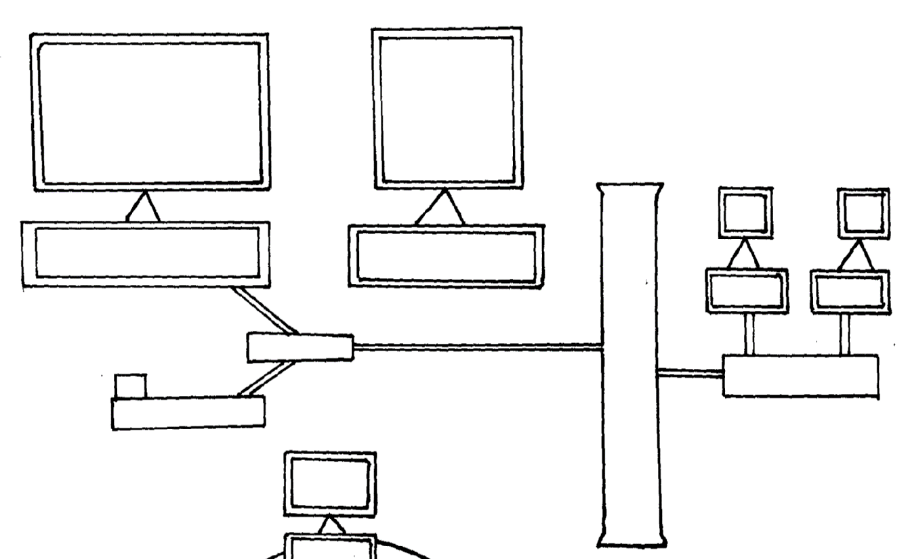
1

2

B

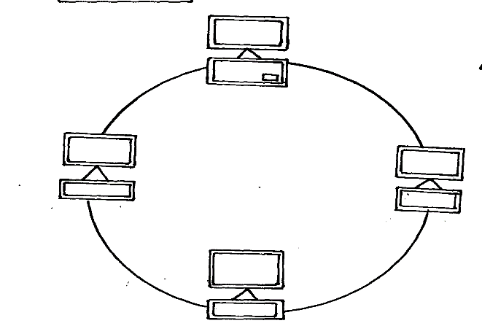

C

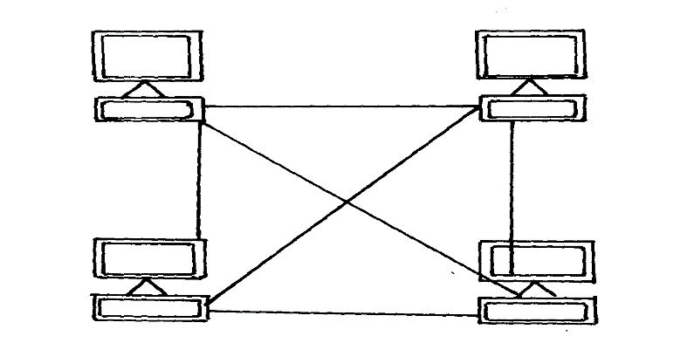

(i) Identify the network topologies. (3 mks)
A …………………………………………………………
B ………………………………………………………….
C …………………………………………………………..
(ii) In topology A, identify the network device that should be at the end points 1 and 2.
(iii) Which of the above topologies is likely to be used in a wide area network? (1 mk)
(iv) Highlight three disadvantages of topology B. (3 mks)
(v) Identify the device labeled x in topology A. (1 mk)
(b) State two main classes of network surface. (2 mks)
(c) Briefly describe the following as used in networking.
(i) Repeaters. (4 mks)
(ii) Network hub
(iii) Fibre optic cables
(iv) Network Interface Card (NIC)
19. (a) Define feasibility study as used in system. (2 mks)
(b) State four devices under direct control of the operating system. (2 mks)
(c) Briefly describe the following terms of computational error. (5 mks)
(i) Truncated
(ii) Transposition
(iii) Transcription
(d) Explain three most commonly used coding schemes. (3 mks)
(e) Distinguish between online and real time processing. (2 mks)
(f) State one advantage and two disadvantages of command line interface. (3 mks)
20. (a) (i) Explain three communication services offered through internet. (3 mks)
(ii) Describe the following terms. (2 mks)
Links
URL

(b) The following is a spreadsheet relating to a farmer.
A B C
1 Crop Amount
2 Maize 150
3 Bean 300
4 Cashew nuts 850
5 Cabbages 1036
(i) A function = IF (B2<200, “Not viable”, IF (B2 > 300 “Moderate”, IF (B2> 1000, “viable”))))
Give the appropriate result returned in cell C2, C3, C4 and 5. (2 mks)
(c) Text can easily be selected using a mouse in word processing. How do you select;
(i) Multiple paragraphs? (2 mks)
(d) (i) Distinguish between a widow and an orphan in word processing. (2 mks)
(ii) Cut and copy commands.
(e) Give one purpose of drop caps on a text paragraph. (2 mks)
(f) Give two application of expert systems. (2 mks)

*RCH*
1. (a) Define the terms ‘Data Integrity’. (1 mk)
(b) Give two features of data integrity. (1 mk)
2. Describe how each of the following printers work. (3 mks)
(a) Thermal ………………………………………………………………………………………….
(b) Electrostatic printer ………………………………………………………………………….......
(c) Laser printer ……………………………………………………………………………………..

3. Nina Secondary School wanted to buy some text books for Computer Studies. The following list
show an example of a spreadsheet which was used to calculate the minimum, maximum and Total
of the total price.

 | A | B | C | D
1. | BOOK | UNIT PRICE | COPIES | TOTAL PRICE
2. | Computer Studies BK 1 | 250 | 70
3. | Computers Studies BK 2 | 275 | 50
4. | Computer Studies BK 3 | 280 | 60
5. | Computer Studies BK 4 | 320 | 70
6.
7. | Minimum
8. | Maximum
9. | Total
- Write down in each case the formula that can be used in:-
(i) Cell D7
(ii) Cell D8
(iii) Cell D9
(b) Format all the numeric figures to US Dollar symbol and 2 decimal places. (1 mk)
4. State any two uses of personal computers in office. (2 mks)
5. State the difference between tracking and kerning as used in Page Maker. (2 mks)
6. (a) Differentiate between soft system and hard system. (2 mks)
(b) List any four characteristics of a system. (2 mks)
7. Explain the meaning of the following terms as used with operating system.
(a) Multitasking. (1 mk)
(b) Single user. (1 mk)
8. Explain the uses of the following keys on the keyboard.
(a) Backspace Key. (½ mk)
(b) Space Bar Key. (½ mk)
(c) F1 Key. (½ mk)
(d) Insert Key. (½ mk)
9. (a) Explain any two types of transcription error. (2 mks)
(b) Define the term ‘Algorithm errors’ as used in object oriented programming. (1 mk)
11. (a) (i) What is meant by the term “Upload” as used in the internet?. (1 mk)
(ii) Explain the term “hypertext.” (1 mk)
(b) Give two examples of search engines you know. (1 mk)
12. (a) Name any three special purpose memories found either inside and outside the microprocessor.
(b) Distinguish between an accumulator and an address register. (2 mks)
13. (a) Define the term “mail merging” as used in Word Processing Application Program. (1 mk)
(b) List any two documents that are involved in mail merging. (2 mks)
14. Explain the three components of an expert system. (3 mks)
15. Define the term Robot as used in Expert system. (1 mk)
16. Kenya Tea Packers Company pays two different rates for all the tea grades of Tea delivered to
her deports. The rates are as follows:- Grade A = Kshs. 20.00 per Kilograms and Grade B = Kshs.
10.00 per kilogram.
(a) Write an algorithm and pseudo code for the above program. (5 mks)
(b) Draw a flow chart for the above program. (5 mks)
(c) A school has two sets A and B. Write a structure algorithm to read a set and the points
awarded for winning each race in an athlete final terminated by “C”. Calculate and print the
total points gained by each set appropriately labeled. (5 mks)
17. (a) Define the term field properties as used in Database program. (2 mks)
(b) (i) What do you understand by the term normalization as used in Ms Access database? (1 mk)
(ii) What is an input mask in a database? (1 mk)
(c) (i) What is a query? (2 mks)
(ii) Differentiate between an action query and select query? (2 mks)
(d) (i) Differentiate between a Primary key and an Index key. (2 mks)
(ii) What is the difference between a field name and a Caption? (2 mks)
(iii) Differentiate between Columnar and Tabular form. (2 mks)
18. (a) (i) Give one advantage of a hub on a computer network. (1 mk)
(ii) Define the VSAT technology. (1 mk)
(iii) List any four examples of network operating systems. (4 mks)
(iv) State any three advantages of coaxial cables in a computer network. (3 mks)
(v) State any three devices used in data communications. (3 mks)
(vi) Differentiate between a router and a brouter. (2 mks)
(b) Define the term “ Protocol” as used in networking. (1 mk)
19. (a) State the uses of the following MS-DOS commands.
(i) CD. (1 mk)
(ii) DIR/P/W (1 mk)
(iii) Input devices are classified according to how they are used to enter data. Can you list five
classifications based on this. (5 mks)
(b) Name and explain four types of human computer interfaces. (4 mks)
- (i) Give any two control measures you would take avoid unauthorized access to data and
information. (2 mks)
(ii) Give two examples of anti-virus software you know. (2 mks)
20. (a) Perform the following conversions appropriately.
(i) Convert 91B₁₆ to Octal. (3 mks)
(ii) 376₁₀ to hexadecimal. (3 mks)
- Perform the following Binary arithmetic.
(i) 1110.0111 + 1101001.011 (3 mks)
(ii) 1001011.011 – 111.111 (3 mks)
(c) Convert 298.125₁₀ to hexadecimal equivalent.

*KKE*

1. State two reasons why personal computes are so important to small businesses and
entrepreneurs
2. State two characteristics for each of the following;
- First generation computers
- Second generation computers
- Third generation computers
3. Give a reason for each of the following hardware considerations when selecting a computer
system
- Processor speed
- Warranty
- Upgradeability and compatibility
- Portability
4. (a) What is disk partitioning?
(b) Give two reasons for partitioning a disk
5. Explain the following features as used in word processing.
- Word wraps
- Thesaurus
6. The first column in the table below contains the formula stored in cell C10 of a spreadsheet.
Enter the formulae as they would appear when copies to cell F15 of the same spreadsheet
FORMULA IN C10 | FORMULA IN F15
=A5*B5
=4*B$6
7. State three functions of a database management system
8. (a) Differentiate between signing-in and signing –up in relation to the internet
b) Distinguish between downloading and uploading
9. (a) Define the word expert system?
(b) List the three components that make up an expert system
10. Using the two components, perform the following arithmetic operation in 8 bits
11. What is a procedural language?
12. List any four resources under the operation system control
13. State two advantages of the Winchester disk as compared to other forms of secondary
storage media
14. a) List the two main type of DTP software
b) Differentiate between the following terms as used in DTP
Tracking
Kerning
15. Explain the function of the following parts of the URL
http:/www.kakamega.com
16. (a) Draw a flow chart for a program that can be used to get the sum of mark for 45 computer
studies student then get the subject mean
b) Define the following;
i) Source program
ii) Pseudo-code
iii) Translators
iv) Flowchart
v) Algorithm
17. (a) Giving an example for each, differentiate between transcription and computational errors
(b) Briefly describe the following elements of a computer file;
(i) Character
(ii) Field
(iii) Records
(c) Explain the functions of;
- Master files
- Back up files
- reference files
(d) Differentiate between
(i) Real-time processing mode and batch processing
(ii) Distributed data processing mode and multiprocessing mode
18. a) State the function of;
i) Web master
ii) Database administrator
iii) Computer operator
iv) Computer technician
b) Explain how computers have led to the following effects of employment:
i) job replacement
ii) Job displacement
c) State one negative impact of computers in our society
19. (a) Describe any three physical LAN topologies
(b) Define the following terms
- Protocol
- Server
- Gateway
iv) Repeater
v) Bandwidth
(c) Give two advantages of networking (d) Explain the line of sight principle in wireless communication
(e) What’s the work of the following in networking?
(i) Crimping tool
(ii) Network interface card
iii) Network neighbouring icon
20. (a) Differentiate between private data and confidential data
(b) Describe three types of computer virus
(c) Explain the following terms as used in data security
i ) Eavesdropping
ii) Surveillance
iii) Industrial espionage
d) Differentiate between hacking and cracking
e) State two laws that govern the protection of information

*UGU*
1. Differentiate between Access Time and Seek Time (2mks)
2. List four activities that can be carried out using Windows OS during disk management (4mks)
3. Give four reasons why a firm may decide to computerize its operations (4mks)
4. List three functions of the Arithmetic and logic unit (3mks)
5. What is the major difference between a web page and a web site (2mks)
6. (i) Write down all the digits in base 4 number system (1mk)
(ii) Calculate the sum of the second and the fourth digits (i) above (1mk)
7. What is the major difference between a webpage and a web site? (2mks)
8. Differentiate between physical and logical topologies (2mks)
9. Give the difference between tower and desktop system unit (2mks)
10. Differentiate between computational errors and transcription errors (2mks)
11. Using the place value method, convert 247₁₀ into its binary equivalence (4mks)
12. Perform the following binary arithmetic and give your answers in decimal notation (14mks)
1010.101 + 11.011
13. (a) Differentiate between :
(i) Primary key and foreign key (1mk)
(ii) What is cell referencing (2mks)
14. Define the word blocking as defined in Ms-Word (1mk)
15. (i) What is a server? (1mk)
(ii) Differentiate between peer to peer and client server (2mks)
16. Study the flow chart below and answer the questions that follow:
START
READ N
PRINT. F
STOP ART
M = 1
F = 1
M = 1
F = 1
M = 1
F = 1
M = F X M
M = N
Y
M = M + 1
Y

(a) What would the following generate as output if the value of N at input was:
(i) 6?
(ii) 1?
(b) Write a pseudo code that does the same thing as the flow chart above (15mks)
(c) Text can be select using a mouse processing. How do you select
(i) Multiple paragraph
(ii) Vertical text
(d) Distinguish between:
(i) A widow and an orphan in word processing
(ii) Cut and copy commands
(e) Give one purpose of drop caps on a text paragraph
(f) (i) What is an expert system?
(ii) Give two applications of expert systems
17. A school keeps a spreadsheet of examination results in four subjects. Part of the spread sheet is
as shown below:-
 | A | B | C | D | E | F | G | H
 | Name | Class | Maths | Science | IT | English | Av. Mark | Pass/Fail
1 | Allen | 11A | 33 | 24 | 19 | 44 | 30
2 | Dyos | 11B | 41 | 54 | 70 | 31 | 49
3 | Keg | 11A | 82 | 69 | 57 | 52 | 65
4 | Khan | 11C | 44 | 21 | 50 | 85 | 50
5 | Kolacz | 11A | 73 | 51 | 73 | 51 | 62
6 | Lenski | 11B | 17 | 41 | 40 | 34 | 33
7 | Peruza | 11C | 87 | 72 | 64 | 61 | 71

- Which column has been used to sort the data?
- What formula has been entered in cell G2 to calculate the Allen’s average mark?
could be done
(iii) The IT results need to be sorted so that the highest mark is at the top. Describe how this sort
(iv) The formula IF (G5>45, “PASS”, “FAIL”) is entered in cell H5. What output appears?
(v) State the validation check that should be carried out on data entered in cells C2 to F8 to ensure
values over 100 are not input (15mks)
18. (a) (i) Explain three communication services offered through internet
(ii) Describe the following internet terms:-
Links …………………………………………………………………………………………………..
URL……………………………………………………………………………………………………
(b) The following is a spreadsheet relating to a farmer
 | A | B | C
1 | Crop | Amount
2 | Maize | 150
3 | Bean | 300
4 | Cashew nuts | 850
5 | Cabbages | 1036

(i) A function = IF(B2<200,”Not
Viable”), IF(B2>300, “Moderate”), IF(B2>1000,” Variable”))).
Give the appropriate result returned in cells C2, C3, C4, and C5
18. (c) Text can easily be selected using a mouse in word processing. How do you select
(i) Multiple paragraph
(ii) Vertical block of text
(d) (i) Distinguish between widow and an orphan processing
(ii) Cut and copy commands
(e) Give one purpose of drop caps on a text paragraph
(f) (i) What is an expert system?
(ii) Give two applications of expert systems
19. (a) Explain the advantage of using two’s complement over one’s complement
(b) Using two’s complement, subtract 4 from 7 and give your answer in decimal notation
(c) An organization is planning to develop a new information system to manage its operations.
(i) Explain the following characteristics of a system
Holistic thinking
System entropy
(ii) List four tools that could be used in designing the information system during the design stage
(d) Explain any three threats to data and information
(e) Explain the purpose of the following types of program documentation
(i) User manual
(ii) Reference guide
20. (a) Define feasibility study as used in system
(b) State four devices under direct control of the operating system
(c) Briefly describe the following types of computerized errors:
(i) Truncated
(ii) Transposition
(iii) Transcription
(d) Explain three most commonly used coding schemes
(e) Distinguish between online and real time processing
(f) State one advantage and two disadvantages of command line interface

*MUM*
1. State two functions of the SHIFT key as used in a word processor.
2. (a) How do registers differ from buffers.
(b) List four examples of registers.
3. Daniel has noticed the following problems in his computer;
(i) It is taking a longer time to start up.
(ii) It is often hanging
(iii) Applications are taking long to load.
State three possible causes of these problems and how they can be solved.
4. List three functions of an anti-virus software.
5. Differentiate between a virus and a logic bomb.
6. The cells K3 to K10 of a worksheet contain remarks on students performance such as very good,
good, fair and fail depending on the average mark. Write a formula that can be used to count all
students that have the remark “very good”.
7. The following information shows the income and expenditure for “Beba yote” matatu for five
days. The income from Monday to Friday was Ksh.4,000, 9,000,15,000 and 20,000 respectively
while expenditure for some period was Ksh.2000,3000, 7000, 5000 and 6000 respectively.
(a) Draw a spreadsheet that would contain the information. Indicate the rows as 1 , 2, 3 and 4 and
the column as A,B,C
(b) State the expression that would be used to obtain:
(i) Monday profit.
(ii) Total income
(iii) Highest expenditure.
8. Describe the following terms:
(a) Software suite
(b) Shareware
(c) Groupware
(d) Integrated software
9. (a) Subtract 0111₂ from 1001₂
(b) Using two’s compliment subtract 7 from 40 and give the answer in decimal notation.
10. Distinguish between uploading and downloading.
11. Distinguish between peer-to-peer Networks and client-server networks.
12. List any two techniques used to implement information systems in various organizations.
13. Distinguish between a word and word-length as used in data representation.
14. Describe three types of maintenance that can be applied on information systems.
15. (a) Study the flowchart extracts below
(b) State the looping structure demonstrated in
(c) List any four methods of detecting and correcting programming bugs.
(d) Draw a flowchart for a program that can be used to add any positive integers that can be keyed
into the computer through the keyboard. The program should count the positive numbers entered
and should be terminated when a zero is keyed in.

16. Below are two table structures of files in a database:
TABLE 1 TABLE 2
Field Data type Field Data type
Employee number Text Employee number Number
Employee Name Auto number Data employed Date/time
D.O.B Date/time Department Test
Address Test Salary Currency
(i) Which of the two tables is likely to be the parent table? *MUM*
(ii) It is advisable to enforce referential integrity when creating a relationship. When creating a
relationship, what do you understand by the term referential integrity? *MUM*
(iii) The field “employee No” in Table 2 is likely to be the primary key.
What is a primary key?
iv) Which fields in both tables is most appropriate for creating a relationship? *MUM*
(v) What will make the relationship between the tables fail to work? *MUM*
(b) In databases, the field properties specify finer details related to the fields and the entries
expected. State four field properties. *MUM*
(c) State three functions of a database. *MUM*
17. (a) Explain three communication services offered through the internet. *MUM*
(b) Describe the following internet terms. *MUM*
(i) Browsing
(ii) Web portal
(iii) Home page
(iv) Hyperlink
(v) Uniform resource locator
(c) The following spreadsheet is relating to a farmer.
 | A | B | C
1 | Crop | Amount
2 | Maize | 150
3 | Beans | 300
4 | Cashew nuts | 850
5 | cabbages | 1036
(i) A function = IF (B2< 200, “Not viable”, IF(B2>300,”moderate”, IF(B2> 1000, “VIABLE”))).
Give the appropriate result returned in cells C2, C3, C4 and C5.
(d) List any three functions of the control unit.
18. (a) List any three differences between an interpreter and a compiler.
(b) State four characteristics of Random access memory.
(c) Describe the following data security measures
(i) Log files
(ii) Fire walls
(iii) Antispyware
(iv) Audit trial
19. (a) What is a transmission media?
(b) List two types of transmission media
(c) Distinguish between a Hub and a switch.
(d) With help of a well labeled diagram, describe the fibre optic cable
(e) What are the functions of the following devices on a network?
(i) Repeaters
(ii) Network interface card
(iii) Router
(f) Distinguish between physical topology and logical topology as used in Networking

*KSM*
1. Describe four electrical safety precaution rules that should be observed in a computer room.
2. Distinguish between a compiler and an interpreter. (2mks)
3. (a) Describe the term keys to storage system (1mk)
(b) Games programs can be purchased from computer stores on CD-ROM. State two
advantages of CD-ROMS over floppy disks (2mks)
4. State two outputs device that are found at the point of sales terminal (2mks)
5. Outline any four editing features of a word processor. (2mks)
6. Describe briefly how a laser printer works (2mks)
7. (a) Identify the main stage of program development (4mks)
(b) Define the terms program documentation (1mk)
(c) List program control structures giving examples (3mks)
8. Distinguish between high levels and low levels language giving one advantage and one disadvantages of each of them (2mks)
9. (a) Explain the difference between the following commands as used in MS-DOS (2mks)
(i) Dir/p
(ii) Dir/w
(b) Write one command that can be used to format a diskette and copy system files to it (1mk)
10. Differentiate between real time processing and batch processing giving examples where
each could be used. (2mks)
11. Differentiate between computer added design and computer aided manufacture (2mks)
12. What is a computer network? (1mk)
13. Describe three difference types of computer network (3mks)
14. State three symbolic data representation (3mks)
15. State two properties that an opening system display about a file (1mk)
16. (a) Distinguish between Algorithm and Pseudo code. (3mks)
(b) A company has 5000 CDs, video and books in stock each items has a unique 5 digit
code with the first identifying the type of item i.e.
1=CD
2=DVD
3= video
4=Book
For example, for the code 15642 the 1 identifies that it is a CD, and for the code 30055 the 3 identifies these it is a video
Write an algorithm, using pseudocode or otherwise, that
-inputs the code for all 5000 items
-validates the input code (12mks)
17. (a) List three differences in the computer training provided by colleges as opposed to those
offered by the universities (3mks)
(b) Describe three duties of each of the following computer specialists :- (6mks)
(i) Database administrator
(ii) System analyst
(c) Information technology has bought about a lot of concern in people’s lives-social effects,
list three arguments for and against information technology (3mks)
(d.) Repetitive strain injury happens when one overuses the computer keyboard or mouse.
Causing inflammation or injury on muscles or tendons .Describe three measures users
can apply to prevent or reduce RSI (3mks)
18. A school computer laboratory is scheduled o undergo major renovations. The lab is schedule to
receive new computer whose specifications are given below:-
Pentium IV 2.8GHz processor
40GB HDD
31/2 FDD
256 MB RAM
568CD ROM
17” SVGA TFT monitor
The computers are gong to be networked and will be able to browse the internet.
(a) Explain what is meant by the terms:- (2mks)
(i) FDD
(ii) HDD
(iii) SVGA
(iv)TFT
(b) The computer is to be networked, name one extra device that should be fitted on every
computer to enable this to happen (1mk)

(c) The computer is to receive internet facilities through the server on a dial; up system. Name
and describe the function of a special device that needs to be connected to the server to
complete the connection (1mk)
(d) (i) The school has to apply he star topology to link up the computer. List two advantages
of this type of topology (1mk)
(ii) Name the central device used to connect the computers in this topology. (1mk)
(e) List two other types of topologies that the school could have opted for (1mk)
(f) List four advantages of using a network (2mks)
(g) (i) Data transmission via the internet is done using a mode known as packet switching.
Describe this data transmission mode (1mk)
(ii) Name two other modes of data transmission (1mk)
(h) (i) The school’s LAN is done using UTR cable. List two disadvantages of using this
type of cable. (1mk)
(ii) List two advantages of using fibre cable in networking (1mk)
(j) Data flows in the school’s LAN in a duplex manner. Discuss two other type of data
transmission in network giving examples (2mks)
19. (a) Differentiate between a database and a DBMS (1mk)
(b) List four advantages of using database systems (2mks)
(c) In a data base system, data integrity ensures the correctness and completeness of the data
in the database. Differentiate the following types of integrity constraints:-
(i) Validity integrity (1mk)
(ii) Entity integrity (1mk)
(iii) Referential integrity (1mk)
(d) Briefly describe the three database models :- (3mks)
(i) Hierarchical model
(ii) Network model
(iii) Relation model
(e) Using diagrams describe the following three types of relationships (3mks)
(i) One –on- one
(ii) One –to- many
(iii) many-to-many
(f) File organisation refers to the arrangement of records on secondary storage. Briefly
describe the following file organization methods:- (3mks)
(i) Sequential
(ii) Random /direct
(iii) Serial
20. (a) State and describe any two areas of Artificial intelligence (2mks)
(b) What is virtual reality? (1mk)
(c) List three component of a virtual reality gear (3mks)
(d) By giving an example define:-
(i) A smart terminal (2mks)
(ii) An embedded computer (2mks)
(e) State three factors to consider when selecting a UPS (3mks)
(f) Give two uses of computer in stock exchanges (2mks)

*TZM*
- The computer processing cycle involves a four step process List them (2mks)
2. The CPU consists of control unit and arithmetic logic unit State the functions of the two units(2mks)
3. Name and explain the two types of primary memory. (3mks)
4. State the functions of the following keys in a computer key board
- Pause (1mk)
(ii) Function keys (1mk)
(i) Explain the importance of microphones combined with speech recognition device such
as voice output. (2mks)
(ii) State the main disadvantage of the above method of data input. (2mks)
5. The most popular type of electronic data storage currently is magnetic disk storage such as
hard disk or Winchester disk. Give reason as to why they are popular (2mks)
6. Outline two advantages of hard disk over floppy disk. (2mks)
7. One stage of system development is system testing. Outline the advantages of this stage
before implementation. (1mk)
8. (a) Convert 111.011${}_{2}$to a decimal notation. (2mks)
- State one advantage of using binary number system in computers. (1mk)
9. State one function of each of the following terms (3mks)
- Buffer…………………………………………………………………………….......…………
ii) An accumulator…………………………………………………………………………………
iii) Cache memory...............................................................................................................................
- Explain any two factors that should be put into consideration during output design. (2mks)
- (i) Define the term graphic and give two examples (2mks)
(ii) List any two sources of graphic that can be used in Microsoft word. (1mk)
12. State the functions of the following logical functions as used in excel
- If……………………………………………………………………………........… (1mk)
- Sum If ……………………………………………………………………............. (1mk)
- Count If……………………………......……………………………………… (1mk)
- Why would one prefer to use a form for data input rather than entering data directly into a table. (2mks)
- When using wizard to create a form, list four forms layout that you can use. (2mks)
13. Distinguish between the following terms as used in DTP (4mks)
- Tracking and kerning
- Stroke and fill
14. (a) Define the following terms
- Structured programming (1mk)
Constants (1mk)
Variable (1mk)
(b) Distinguish between dummy data and real data as used in system testing (2mks)
(c) Mr Lugeno borrowed a loan of 200,000 from Ndege chai cooperative society at a rate
of 10%payable in 2 years flat rate. Draw a flow chart that can be used to develop a
computer program that will keep track of monthly repayments (5mks)
15. (a) Define the following computer crimes
- Piracy (1mk)
ii) Industrial espionage (1mk)
(b) Explain two ways of protecting data and information against unauthorized access (4mks)
(c) Explain two functions of network operating system. (4mks)
(d) Differentiate between a repeater and a router as used in computer networking. (2mks)
(e) List down three duties of a computer trainer (3mks)
16. (a) Explain any two types of human computer Interface. (4mks)
(b) State four basic requirements of a standard computer laboratory (4mks)
- Out line three types of job opportunities that are available in the computing field (3mks)
(d) (i) Differentiate between video conferencing and telecommuting as used in communicating
system (2mks)
(ii) Highlight two advantages of telecommuting (2mks)
17. (a) Distinguish between the following
(i) Sequential and serial file organization methods. (2mks)
(ii) Random and indexed sequential file organization methods (2mks)
(b) Explain the following types of data processing modes
- Batch processing (2mks)
ii) Real time processing (2mks)
(c)Define the following terms
- Undo (1mk)
ii) Redo (1mk)
(d) State three breakthrough of Information Communication Technology (ICT) in
health care (3mks)
(e)List any two under graduate programs offered in public universities in Kenya (2mks)
18. (a) Draw a flowchart showing;
- The WHILE loop (2mks)
- The REPEAT…………UNTIL loop (2mks)

- Differentiate between the following terms
- Information system and system (2mks)
- Hard system and soft system (2mks)
(c) List the seven stages of System Development Cycle (SDLC) (7mks)

PAPER TWO
*NYR*
QUESTION 1
M/s Ann Momanyi, an ICT consultant with Makueni Distributors is in the process of developing a Management Information System (MIS) for the Company. Currently, she is designing sales database using three tables namely: - customers, products and transactions. The details for each table are given below:-
Customers Products Transactions
Customer ID ProductID TransID
CustomerName ProductDescription ClientName
PostalAddress Packaging TransacDate
Town UnitPrice Product
Phone Stock Quantity
Questions
(a) Create a database named MIS and in it create three relations
(b) Identify the most appropriate field as the primary key in each table
(c) Establish relationships among the three tables and enforce the referential integrity
(d) Create a form for each table. Save the forms as Customer Form, Product Form and
Transaction Form
(e) Use the respective forms to enter the following records in each table
CUSTOMERS TABLE
CustomerID | Customer Name | Postal Address | Town | Phone
H001 | Andrew Mwove | 209 | Mutituni | 200870
H002 | Erick Onsongo | 68 | Nyamira | 248567
H003 | Brenda Nyabuti | 100 | Bomet | 789678
H004 | Lydiah Winzaa | 250 | Mwingi | 778009
H005 | Jeff Ogero | 330 | Keroka | 666790
H006 | Maureen Makuthu | 550 | Kakeani | 780906

PRODUCTS TABLE
ProductID | Product Description | Packaging | Unit Price | Stock
AA001 | Cooking Oil | 20 kg Gal | 16000 | 80
AA003 | Rice | 50Kg Bags | 4500 | 60
AB004 | Detergents | 5 Litres | 11000 | 40
AC006 | Fertilizer | 50Kg bags | 4700 | 30
AA007 | Mineral Water | 1.5 Litres | 8200 | 400
TRANSACTION TABLE
CustomerID | ClientName | TansacDate | Products | Quantity
1001 | Andrew Mwove | 06/04/2007 | Cooking oil | 6
1002 | Andrew Mwove | 26/04/2007 | Mineral water | 8
1003 | Erick Onsongo | 23/04/2007 | Detergents | 10
1004 | Maureen Makuthu | 14/04/2007 | Cooking oil | 12
1005 | Maureen Makuthu | 02/05/2007 | Rice | 4
1006 | Maureen Makuthu | 08/05/2007 | Fertilizer | 3
1007 | Erick Onsongo | 16/05/2007 | Detergents | 25
(f) Create a query that displays the customer Name, Product Description, Quantity, Unit price and a
calculated field total payable by each customer. Save the query as MISQuery
(g) Generate a report from MISQuery. Save the report as MISReport
(h) Print the Customers, Products, Transaction table’s design, MISQuery and MISReport

QUESTION 2
Using DTP software design the publication based on the following instructions to appear as it is
1) Set the page to have portrait orientation and margins to be as follows;
(a) Format the heading: BISELEX BUSINESS” to bear the following features:-
(b) Font type: Copperplate Gothic
(c) Font size: 26
(d) Background color: grey
(f) Alignment: centered
2) Format the heading “New Arrivals for new generations’ to bear the following features:-
(a) Font type : Monotype corsiva
(b) Font size: 22
(c) Alignment: Centered
(d) Border style: 6pt
(e) Rotate it appropriately
3) Format the heading “All Under One Roof” to bear the following features:-
(a) Underline style: words only
(b) Font type: Arial Narrow
(c) Font size: 20
(d) Alignment: centered
(e) Rotate it appropriately
4) Format the text below the heading “Motto : Customer Satisfaction” to be in three columns
and format it as follows:-
1st column
i) Drop cap the first character to four lines
ii) Line spacing 1.25pt
2nd column
i) Underline the title “Items” with a broken line
ii) Text weight: bold italics
iii) Bullet the listed items appropriately
3rd column
5) Insert the rounded rectangle and format its heading to :
(i) Underline : Double
(ii) Font type: Arial Black
6) Format the text under the heading “LOCATION” as follows:-
(i) Font type: Castellar
(ii) Font size: 9pts
7) Insert the suitable picture as it appears in the publication
8) Insert the header to bear Your Name and the Footer to bear Your Index Number

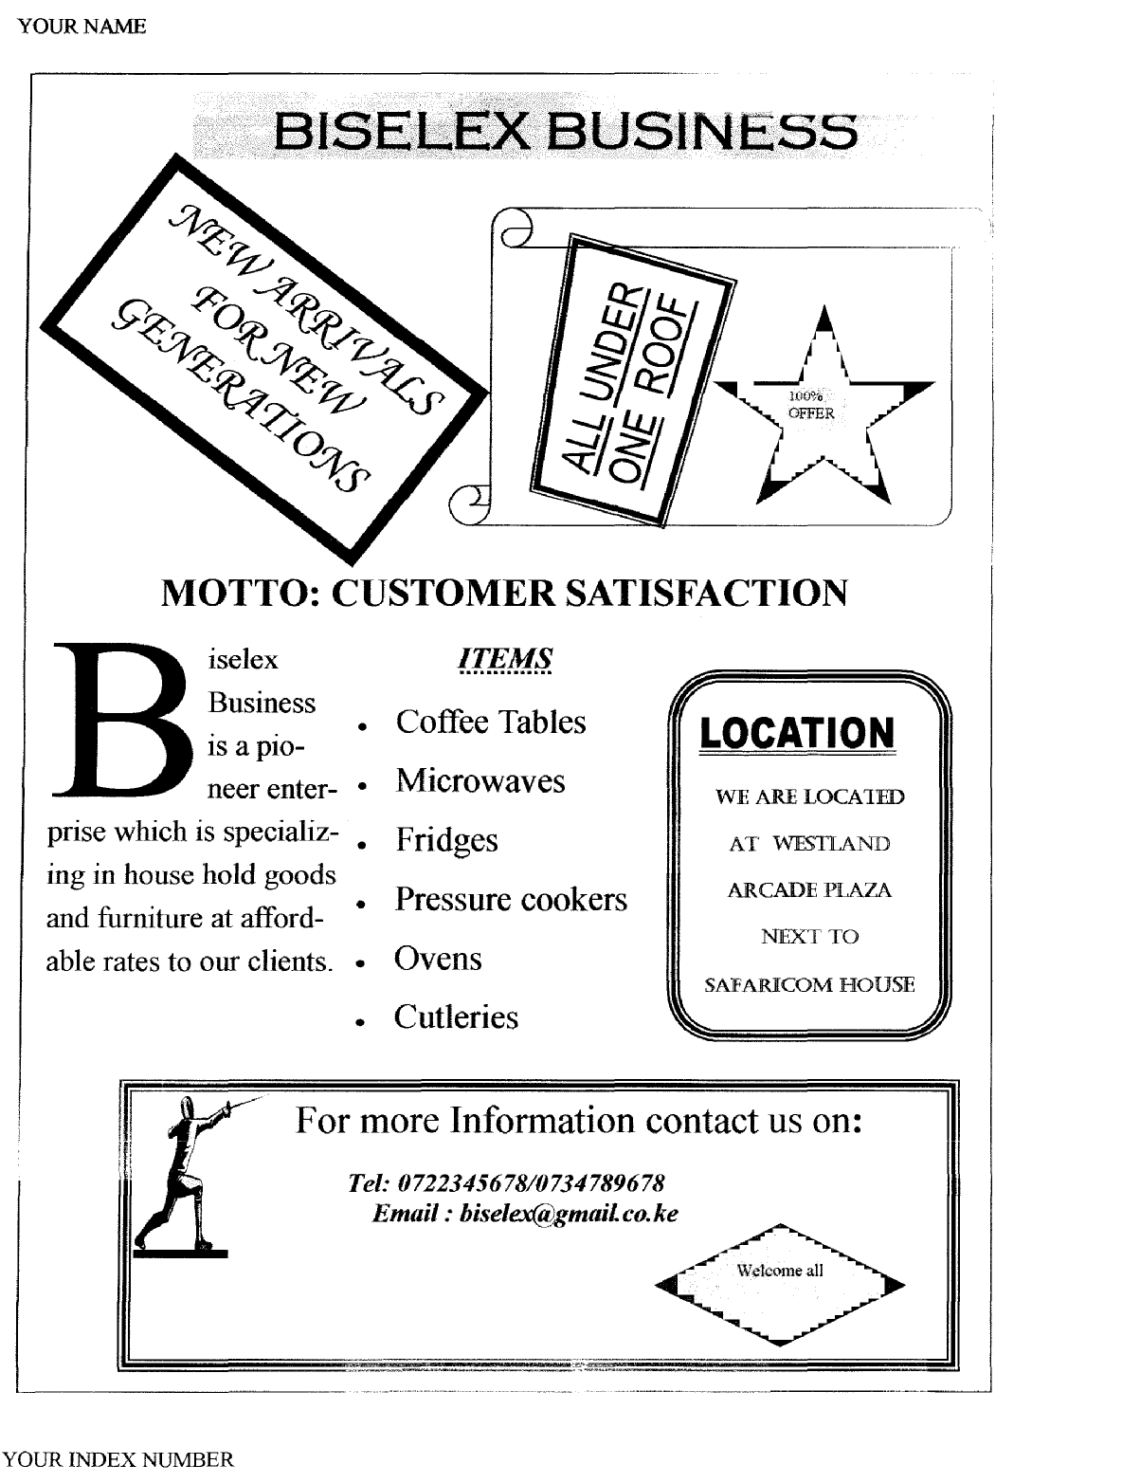

*MAT*
Question 1
(a) Wafula is a secretary for all clubs in the school. He has been told to create Club_DBMS id database
management system (DBMS) to help the club maintain record on the clubs’ members.
Relation name | Fields | Primary key
Student | Admission Number | Admission number
Student | First Name | Admission number
Student | Last Name | Admission number
Student | Form | Admission number
Student | Stream | Admission number
Club_Details | Club Number | Club Number
Club_Details | Club Name | Club Number
Club_Details | Date established | Club Number
Membership | Registration Number | Registration Number
Membership | Club Number | Registration Number
Membership | Admission Number | Registration Number
Membership | Date of registration | Registration Number
Membership | Membership fee | Registration Number

(a) Perform the following operations just like Wafula would:
(i) Create a database Club_DBMS with the tables shown above. (12mks)
(ii) Index on last name on the able student (2mks)
(iii) Crate a lookup list for the following fields in class student (3mks)

Field | Lookup list |  | Field | Lookup list
Form | One |  | Class | East
Form | Two |  | Class | North
Form | Three |  | Class | West
Form | Four |  | Class | South

(iv) Create One-Many relationship between the relations and enforce referential integrity (3mks)
(b) Create use friendly screen inputs with the Add New Record, Find Record, Delete Record and
Close Screen Input commands for each of the table, save them using respective table’s name (12mks)
(c) Using the input screens, enter the records below: (6mks)
Admn. No. | First Name | Last Name | Form | Stream
3200 | Busaule | Mwitani | Two | East
3811 | Mawi | Martha | One | South
2844 | Nambwaya | Nancy | Four | East
2910 | Wafula | Victor | Four | Central
3295 | Hassan | Eunice | Three | East
2956 | Busolo | Josephat | Three | North
2977 | Makhanu | Josephat | Four | South
3216 | Mateshe | Jackline | Three | West

Club Number | Club Name | Date established
97/Mat | Mathematics | 05/02/1997
02/Sci | Science | 08/04/2002
01/Env | Environment | 01/09/2001
97/Lan | Debate | 08/04/1997

Reg. Number | Admn. No. | Club No. | Reg. Date | Membership Fee
MT/0013 | 2844 | 97/Mat | 12/03/2007 | 100
SC/0189 | 2977 | 02/Sci | 11/03/2007 | 120
MT/0975 | 2910 | 97/Mat | 05/05/2007 | 100
DB/0111 | 2977 | 97/Lan | 11/03/2007 | 90
EN/1001 | 3811 | 01/Env | 01/03/2010 | 80
SC/0998 | 3216 | 02/Sci | 09/10/2008 | 120
SC/1006 | 2844 | 02/Sci | 12/03/2007 | 120
DB/0565 | 3295 | 97/Lan | 10/05/2008 | 90

(c) Create a query for each record containing the product of membership fees $ multiplied by 79.8.
Label this column “Amount in shillings”. The query should display: Last Name (in ascending order),
First Name, Registration Number, Date of Registration, Amount in shillings. For all members whosel
last name start with M or J and first name start with M save the query as Query M (8mks)
(d) Create a query that Display Admission Number, Last name, first Name, Club Names and
Registration date for form four students. Save query as Members (3mks)
(e) Create a tabular report from Query-M that displays Last Name, First Name, Membership Number,
Date of Registration, Membership Fees paid in shillings and display the total to the membership fees
at the end of the report. Save the repo\rt as “Membership Report” (5mks)

Admn. No. | First Name | Last Name | Form | Stream
3200 | Busaule | Mwitani | Two | East
3811 | Mawi | Martha | One | South
2844 | Nambwaya | Nancy | Four | East
2910 | Wafula | Victor | Four | Central
3295 | Hassan | Eunice | Three | East
2956 | Busolo | Josephat | Three | North
2977 | Makhanu | Josephat | Four | South
3216 | Mateshe | Jackline | Three | West
(f) Create a tabular report from Members query, sort the records by first name and save it as
Club Members. (4mks)
(g) On each report, add your name, index number and page number in the format “Page X of Y
pages” as footer (4mks)
(h) Add “Mary Seat of Wisdom Bulimbo Girls’ Sec. School” and Report Name as Header on
each report (2mks)
(i) Print membership Report, Club Members, Query-M and Student table (4mks)

Question two
(a) Enter the following as it is onto worksheet and save it as the budget (7mks)
A | B | C | D | E | F | G
No. | Item description | Quantity bought | Unit price | Amount | Comments | Cost Rank
1 | 2Kg Mumias Sugar | 4 | 210
2 | Sony 2HD floppy | 3 | 37
3 | Rapid spring file | 10 | 56
4 | 200pg A4 books | 9 | 89
5 | 1 litre Quencher | 2 | 256
6 | AIHAO Gelink pen | 15 | 55
7 | Omega dustless chalk | 18 | 105
8 | LG 2GB Flash Disk | 4 | 1055
 | Total
(b) Rename worksheet 1 as Budget and Worksheet 2 as My Graph (3mks)
(c) Insert two rows above labels in the budget 1 worksheet. Enter in the first row, a Word Art “
A sample Budget: Back to Business.” (4mks)
(d) Enter cell B2 and C2, VAT and 18% respectively (1mk)
(e) Calculate ;
(i) Using name referencing calculate the amount for each item (amount = quantity *price) (4mks)
(ii) Total quantity, price and amount using formulae (3mks)
(iii) Display “Thank for shopping” for amount above 500, “Almost in a draw” for amount
between 250 and 499, otherwise “Buy More” (4mks)
(f) Using column E, rank the items with the most costly ranked as the last (4mks)
(g) Format all values on the worksheet to two decimal places aligned right of cell and in
pounds (£) (3mks)
(h) Copy the information on Budget1 worksheet to workshet3. Rename corksheet3 as copied(2mk
(i) Save the workbook as Budget2 (1mk)
(j) Change respective quantities of items on budget 1 worksheet (1mk)
Sony 2HD floppy 18
200pg A4 books 12
(k) Using item name and taxes on Budget1 worksheet, create a line chart of item description and
amount on worksheet My Graph (8mks)
(l) Save the workbook as Final Budget and print the chart (2mks)

*MUM*
WORD PROCESSOR
1. (a) Type the following passage exactly as it appears into a word-processor, spell check and
format it accordingly. Use typeface Times New Romans, font size 12.
Format your document to fit exactly on one page. Save it as A: NET 1 (26marks)

NETWORKS MODELS
Networks can be organized into three basic models client/server, peer to peer and centralize computing. Client/Server and peer-to-peer are used with PC networks. While centralized computing models are used with mid-range and mainframe computers usually running a UNIX-based operating system. The peer-to-peer model is the simplest to implement and assemble. Client/server is the most popular configuration, because of its versatility and power drawing mainly from the vast variety and higher performance of specialized server hardware.

Central computing networks
The host is the core of the centralized computing model. Host computers typically run the UNIX operating system and can process multiple jobs simultaneously and in a very efficient manner. Jobs are initiated by the Terminal, which has no processing capability on its own and simply provides input/output for the host. The user logs into the host computer to process the user’s job; when the job is finished, the host computer sends the results of the job back to the terminal.

The main advantage of centralized computing is that they are the highest performance networks today. Its major disadvantages are:
• They are costly
• They are dependent on custom written software
• They are more complicated than PC severs

Client/Server Networks
The client/server network is the workhorse of the network world and consists of at least one server with shared recourses and one or more clients which users do their work on. The server, often called the back end, stores and secures users’ files. It provides the single point of administration for network users, files, and applications. In a client/server network, the function of the server is to provide services, where as the function of the client is to provide the actual processing. Most client/server networks are built round a domain structure, where all servers within a given domain share a common administration scheme.
Peer-to-peer Networks
A peer-to-peer network is simply a group of computers that function as both servers and clients (share and access resources). In this type of network, a user works on a workstation and actually shares that workstation’s resources with other workstations.

Disadvantages
• It may be slow
• Lack of a central security administration
• Decentralized administration might be a nightmare.

(b) (i) Bold face and italicize all the occurrences of the words client/server
(ii) Justify and set the left and right indents of the second paragraph at 1 inch.
(ii) Save the document as A: NET 2 (6mks)
(c) (i) Copy NET 1 passage to a new document
(ii) Present the document into two columns with a line between the columns. Introduce a
column break on the sub heading “Client/Server Networks” so that your second column
begins exactly with that header.
(iii) Save the new document as A:NET 3 (6mks)
(d) (i) Introduce double space in the last paragraph of NET 2
(ii) Search and replace the word “host” with “main” in the whole passage.
(iii) Save the document as A:NET 4 (6mks)
(e) (i) Animate the title of the passage of document NI-T4 to have a blinking background.
(ii) Convert the paper orientation to landscape and format your document to fit on one page.
(iii) Save the passage as A: NET5 (5mks)
(f) Print2. A stationery store keeps a record of all items sold in the store. The details are given
in table 3 table 3 below.
Item code | Description | Quantity | Supplier
005  001  009  007  010  006  002  003  008  004 | HBI pencils (doz)  Stapler  Photocopy paper (reams)  Staples (packets)  120 pages (ex. Books)  Spring files  Diskettes  HB2 pencils (doz)  Foolscaps (reams)  Chalk | 200  100  200  300  200  200  300  500  300  350 | Shah  Shah  Chania  Vipingo  Vipingo  Shah  Chania  Shah  Vipingo  chania
(a) Create a database structure containing the fields:
Item code
Description
Quantity
Supplier
(b) Enter the records as shown in table 3 into your database and save it as Stat 1. (l2mks)
(c) Modify Stat 1 to include the field for date received and save as Stat 2. (3mks)
(d) Items with cods 001, 007, 009 and 010 were received on 10/05/200 1. Items with codes
002, 005, and 008 were received on 12/05/2001 and the rest were received on 15/05/2001.
Enter this information on the date received field. (5mks)
(e) Sort Stat 2 on item code field in descending order and save it as Stat3. (6mks)
(f) Create a query to extract all items delivered by Shah on 15/05/200 1 and save as query 1.
(g) Using Stat 1, generate a tabular report titled “Stationery store items” and containing the
following fields in the order shown.
Supplier Description Quantity
Save the report as report 1
Print Stat1, Stat3, query 1 and report1 (8mks)

*TNW*
Q1. (a) Type the passage below as it appears using a word processing package and save it as A:\Bono1.
(Settings: Font Arial, font size 12 for all text, margins; top 0.5”, bottom 0.6”, left 1”, right 0.5”,
1st Heading Size 20, 2nd & 3rd Size 14 ). 36mks

WE MUST STRIVE FOR GREAT THINGS IN LIFE

Apart from being famous
one should leave legacy that speaks for years. Paul Hewson was in Nairobi recently. That won’t mean much to you, until I explain that I was referring to Bono, the world – famous lead singer of rock band U2 and campaigner against global poverty. Bono didn’t really make much noise while in Kenya. He attended the ⎣Nation Media⎦ group’s Pan Africa Media Conference, took H₂o, talked to a couple of journalists and left.

He didn’t do the other things that visiting celebrities of his stature do when in Africa: adopt a cheetah or a baby hippo, start a school for orphans, shoot the breeze pointlessly with Emilio and Tinga, utter banalties about the girl child. Bono reserves his energy for other things.
Popular Media
Bono is not famous just for being a singer. For the past couple of decades he has been one of the most visible humanitarian activists, using his fame to enlist powerful allies from:
- Government
- Religious institutions
- Philanthropic groups
- Popular media and
- The business world.
He has personally spearheaded the campaign for debt relief for the world’s poorest countries, and has been a vocal champion for Africa. Not everyone agrees with these efforts. Author Paul Theroux savaged Bono, Bob Geldof and other celebrity humanitarians, saying that creating “the impression that Africa is fatally troubled and can be saved only by outside help – not to mention celebrities and charity concerts – is a destructive and misleading conceit.”

I happen to agree with that view and have propagated it in writing for many years. I don’t think Africa’s
salvation will come from outsiders,

AID FROM EUROPE

and it certainly won’t come from endless handouts and a crippling dependency culture.

On Trivia

What about you? How big is your life? Are you allowing your time on earth to be frittered away on trivia, or are you going to make a net positive impact on the planet? Are you doing something, anything bigger than yourself? Are you raising
a child to be a better person than you are? Are running a business or conducting a profession that sets a standard in good practice? Or are you content to be a small person imprisoned in a small life?
b) i. Copy the paragraph that begins with “He has personally……..” to page 2. (1mk)
ii. Set the paragraph to hanging indent. (1mk)
iii. Change the line spacing of the entire paragraph to double and convert it to landscape.(4mks)
c). Insert your name and index number as the header left aligned. (1mk)
d). Carry out word count on the document and write on the paper provided the number of:
- Words
- Characters (with spaces)
- Characters (no spaces) (3mks)
e). Paginate the document using page x of y at the top center. (2mks)
f). Save the entire document as A:\Bono2 (1mk)
g). Print document A:\Bono2. (1mk)

Q2. The information in the following two tables relates to a vehicle buying and selling business.

Table 1: Seller details

Seller No | Seller Name | Address | Town
8215 | Samcon | 23454 | Nakuru
8242 | CMC | 654 | Eldoret
8430 | DCM motors | 3554 | Nairobi
8620 | Farmers Garage | 7645 | Kitale
8845 | KCI | 8643 | Kisumu

Table 2: Vehicle details

Reg No | Make | Type | Price | Seller No
KAJ 543Q | Nissan | Matatu | 1,200,000 | 8242
KAQ 952R | Mercedes | Saloon | 4,000,000 | 8242
KAX 534S | Peugeot | Pickup | 960,400 | 8620
KAZ 454C | Mazda | Saloon | 550,000 | 8215
KBA 386A | Toyota | Pickup | 750,000 | 8620
KBB 917A | Toyota | Saloon | 800,000 | 8430
KBE 875T | Isuzu | Lorry | 1,800,650 | 8430
KBG 805G | Scania | Bus | 10,500,000 | 8845
KBJ 324D | Isuzu | Bus | 9,200,000 | 8845
KZL 931 | Toyota | Matatu | 1,400,000 | 8620

a). Create a database file named A:\Business. (2mks)
b). Create the two tables above and save them using their respective names. Determine the
appropriate primary keys. (10mks)
c). Create a form based on each table. Insert form titles as seller details form and vehicle
details form respectively. (5mks)
d). Use the forms to enter the records in the two tables as shown above. 15mks)
e). Create a query containing the following fields(Reg no, Make, price and Seller name). It.
Should display only those vehicles whose prices are above 1000,000. Save as Sales1. (6mks)
f). Remove the criteria set in sales1 query. Include a calculated field in the sales query to
derive new prices if the current prices went up by 5%. Save as sales2. (5mks)
g). Create a tabular report based on sales2 query. The report should show the total amount
collected from selling the vehicles if they were sold at their new prices. Save as report. (4mks)
h) Print the seller details table, vehicle details table and the report. (3mks)

*KKC*
QUESTION 1
(a) Type the following letter as it appears in a word processor. Use the mail merge feature to produce copies of the same letter to the persons whose details are given below:- (12 mks)

MWANGAZA HIGH SCHOOL
P.O. BOX 4800
ELDORET
8TH JULY, 2010

<NAME≥ <ADMNO≥
<ADDRESS>
<TOWN>
Dear <Name>

RE: 2009 KCSE RESULTS
I AM Happy to inform you that NOKDEC Examinations are out. Kindly arrange to visit our school on <<Date to visit > at 9.00 a.m. In order to know the details. Remember to carry your original K.C.P.E certificate and Examination register card bearing the index number.

Yours truly,

Headteacher

Data source (List of candidates)
Name | Adm. No. | Address | Town | Date of visit
Mark Otieno | 8071 | P.O Box 24 | Sondu | 10/08/2010
Kevin Kirui | 8089 | P.O. Box 172 | Kericho | 11/08/2010
Benard Soi | 8065 | P.O. Box 84 | Bomet | 24/08/2010
Required:-
i) Save main document as Main Doc (1 mk)
ii) Save data source as Data source (1 m)
iii) Change addresses and reference font size to 14 points. (1 ½ mk)
iv) Underline the reference. (½ mk)
v) Merge the letter onto main document so as to produce copies for all the candidates
and save it as Results 2009 (6 mks)
vi) Print the letter, main Doc, Data source, Results 2009 (3 mks)

b) Type the following text in a word processing software. (22 mks)
INTRODUCTION TO COMPUTERS & OPERATING SYSTEMS.
A computer is a machine or an electronic device that can solve problems by accepting
data, performing certain operations on that data (processing) and presenting the results
of those operations (information)
Basic characteristics that distinguish a computer from other information processing
devices:-
(i) A computer is electronic – That is, all its processing operations are carried out
with electrical signal.
(ii) A computer can store information for future reference. This is done on temporary
basis with memory circuits and permanently with storage devices such as magnetic
disks and tape.
(iii) Computer is programmable – unlike other devices built to perform a single function,
a computer can be instructed or programmed to perform a variety of tasks.

HOW A COMPUTER WORKS.
Connecting the data (raw facts) into information (organized, usable form) is called data processing. Data get into system by means of an input device e.g. keyboard then the computer performs the necessary calculations or manipulations on the data and finally the organized information is displayed by an output device e.g. a monitor.

FUNCTIONS PERFORMED BY A COMPUTER.
Although computers have many applications, they can perform only three basic tasks
(i) Arithmetic functions on numeric data (Adding, subtracting, multiplying and dividing).
(ii) Test relationship between data items (by comparing values).
(iii) Store and retrieve data.

These skills are really no more than people can do, but the computer can accomplish the task more;
- Faster
- Accurately
- Reliably

Required:-
(a) Align the title to the centre and underline it. (1 mk)
- Add boarder to the title. (2 mks)
- Replace all the Roman Numbers with bullets. (2 mks)
(d) (i) Insert the footer “Computer Assessment Test 2010.” (1 mk)
(ii) Insert the header “Your Name and the Index No.” (1 mk)
(e) Set the spacing to exactly 1.5 (4 mks)
f) Insert Word Art “COMPUTER” and set it to appear behind the text. (5 mks)
(g) Search for words “computer” and replace all with “PC.” (2 mks)
(h) Move paragraph with heading “How a computer operates” to the end of the document.
(i) Set the front style of the document to Aerial black. (3 mks)
(j) Save your work as “computer literacy.” (1 mk)
(k) Print your document. (2 mks)

2. (a) Create a new workbook and name it as form 4 computer exams. (1 mk)
NAME | CLASS | Adm No. | CAT1 | CAT2 | CAT3 | TOTAL | AVERAGE | CLASS POSITION | REMARKS
Maina Joan | E | 7984 | 80 | 70 | 59
Ken Korir | W | 7896 | 75 | 55 | 72
Benard K. | E | 8092 | 86 | 59 | 75
John Soi | E | 7460 | 80 | 79 | 70
Kipsang Bett | W | 7892 | 76 | 75 | 80
Mitei E. | E | 7800 | 38 | 48 | 25
Mark J. | W | 8490 | 37 | 51 | 29
Koech Ben | W | 8184 | 30 | 86 | 75
James W. | E | 8082 | 25 | 27 | 20
Abuya Ken | E | 8083 | 30 | 25 | 25
Leonard B. | W | 8047 | 39 | 24 | 25

(b) Enter the following data in sheet 1. (20 mks)
(c) Rename the sheet as Term One Results. (1 mk)
(d) Find:
(i) Totals (2 mks)
(ii) Average (2 mks)
(e) Use IF function to award remarks as follow:
- A student whose average is above or equals to 65 gets “Excellent.”
- An average of 55 or above but less than 65 gets “Average.”
- An average of less than 55 award “Below Average.”
(f) (i) Award positions to students basing on the average score. (3 mks)
(ii) On the last rows enter formulas to count students from both classes. (2 mks)
(g) Sort the student list by class position in ascending order. (2 mks)
(h) (i) Insert a bar graph to display the information below:-
- The three CATS
- Names
- Title as “TERM ONE COMPUTER RESULTS”
ii) Place the legend at the bottom of the graph. (1 mk)
iii) Save the chart on a new sheet and name it graphical analysis. (1 mk)
(i) Print:
i) The filtered lower group. (1 mk)
ii) The chart. (1 mk)
iii) Term one results sheet. (1 mk)

*UGU*
1. (a) Using a word processing package, type the passage below as it appears and save it as
A:/STRESSDOC1 (27mks)
A parent who appreciates by saying, “Well done’ or I’m proud of you’ can leave an indelible mark.
1

There is much more to facing stress in life than the right diet and physical exercises. Indeed, it could be that the attitude on which your life is founded is the most vital part of the picture.

Take charge of your life
Keeping stress at bay involves treating yourself as someone with a right to life. That will involve a degree of assertiveness and confrontation. Those very words can conjure up images of a shoot-out at the OK Corral. It does not have to be that way. There is a world of difference between being assertive and being aggressive. Sadly, many who need to break out from being always submissive to the expectation and demands of others can only imagine that the alternative is to be aggressive.

You are submissive when:
- you are not willing or not able to express your feelings, needs, values and personal concerns
- you let others invade personal space and trample on your rights.

You are aggressive when:
- you tend to stomp over other people
- you inflict and impose your views and values on others, expressing your feelings at their
expense.

You are assertive when:
- you say what you want, without overwhelming or abusing other people
- you are clear about your own position and let other people know
- you can accept that others may have views different from your own and may wish to negotiate their position accordingly.

Assertiveness involves much more than defending your rights. It equally concerns your being prepared to expect that your own needs be recognized and met. In particular, two key statements typify the maturity of character that lies behind assertive. These are the conviction that:
- I have the right to decide for myself whether or not I am responsible for finding a solution to someone else’s problem and they have the same right when faced with mine.
- I have the right to deal with people without having to make them like me and they have the same right concerning me.

Few people find that assertiveness comes easily. But the hard work involved in monitoring your personal style together with some training through a local evening class or appropriate reading pays dividends. This is because mastering assertiveness leads to:
- better and more honest communication
- giving others greater dignity and respect
- learning to relax and reduce anxiety
- getting more of your needs accepted
- closer interpersonal relationships
- taking responsibility of what happens in your life
- feeling better about yourself
- protection from being taken advantage of by others

(b) (i) Spell check the passage (2mks)
(ii) Indent the first line of the paragraph starting with “Keeping stress at bay…..” (2mks)
By 1.2cm (or 0.47”)
(iii) Select the paragraph starting with “Assertiveness involves much more…..” and set the
left and the right margins to 2cm (or 0.79”) and fully justify. Save the changes as A:/STRESSDOC2. (6mks)
(iv) Insert page numbering at the bottom center of each page (2mks)

(c) (i) Retrieve A:/STRESSDOC1 and covert all the text from the paragraph starting with
“There is much more…”” into two columns of the same width and height. (5mks)
(ii) Change the line spacing for the entire paragraph starting with “There is more to facing
stress….” to 1.5. (2mks)
(iii) Save the changes as A:/STRESSDOC3 (1mk)
(d) Print the documents; A:\STRESSDOC2 A:\STRESSDOC3 (3mks)

2. Use the information in the table below to design a database. Name the table as “EmpT and store the database file as Company (20mks)
Name | Date of birth | Sex | ID No. | Dept | Salary paid (Kshs.)
Peter | 20-07-71 | Male | 1377841 | Accounts | 3000
James | 30-5-78 | Male | 1235542 | Sales | 4000
Gregory | 30-06-79 | Male | 1244745 | Account s | 5600
Job | 14-04-77 | Male | 2213540 | Marketing | 4500
Sarah | 14-07-79 | Female | 1124681 | Sales | 3000
Paul | 12-04-80 | Male | 1455367 | Accounts | 3500
Onyango | 25-04-08 | Male | 0147535 | Sales | 7000
Jessica | 01-01-79 | Male | 5664124 | Sales | 3500

(a) Create a form named EmpF and add two more records using the form (5mks)
(b) Create three reports to print the information below:
(i) Employees listed by Department types (EmpR1) (6mks)
(ii) Alphabetical listings of all employees (EmpR2)
(iii) All employees in the sales department get a 2% commission on sales. Create a report to
show the commission paid to all the sales people, if the basic salary for the sales people is
Kshs.3000 (EmpR3) (8mks)
(c) Create a query (EmpQ) to show who will be retiring at the end of the year, if the retirement
age is 55.

*KSM*
1. You are an accountant in affirm that provides mobile phone services. You wish to work out
the pay details for a new employee and present a report.
NAME | YEARS  WORKED | BASIC  PAY | DEPARTMENT | SALES  (KSH) | HOUR OF  OVERTIME | MILEAGE  (KM)
Eric | 9 | 14000 | sales | 16000 | 10 | 120000
Stephen | 23 | 18000 | admin | 25000 | 11 | 130000
Fred | 5 | 7000 | sales | 22000 | 12 | 112000
John | 17 | 18000 | marketing | 12000 | 15 | 134200
Julius | 18 | 16000 | sales | 11000 | 22 | 123000
Daniel | 3 | 25000 | admin | 30000 | 12 | 10200
Martin | 11 | 19000 | sales | 35000 | 33 | 132000
Stanley | 15 | 15000 | marketing | 14000 | 14 | 112000
Evans | 11 | 23000 | admin | 25000 | 0 | 12000
Gideon | 8 | 17000 | accounts | 14000 | 7 | 154000
(a) Using the information above, design an appropriate spreadsheet and enter the given data, give
it a suitable title and save it as A: Tel 1 (14mks)
(b) (i)calculate the total sales and total mileage and labels them accordingly (4mks)
(ii) Write on the paper provided the formula used for total mileage (1mk)
(iii) Save the spreadsheet now as A: Tel 2 (1mk)
(c) (i) The employees sales commission is calculated as 11% of the employees sales. Input this
commission rat in cell C20 and label it appropriately. (3mks)
(ii) Insert a new column labeled ‘sales commission’ between ‘sales’ and ‘hours of overtime’
(iii) Create a formula to give the amount f sales commission by making reference to sales
commission cell. (4mks)
(iv) On the paper provided write the formula created. (1mk)
(v) Copy the formula to get the sales commission for all the other employees and save the
worksheet as A: Tel 3 (3mks)
(d) (i)staff who work in admin and work overtime are given a bonus of shs.3600 but no overtime
pay, while staff who work in other departments are paid overtime pay at a rate of shs.200
per hour. Create a new labeled ‘overtime and use a function to fill the value into the column
appropriately. (6mks)
(ii) On the paper provided write the function you have used (2mks)
(iii) Save the spreadsheet now as A: Tel 4(1mk)
(e) (i) Create a column for the sales/mileage ratio and label it ‘sales/mileage’. Use a function
to calculate the ratio and copy it down the column to fill the value for all employees.
(ii) Use the IF function to put the remarks ‘GOOD’ in a new labeled REMARK for only these
employees whose sales/mileage ratio is greater than 2 (4mks)
(iii) Save the spreadsheet now as A: Tel 5 (1mk)
(iv) Print files Tel 1, .Tel 2, Tel 3, and Tel4and Tel 5 (2mks)

2. Compulynx is a company with numerous branches in east Africa. in order to monitor the
performance of the branches and that of the cities in which the branches are located, a database
to organize the information is required:-
(a) Create a database file and name it company (2mks)
(b) (i) create a table containing the following fields (4mks)
Field name | Field type
STORE-NO | Number/numeric
BRANCH | Text/character
CITY | Text/character
STAFF-SIZE | Number/numeric

(ii) Make the field STORE-NO the primary key and save the tables as STORES. (2mks)
(c) (i) Create a form from the STORE able and save it as STORE-FORM (5mks)
(ii) Use the form to enter the records below (5mks)

STORE-NO BRANCH CITY STAFF SIZE
I Tudor Mombasa 15
2 Bongo Dar-es-salam 14
3 Sunset Nairobi 21
4 lake view Kampala 15
5 king’orani Mombasa 9
6 Beach town kisumu 16
7 ABC Nairobi 89
8 crane Ltd kampala 7
9 wheat land nakuru 12
10 ocean view Dar-es-salam 6

(d) (i) Modify the Store table to include and additional field with the heading SALES(SHS) (3mks)
(ii) Enter the information below for each of the stores (2mks)
STORES-NO SALES
- 789,300
- 685,400
- 376,958
- 355,420
- 457,800
- 682,458
- 541,000
- 235,420
- 352,415
- 433,443

(iii) In the STORES table, swap the fields CITY with BRANCH (2mks)
(e) (i) Create a query from the STORE tales to display the field BRANCH,CITY,STAFF-SIZE
and SALES(SHS) for stores whose sales are less than 400,00 (3mks)
(ii) Sort the records in the query above in alphabetical order of BRANCH field and save it as
POOR PERFORMERS (2mks)
(f) (i) create a tabular report with landscape orientation from STORE tables to display the field
in the following order
STORE-NO BRANCH SALES (SHS) 4mks)
(ii) Sort records in the report in alphabetic order of the BRANCH field (1mk)
(iii) Compute the total sales and place it below the SALES (shs) column and change its font
size to 13 (5mks)
(iv)Place two straight lines cutting across the page, one above and one below the sales total
(g) (i) Insert a header COMPULYNX PERFOEMANCE in the report having font size 19 and
centre it across the page (3mks)
(ii) Remove the report pagination and insert your name and index number in its place and
save the report as PERFORMANCE (2mks)
(h) Print STORES table, POOR PERFORMER query and performance report

*KKE*
1 a) Create anew workbook and name it as form 2 computer exams (1mk)

Name | class | Adm.No: | CAT1 | CAT2 | CAT3 | total | average | Class position | Remark
Maina john | E | 7984 | 80 | 70 | 59
Ken Korir | W | 7896 | 75 | 55 | 72
Bernard K | E | 8092 | 86 | 59 | 75
John Soi | E | 7460 | 80 | 79 | 70
Kipsang Bett | W | 7892 | 76 | 75 | 80
Mitei E | E | 7800 | 38 | 48 | 25
Mark J | W | 8490 | 37 | 51 | 29
Koech Ben | W | 8184 | 30 | 86 | 75
James W | E | 8082 | 25 | 27 | 20
Abuya ken | E | 8083 | 30 | 25 | 25
Leonard | W | 8047 | 39 | 24 | 25
b) Enter the following data in sheet 1 (15mks)
c) Rename the sheet as term one result (1mk)
d) Find:
i)totals
ii) Average (2mks)
e) Use the subtotals function to find the average of each class (5mks)
f) Use the IF function to award marks as follows

- A student whose average is above or equal 65 is given “excellent”
- An average of 55 or above but less than 65 award “average work”
- An average less than 55 award “work below average”
- Award position to students basing on the average scored (3mks)
ii) On the last rows, enter formulas to count students from both classes (2mks)
g) Sort the student list by class position in ascending order (2mks)
h) i)copy the entire worksheet onto sheet 2 and rename it “lower group”(2mks)
ii)filter “lower group” sheet to display students from “E” class and whose average score is
below 50
i) Draw a bar graph to display the following information (3mks)
-the three cats
-names
-Title as “TERM ONE COMPUTER RESULTS”
- Place the legend at the bottom of the graph (1mk)
ii) Save the chart on a new sheet and name it graphical analysis (1mk)
j) Print
- The filtered lower group (1mk)
- The chart (1mk)
iii) Term one results sheet (1mk)

2 a) Create a database called ELIMU (2mks)
b) Create three tables EXAMINATION, DOS and BOARDING with the field as shown below
c) Create a relationship between the three tables and enforce integrity (6mks)
d) Enter the data items in the given three tables (15mks)
 | EXAMINATIONS
Admission number | mathematics | English | Kiswahili | Biology
1 | 45 | 67 | 90 | 23
10 | 45 | 89 | 90 | 20
2 | 45 | 70 | 80 | 45
3 | 89 | 90 | 90 | 20
4 | 78 | 9 | 90 | 50
5 | 67 | 89 | 60 | 90
6 | 67 | 90 | 7 | 80
7 | 34 | 78 | 70 | 90
8 | 23 | 50 | 38 | 90
9 | 23 | 15 | 67 | 20

 |  | DOS
Admission number | S name | Other names | KCPE Mark | Year of KCPE
1 | Peter | Barasa | 327 | 2007
10 | Johnson | Suk | 250 | 2001
2 | Alex | Ojwang’ | 340 | 1998
3 | Chepkuto | Esther | 250 | 2008
4 | Wekesa | Raymond | 450 | 2007
5 | Alex | Wamwana | 410 | 2003
6 | Jane | Kilonzo | 400 | 2000
7 | Mathew | Kariuki | 450 | 1999
8 | Nasimiyu | Catheen | 290 | 2003
9 | Kimathi | John | 300 | 2001
 | BOARDING
Admission number | uniform | tool | Tool name
1 | No | 12 | JEMBE
10 | Yes | 20 | JEMBE
2 | No | 11 | PANGA
3 | Yes | 1 | SLASHER
4 | Yes | 111 | JEMBER
5 | No | 15 | RAKE
6 | Yes | 22 | BASIN
7 | Yes | 11 | BROOMS
8 | Yes | 90 | RAKE
9 | yes | 23 | BUCKET

e) Design query that would display the following fields as shown below and write down the formulae for getting the total score and criteria for extracting the records below (10marks)
 | Admin
Admission number | uniform | S Name | KCPE Mark | maths | English | Kiswahili | TOTAL SCORE
1 | Yes | chepkuto | 250 | 89 | 90 | 90 | 269
10 | Yes | wekesa | 450 | 78 | 9 | 90 | 177
2 | Yes | Jane | 400 | 67 | 90 | 7 | 164

f) Design a report that would sort the following in ascending order of the following fields, total score, and KCPE score, name the admission number and the report should display all the fields. Save the report as administration (5mks)
g) Print, administration and admin (2mks)

*RCH*
Question 1.
Ms – Access Database
(a) Create a database file called VIDEOS and use it to enter the details that follow. (3 mks)
(b) Create a table called Customer using the following structure. (4 mks)
Field Name Data type Size Description Caption
Customer ID Number 3 3 – digit unique number Customer ID
Last Name Text 25 Enter the Last Name Last Name
First Name Text 15 Enter First Name First Name Address Text 50 Address Address
Birth Date data/time Enter yyyy/mm/dd Date of birth
Home Tel Text 14 Home Tel. Home Tel.
Work Tel Text 14 Work Tel. Work Tel.
Email Text 40 Email Address Email Address
Gender Place Text 1 M or F Gender
Work Place Text 40 Place of employment Place of employment
(i) Make the Customer ID Field the primary key. (1 mk)
(ii) Format the Last Name and First Name fields to convert characters to upper case by using >.
(iii) Enter Yes in the required property of the Last Name, First Name and Gender fields. (1 mk)
(iv) Format the Birth Date field yyyy.mm.dd to input the birth dates ,year, month abd day.(1 mk)
(v) Use the input mask for the Home Telephone and work Telephone fields. The input mask should be (999) 999 – 999.
(vi) Format the Gender field to convert the character to upper case using >. (1 mk)
(vii) Enter the M or F for the Validation rule field of the gender Field. (1 mk)
(viii) Enter the Only valid entries are M or F in the validation Text of the Gender Field.(1 mk)
(ix) Enter Yes in the required property of the gender field. (1 mk)

(x) Save the tables as Customer. (1 mk)
Customer ID | Last Name | First Name | Address | Birth Date | Home Tel. | Work Tel. | Email | Gender | Work place
201 | JOHNSON | MICHELE | RUBY PARK, ST PHILIP | 1969/02/15 | (245) 431- 2916 | (246)_ 2196 | Michele@bclub.com | F | Bankers  Night  Club
202 | CHANDLER | TRYONE | BANK HALL, ST. MICHAEL | 1969/03/05 | (246) 431- 8971 | (246) 422- 1119 |  | M | GE  Electronics
203 | BANFIELD | SHIRLEY | 71 LONG BAY DEVELOPMENT | 1970/10/26 | (246) 5441 |  | sheba@email.com | F
204 | ISIDORE | EYSTHER | 4MT STANDFAST, ST. JAMES | 1968/11/10 | (246) 433 – 9172 | (246)  422 – 1999 |  | F | Queen  Elizabeth  Hospital
205 | CONNEL | WINSTON | CANE GARDEN, ST. THOMAS | 1971/12/10 | (246) 433 – 9172 | (246) 417- 4177 | connel@hotmail.com | M | Transport  Board
206 | KELLMAN | ARLENE | ST. PATRIICKS, CHRIST CHURCH | 1974/06/10 | (246) 421 – 2031 | (246) 426 – 2979 | sypher@hotmail.com | F | KMGP
207 | PAYNE | REBA | FOSTER, HALL, ST. GEORGE | 1967/01/03 | (246) 423- 6823 | (246) 423 – 9741 | rebapay@sunbeach.com | F | Core  Crystal  Hotel
208 | GRANT | FREDERIC H | GRAPEHALL,  ST. LUCY | 1962/09/09 | (246) 417 – 2280 |  |  | M
209 | SMITH | IRENE | ASHTON HALL, ST. PETER | 1945/07/07 | (246) 433- 3302 |  | storm@hotmail.com | F
210 | THOMAS | WICKMAN N | BOSCOBELLE, ST. ANDREW | 1943/04/06 | (246) 429 – 2916 | (246) 422 – 1231 |  | M | JG  Retirement home
211 | CATWELL | PAULINE | BRAGGS HILL, ST. JOSEPH | 1970/02/02 | (246) 433 – 87 91 |  | catpur@yaho.com | F | Caribbean  Union
212 | GREAVES | LINDA | TOHMPSON ROAD, ST. THOMAS | 1970/09/10 | (246) 417 - 4177 | (246)  417-  4177 |  | F | Shoppers  Retail  Store
c) Enter the following data into the customer table. (10 mks)

(d) Save the table as Customer.

(e) Some new data become available and a few changes have to be made to existing table.
These tasks are listed below.
(i) Enter the new address for Shirley Banfields as 7 Bayfield Development. (1 mk)
(ii) Delete record 12.

(f) Index in ascending order the customer table on the last name and first name fields in the design
view. The index is called Name. (5 mks)

(g) Perform a select query and print the last name, first name, address, home and work telephone
numbers for each customer. He would like the information printed with the last names in
alphabetical order. Save the query as Customer List. (5 mks)

(h) (i) Create a query to display all customers who live in St. Michael or St. Thomas. Save
the query as Saint. (2 mks)
(ii) Display all customers whose last names begin with “B’ save it as B. (2 mks)

(i) Create a Customer data entry form from the customer table. The title of the form should be
“Customer Data Entry Form” (4 mks)

(j) Print customer table, Customer List, Saint and B. (2 mks)

Question 2.
Spreadsheet Microsoft Excel

You are employed as a sales clerk at JOY TO THE WORLD Mobile Shopping Center. Make a Spreadsheet, which keeps track of 2001 Xmas Orders. Enter the data below, using a format of $ and 2 decimal places for the Cost.
 | A | B | C | D | E
1 | CLIENT # | ORDER 1 | ORDER 2 | ORDER 3 | COST
2 | A-039 | 393 | 567 | 452 | 59.00
3 | M-539 | 239 | 189 | 102 | 41.00
4 | A-725 | 257 | 200 |  | 35.00
5 | R-341 | 775 | 348 | 183 | 53.00
6 | M-910 | 158 | 358 | 455 | 89.90
7 | P-394 | 981 | 208 |  | 47.25
8 | M-032 | 319 | 186 | 128 | 38.75
9 | M-333 | 456 | 235 | 185 | 62.00

(a) Type the following data in a spreadsheet program and save it as SHOPPING. (5 mks)
(b) Calculate the NET ORDER (i.e. the total number of orders for each client). (3 mks)
(c) Calculate the SUBTOTAL for each client. (3 mks)
(d) Sale tax is 6%. Handling cost is $8.00. Write them in appropriate cells in the spreadsheet.(2 Calculate the TAX AND HANDLING charge foe each client. (5 mks)
(Subtotal* sales tax) + handling cost.
(f) Calculate the TOTAL CHARGE for each. (5 mks)
(g) Format ALL results from the above calculations as $ and zero decimal places. (3 mks)
(h) Show the lowest, highest and average figures for each order. (5 mks)

(i) Center, underline the name of the company at the top of the spreadsheet. (2 mks)
(j) Save the spreadsheet as ORDERS 1. (1 mk)
(k) Change the sales tax to 7% handling charges to $9.50 and the cost for client # M-910 to $45.78.
(l) Delete the record of client # P-394. (2 mks)
(m) Sort the records so that the client numbers appear in descending order. (3 mks)
(n) Save as ORDERS 2. (1 mk)
(o) To the right of $9.95, enter the alternative handling charge as $11.95. (1 mk)
(p) Using ORDERS 2 to analyze the sales of order 1 only, delete the columns for ORDERS2, ORDERS S3 and the NET ORDER. Recalculate the SUB-TOTAL for each client. (5 mks)
(q) Using ORDERS 2. If a customer buys 319 items or less, the handling charge will be $ 9.95. If the order is 320 or more then the handling will be $ 11.95.
Recalculate the TAX and the HANDLING charge for each customer where TAX AND HANDLING = (Subtotal* sales tax) + handling cost.
Enter the new formula in the TAX AND HANDLING column. (3 mks)

(r) Make a bar graph in a new sheet called COMPARISON which shows the total charge for each client. The graph should also reflect how much of this is tax and handling and show how much is subtotal.
(2 mks)
(s) Save it and print all the files. (2 mks)

*TZM*
QUESTION ONE (50 MARKS)
A), using an appropriate word processing, type the following passage and save it in
diskette as DATA SECURITY (l0marks)

Data security and control
External threats
- Fire, floods, earthquakes and other natural disasters. These are the potential
threats hut are not the most common external problems,
ii. Theft of equipment-theft of pc's laser printers and even memorychjps after a
Break into a building are very common,
iii. Espionage (intelligence)-information in the wrong hands can do a lot of
damage. Example access to a payroll or accounting information is restricted so
Such information should be shielded away from external and internal spies.
Internal threats
Internal threat would include
- Hacking
- Fraud
- Hardware failure
- Corruption of databases
Viruses load and run without the user requesting them to run; and cause considerable damage e.g.
i. Modifying other program
ii. Hiding inside other programs with an aim of spreading to other mashine
iii. Destroying data and programs.
It is a computer code which usually designed to carry out two tasks:
- To replicate itself from one computer system to another.
- To locate itself within a computer system in such a way as to make it possible
for it to amend or destroy programs and data files, by interfering with the normal processes of the operating, system.

Questions
i) Copy the original document (data security) to the next page (2marks)
ii) Format the headings as follows: (6marks)
 | Font size | Font type | underline | bold
Data security and control | 14 | Times new Roman | Yes | Yes
External threats | 14 | Monotype corsiva | None | Yes
Internal threats | 14 | Default | Yes | No
iii) Change the numbering to bullets; as follows: (2 marks)
Headings | bullet
- External threats  - internal | >

iv) Strike through the word internal threats (2marks)
C). i) Insert the ANY clipart at the bottom center of the document. (3marks)
ii).Create word art as indicated by the symbol. (2marks)
DATA SECURITY
iii) Using auto shape, design a logo as indicated by the symbol. (2marks)

SECURITY

D) Save the document as SECURITY (2marks)
E)i. Copy the original document (data security) to the next page (2marks)
ii. Drop cap the first letter of the document (D) to cover two lines (1mark)
iii. Spell check the whole document. (2marks)
iv. Double space and italics the first paragraph (3marks)
v. Insert a header "computer threat" to appear in every page (2marks)
vi. Number the pages using the format 1, 2, 3.....
F) Save the document as COMPUTER THREAT (2marks)
G) Print the document
i. Data security (1mark)
ii. Security (1mark)
iii. Computer threat (1mark)

QUESTION TWO (50 marks)
The following is a worksheet extracted from business Join venders.. They have come together to do a business of selling computer accessories.
Names | Cost | Sales | Gross profit | Expenditure | Reserves | Net profit | Remarks
Benson | 700 | 350 |  | 450
Betwel | 400 | 700 |  | 50
Kimwat | 200 | 900 |  | 200
Amos | 300 | 1000 |  | 300
Tembur | 100 | 500 |  | 100
Korir | 400 | 600 |  | 40
Towett | 600 | 850 |  | 55
Maritim | 500 | 350 |  | 70
Kerich | 200 | 350 |  | 45
Bency | 500 | 1000 |  | 40
Danson | 600 | 900 |  | 170
Kones | 900 | 1000 |  | 20
Koech | 100 | 800 |  | 130
Additional Information.
a) Gross profit = Sales-Cost
b) Net profit = gross profit - (expenditure+ reserves)
c) Reserves = 10% gross profit
d) Remarks are: "very good vendor", "good vendor", "domain vendor"," burden
vendor". "Quite vendor".

REQUIREMENT
(i) Create the workbook and enter the details, save as vendor.ex (15marks)
(ii) a) Keep the title of the workbook to be JOIN VENDORS and format it to be bold, font size
14 and a align at 20° (4marks)
b) Format the figures in sale column to 2 decimal places (2marks)
c) Insert two rows between Tembur and Korir and enter the records below: (5marks)
- Name Bii, cost 100, sales 500 and expenditure 10.
- Name Mutai, cost 800, sales 2000 and expenditure 80.
(iii) Use sum function to calculate gross profit for each member (3marks)
(iv) Use product function to calculate reserves for each member (3marks)
(v) Use "IF function" and net profit to analyses the vendors, taking the following remarks: (6marks)
a) If net profit >=500, then "very good vendor"
b) If net profit > 400, then " good vendor"
c) If net profit <=300, then" domain vendor"
(vi) a) Use names of the vendor and cost to insert a line graph, keep the title of the graph to be PRODUCTIVE ANALYSIS, format it and place it in a separate sheet. (5marks)
b) Save the changes as productive analysis (2marks)
c) Print the "Join vendor" and "productive analysis" including gridlines 4marks)
QUESTION 3 (50 MARKS)
3. You have been asked by the school administration to design school advert to inform school members about form four farewell party. Your advert should look like the design below.

Answers
paper one
*NYR*
1. Identify programming language used in the following generations:- *NYR*
(i) First generations – machine language
(ii) Second generation – assembly language
2. Give importance of having the following in computer laboratory:- *NYR*
(i) Standard furniture in the laboratory
- To avoid poor posture during machine use this may lead to strain injury and limb fatigue
(ii) Antiglare screen/monitor
- To avoid eye strain and fatigue caused by over bright cathode ray tube monitors (CRT)
(iii) UPS
- Temporarily supply to the computer to allow the user to save the work (power backup)
- Stabilizes power (clean unstable power supplied from the main source to clean stable voltage)
3. (a) Explain the following terms as used in booting:-
(i) BIOS:- it’s the basic input output system. it’s special firmware program that Post to
take place
(ii) POST:- Power on self test. It checks on existing drives, basic input/output devices and
communicates in case of a problem.
(b) Differentiate between:-
(i) Backspace and delete keys on the keyboard
- Backspace and delete keys on the keyboard – erases character from the right while delete keys key erases from the left of the cursor.
(ii) Insert and type over mode
- Insert and type over mode- in the insert mode when the text is inserted between words or character it pushes the existing text away without replacing it while in the type over mode when text is type between words or characters the new text automatically replaces the existing text by de letting it.
4. Explain the functions of the following central processing unit components
(i) ALU
- To carry out all the arithmetic and logical operations (i.e mathematic computations and comparison of values)
(ii) Control unit
- Coordinating all processing activities in the CPU as well as input,storage and output operations.
(iii) Primary memory
- Provides storage location for data and instructions accessed by the control unit
5. (a) Differentiate between static RAM and Dynamic RAM
- Static RAM is a very fast memory and holds its contents as long as there is power
- Dynamic RAM holds the contents for a short while even if when the power is on.
(b) Distinguish between compilers and interpreters
- Compilers – translates the entire source program into object code.
- Interpreters- translates the source code line by line
6. (a) List two softcopy output devices Speakers
- Monitors
(b) Distinguish between impact and non-impact printers citing one example in each *NYR*
- Impact printers – these printers print using striking mechanism i.e they strike the paper
in order to form an imprint on it. e.g dot matrix, daisy wheel, drum, chain and golf ball
- Non impact printer :- they print using ink, thermal or laser mechanisms e.g laser, thermal,,ink jet, electrstatic
7. State two merits of using the following input devices:
(i) Speech recognition
- NO keyboard is necessary
- Useful in instruction where hand/eyes are too busy handling documents
- Can be used in remote locations via the phone.
(ii) Touch screen
- Faster in data entr.
- Can be used with non-computer literates.
- It’s applicable to people with disabilities.
8. Differentiate between freeware and open source as end-user –license softwares.
Freeware- software whose source code hidden from the users. Modifications only made by the manufacturer
- Open source software whose source code is free made to the users. The users are encouraged to use ,modify and distribute the product.
9. (a) List four types of system software
Operating Systems
- Firmware.
- Utility Software
- Networking Software.
(b) Explain the following functions of the operating system:- *NYR*
(i) Job scheduling:- the OS prepares, schedules, controls and monitors task submitted for
execution, to unsure the most efficient processing.
(ii) Interrupt handling:- the processor stops executing the current process to attend to a break from the normal sequential processing of instruction in program.
10. Explain the following disk management tools:-
(i) Disk formatting
- It prepares a new disk for use by imprinting empty sectors and tracks on the surface of the disk so that the OS can recognize and make it accessible.
(ii) Disk defragmentation
- Arranging scattered files or folders on folders on a storage media for easy access of files and
folders.
11. Differentiate between the following terms as applied in operating system:- *NYR*
(i) Multi-user – OS allow more than one user to interactively use a computer.
(ii) Multi-tasking- when the OS allows the CPU to executes more than one
application program at the same time
12. Explain the following terms as applied in word processor *NYR*
(i) Text wrap:- this feature allows a text to surround an object inserted
(ii) Word wrap:- the cursor move automatically to the next line after reaching the end
of the line.
13. (a) Distinguish between first line and hanging indentation *NYR*
- First line indent – the first line is indent while other are left along the margin
- Hanging indent- the whole paragraph is indent except the first line
(b) differentiate between auto complete and auto correct features.
- Auto complete feature displays a word when the user types the first few characters of the word
- While autocorrect feature automatically detects wrongly spelt or capitalized words and replaces them with the correct word
14. (a) Differentiate between the following combinations of terms:- *NYR*
(i) Filtering and sorting:-
- Filtering:- This is displaying entities that meet a certain ser criteria
- Sorting:- This is arranging data in predefined order i.e ascending or descending
(ii) Relative and absolute cell referencing
- Relative reference – cell references keeps on changing automatically depending on their position in the worksheet. e.g when formula= B2 + C2 in cell D2 is copied to D3 it automatically changes to B2 + B3
- Absolute reference – the copied formula in different cells does not adjust references. Its identified by adding a dollar sign before the parts of cell that do not change.
15. Identify the elements of a function *NYR*
Equal sign (=) function name and arguments
16. A class teacher of form 3E in Nzambani secondary school requested a programmer to design a ple program that would help do the following:- *NYR*
(a) Enter the names of students and marks obtained in 8 subjects; maths, English, Kiswahili, Biology, Chemistry, Business Studies, History and Computer Studies.
(b) After entering each subject mark the program should calculate for each student
(c) Depending on the average mark obtained, the program should assign the grades as
Between 80 and 100 = A
Between 70 and 79 = B
Between 60 and 69 = C
Between 50 and 59 = D
Below 50 = E
(d) The program should display each students name, total marks and the average grade. Using low chart, show the design of the program
17. (a) Define the following terms in reference to the internet:-
(i) Protocol:- set of rules that govern transmission of data or information over a net work
(ii) Website:- it’s collection of related web pages where individual or organization
documents are placed for easy access by external world by using their address.
(iii) Search engine:- it’s a program that searches documents for specific keywords and returns a list of the documents where the keywords were found.
(iv) Spam mail:- its; a feature in e-mail which inhibits receiving mails from unknown
sources.
(b)List three examples of search engines
- Google
- Yahoo
- Hotmail
- Gmail
(c) Identify the functions of the following devices in data communication:- *NYR*
(i) Modem:- it’s a special digital to analog interface card that changes data from digital to analog so as to be transmitted on telephone lines and on the receiving end the data is changed from analog to digital for computer to understand.
(ii) Network interface card:- it’s a circuit board that fits inside an expansion slot of a
workstation and acts as a physical between the computer and the transmission media.
(iii) Brouter: collection of routers in network.
(d) Describe bounded and unbounded forms of communication giving two examples
in each case *NYR*
Bounded media – it is physical connection of communication devices mainly by use of cables e.g coaxial cables twisted pair , two wire cables and fibre optic cbale.
(e) Outline four advantages of using fibre optic cables
- Low attention
- High bandwith
- Immune to electromagnetic interference
- Very secure because they are untappable.
18. (a) Define the following terms as used in data representation *NYR*
(i) Amplitude:- the maximum value a wave can attain
(ii) Frequency:- the number of cycles made by a wave in one second
(iii) Nibble:- half abyte (4 bits)
(iv) Byte:- a group of 8 bits
(b) Perform the following 11111.1111₂ + 100001.1010₂ – 1111.00111₂ *NYR*
11111.1111
+ 10001.1010
Answer 110001.1001
-1111.0011
Answer = 100010.01011₂
(c)Using two’s complement subtract 73from 115 and convert the answer to decimal notation*NYR*
115 – 73 = 115 + (-73)
Convert 115 to binary = 1110011₂
Convert 73 to binary = 1001001₂
Convert 73 to8-bits = 1001001₂
Convert the 8-bit above to ones complement = 10110110
Convert to two complement by adding 1 to ones complement above = 1100111101₂
Answer = 110011101₂
(d) Identify the duties of the following ICT specialists *NYR*
(i)Software engineer
- Developing system and application software.
- Developing user and technical documentation for a new software.
- Maintain and update the software to meet day to day requirements
(ii) System analyst
- Design new and recommend change to existing one.
- Co-ordinate training for users of a new system.
- Repair system specifications
- Co-ordinate the implementation of the new system
- Prepare instruction manual
(e) List two types of opportunities available in the field of computer hardware *NYR*
- Computer technicians
- Computer engineers
19. (a) Describe the following computer files
(i) Logical and physical files
Logical files:- It’s viewed in terms of what data items it contains and detail of what
processing operation may be performed.
Physical files:- its viewed on how data is stored on a storage media.
(ii) Master and backup files
Master file – contains relatively permanent record about particular items or entities and
backup files
Backup files- it holds copies of others existing files.
(b) Explain the following computational errors (i) truncation:- it occurs as a result of having a real numbers that have long fractional
part can not fit in the allocated memory space
(ii) Overflow:- occurs as a result of having too long answer after calculation that can not
fit in the allocated memory space
(iii) Rounding errors:- Results from raising or lowering a digit in a real number to the
required rounded number
(c) Define data integrity and state three ways of minimizing threats to data integrity
- Data entry- it’s the accuracy and competences of data entered in a computer or
received from an information system
Ways of minimizing data threats are
- backing up data
- using devices that capture data directly from the source
- designing user interfaces that minimizes invalid data reality
- using error detection and application areas of virtual reality
(d) Define virtual reality and state three ways of minimizing threats to data integrity
Virtual reality – a condition in which a person becomes psychologically immersed in artificial environment generated by a computer system.
Areas of application
- Aircrafts
- Military training
- Simulation
- Design evaluation
- Education
(e) Discus how computers are used in reservation systems
- Hotels booking – booking of rooms online
- Airline booking – clients can book for a seat online
20. (a) Explain the main activity carried out in each of the following system
development stages
(i) Problem recognition :– identifying whether a problem exists.
(ii) Coding: - writing a program using a programming language.
(iii) Implementation: - file conversion, staff training and changeover strategies
(b) Explain the following changeover methods:- *
(i) Direct:- the old system is discarded and the new system starts immediately.
(ii) Parallel:- both old and new systems are run parallel to each other for some time
till the users have confident with the new system then the old system is phased out.
(iii) Phased:-the new system is implemented in phases or stages.
(c) Explain two advantages of modular programming
- Easy to debug
- Easy to develop
- Its flexible
- Easy to read and modify
(d) Explain how the use ICT may affect the society
- Environment pollution due to poor dispose of computer parts
- Cultural effects
- Affecting user’s health
- Effects on employment
- Automated production
(e) Explain the four main areas of artificial intelligence
- Expert systems- soft that stores then knowledge of human experts and then used as consultant in a particular filed.
- Natural language processor – ability of a computer to understand human language and translate it to instruction upon which the computer can understand.
- Voice recognition-systems that allow voice input a microphone.
- Voice synthesis – machine able to create human voice or talk.
- Computer vision – computers to be able to process and interpret light waves like human being.
- Robotics – it’s a computer controlled device that emulate beings in carrying o ut tasks.
*KKC*

1. - ROM (read Only Memory) it is used to store programmed instruction and a data permanently or semi permanently.
- Data and instruction stored in Rom are those require to remain uncharged for long period of time
- RAM (Random Access Memory) its content can be read directly regardless of the sequence in which it is stored.
- Its contents is held temporarily and it content lost is lost once the computer is turned off.

Place Value | 8³(512) | 8²(64) | 8¹(8) | 8⁰(1)
Octal digit | 1 | 1 | 1 | 1

2.a) Working out
N₁₀ =(1X8³) + (1X8²) +(1X8¹)+ (1X8⁰)
=512 + 64+8+1
N₁₀ = 585
∴ 1111₈ =585₁₀

2 | 2 | . | 2⁻¹ | 2⁻² | 2⁻³
1 | 1 | . | 0 | 1 | 1
2 | 1 | . | 0 | 0.25 | 0.25
b) Solution
Weight
Binary
digit value
in bare 10

Integral part Fraction part
(2¹X1) + (1X1⁰) = 0.50 X0 = 0.000
2.000+ 1.000 0.25 X 1= 0.250
=3.000₁₀ 0.125X1= + 0.125
0.375₁₀
3.000₁₀+ 0.375₁₀ =3.375
Thus 11.011₂ = 3.375₁₀

3. i) Cracking refers to the use of guesswork over and over again by a person until he/she finally discovers a weakness in the security policies or codes of a software.
ii) Hacking is breaking codes and password to gain unauthorized entry to computer system data and information files.
b) - Data not to be transferred to other coutities without the owners permission
- Data and information should be kept secure against loss and exposure.
- Data and information should be accurate and up to date
- Data informatuor be collected used and kept for specified lawful purposes

4. - Job scheduling can only handle one task at a time therefore, the operating system has to determine which task will be processed first and makes sure that the one that is currently being processed closely monitored to avoid wasting time in the processor.
- Job sequence - the operating sys tem keeps a list of jobs or tasks currently being run and clocks them in and out of processor.
5.– Avoid smoking or exposing computer to dust.
- Avoid carrying food and beverage to computer soon
- Avoid unnecessary movements because you Mary accidentally knock down peripheral devices.
- At all times following the current procedure for starting and shutting down the computer to avoid loss of data damage to computer programs.
- Do not open the metallic covers of computers or peripherals devices without permission and particularly when the computer power is still on.

6. a) Web page is the major page containing data i.e Text pictures clips etc while a website is a collection of web pages.
b) - Flat file
- Network
- Hierarchical
- Relational
7. - Computer operator is a person who enters data in a computer and keeps upto date records of all information processing activities.
- Computer technician is a person who troubleshoot computer hardware and software, assemble and upgrades computer components such as storage device and motherboards.

8. Mail Merge is the process of generating letter or documents by combining a main document.

9. a) advantage
- Utilizes the powerful like speed, accuracy tot enable the user quickly accomplish tasks.
- Offers a large storage space on computer storage device to save and retrieve document.
- The user produces neat work due to lack of pencil pen work.
- Have better document formatting capabilities.
- Inbuilt formula that enables the user to quickly manipulate data.
b) Cell referencing identifies a cell or range of cells on the worksheet and show Ms cells where to look for the values or data needed to use in a formula.

10. Graphical based e.g adobe photoshop
- Coreldraw
- Havard graphic
- Layout based.
11. - Data communications media – Optic fiber
- Communication devices e.g hub routers
- Networking software e.g network operating system.

12 . - Financial system –payroll, accounting and banking
- Retail system – stock control, electronic point of sale.
- Reservation system
- Education system – computer aided instruction, aided learning.
- E – learning & computer simulation.

13 a) CD’S, CD- ROM, CD RW,CD –R
DVD
LS – 120 SUPER DISK
OPTICAL CARD
OPTICAL TAPE
b) Magnetic Disk, Floppy disks, Zip disks, Jaz disks

15. a) master file main file that contain permanent records of a particular entry.
b) Sequential organization
Index –sequential organization.
SECTION b (60MARKS)
16. a i) While – do structure
ii) Repeat –until
b) i) Assembler – translate assembly source program into object code.
ii)Complier – translate entire source program into object code
iii)Interpreter – translates source program line –by tine allowing the CPU to execute one line before translating the next.
b) 1. Check the loop used
The psendocode can use two looping structure
a .If – then – else
b. Case structure
2. Confirm that loops used can be able to give out the desired results.
3. See that the candidate has used appropriate amount and discount.

17. i) employee because it has employee information
ii)To ensure all records entered in the related table exists in the primary table.
iii)Is a unique identity of a record
iv)Employee number
v)The data is not similar
b) 1. Input mark
2. validation rule
3.Required
4. Indexed
c) 1. To enhance security of data
2. To share file between department
3. To reduce redundancy
4. To enable updating and deleting of data.
5. In faster searching of data.

18. a) i) A - free/hierarchical topology
B -Ring topology
C -Mesh topology

ii) Point 1 and 2
Terminator
iii) Mesh topology
iv) - Modifying the topology
- Troubleshooting is difficult
- One device breakdown affects the whole system.
v) Identify the device labeled X in topology A – HUB.
b) a. Network protocol
b. Network Operating System
c) i) Repeaters – A device that receives signals from one send it to another segment.
ii) Network hub – A device that connects computer onto network.
iii) Fiber optic cables – transmission medium that transmits data by using light.
iv) Network interface (NIC) - A device inside the system box for linking them onto transmission
medium.
19. Feasibility study – is the process of going out of the filed to identify information that is related to an organization.
b) 1. Main memory
2. Input/output devices
3. Processor
4. Secondary storage.

c) i) Truncated – Errors that results from having real numbers that have a long fractional part.
ii) Transposition – Errors that result from incorrect reading of source document.
iii) Transcription – errors that occur during data entry.
d) 1. ASCII(American Standard Code for Information Interchange )
2. EBCDIC (Extended Binary Coded Decimal Interchange Code)
3. BCD (Binary Coded Decimal)
e) Online - data processed immediately it is received
Real time – the incoming data is processed as soon as it occurs.
f) i) Advantages
It is fast in processing commands as compared to GUI and means driven interface.
Disadvantage.
- It is difficult to the users because they need to memorize command
- Single tasking and can not support more than one task.
20. a) i) - Chatting
- E-mails
- Video conferencing

ii) Links – A text or picture that when chicked causes other web pages to be opened.
URL – A special internet address made up of organization name and an extension explaining to type of organization and country.
b)
 | A | B | C
1 | Crop | Amount | Not Viable
2 | Maize | 150 | Not Viable
3 | Bean | 300 | Not Viable
4 | Cashew Nuts | 850 | Moderate
5 | Cabbages | 1036 | Viable
c) i) Triple click
ii)Hold down ctrl as you drag the mouse pointer.
d) i) A window is a rectangular feature where an application is running and bears close, minimize and restore button while orphan is body without heading.
ii) Cut and copy command.
Cut – more or transfer text of file from the original location to another without leaving a copy .
Copy – duplication of text or files i.e a file retails its original location and appears in another location.
e) - To emphasize the beginning letter enlarge on a paragraph.
f) i)Expert system – is a system developed and installed in an office using the intelligence of human being.
ii) - Hospital
- Education
- Other scientific department.

*MUM*
1. State two functions of the SHIFT key as used in a word processor. *
- Activating from upper case to lower case and vice versa
- Enable one to type extra characters on the key board like ?, !, & e.t.c.
2. a) How do registers differ from buffers. *
They store more than one piece of data and they have a bigger memory capacity
(b) List four examples of registers. *
- Program counter
- Stack pointer
- Instruction register
- Index register
3. Daniel has noticed the following problems in his computer; *
(i) It is taking a longer time to start up.
(ii) It is often hanging
(iii) Applications are taking long to load.
(iv)State three possible causes of these problems and how they can be solved.
- Virus attacks
- Processor over heating
- Small capacity of RAM
4. List three functions of an anti-virus software.
- Detecting viruses in a computer
- Cleaning computer viruses
5. Differentiate between a virus and a logic bomb. *
- A virus attacks both the hardware and software while a logic bomb attacks hardware at a specific time it has been programmed to.
6. The cells K3 to K10 of a worksheet contain remarks on students performance such as very good, good, fair and fail depending on the average mark. Write a formula that can be used to count all students that have the remark “very good”.
- Count if (KII, “Very good”)
7. The following information shows the income and expenditure for “Beba yote” matatu for
five days.
The income from Monday to Friday was Ksh.4,000, 9,000,15,000 and 20,000 respectively while expenditure for some period was Ksh.2000,3000, 7000, 5000 and 6000 respectively.

(b)
a) Draw a spreadsheet that would contain the information. Indicate the rows as 1 , 2, 3 and
4 and the column as A,B,C
 | A | B | C | D | E | F
 |  | MON | TUE | WED | THUR | FRI
1 | Income | 4000 | 9000 | 15000 | 20000
2 | Expenditure | 2000 | 3000 | 7000 | 5000 | 6000
3

b) State the expression that would be used to obtain:
(i) Monday profit. = B1 – B2 (ii) Total income = Sum (B1 : F1)
(iii) Highest expenditure. = Max (B2 : F2)
8. Describe the following terms:
(a) Software suite :- A group of programmes that are sold together e.g.
MS office which contains MS word, MS excel, MS access e.t.c.
(b) Shareware:- Is copyrighted software that is distributed free of charge but requires users
to make a monetary contribution in order to continue using it
(c) Groupware:- Online software that allows several people to collaborate on the same
project
(d) Integrated software:- A software that combines features of different programs as a whole
9. (a) Subtract 0111₂ from 1001₂
1001₂
0111₂
010₂
(b) Using two’s compliment subtract 7 from 40 and give the answer in decimal notation.
10. Distinguish between uploading and downloading. *
- Uploading – sending information from a local computer to a remote computer on the internet
- Downloading – transferring information from a remote computer on the internet to a local computer
11. Distinguish between peer-to-peer Networks and client-server networks. *
- Peer to peer networks are equal in a network while client server networks contain a computer called a server that serves other computers called clients
12. List any two techniques used to implement information systems in various organizations.
- Direct
- Parallel
- Pilot
- Phased
13. Distinguish between a word and word-length as used in data representation.
- Word is a general term that can mean a single character or a group of characters while a word length is a measure of the NO. of bits in a word.
14. Describe three types of maintenance that can be applied on information systems. *
- Perfective maintenance
- Preventive maintenance
- Adaptive maintenance
15. (a) Study the flowchart extracts below *
(b) State the looping structure demonstrated in *
(c) List any four methods of detecting and correcting programming bugs.
(d) Draw a flowchart for a program that can be used to add any positive integers that can be keyed into the computer through the keyboard. The program should count the positive numbers entered and should be terminated when a zero is keyed in.
15. a) Study the flowchart extracts below
i) While .. Do
ii) Repeat… Until
b) State the looping structure demonstrated in
- Debugging utilities
- Dry running
- Using test data
- Using translator programs
c) List any four methods of detecting and correcting programming bugs.
16. Below are two table structures of files in a database:
TABLE 1 TABLE 2
Field Data type Field Data type
Employee number Text Employee number Number
Employee Name Auto number Data employed Date/time
D.O.B Date/time Department Test
Address Test Salary Currency
(i) Which of the two tables is likely to be the parent table?
- table 1

(ii) It is advisable to enforce referential integrity when creating a relationship. When
creating a relationship, what do you understand by the term referential integrity?
- Is a feature that ensures that a record in a child table exists in a parent table
(iii) The field “employee No” in Table 2 is likely to be the primary key.
What is a primary key?
- Is a special index that uniquely identifies a record to avoid duplication of data
iv) Which fields in both tables is most appropriate for creating a relationship?
- Employee number
(v) What will make the relationship between the tables fail to work?
- Linking fields have different data types
(b) In databases, the field properties specify finer details related to the fields and the entries expected. State four field properties. Caption
- Input mask
- Field size
- Required
- Validation rule
- Validation text
(c) State three functions of a database.
- -Storing records
- Arranging records for easy retrieval
- Updating and modifying records
17. (a) Explain three communication services offered through the internet.
- Electronic mail
- Internet radio
- Voip (vice oner internet protocol)
(b) Describe the following internet terms.
(i) Browsing:- Moving around and between web pages
(ii) Web portal:- Website that contains several features like searching, e mail,
advertisements, e.t.c.
(iii) Home page:-First page displayed when a browser is started
(iv) Hyperlink :-Text or graph when clicked links one to another web page or links
(v) Uniform resource locator:- An address of a web page

(c) The following spreadsheet is relating to a farmer.
 | A | B | C
 | CROP | Amount
1 | Maize | 150 | Not viable
2 | Beans | 300
3 | Cashew nuts | 850 | Moderate
4 | Cabbages | 1036 | Moderate

(i) A function = IF (B2< 200, “Not viable”, IF(B2>300,”moderate”, IF(B2> 1000, “VIABLE”))).
Give the appropriate result returned in cells C2, C3, C4 and C5.
(d) List any three functions of the control unit.
- Executing tasks
- Controlling all devices within the CPU
- Monitoring activities within the CPU
18. (a) List any three differences between an interpreter and a compiler. *

Interpreter | Compiler
- translates source program one statement at a time  - Translates the program each time it is run hence slower than compiling | - translates entire source code all at once  - translated object code requires more memory space  - compiled program can be stored in a storage media and run as required hence executes faster than interpreted programs

(b) State four characteristics of Random access memory.
- is volatile
- contents are user defined
- one can perform both read and write operations
- has high access speed
(c) Describe the following data security measures
(i) Log files:- Special computer files that keep a record of computer users and actions they
have done within that particular computer
(ii) Fire walls:- Is software or hardware that filters information coming from the internet to your computer system
(iii) Antispyware :- A soft ware that blocks spy ware programs from accessing your
computer system to collect information
(iv) Audit trial:- Careful study of an information system to determine weakness in order
to collect them

19. (a) What is a transmission media?
- Channel that transmits data from one point to another. May be physical or non- physical
(b) List two types of transmission media
- Physical e.g. coaxial cable, fibre optic e.t.c.
- Non physical e.g. radio waves, infrared e.t.c.
(c) Distinguish between a Hub and a switch. *
- A hub broadcasts data packets to all computers in a network and the recipient computer
receives the packet while the others discard it while a switch directs a data packet to its
intended destination computer
(d) With help of a well labeled diagram, describe the fibre optic cable *
- Core – is the light transmission element at the centre of the optical fibre
- Buffer – used to shield the core and cladding from damage
- Strengthening material- surrounds the buffer, prevents the fibre cable from being stretched
- Cladding – Acts as a mirror by reflecting light back.
(e) What are the functions of the following devices on a network? *
(i) Repeaters :- They amplify or regenerate signals that have been affected by attenuation
(ii) Network interface card :- Is an interface that links a computer to a communication
channel
(iii) Router :- Is a network device that connects different networks to enable communication
(f) Distinguish between physical topology and logical topology as used in Networking
- Physical topology is the physical layout of computers in a network e.g. star, bus e.t.c. while logical topology is the way computers communicate on the network e.g. oken ring, Ethernet

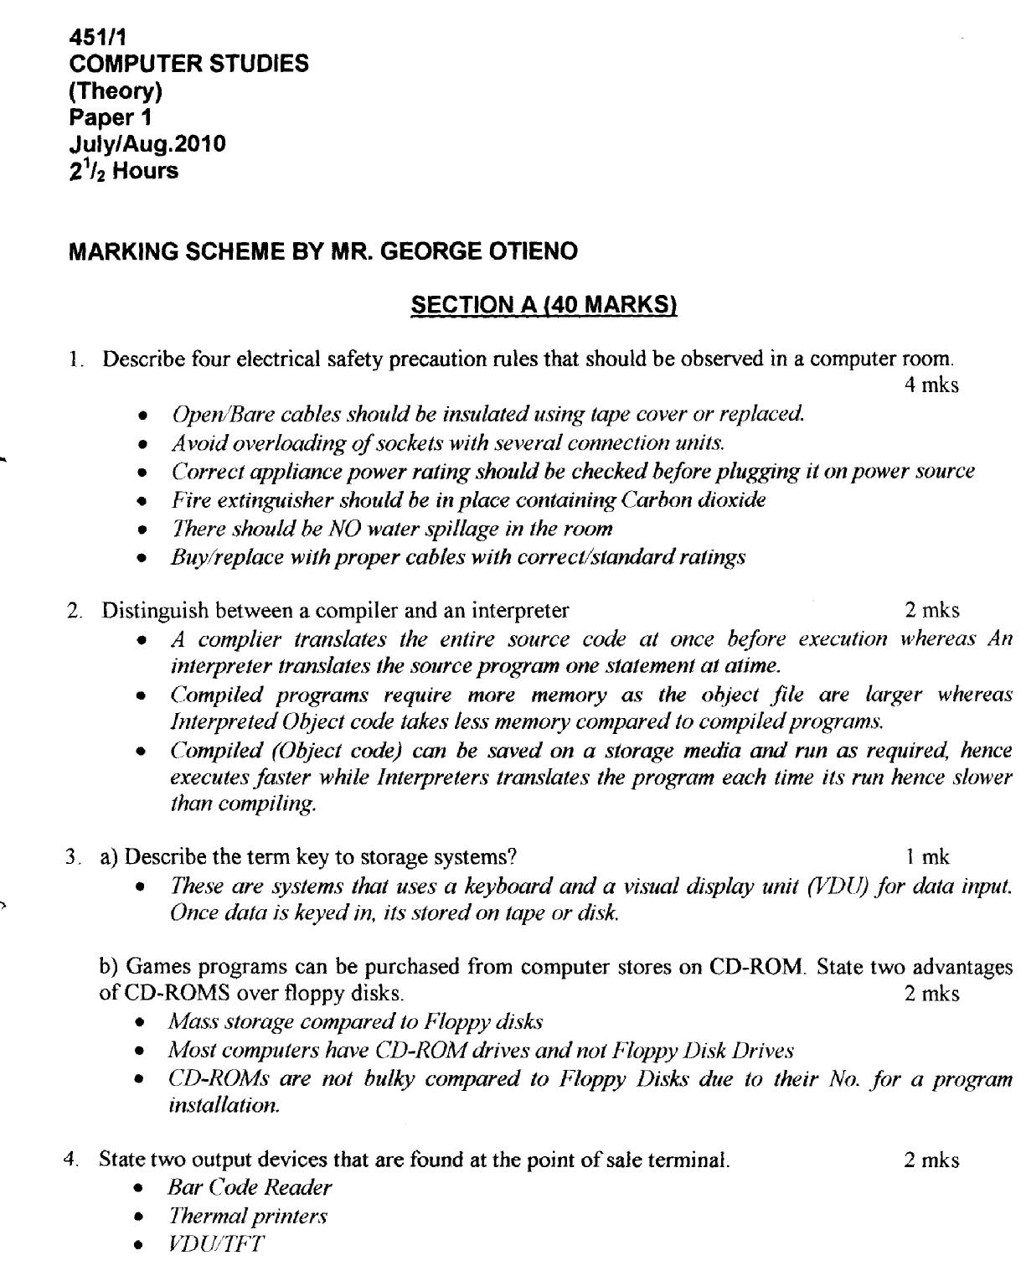
*KSM*

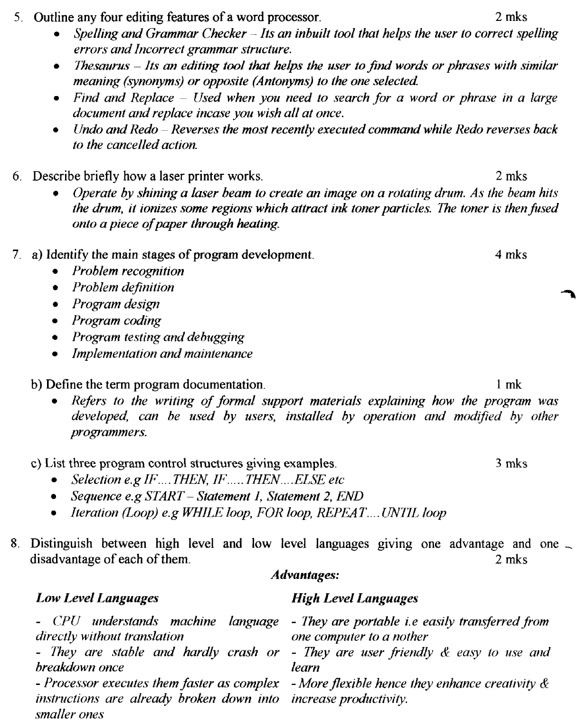

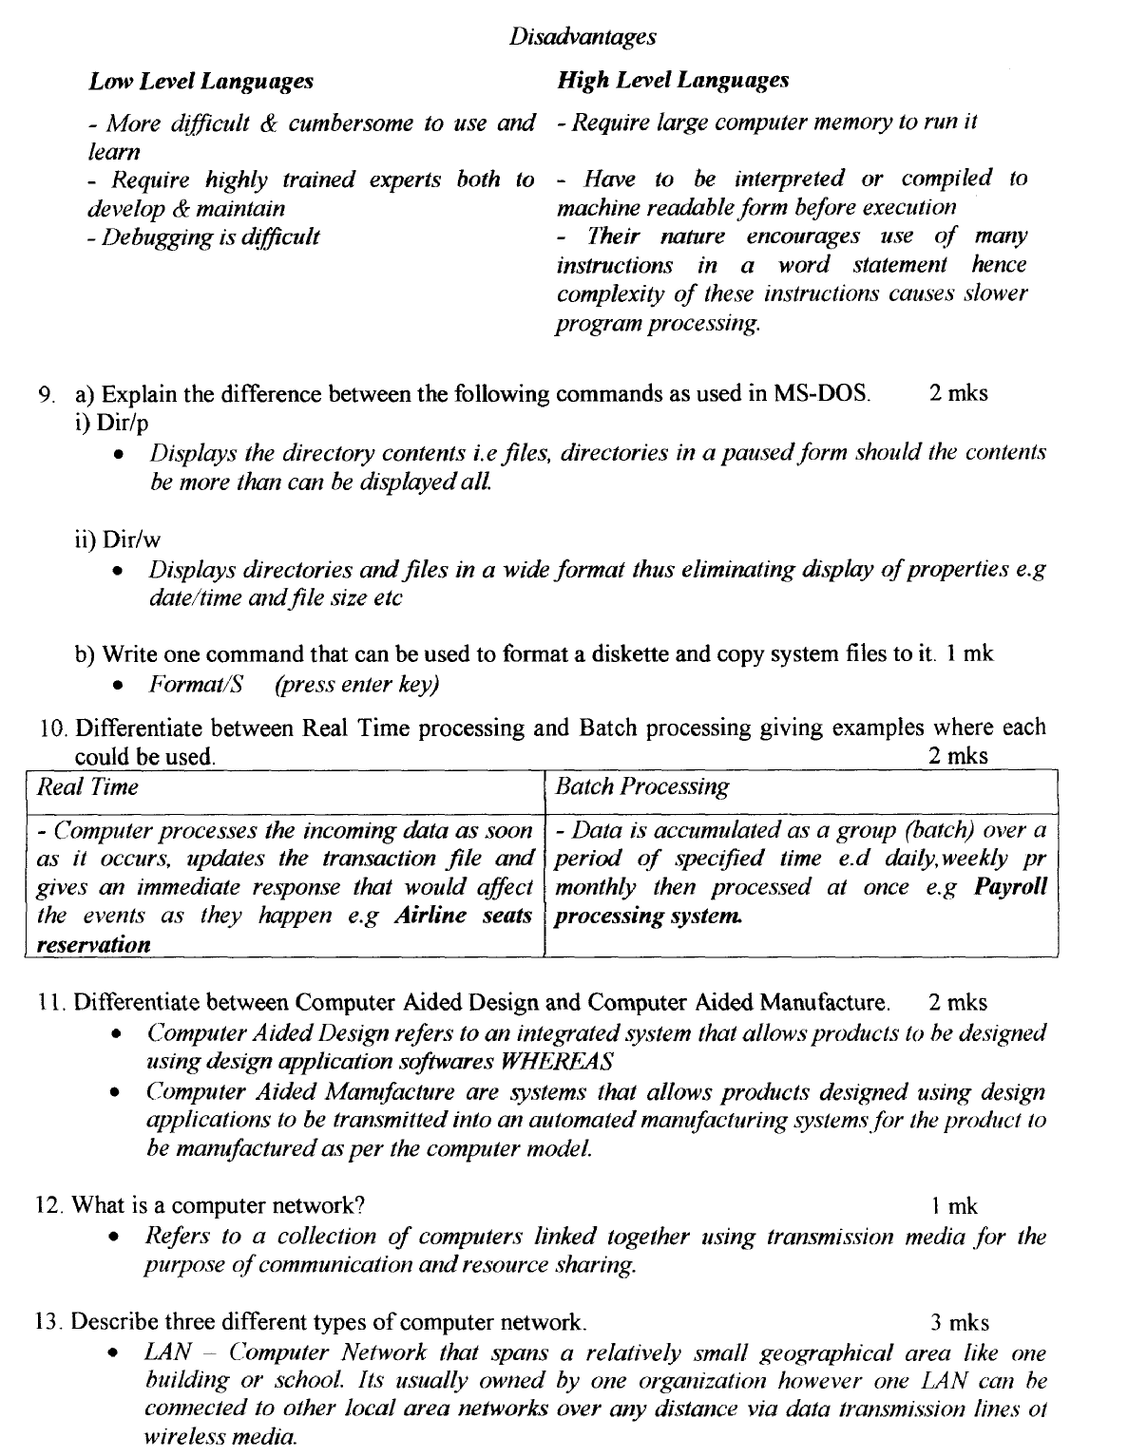

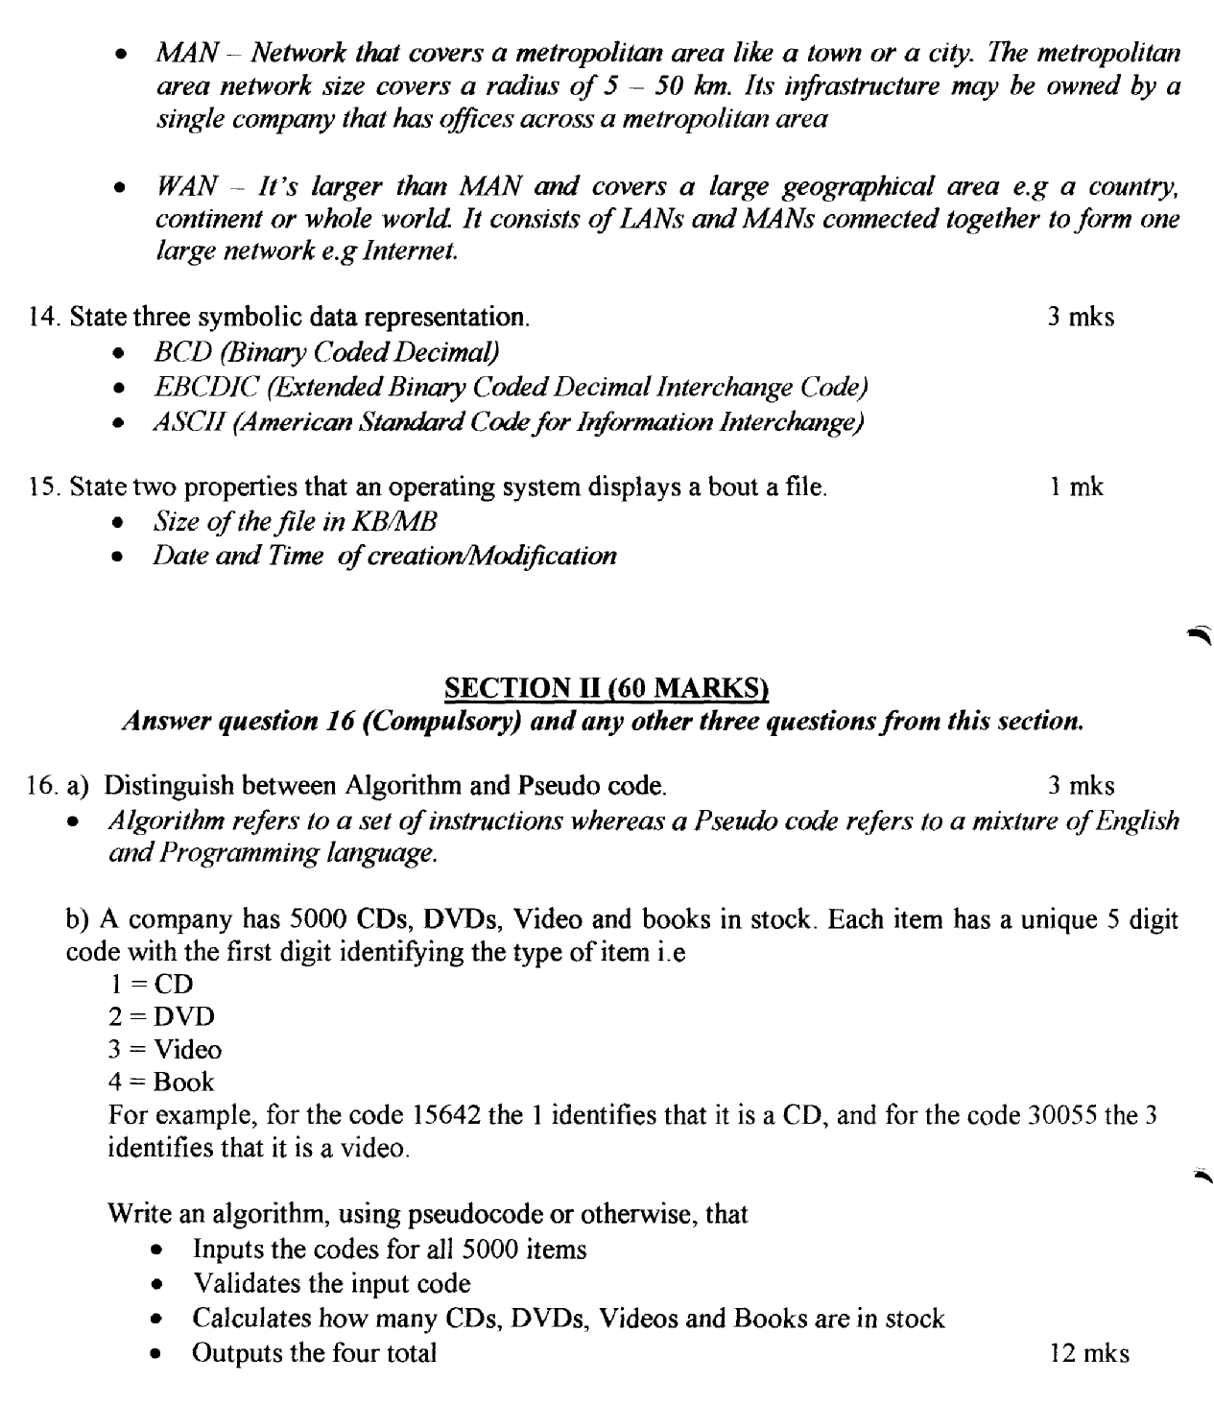

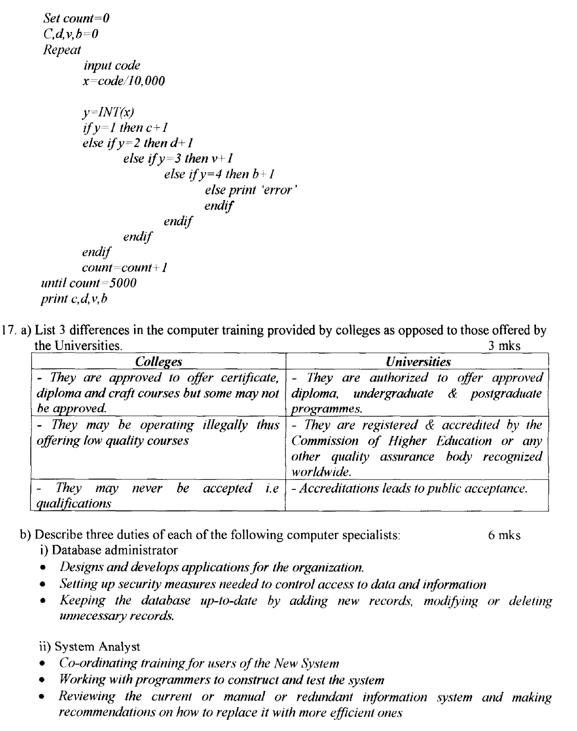

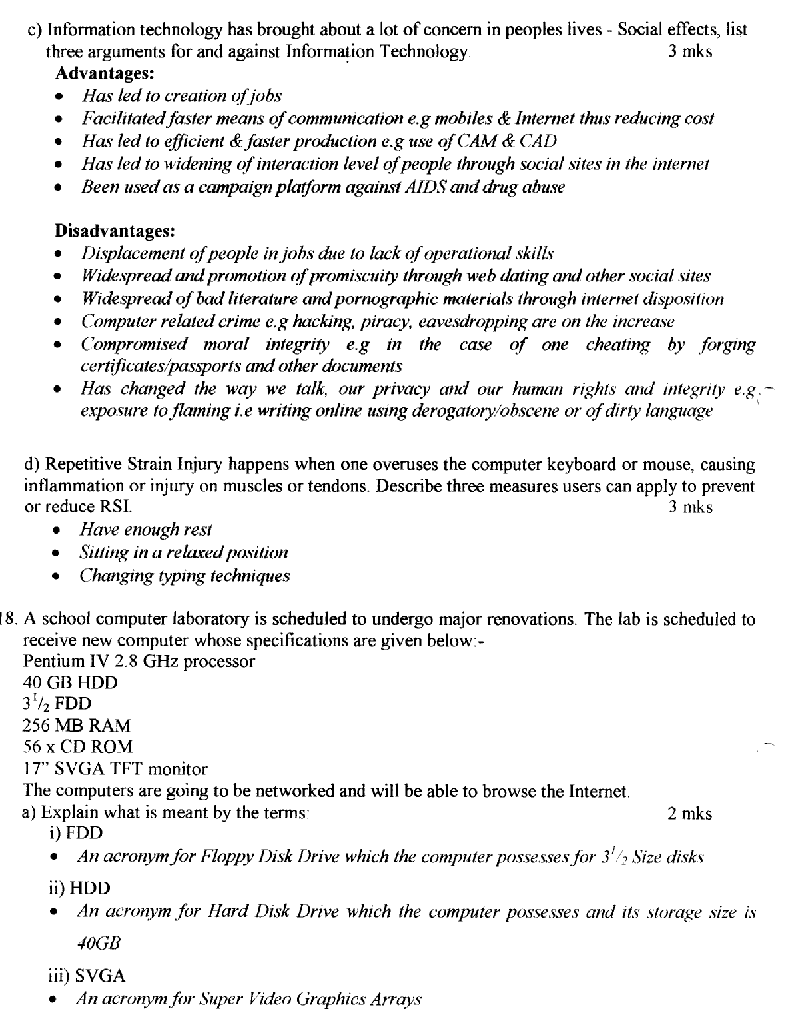

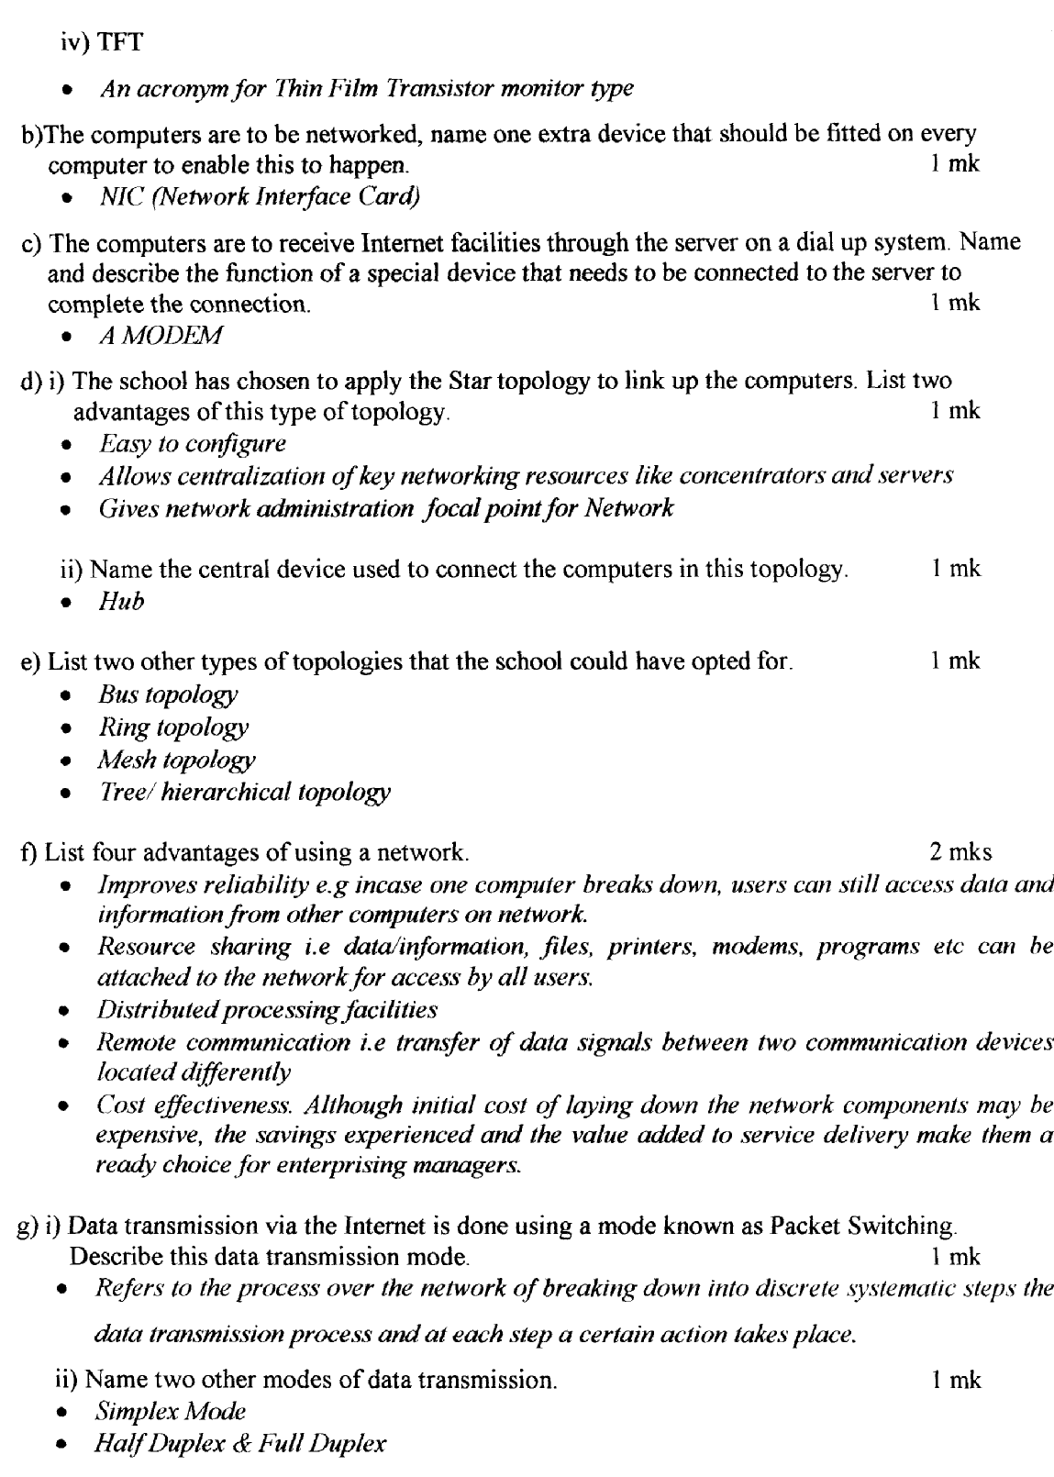

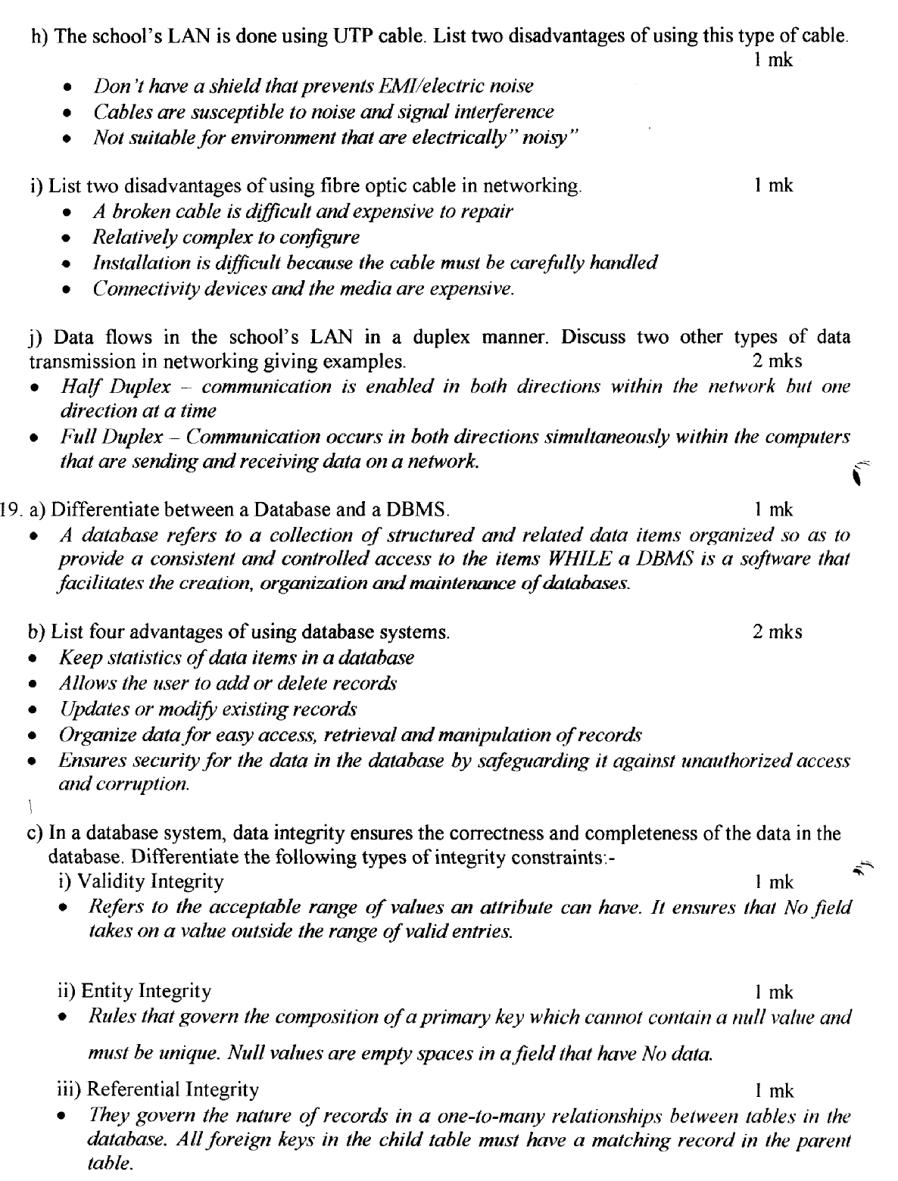

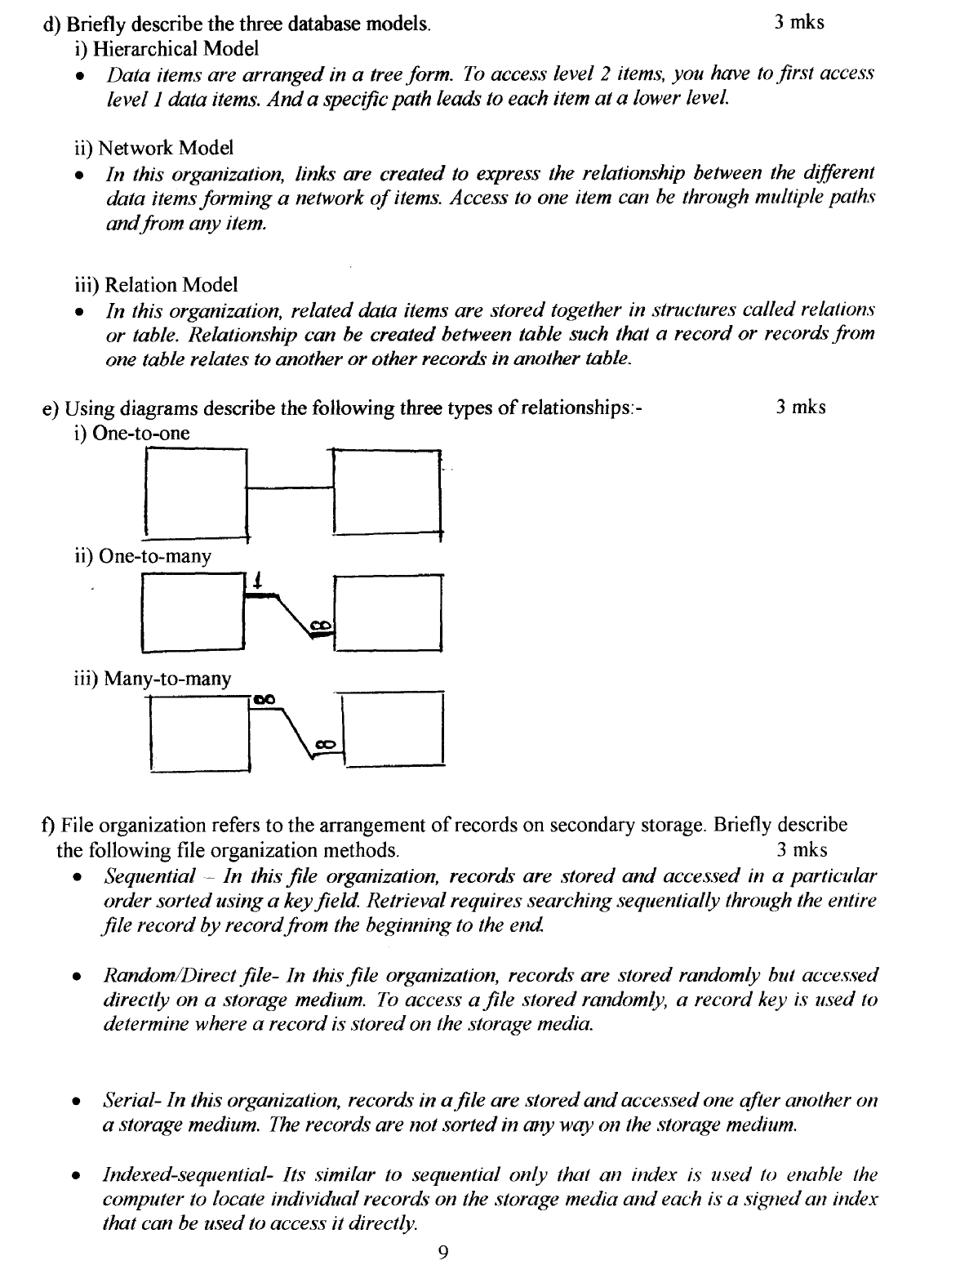

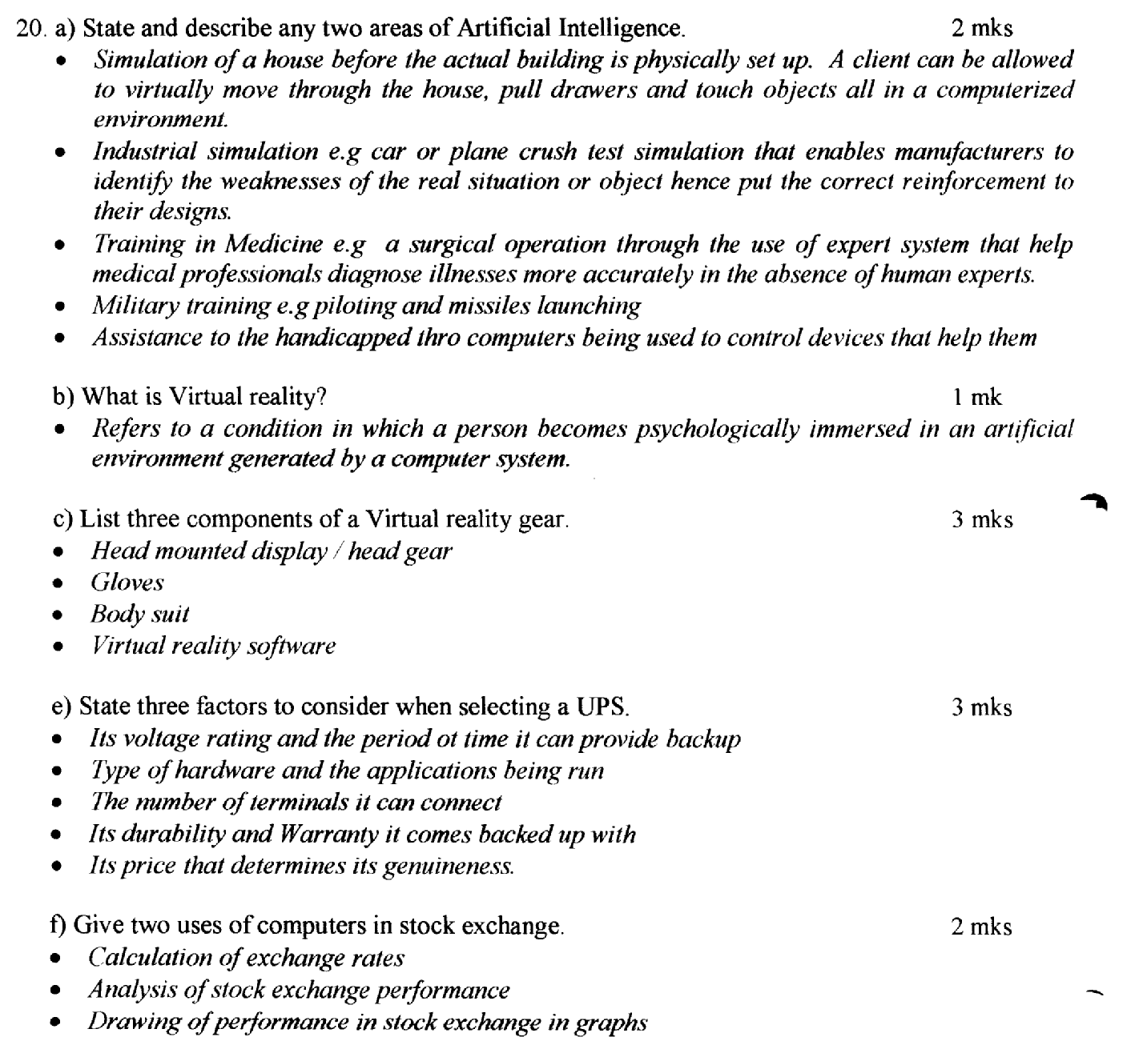

**PAPER TWO
*NYR*

The question tested the candidates’ ability to do the following in a database
    - award full marks for a created database with three tables bearing all the fields (3x4=12mks)
    - (b) Award 1mk for each idenitifed primary key fields in each table (1x3=3mks)
    - Award 2mks for each established relationship between the three tables (2x3=6mks)
    - Award 3mks for the records in each tacle (3x3=9mks)
    - Award 1mk for each identified field in the querry i.e customer Name, Product Description, Quantity, Unit price and calculated field total payable by each customer and 1mk for saving with appropriate name.(1x6=6mks)
    - Award 5mks for a clearly generated report (5mks)
    - Award 1mk for the printed customers, products, transaction tables designs, querry and the report

*MUM*
1. a) text typed as indicated (26 mks)

b)
- Bolditacing (1 mk)
- Italics (2 mks)
- Justification (2 mks)

c) i) Columns (6 mks)

d) i) Double spacing (2 mks)
ii) Searching and replacing (2 mks)
iii) saving the document as A: NET 4 (2 mks)

e) i) Animated title (2 mks)
ii) Landscape orientation (3 mks)

f) Printing NET 1, NET 3 and NETS (3 mks)

2. a) Availability of database with all fields (8 mks)
b) Availability of all records (12 mks)
c) Addition of data field (3 mks)
d) Information entered as indicated (5 mks)
e) Start 2 sorted in descending order (6 mks)
f) Query indicating items delivered by Shah on 15/5/2001 (8 mks)
g) Tabular report (4 mks)
h) Print outs: start 1, start 3, query 1 and report 1 (4 mks)

*TNW*

Index No:____________________ |  |  |  | Index No:____________________
Item | Max score | score |  |  | Max score | score
Page Setup |  |  |  | A. - database file created | 1
Font-Arial | 1 |  |  | - File saved as Business | 1
Font size 12 for text | 1 |  |  | B. - Two tables created | 1
Left margin 1" | 1/2 |  |  | - 4 Correct fields for table 1 | 4
Right margin 0.5" | ½ |  |  | - 5 Correct fields for table 1 | 5
Top 0.5" | ½ |  |  | C. Seller details form
Bottom 0.6" | ½ |  |  | - 4 fields @ 1/2 mk | 2
Headings |  |  |  | Vehicle details form
H1 |  |  |  | - At least 4 fields @ 1/2mk | 2
Bold | 1 |  |  | Forms titles
Centered | 1 |  |  | - Seller details form | 1/2
Font size - 20 | 1 |  |  | - Vehicle details form | 1/2
1st Paragraph |  |  |  | D. Table 1
Two columns | 1 |  |  | - 5 correct records @ 1mk | 5
Word art | 1 |  |  | Table 2
Words complete | 1 |  |  | - 10 correct records @ 1mk | 10
Word art diagonal | 1 |  |  | E. Query
Two symbols @ 1/2mk | 1 |  |  | 4 correct fields @ 1/2mk | 2
Subscript | 1 |  |  | - Correct criteria | 1
2nd Paragraph |  |  |  | - 6 records @ 1/2mk | 3
Complete text | 1
Drop cap | 1 |  |  | F. - 10 correct values for new prices @ 1/2mk | 5
In margin | 1 |  |  | Report
3 lines drop | 1 |  |  | G. - 5 fields @ 1/2 mk | 2 1/2mks
3rd paragraph |  |  |  | - Correct total amount | 1
H2 |  |  |  | - saved as report | 1/2
Bold and size 14 | 2 |  |  | H. Printing
Italic | 1 |  |  | - Seller details table | 1
4 bullets @ 1/2 | 2 |  |  | - Vehicle details table | 1
Italicized text | 1 |  |  | - Report | 1
4th Paragraph |  |  |  | TOTAL
3 columns | 1
Clip art | 2
Word art | 2
Clip art/Word art psn | 1
5th paragraph
H3
Bold and size 14 | 2
Italics | 1
Drop cap | 1
3 lines drop | 1
Bold text | 1
Italicized text | 1
B. i) Paragraph copied | 1
ii).Hanging indent | 1
iii).- Double space | 2
- Landscape | 2
C. - Name | 1/2
- Index | 1/2
D. Word count
- Words(376+/- 2) | 1
- Characters(With spaces)21,660 +/- 2 | 1
- Characters(no spaces)1,800 +/- 2 | 1
E. - Paginated doc x of y | 1
- Top | 1/2
- Center | 1/2
F. Doc saved as Bono2 | 1
G. Printing Bono2 | 1
TOTAL

WE MUST STRIVE FOR GREAT THINGS IN LIFE

Apart from being famous
one should leave legacy that speaks for years. Paul Hewson was in Nairobi recently. That won’t mean much to you, until I explain that I was referring to Bono, the world – famous lead singer of rock band U2 and campaigner against global poverty. Bono didn’t really make much noise while in Kenya. He attended the ⎣Nation Media⎦ group’s Pan Africa Media Conference, took H₂o, talked to a couple of journalists and left.

He didn’t do the other things that visiting celebrities of his stature do when in Africa: adopt a cheetah or a baby hippo, start a school for orphans, shoot the breeze pointlessly with Emilio and Tinga, utter banalties about the girl child. Bono reserves his energy for other things.
Popular Media
Bono is not famous just for being a singer. For the past couple of decades he has been one of the most visible humanitarian activists, using his fame to enlist powerful allies from:
- Government
- Religious institutions
- Philanthropic groups
- Popular media and
- The business world.
He has personally spearheaded the campaign for debt relief for the world’s poorest countries, and has been a vocal champion for Africa. Not everyone agrees with these efforts. Author Paul Theroux savaged Bono, Bob Geldof and other celebrity humanitarians, saying that creating “the impression that Africa is fatally troubled and can be saved only by outside help – not to mention celebrities and charity concerts – is a destructive and misleading conceit.”
AID FROM EUROPE

I happen to agree with that view and have propagated it in writing for many years. I don’t
think Africa’s salvation will come from outsiders,

and it certainly won’t come from endless handouts and a crippling dependency culture.

On Trivia

What about you? How big is your life? Are you allowing your time on earth to be frittered away on trivia, or are you going to make a net positive impact on the planet? Are you doing something, anything bigger than yourself? Are you raising
a child to be a better person than you are? Are running a business or conducting a profession that sets a standard in good practice? Or are you content to be a small person imprisoned in a small life?

He has personally spearheaded the campaign for debt relief for the world’s poorest countries, and has been a vocal champion for Africa. Not everyone agrees with these efforts. Author Paul Theroux savaged Bono, Bob Geldof and other celebrity humanitarians, saying that creating “the impression that Africa is fatally troubled and can be saved only by outside help – not to mention celebrities and charity concerts – is a destructive and misleading conceit.”

*KKC*
Question One.
A. 1. (A) Complete typed letter 7mks
Single error ½ mk
More than 6 errors 5mks
- Saving main document
Using correct name 1mk
Using any other name ½ mk
- Saving data source list
Using correct name 1mk
Using any other name ½ mk
- Changing the Font Size, address and reference to 14 pts
Changing each address ½ mk
Changing reference ½ mk
iv) Underlying reference ½ mk
v) Merging Data source to the main document
- Each filed at the right position. ½ mk
- Each filed at any other position. ½ mk

vi) Print the letters
Each (1X3) 3mks
B
a) –Aligning title to the centre ½ mk
underlining title
b) – Adding border to the title ½ mk
c) - Replacing all remain number with bullets
- Not replacing one -½ mk
- Not replacing more than 3 (0mks)
d) i) Inserting the correct footer 2mks Any other footer 1mk
ii) Inserting the correct header. 2mks
Any other header 1mk
e) - Line spacing of 1.5
-Line spacing other than Single
f) Inserting word Art “computer” and not placing at the behind of text. 2 mks
g) - Replacing “computer” with “PC” 2 mks
- Replacing but not all words “computer” ½ mk
h) Moving whole paragraph to end of document. 2 mks
i) Font style set to Aerial Black. 3mks
j) Saving with correct name other than document N ½ mk Using document N 0mk
k) Printing the document currently 2mks
Printing off page ½ mk

Question 2
- Saving the workbook with correct name 1mk
- Using a different name
- Using default name book n no mark ½ mk
- All data entered correctly 20 mks
- Every wrong entry ½ mk
- More than 6 wrong entries -8mks
- Renaming the sheet to “term one result”
- Default name sheet, No mark
- i) Correct totals and formula 2mks
ii) Correct averages and formula 2mks
- Manual calculation no mark
- Correct use of IF function to attain 3 conditions (1X3) 3mks
- i) Correct formula and ranking
ii) Correct use of the “count IF” function (1X2)2mks
- – Sorting list of class position in ascending order 2mks
- Sorting list by classes position in descending order 1mk
-No sorting, no mark
h) i) Copying to new worksheet and renaming the new worksheet 2mks
ii)Filtering the “lower group”
  - Display students from “E” class
  - Students with average less than 50 4mks
  - Filter shows a all students from E class
  - Filter shows all students with average less than 50 2mks
i) i) – The chart is
- A bar graph
- Show 3 cats
- Shows names of students
- Title is TERM ONE COMPUTER RESULTS 3mks
- Missing a point -½ mk
ii) Legend placed at the bottom of chart. 1mk
iii) Saving chart on a new sheet and renaming the sheet graphical analysis. (½ X2) 1mk
- Saving chart as an object on the worksheet. ½ mk
- Printing
i)The lower group from “E” class 1mk
ii)The chart 1mk
iii)Term one results sheet 1mk

