ART & DESIGN
PAPER ONE
*MUM*
1. a) Define the term “Grog” (1 mk)
b) Explain any two uses of grog (2 mks)
b) Explain the meaning of the term simultaneous colour contrast (2 mks)
c) In the spaces below, illustrate how wax is boiled in a double container in batik (2 mks)
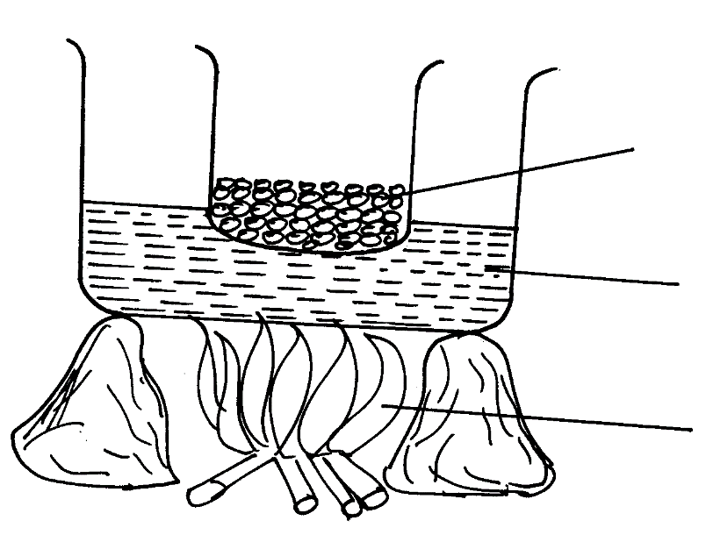
Wax
Water
Source of heat

Explain two reasons for boiling wax in a double container during the batik process (2 mks)
d) Differentiate between a picture plane and a picture frame (2 mks)
e) Explain what happens during “Glost firing” (1 mk)
f) Outline the purpose of a roller in printing (2 mks)
g) With the use of an illustration show the ³/₁ twill weave (2 mks)
h) Mention the term used to describe clay that is completely dry and ready for firing and it can
no longer be worked on. (1 mk)
i) Explain how brushing is done. (1 mk)
j) Explain any four advantages of modeling over carving. (2 mks)
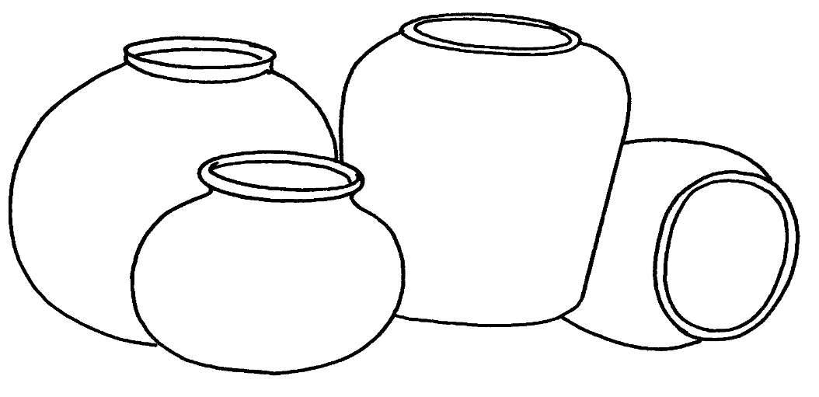
2. Using a biro pen/ ink pen and the cross hatching technique, shade the composition below (5 mks)

3. a) Define the term “Kiln” (2 mks)
4. Illustrate a half drop repeat pattern using a motif derived from nature in the space below (5 mks)

5. Study the picture below
Analyse the picture under the following concepts
a) Format (2 mks)
b) Style (2 mks)
c) Technique (2 mks)
d) Theme (2 mks)
6. In the spaces below; illustrate the word “worm” in upper case, worm’s eye view, downward
left, in three dimensions. The letters should be 4cm in height (3 mks)
7. Instead of varnish, what other material could be used to block the screen in screen printing(2 mks)
8. a) Define and explain two uses of ‘slip’ (2 mks)
b) Distinguish between earthenware and green ware (4 mks)
c) State and explain the step by step procedure of preparing clay (8 mks)
9. a) Define the term ‘design brief’ (1 mk)
b) What is a caption? (2 mks)
c) Define the term ‘animated cartoons’. (2 mks)
d) Discuss the graphic design problem solving process (10mks)
10. a) Define the following terms; (3 mks)
i) Jewellery
ii) Ornaments
iii) Ornamentation
b) Name any two techniques of making ornaments (2 mks)
c) Using illustrations explain the process of making a strung bead necklace (10mks)

*KKE*
1. Study the illustrated marks below:
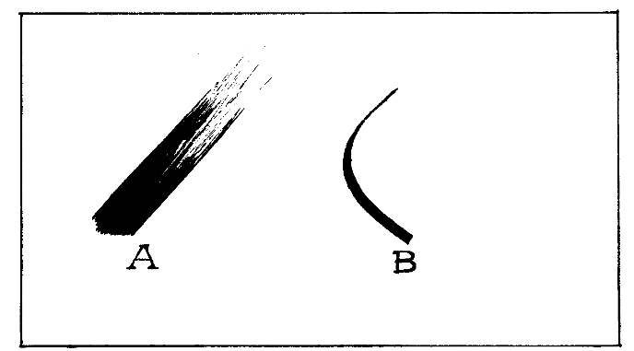

a) Identify lines A and B on the illustration and state the media used for each (3mks)
b) State one way in which lines can create the illusion of depth in space (2mks)
c) The drawing below shows a human figure, name the skills portrayed on the drawing and
state the tool used (2mks)

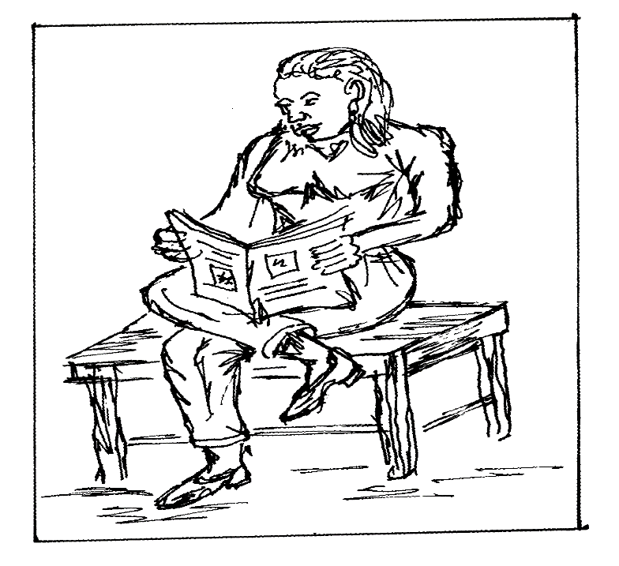

d) Explain three ways of creating Rhythm and movement in art and design (3mks)

e) Below is a drawn sketch showing a ceramic building technique
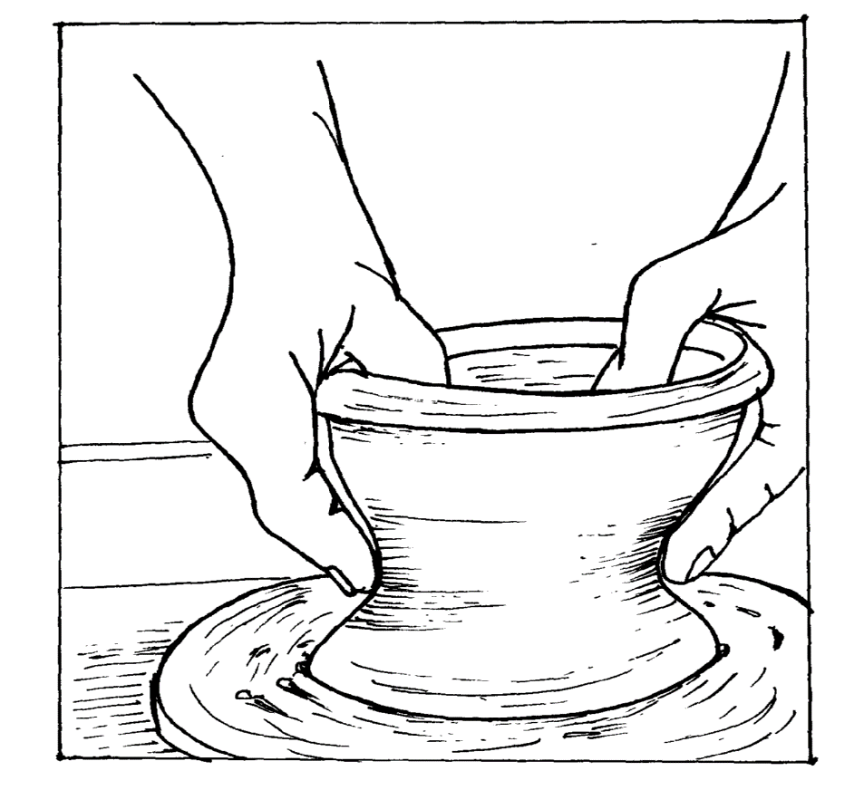

Name the methods and describe the process (2mks)
f) State three factors considered before constructing a sculpture in the round near your
school gate
g) Identify three sources of motif used in fabric decoration (3mks)
h) Explain the main reason why a lino block is sanded before using it is printing process (2mks)
i) Distinguish between open fire and closed fire in pottery (2mks)
j) Study the drawn illustration below and answer the questions that follow:

Identify the technique used in preparing the picture and state its function (2mks)
2. The structure below shows a type of perspective
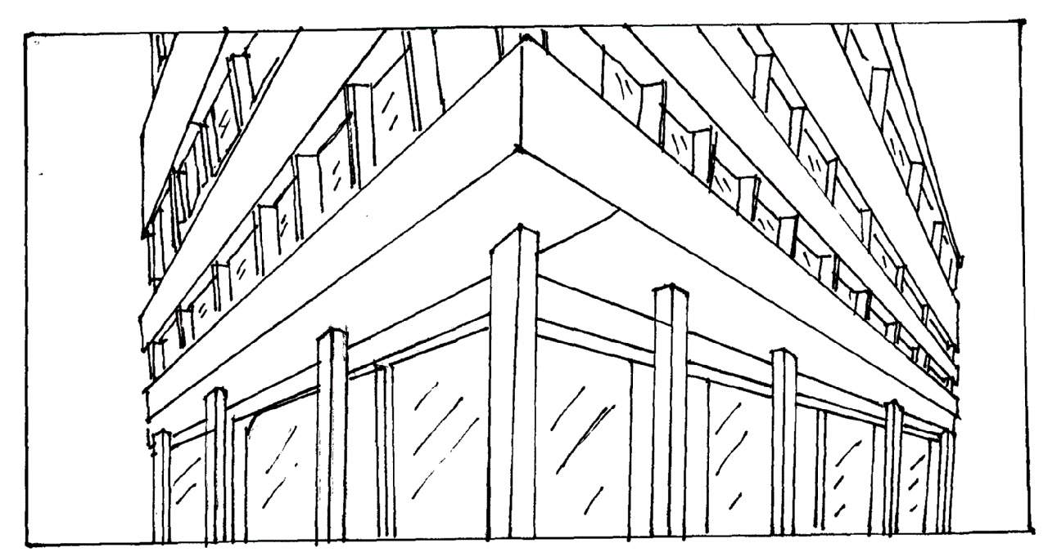

a) Identify the eye view shown and state its main characteristic (3mks)
b) Indicate and describe the diminishing points for the structure (2mks)

3. By giving appropriate illustrated examples for each; differentiate between a monogram and a logo
gram, used as identification symbols (5mks)
4. Study the drawn example of the tie and dye fabric which is ready to be dyed

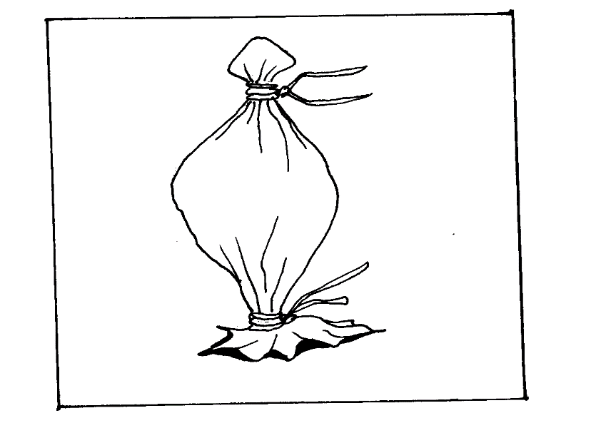

a) In the space provided below, draw the resultant dyed fabric pattern (2mks)
b) State three major functions of a dyed fabric (3mks)
5. Describe the following terms as used in painting:
a) Analogous colour (1mk)
b) Secondary colour (1mk)
c) Tertiary colour (1mk)
d) Subjective colour (1mk)
e) Objective colour (1mk)
6) State two characteristics of letter forms and use the word ‘CART’ to illustrate an example
for each, in the space provided below (5mks)
7. a) Study the artwork in A and B below

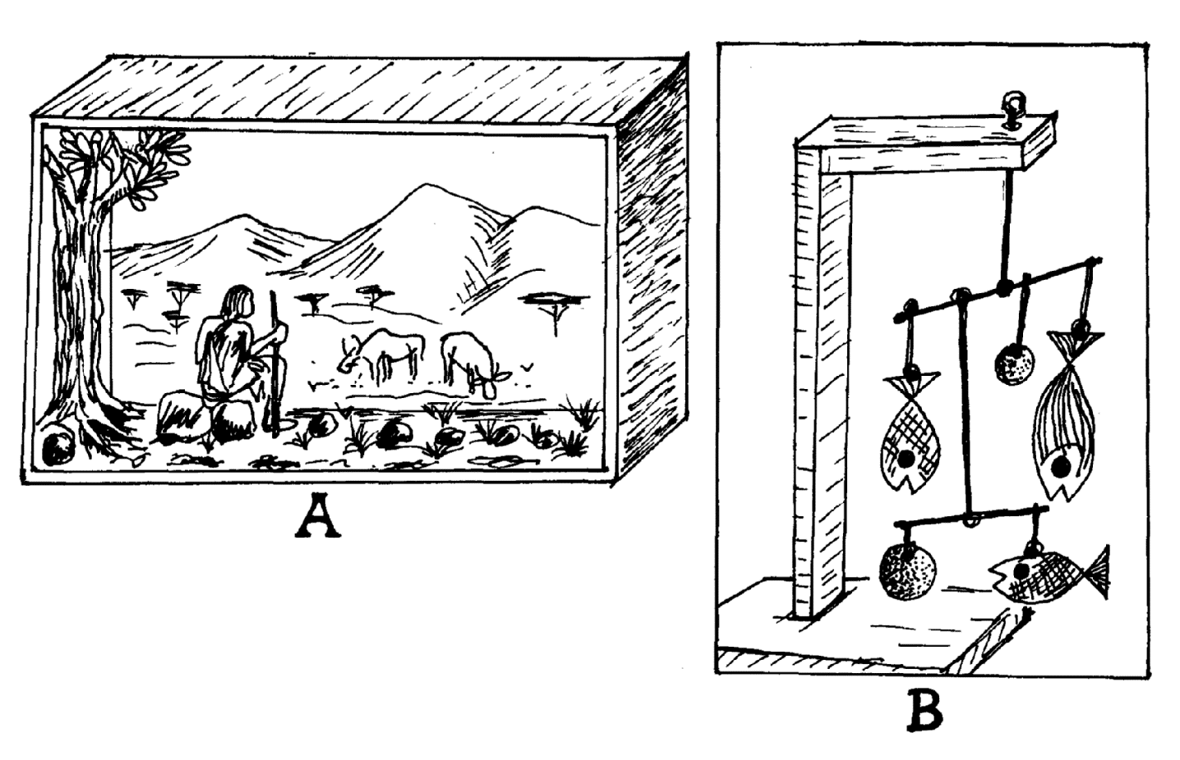

Name the type of work in A and B respectively and state their functions (4mks)
b) Distinguish between the two constructivism (2mks)
c) Using appropriate illustrated examples, explain the process of preparing a block plaster
which is then carved into a sculpture (9mks)
8. a) Explain ‘registration marks’ with reference to definition and function (2mks)
b) By use of appropriate sketches, explain three major ways of making a design onto the screen
to be used for printing (13mks)
9. a) Define a trade mark and explain its function (2mks)
b) Explain the three layouts stages used in graphic design (6mks)
c) Describe the main characteristics of an emblem, giving illustrated examples for each (7mks)

*RCH*
1. a) Why is symmetrical balance undesirable in a pictorial composition? (1mk)
b) Name at least considerations in designing personal ornaments. (1mk)
c) Differentiate between sculpture in high-relief and in intaglio (1mk)
d) State two visual differences between collage and mosaic (2mks)
e) Name the primary and secondary sources of colour 1mk)
f) What is simulated texture in painting (1mk)
g) Define the following terms:- i) Colour contrast ( ½ mk)
ii) Balance (½ mk)
h) Give two advantages of quick sketching (2mks)
i) Identify the three commonly used approaches to painting (3mks)
j) Define the following terms used in printing process (3mks)
i) Relief printing
ii) Lithography
iii) Intaglio
k) Define the term Logo (1mk)
l) Describe the two types of shape as used in art and design (2mks)
m) Define the term layout in graphic design (1mk)
2. a) Define the term ‘value’ (1mk)
b) State two techniques of creating value on a surface (1mk)
3. Explain the difference between carving and modelling as techniques used in sculpture (2mks)
4. a) Why is it necessary to wedge clay before using it for ceramic work (2mks)
b) What’s the most appropriate way of keeping clay in the right moisture for a long time (1mk)
c) Name and explain briefly the three qualities of good clay (3mks)
5. a) Define the term dominance (2mks)
b) Explain four techniques of creating dominance in a composition (8mks)
6. a) Define fabric decoration . (1mk)
b) Name and explain 6(six) functions of decorated fabrics. (9mks)
7. a) List five methods used in the production of ceramic pieces. (2 ½ mks)
b) Explain how traditional potters fired their ceramic pieces . (7 ½ mks)

*KSM*
1. Art and design contribute immensely in all area of the society specify 5 areas you know the society benefits from art and design (2½mks)
2. Illustrate the following elements of art and design in the space provided below (1½mks)
(i) Lines shading motion (ii) value (iii) texture

3. What is the difference between drawing and painting in art and design (½mk)
4. Identify the principal illustrated below: (1mk)
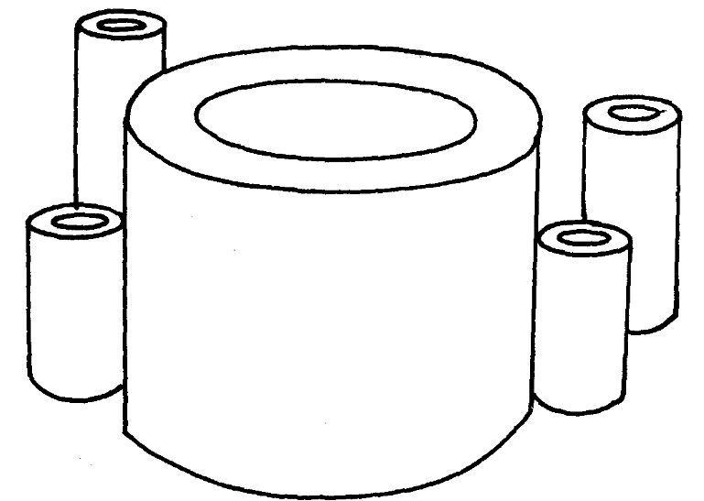

5. In the space below draw the typographical illustration of any alphabet and show the
(i)SERIF (ii) SANSERIF (1mk)

6. What are the characteristics of letter forms (3mks)
7. What is the difference between ornamentation and weaving (2mks)
8. List down four methods of decorating ornaments (2mks)
9. Illustrate the following design layouts in graphic design (1 ½mks)
(i) SYMMITRICAL LAYOUT (II) ASSYMETRICAL LAYOUT (iii) RADIAL LAYOUT

10. What are the differences between a logo and a monogramme? (2mks)
11. Illustrate the following visual symbols in the spaces provided below (1mk)
(i) Sports symbol (ii) Road sign

13. a) In the space below make a sketch and a complete work of a composition of a lady carrying
a tray of bananas on her head with a lesso tired around her waist (5mks)
b) Design a monogramme with an illustration for a company called “VIATU POA COMPANY”
in the space provided below (3mks)
c) In the space below draw:
i) One point perspective (1mk)
ii) Two point perspective
d) i)Name five building techniques in pottery/ceramics (5mks)
ii) List down the two methods used in the firing of pottery items (2mks)
iii) Name three methods of decorating pots (3mks)
e) i)What is a cartoon? (1mk)
ii) Draw a 4 strip cartoon with a political theme of your own choice-in the space provided
below
f) Differentiate tie and dye from batik as techniques of fabric decoration (2mks)

14. a) What is the difference between modelling technique and construction technique in sculpture
b) Name the three sculpture technique employed in the construction of sculptures
c) Naming the principals of sculptures and with an illustration explain how you can create
sculpture in the mound with the theme birds in fight, name the tools and materials for
the same
15. a) What is serigraphy?
b) Explain how you can produce a motif on fabric using the silk screen printing technique in
the colours, the fabric will be used for sewing a dress of shirt or short for casual use.

16. a) i) What is a critique in art and design?
ii) What s mounting in picture presentation?
iii) What is framing in picture presentation?
iv) Using a picture illustrate the following picture presentation

a)MATT MOUNTING
b)WINDOW MOUNTING

17. Mention the tools and materials explain with the aid of diagrams how you can create a
design on a fabric in two colours using tie and dye technique combined with batik technique.

*TNW*
1. a) State two textured effects that can be produced in a batik (2mks)
(b) Explain balance as an attribute of pictorial composition in painting (2mks)
(c) Name two artists that are associated with the development of cubism style in painting (1mk)
(d) Explain the following terms:
i) Hue (1½mk)
(ii) Colour chroma (1½mk)
(e) What is meant by the term armature in sculpture? (2mks)
f) Which technique in sculpture can be used to produce identical items? (1mk)
g) State four hand building techniques used in ceramics (2mks)
h) What is a mono print? (1mk)
i) If all primary colours are mixed, what is the result? (1mk)

2. Differentiate between collage and photomontage (2mks)
3. (a) Name and explain the three qualities which good clay should have (1½mks)
(b) State two used of a rigid heddle in a rigid heddle loom (2mks)
4. (a) State that difference between an emblem and a logo (2mks)
(b) state the four main components of design brief (2mks)
5. Draw a portion of a woven mat and a twined basket to show the difference in their structures (3mks)
6. Use explanations and diagrams to show linear perspective (3mks)

7. Describe the process of executing a two colour tie and dye decorated fabric.
8. What do the following terms mean in pottery?
(a) Plasticity
(b) Wedging
(c)Press mould
(d) Slaking
(e) Glaze
9. Explain the following processes of modeling;
(i) Centering
(ii) Hollowing
(iii) Pulling up
(iv) Shaping

*UGU*
1. (a) Name and explain the method in fabric decoration in which stitching is used as a resist
technique (2mks)
(b) Name the technique of rubbing a smooth object against a leather hard ceramic article to
make it shiny (1mk)
(c) What is colour chroma ? (1mk)
(b) Explain frottage as a printing technique (1mk)
(e) Define printing (1mk)
(f) How do you obtain a secondary colour? (1mk)
Give an example
(g) Define analogous colours (1mk)
(h) Explain the difference between ornaments and jewellery (1mk)
(i) What was the major subject matter in the rock art painting? (1mk)
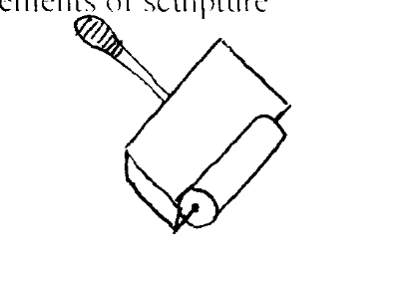
(j) State any two elements of sculpture (1mk)
(k)

(i) Identify the above tool (1mk)
(ii) Identify the specific technique where it is used (1mk)
(l) What is the most distinguishing characteristic in a mosaic art form? (1mk)
(m) Identify any two elements of graphic design (1mk)
(n) State the difference between product design and communication design (1mk)
(o) Define the term calligraphy (1mk)
(p) What is the importance of the following items in printmaking:-
(i) Shellac in screen printing (1mk)
(ii) Water in lithography (1mk)
(iii) Acid in gravure (1mk)

2. Draw and label a rigid heddle loom (5mks)
3. In the space below draw a line illustration to depict the following words. “Refreshingly cool”
4. (i) Define spinning (1mk)
(ii) In the space below make a drawing to illustrate:
(i) Twinning technique (2mks)
(ii) Slit tapestry technique (2mks)
5. Draw the following illustrations :
(i) Sleepy eyes (2½mks)
(ii) Laughing eyes (2½mks)
6. Use a biro or pen and ink to create a portrait in silhoutte (5mks)
7. (a) Define the following terms in sculpture:
(i) bas relief (1mk)
(ii) Intalgio (1mk)
(iii) Mobile (1mk)
(b) Using wood, explain how you would produce a sculptural form in the round using the
carving technique (12mks)
8. (i) Define serigraphy (1mk)
(ii) Identify the two branches of serigraphy (2mks)
(iii) Using two block printing technique, explain how you would produce printing on a
paper in two colours (12mks)
9. (i) Define pottery (1mk)
(ii) Identify any two decorative techniques in pottery (2mks)
(iii) Describe the process of producing a flower vase in clay using the coiling method.
Use illustrations appropriately (12mks)

PAPER TWO
*MUM*
ALTERNATIVE A: DRAWING/PAINTING
Either
1. Draw composition based on the extract below:
Owino and Njeri entered the sitting room as Opiyo, his father was coming down the stairs. He looked at the couple in shock. Njeri covered her mouth with her hands. She too was in shock. Owino became confused. This is the day Owino had chosen to introduce his fiancée to his family.
‘Eh, is this the girl you want to marry?’ Opiyo said in shock.’ God, I must be dreaming. This cannot be, it can’t be true. Njeri, what are you doing with my son? Didn’t you tell me you have no man in your life? You will pay for this.’
Hell broke loose. Father and son were at each others’ throats as Opiyo’s mother got hold of Njeris’ long hair. It was quite a scene.
The work should be done in an area measuring 35cm by 45cm.
Or
2. Paint a composition from imagination based on the theme,
The animals have their sports day.
The composition should measure 35cm by 45cm.
ALTERNATIVE B: GRAPHIC S
Either
3. Tot Spot is a company that sells baby and infant clothing. The company requires designs of a logo, a newspaper advertisement and a carrier bag
In three colours design the logo in an area measuring 10cm by l0cm,the news ad measuring 15 cm by 20 cm and the front face of the carrier bag measuring 25cm by 25cm.
Or

4. Design a book cover titled ‘Kenya, a sporty Nation’. The book is authored by Adonija Kespona,
published by Moon and Stars publishers and will go at a selling price kshs. 1000. The book should be designed in three colours and should measure 25cm by 15cm with a 2cmwide spine.

*KSM*
ALTERNATIVE A - DRAWING/PAINTING
You are remained the use of rulers and other mechanical means is FORBIDDEN in this alternative
EITHER
1. Make an interesting composition from ONE of the following items work in tonal value in a technique of your choice i.e. cross hatching, shading dotting or a wash in a medium of your choice
a) Fruits in a basket
b) A gourd, calabash and pot
c) A bunch of bananas or a sack
d) A cow resting
OR
2. Using pen and ink or pencil or paint depict a creative scene from memory or imagination of two monkeys hanging on a branch of a tall trall

ALTERNATIVE B: GRAPHIC DESIGN
The use of rulers, tracing paper and other mechanical means is ALLOWED in this alternative
EITHER
3. a) Rewrite the verse shown below in improved calligraphy on a size A4 paper with an illustration
b) Using 3 colours design a badge to be used by “CYAN GIRLS SCHOOL” whose motto is “let’s step forward”. The work should cover 10cmx15cm
OR
4. A firm known as COLD FISHERIES dealing with export and import of fish required a logo/logogramme which will be used on all its products, stationeries, briefcases and delivery vans. Using not more than three colours produce a design for the logogramme on a size A3 paper with an illustration

*RCH*
ALTERNATIVE A: DRAWING OR PAINTING
1. Depict in colour or pencil a model having leisure walk with a dog at the beach (make
imaginative composition)
2. Draw or paint a composition based on the statement below
“The market was so busy as the people tried too sell their ware to needy customers”

ALTERNATIVE B: (GRAPHIC DESIGN)
3. A company manufacturing cooking oils would like an identification symbol. Design one for them in three colours in a space of 8x5cm
-The company’s name is BANO OIL REFINERIES
4. Design a packet for a new drug uses in treating FLU and colds. The name of the drug is
VISTA
-Use 3 colours
-Use a space of 10x16cms

*TNW*
Alternative A (Drawing or painting)
EITHER
1. In colour paint an imaginative pictorial composition depicting animals gathered round the watering hole on a scorchingly hot day. The size of the composition should measure 42cm by 30cm.

2. Paint a scenery from memory based on the theme ’floods’.

ALTENATIVE B (GRAPHICS)
You are instructed that the use of rulers and other mechanical means as well as a tracing paper is
allowed in this alternative.
3. “Dine-Inn” is a small catering firm offering a special service producing meals for outside catering
and parties.
You are required to design;
(a) A poster measuring 60cm x 35cm in three colours to advertise the catering firm.
(b) A folding menu measuring 35cm by 20cm to be placed on the tables.
(i) The menu folder should include pictorial illustrations and text.
(ii) The front cover design of the menu should be in two colours.

4. Busy Bee Pharmaceuticals are launching a nation wide campaign about AIDS awareness.
(a) i) Design a pictorial poster with two relevant quotations on AIDS awareness.
ii) The words “Busy Bee Pharmaceuticals Limited” should appear on the poster.
iii) The poster chould measure 60cm x 35cm in three colurs.
(b) Design business card for the pharmaceuticals company.
(i) The business card should include the logo of the pharmaceutical company.
(ii) The business card should measure 6cm x 4cm in not more than three colours, bearing the
name of the Director.

*KKE*
ALTERNATIVE A: DRAWING AND PRINTING
Either
1. Imaginative or memory composition. Using a black biro pen or pencil or ink and pen, draw from
the description below:
‘A tax collector in a busy open market’
Or
2. Compose a picture in colour from memory based on the theme “a captivating story besides the bonfire at night”.
ALTERNATIVE B: GRAPHIC DESIGN
Either
3. Using calligraphic technique, re-write the following message, accompanied with an appropriate
illustration to support the message.

A HOUSEHOLD TIP
If the tips of your knitting needles get worn out, dip them in a nail polish and, let the polish dry, needles will be as good as new!
The illustration should be in two colours only. The dimension of the working area is 30 by 21 cm
Or
4. Design a motif derived from organic (natural) source. The motif will be used for a repeated pattern of fabric decoration meant for an aquatic firm dealing with marine plants and animals.
a) Produce a separate motif in an area measuring 10cm, in two colours.
b) Repeat the motif in (a) above in 16 units (grids) of 5 cm by 5cm to create a pattern, on a
separate space.

**UGU*
ALTERNATIVE ‘A’ DRAWING OR PAINTING
You are instructed that the use of rulers and other mechanical devices is forbidden in this alternative
EITHER
- Create a composition from either memory or imagination of a farm house. The composition should be based on the following:
In the foreground, a farm house with wooden log walls and grass thatched roof sits on a stretch of land with some scattered stones and bushes. Two animals are grazing towards the river; the herdsman is seated on a stone near the house as a woman arrives from the river.
OR
- Compose a picture to depict the tender moment of funeral activities in society

ALTERNATIVE ‘B’ GRAPHICS
- “We lead, others follow.” Incorporating the above slogan and using three colours design a poster to promote sports in Kenya.

4. The Shinda Ushinde curio shop requires a badge to identify its group. The motto of the group is “The Sky is the limit.” Design a two colour badge incorporating a suitable logo and illustration and the groups motto.

*MUM*
1. a) Already fired clay grounded into powder which is mixed with freshly prepared clay
b) i) Increase the strength of the clay
ii) Provide texture especially when using the clay for sculpture
iii) Helps prevent cracking
b) In this type of balance, the weights & attractions on each side of the axis are balanced by
elements which are not identical
c) i) To keep the wax in a molten form for long
ii) To prevent wax from catching fire
d)
e) Here the glaze transformed into a coating of glass which fuses with the clay body/ ware
thus making it impervious
f)
g) Teachers discretion
h) Bone-dry
i) By rubbing a smooth hard surface on a leather hard articule/ ware

j) a) Several exact copies can be cast in metal from the original clay model
b) Modeling materials are sensitive to the lightest touch and can be worked with
great spontaneity
c) Designs can be continually changed as the sculptor develops his idea
d) Carving is more laborous
e) Carving tools are more expensive
2. Teachers discretion
3. a) A hot furnace in which clay articles are fired
b) i)

4. Teachers discretion
5. no picture
a) Horizontal/ landscape format
b) Realism
c) Block/ screen printing/ stencil printing
d) Wildlife

6. Teachers discretion
7. Shellac

8. a) Slip – clay mixed with water and stirred to a porridge like consistency
b) Earthenware – raw unfired clay
Green ware – finished clay works/ ware that have not been fired
c) i) Digging
ii) Slacking/ mixing
iii) Wedging/ kneading
iv) Storing

9. a) Brief- set of instructions given to the artist by the client
Guidelines followed during processing and production of graphic work
b) Caption- A comment that accompanys a visual image
c) Animated cartoons – cartoons in motion
d) - Problem identification
- Dev. A brief
- collection of information/ data
- Analysis of data
- Interprete data
- Development – leading to the solution of the problem
- Finishing
10. a) Jewellery – worn and can be detached from the body
b) Ornaments- General objects that enhance the appearance of a person or object
c) Ornamentation- Process of making jewellery/ ornaments
B Ornament making techniques
- Bead work
- Bone Jewellery
- Metal Jewellery
- Paper mache Jewellery
C Teachers discretion

*KKE*

SECTION A
1. a) A – Brush stroke line
B – Calligraphy pen line 1x2=2 mks
In a paint while B – Imk ½ x2=1 mk
b) – When lines fade towards a distant in a landscape.
- Thick lines represents nearness while thin lines show distance 1x1=1 mk
c) -Scribbling
- The tool used is a pen 1x1=1 mk
d)- It is created through repetition of elements, progression or flow until elements diminish
and alternation where elements alternate after each other 1x3=3 mks
e) Method – Throwing 1x1=1 mk
Process – The use of a wheel on which clay is placed and formed as the wheel is rotating
f) - Audience (public/ students)
- Size of sculpture
- Cost of materials and tools
- Relevance to learning
- Theme of sculpture 1x3=3 mks
g) - Geometric
- Organic (natural)
- Abstract 1x3=3 mks
h) - remove grease
- To roughen the surface 2x1=2 mks
i) Open fire – Low fires or bonfired kilns
Closed fire- High fires or special ovens or furnaces 2x1=2 mks
j) - Use of grids squares
- To obtain the correct shapes and size of forms or shapes

SECTION B
2. a) - Worms eye – view 1x1=1 mk
- Eye level is below/ bottom 2x1-2mks
b) Located at two ends of the structure

3. A monogram
e.g. Khayega Art Academy (abbreviated into a design
Two or more letters of alphabet usually with a name/ initials made into a design
A Logogram
Example

It is a long form of a logo which has a picture alone, letters alone or a combination of both letters
and a picture
4. a)Diagram
b)
- Aesthetic pictures are displayed
- Utilitarian function i.e. table cloths, curtains
- Depict social status or group affiliation
- Cultural recognition/ nationalism i.e. national dress
- Distinguish people of the world – national costume
- Political context – patterned caps and T- shirts
- Ritual/ religious purposes – church dresses 1x3=3 mks
5. a)
- Analogous colour – primary or basic colour
- Secondary colour – colour obtained by mixing two primary hues
- Tertiary colour – colour obtained by mixing a secondary and a primary colour/ hue
- Subjective colour – artistic created colours
- Objective colour – natural or realistic colours of nature 1x5=5 mks
6. Letter forms characteristics
- Deformation – distorted into another form
- Condensation – squashed to become slim
- Extension – stretched or elongated
- Weight Boldness or heavy or thin/ light 1x2=2 mks

Deformation

Condensation
Extension
Weight
7. a) A – Dioroma 1x1=1 mk
B – Mobile 1x1=1 mk
Dioroma is a scene which is looked at through an opening e.g landscape with activities
Function
  - To portray perspective
  - To create imagination

Mobile has series of shapes cur from wood, plastic. Metal fabric e.t.c. They rotate gently when touched
Function
  - To portray balance
  - To show relationships of weight 1x1=1 mk

b) Dioroma is pictorial art while a mobile is a sculptural art 2x1=2 mks
c) Pour water into a bowl

- 3
- 6
- 5
- Use an old kitchen knife or nail files, or hack saw to carve the plaster block into a sculpture
8. a) Registeration marks
- Grid which guides the printer so that the design or motif is accurately on fabric in order
to have the pattern repeating accurately 2x1=2 mks
b)
- Stating materials and tools 1x1=1 mk - Cutting the design (stencil) from a certificate paper hence fixing it with strips of gum or tape
- Using a candle wax to draw the design
- Covering areas with masking tape or opaque layer of water based paint
- Using sensitive film coat and light 2x3=6 mks

Using a stencil
Using a candle wax
covering parts with masking tape

9. a) A word or design used to identify the goods of a manufacturer or a trader to distinguish them
from similar goods produced by others 1x1=1 mk
Function
To disseminate goods and distinguish them from others
Used for business enterprise to identify goods and items
A symbol for a product company 1x1=1 mk
b) - Thumb nail
- Rough
- Final/ comprehensive 1x3=3 mks
Thumb nail stage – making of many small sketches for selection
Rough stage – Compiling all relevant information and ideas into a rough work similar to the final
Final/ comprehensive – Producing the final cloured work to be used e.g. a card, poster
Explanation 1x3=3 mks

c) Characteristics of an Emblem:
- A heraldic device e.g. Uhuru monument
- A symbolic picture consisting of words
- Has an explanatory text e.g. a motto or name of group
- It has a motto
- A visible symbol of a thing or idea
- Emphasizes on moral adage
Any other relevant point
(Student/ candidate to give an example for each point/ characteristic given

**RCH*
1a) why is symmetrical balance undesirable in a pictorial composition?
- Makes the composition boring
- Unappealing
- Unpleasant to the viewers ( ½mk each for 2)
b) Name at least considerations in designing personal ornaments.
- shape
- form
- weight
- materials ( ½ mk each for 2)
c) Differentiate between sculpture in high-relief and in intaglio
- sculpture in high relief is almost a complete form in the round placed against a
background while intaglio designs are curved below the surface of the material
d) State two visual differences between collages and mosaic
- collage –paint like effect
- mosaic-interstices-tesserae
e) Name the primary and secondary source of colour (1mk)
- light
f) What is simulated texture in painting (1mk)
- texture brought about by the use of brush strokes
g) Define the following terms:

- Colour contrast –ability of colours to rebel/balance-a state of equilibrium between
elements in a composition ( ½ )

ii) Balance- (1/2mk)

h) Give two advantages of quick sketching (2mks)
- record image for future use
- acquire visual techniques of recording
- develop confidence as one becomes move skillful; in image drawing

i) Identify the three commonly used approaches to painting (3mks)
- painting from memory
- painting from imagination
- painting from observation

j) Define the following terms used in printing process (3mks)
i) Relief printing-painting is made by raised surfaces
ii) Lithography-printing is made from a flat surface
iii) Intaglio-printing is made from sunken area

k) Define the term Logo (1mk)
- a letter, character or symbol which may represent an entire word
- a word which is full of meaning

l) Describe the two types of shape as used in art and design (2mks)
- organic shapes
- geometric shapes
m) arrangement of visual elements such as lines, shapes, letters and images on paper to
attain a satisfying relationship.
SECTION B
2. a) Define the term ‘value’ (1mk)
  - Lightness or darkness of a surface
b) State two techniques of creating value on a surface (1mk)
  - tinting
  - shading
3. In carving there is only subtraction while in modeling there is addition
and subtraction
4. a) Why is it necessary to wedge clay before using it for ceramic work (2mks)
  - Expel air and remove unwanted particles like stone
  - Bring it to uniform consistence
b) What’s the most appropriate way of keeping clay in the right moisture for a long time1mk)
- plastic buckets
- polythene bags
- pits dug in the ground and covered with banana leaves or polythene
c) Name and explain briefly the three qualities of good clay (3mks)
- plasticity: this refers to the elasticity of the clay .clay must be plastic in order to be
worked. When plastic it can be manipulated into all sorts of shapes
- vitrification: clay must be capable of being converted into a glassy (vitreous) state
during firing in order to make it strong and hard
5 .a)Being conspicuous, bold and attractive to dominate the scene
b) Explain four techniques of creating dominance in a composition (8mks)
- use of contrast
- use of unexpected elements in a composition
- limit the dominant are in the composition possibly to one only
- group the forms of important parts of the composition
SECTION C
6 .a) atterning of an essential plan fabric to render it more appealing
b) Name and explain 6(six) functions of decorated fabric (9mks)
- aesthetic functions-wall hangings, clothing furnishing etc
- cultural-distinguish various people of the world
- social-state social status group affiliation or membership to societies e.g. academic gown
- ritual-circumcision and initiation clothes, wedding garments etc
- religious –religious groups garments/churches e.g. nuns habits, priests dog collars etc
- political –used by political groups or politicians e.g. Kenneth Kaunda suit
- economic –marketable commodities
7 a) List five methods used in the production of ceramic pieces (2 1/2mks)
- pinch, coil, ball, slab, throwing
b) Explain how traditional potters fired their ceramic pieces (7 1/2mks)
- bonfire-hallow pit
- ceramic ware piled-covered with wood and grass
- fired
- wood arranged to allow free circulation of oxygen within the enclosure
- after fire has died pieces are left for some time
- remove to cool

*KSM*
1 .Any of the following
- Social cultural
- Economic
- Political
- Utilitarian
- Communication
- Personal expression
- Philosophy
- Carthasis (any 5 answers=2 1/2mks)
2. Consider the correct illustration for the specified element of art and design (1 1/2mks)
3. Drawing is the making of marks in a surface to create images and painting is the application of colour on sketches on a surface to create images (1/2mk)
4. Dorminance (1mk)
5.
h
ART

6. Characteristics of letter forms
- Size
- Colour
- Weight
- Condensed
- Distorted
- Expanded
7. ornament are objects that enhance the appearance of a person or object .these object can be plain or highly decorative, while weaving is the interlocking of the warps and wefts(2mks)
8. Four methods of decorating ornament are
- Bead work
- Painting
- Burning
- Incising
9. Asses the correct design layout in graphic design for
- Symmetrical layout
- Asymmetrical layout
- Radial layout (1 1/2mk)

10. The characteristics of montage
- Sticking picture
- Superimposition
- Monomedia
- 2 dimension (2mks)
11. A log is the design of a symbol representing a company etc with the text initials and the meaning of the ext while a monogramme has the text initials interlined and designed alone(2mks)
12. Consider the appropriate road sign and sports symbols (1mk)
13 .a)assess the drawing based on the following
Interpretation of the question 1
Use of space 1
Forms and structure 1
Colour/tonal value 1
Composition 1
Total 5
VP
b) Asses the appropriate manogramme (3mks)
c i)one pointed perspective

PS

ii) Two point perspective

d)i)Five hand building techniques are
- Digg method
- coli method
- slab method
- scoop method
- ball pellets (5mks)
ii)2 methods of firing pottery item s are
- kiln
- open air/earth
- bonfire kiln
- saw dust kiln (any two 2mks)
iii) Three methods of decoration pots
- excising
- incising
- stamping
- burnishing
- slip trailing
- inlaying
- embossing
- embedding (any three 3mks)
e)i)a cartoon is a pictorial parody(1mk)
ii) Asses the cartoon strip that is appropriate to the theme (four strips) (2mks)
f) Tie and dye is a resist method where we use strings to resist the appropriate design, batik is a resist
method where we use wax to resist the design on fabrics (2mks)

PAPER TWO

*KSM
INTERPRETATION 15
Theme/relevance of subject matter 13
Dimension 2

COMPOSITION 30
originality and creativity 15
unity/rhythm/balance 10
appropriate use of space 5

FORM/STRUCTURE 30
Definition of form 5
Capture of action and mood 6
Articulation of pasture and features 7
Proportion 7
Texture 5

TONE/COLOUR 15
Effect on form 5
Harmony 5
Personal style/uniqueness 5

FINISH/PRESENTATION 10
competence in use of media/workmanship 10
TOTAL 100

GRAPHIC DESIGN
INTERPRETATION 15
Themes/relevance of subject matter 10
Mood in relation to subject matter 3
Dimension 2
COMPOSITION 30
Originality and creativity 10
Unity/rhythm/balance 5
Layout/appropriate use of space 5

FORM/STRUCTURE 30
Definition of letter forms 10
Appropriate application of illustration techniques 10

TONE/COLOUR 10
Appropriate application of colour-harmony and contrast 8
Number of colour used 2

PROFFESIONAL SKILLS 15
Precision 7
Neatness 6
Presentation/finish 2
TOTAL 100

*RCH*
ALTERNATIVE A: DRAWING OR PAINTING
Option 1
Drawing 08
Creativity 08
Interpretation of the theme 10
Shape 02
Textural effect 03
Use of tonal value 05
Proportionality 04
Use of space 03
Balance 05
Finishing (craftsmanship) and presentation 10
Total 50
Option 2
Painting
Creativity 05
Interpretation of the theme 06
Shape 06
Textural effect 02
Use of tonal value 06
Choice and use of colours 06
Proportion 04
Balance 05
Use of space 02
Finishing (craftsmanship) and presentation 08
Total = 50
OR
ALTERNATIVE B
No. (3) and (4) GRAPHIC DESIGN
Originality 07
Creativity 05
Choice and use of letters 05
Use of space 06
Choice and use of colours 05
Balance 05
Layout/format 05
Dimensions/specifications 02
Finishing (workmanship) and presentation 10
Total 50

*KKE*

INTERPRETATION 15
Theme/relevance of subject matter 13
Dimension 2

COMPOSITION 30
originality and creativity 15
unity/rhythm/balance 10
appropriate use of space 5

FORM/STRUCTURE 30
Definition of form 5
Capture of action and mood 6
Articulation of pasture and features 7
Proportion 7
Texture 5

TONE/COLOUR 15
Effect on form 5
Harmony 5
Personal style/uniqueness 5

FINISH/PRESENTATION 10
competence in use of media/workmanship 10
TOTAL 100

GRAPHIC DESIGN
INTERPRETATION 15
Themes/relevance of subject matter 10
Mood in relation to subject matter 3
Dimension 2
COMPOSITION 30
Originality and creativity 10
Unity/rhythm/balance 5
Layout/appropriate use of space 5

FORM/STRUCTURE 30
Definition of letter forms 10
Appropriate application of illustration techniques 10

TONE/COLOUR 10
Appropriate application of colour-harmony and contrast 8
Number of colour used 2

PROFFESIONAL SKILLS 15
Precision 7
Neatness 6
Presentation/finish 2
TOTAL 100

